A/R History Maintenance (DRHM)

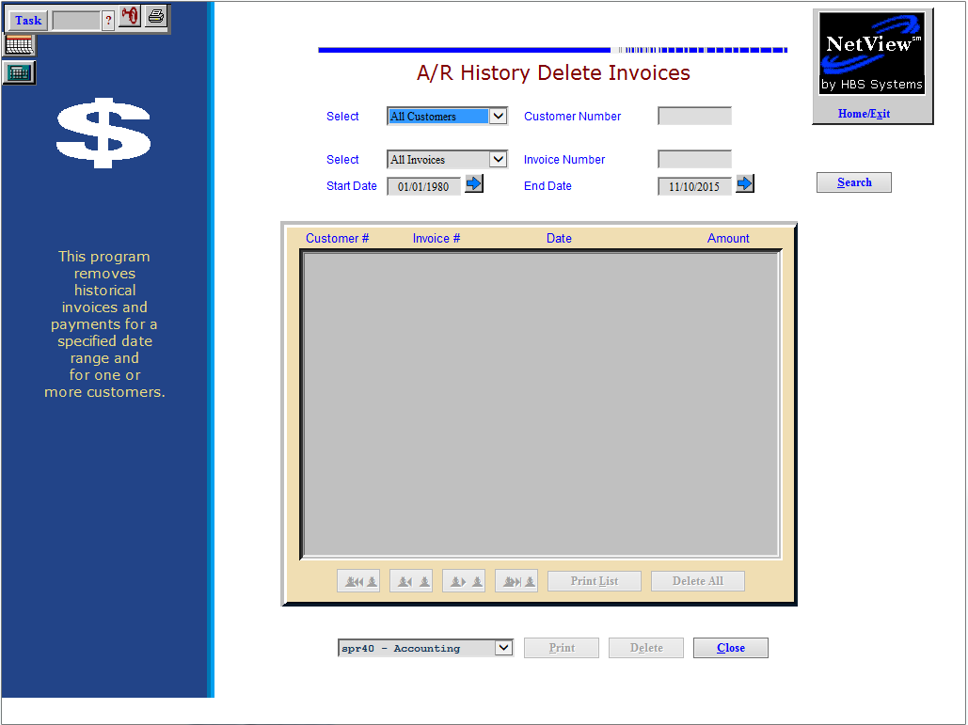

EXTREME CAUTION should be exercised when using this maintenance routine. This removal process is NOT recommended. The records purged are NOT retrievable!

Your system's size and how much data you process on your system through your POS Invoicing and Accounts Receivable programs determine how often you should maintain or purge your A/R History data. We recommend that you keep as much A/R history as possible, so you may never have to actually run this process.

- To access this function, either:
  - Select “System Maintenance” from the menu, then the “Data File Review” submenu. Choose the “Accounts Receivable” submenu underneath that, then click “A/R History Maintenance.”
  - Type “DRHM” in the Shortcuts Bar.

Field Definitions

Select Customers: Choose to look through the history of all customers or select the customer to examine. Use the drop-down menu to make your choice.

Customer Number: This field is active if you chose to select the customer to examine. You may type in a customer number or look it up. To look it up:

Type in a few characters of the customer’s last name or the business name.

Scroll through the choices.

Click on the customer desired.

Select Invoices: Choose to look through the history of all invoices or select the invoice to examine. Use the drop-down menu to make your choice.

Invoice Number: This field is active if you chose to select the invoice to examine. You may type in a specific invoice number here.

Start Date: This search always defaults to 01/01/1980. You can change the date to limit the focus of your search. The range of dates you define in the Start Date and End Date fields covers both the invoice and payment dates. For example, if an invoice is dated 10/01, but the payment was processed on 11/02, that item would not show up on a search unless both dates fell within the search criteria.

End Date: This field pre-fills with the current date. You will need to change this date to limit the focus of your search.

Search (Alt S): Press this button or its corresponding shortcut keys to start your search. The screen will display “Searching for Zero Balance Invoices” while it searches for invoices that match your selections.

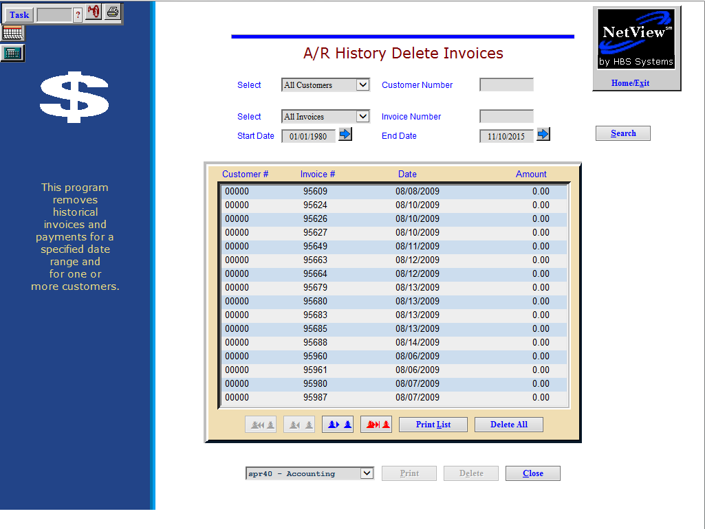

If invoices are located which match the criteria you entered, they will be displayed on the screen. From here you have several options:

View an individual invoice: Click on an invoice to examine. To display it, choose the see printer from the drop-down menu and press “Print.”

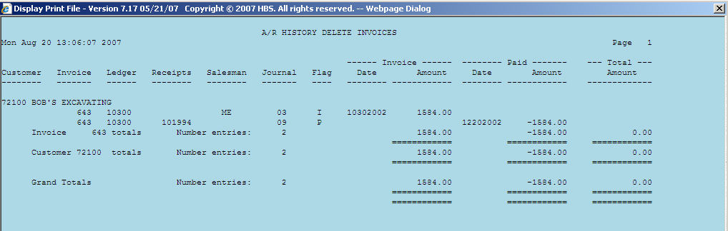

Print an individual invoice report: Click on an invoice to examine. To print it, select a printer from the drop-down menu and press “Print.”

Report Columns Include:

Customer: This column shows the customer account number and name.

Invoice: This column shows the original Invoice Number or Document Number of this invoice.

Ledger: This column shows the account number affected:

Typically 10300 for A/R charges

Other account numbers for Farm Plan or Credit Card transactions.

Receipts: This column shows the receipt number from Cash Apps/POS for money received on account.

Salesman: The initials or code of the person who wrote the original invoice shows here.

Journal: This is the Journal Number where the invoice or receipt transaction was posted.

Flag: This shows the Status Codes:

I=Invoice

P=Paid

Invoice Date/Amount: If the Status Code is “I,” the date and amount of the invoice print in these columns.

Paid Date/Amount: If the Status Code is “P,” the date and amount of the payment print in these columns.

Total Amount: Shows the Net Balance due per Invoice.

Delete an individual invoice: Click on an invoice to examine. To delete it, press the “Delete” button. A box will appear, asking if you are sure you want to remove the invoice. Press “OK” to confirm that you want to remove it from history or “Cancel” to keep the invoice.

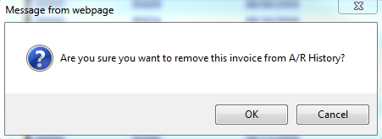

Print List (Alt L): Press this button or its corresponding shortcut keys to get a printout of the invoices selected by your search. See the detailed description of the fields under the description for individual invoice report. Be sure to file any reports generated from A/R History Maintenance as they are the ONLY record of the invoice detail deleted from your system. This information cannot be retrieved once it has been removed.

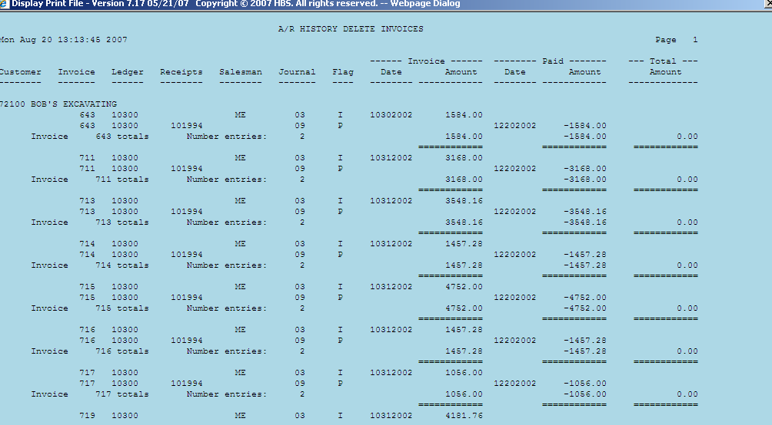

Delete All: Press this button when you are sure you want to permanently delete ALL the selected invoices. A box will appear, asking if you are sure you want to remove all the invoices. Press “OK” to confirm that you want to remove them from history or “Cancel” to keep them.

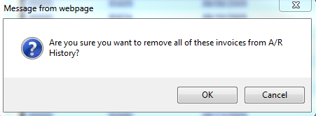

Close (Alt C): Press this button to abandon the screen and return to the home page.

Considerations: Since this program permanently removes information from your system, here are a few thoughts to consider before running A/R History Maintenance.

- Before you run A/R History Maintenance:
  - Go to A/R History and select the same criteria as you would for the maintenance run.
  - Select “Print” or “Display.” The A/R History printout or screen displays show you what will be purged from this file if you apply the same setup criteria for the maintenance run.
  - Always do this procedure if you are unsure what to use for the maintenance setup specifications.
  - Remember that once you start A/R History Maintenance, the A/R History purge is final.
- Always select “Print.” Once you run it, the data no longer exists in A/R History. Therefore, printouts become your only source for future research. Store these printouts in a separate binder marked for this purpose.

