Daily Utilization Report: The Daily Utilization Report in Rental Reports (RR) provides a snapshot of your current Rental inventory’s utilization. Dividing up your inventory by Group and Class, it lets you see how much of your inventory is currently On or Off Rent, and thus how your assets are currently employed.

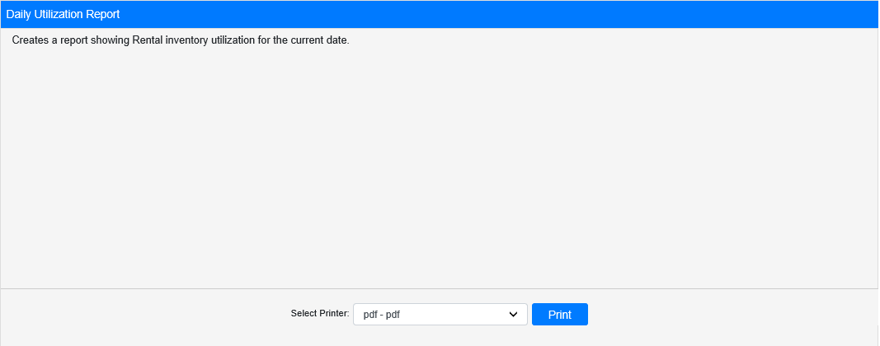

Field Definitions:

Select Printer: Select the printer to receive the report. Use the pdf printer to preview the report.

Click “Print” to print the report.

Sample Report:

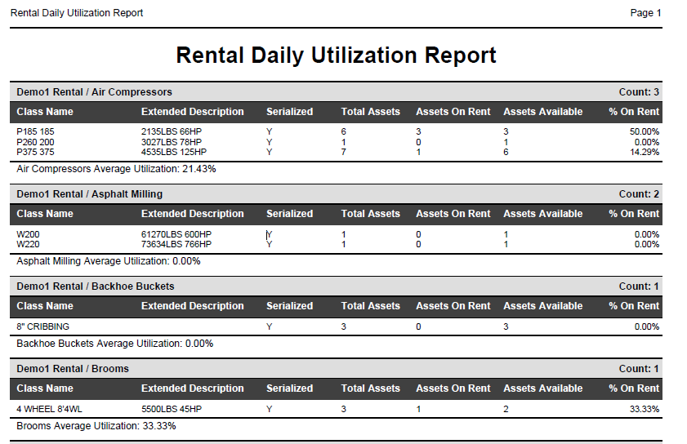

The report is divided into sections by Rental Group. Each line represents a Rental Class in that Group, and provides the following information about the Class as of the current date:

- Class Name
- Extended Description
- If the Class is Serialized (Y) or Non-Serialized (N)
- Total Assets (# of units in Class)
- Assets On Rent (# of Class units currently rented out)
- Assets Available (# of Class units not currently On Rent)
- % On Rent (Percentage of Assets on Rent to Total Assets)

Each Group section ends with a line showing the Average Percent Utilization for the Group as of the current date, calculated by taking the average of the % On Rent values for each Class in the Group.

