Appendix E: Clearing “0.00” Balance Invoices with Manual Checks (MC)

Sometimes you may need to apply credit invoices or other credit document entries to existing invoices. For example, you have an original invoice for $100.00 and a credit invoice for $-100.00. These two invoice documents cancel each other out. However, they continue to hang around, cluttering your open invoices.

Use Manual Checks (MC) to clean them up.

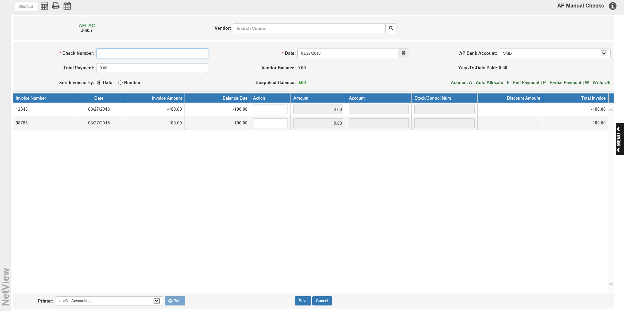

Step 1: Apply the credit invoice to the other invoice.

- Type your document number at the Check Number field.
- Type 0 at the Total Payment field.
- Type F on the credit invoice line. This fully “clears” this amount from the vendor’s account.
- Type F on the other invoice line. This fully “clears” this amount from the vendor’s account.
- Press Save.
- Select a printer, click Print, and review the proof sheet.

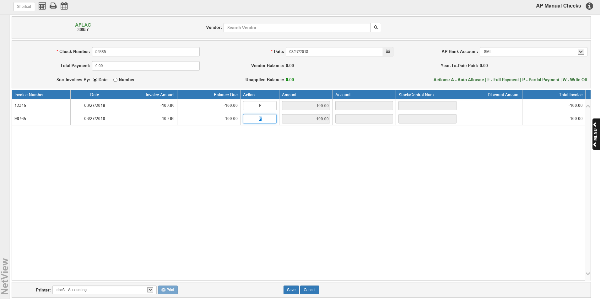

Step 2: Post the entry with the Disbursement Journal (DJ), or include it with your end of day postings.

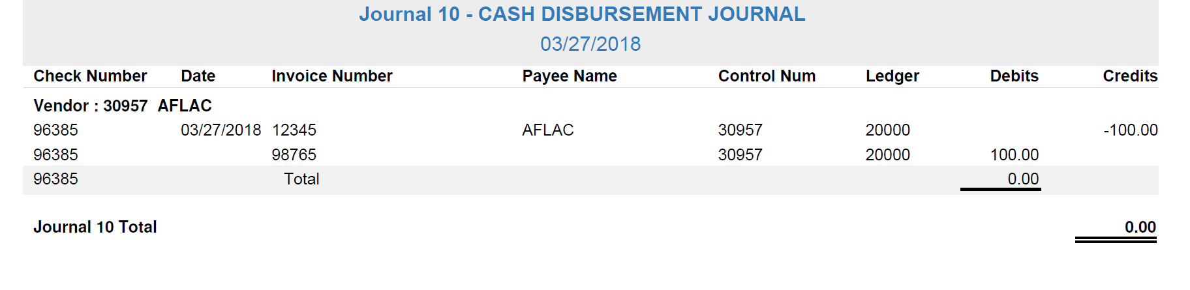

The invoice detail is retained in A/P History (VH). Notice the CHECK number is the document number you assigned to the Manual Checks entry. The detail for open invoices is now clutter free.

