Expense Analysis Report (EA)

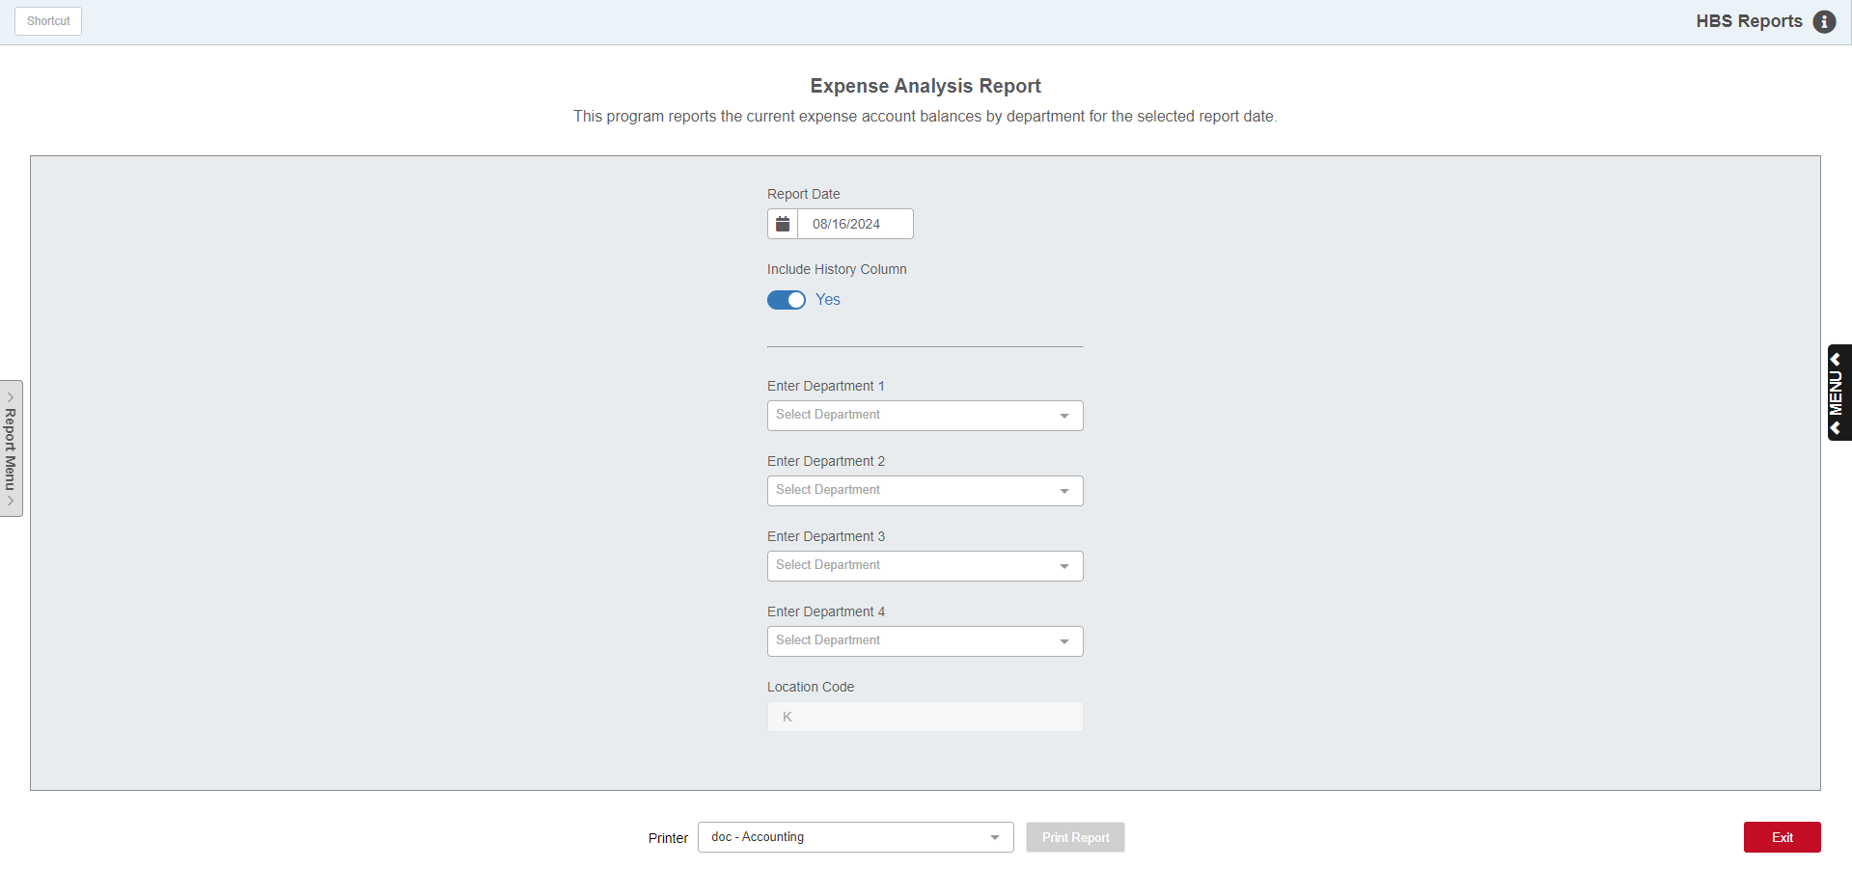

Expense Analysis (EA) charts the distribution of all the expense accounts (Direct Controllable, Direct Uncontrollable, and Indirect Expenses) across the company's departments. It also shows the relationship of the expense account's net total to the total sales for the report period and YTD in the Percent to Sales columns.

To access this function, you can either:

Select “General Ledger” from the menu. Choose the “Memo Reports” submenu and click “Expense Analysis.”

Type “EA” in the Shortcuts Bar.

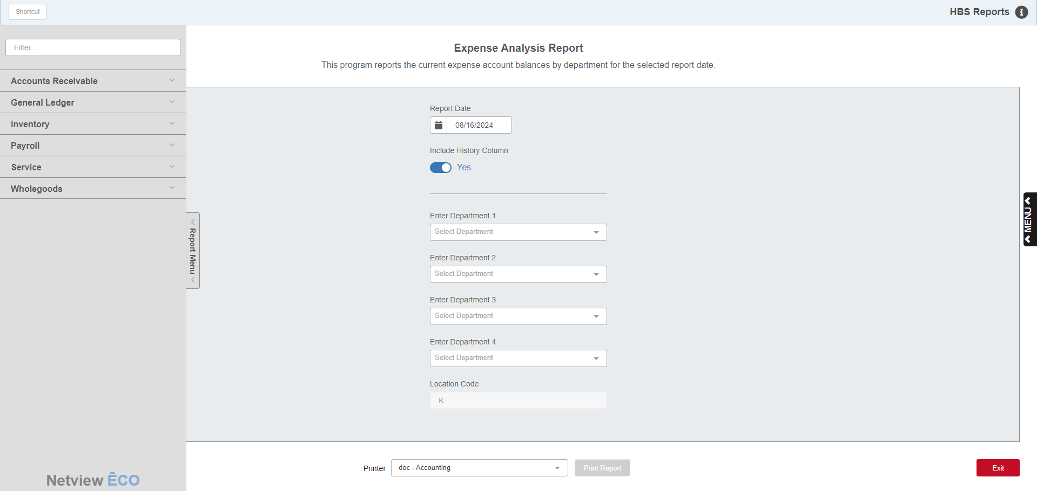

Reports Navigation Menu: This new menu appears on the left side of the screen for all reports and allows the user easy access to all report programs in the system. It is collapsable and can be easily hidden.

Field Definitions:

Report Date: Enter a date or choose one from the calendar.

Include History Column:

- Choose Yes to include a History column for last year’s results on the report (this is the default option).
- Choose No here to omit the prior year column from the report.

Enter Departments: Type the department codes in the field provided or select them from the attached dropdown. You can select up to 4 departments. If your dealership has defined more than 4 departments, the additional departments will be summarized in Other column of the report. NOTE: If you set “Include History Column” to No, you will be allowed to enter a 5th department as the report now has room to include it.

Location Code: This field is used for multi-store operations within the Consolidated location. For these operations, choose a location from the drop-down menu or leave it set for “All Locations.” Otherwise, the field will automatically default to your current location, and you will not be able to change it, as seen in the example above.

Printer Name: Identify the printer to receive your printout. A default printer is pre-filled but you may change it as necessary. Use the PDF printer to display the report.

Print Report: Press the button to run the report. This button will only activate after you select at least 1 department for the report, as you cannot run the report with no department selected.

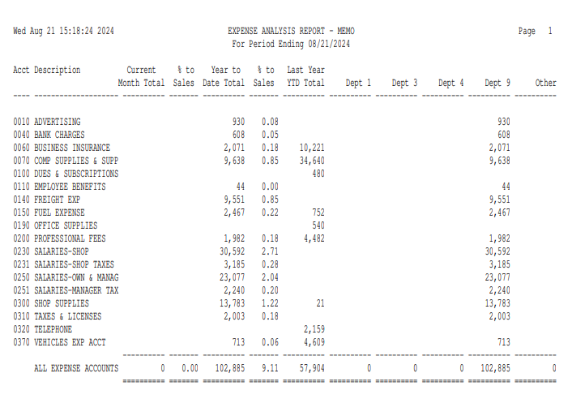

Report Columns:

Acct: The Account Numbers printed in this column show the first four numbers of the account as the department code is excluded from number. Each four-digit number represents an Account Number Group (the same account number format is used for one or more departments).

Description: The Description column reads Account Number Maintenance (ANM) and shows the description for the first account number in the account number group.

Current Month Total: The figure in this column represents the total for all departments. It is the amount for the month up to the report date entered. For example, a report dated 04/30 would include activity from 04/01 through 04/30, but a report dated 04/15 would only include activity from 04/01 through 04/15.

(Current Month) % to Sales: This column compares the Current Month amount to the Total Sales for the month.

Year to Date Total: The YTD column will strictly show you the activity for the current fiscal year through the end of the MONTH selected, even if the prior year is still open. For example, if the prior fiscal year of January to December has not been closed, when you run a report for the month of April of the following year, the YTD column shows the activity only for the current fiscal year (January 1 to April 30).

(Year to Date) % to Sales: This column compares the YTD amount to the Total Sales for the current fiscal year.

Last Year YTD Total (Optional Column): This optional column shows the Year-to-Date totals from the last fiscal year for the same period. It lets you compare last year’s expenses to the ones for this year.

Dept: These columns show the amount of YTD expenses for the departments chosen for the report. You will see one column for each department chosen.

Other: This column summarizes any additional departments, if any, beyond those specified on the report selection screen.

