Enter A/P Invoices (EAPI)

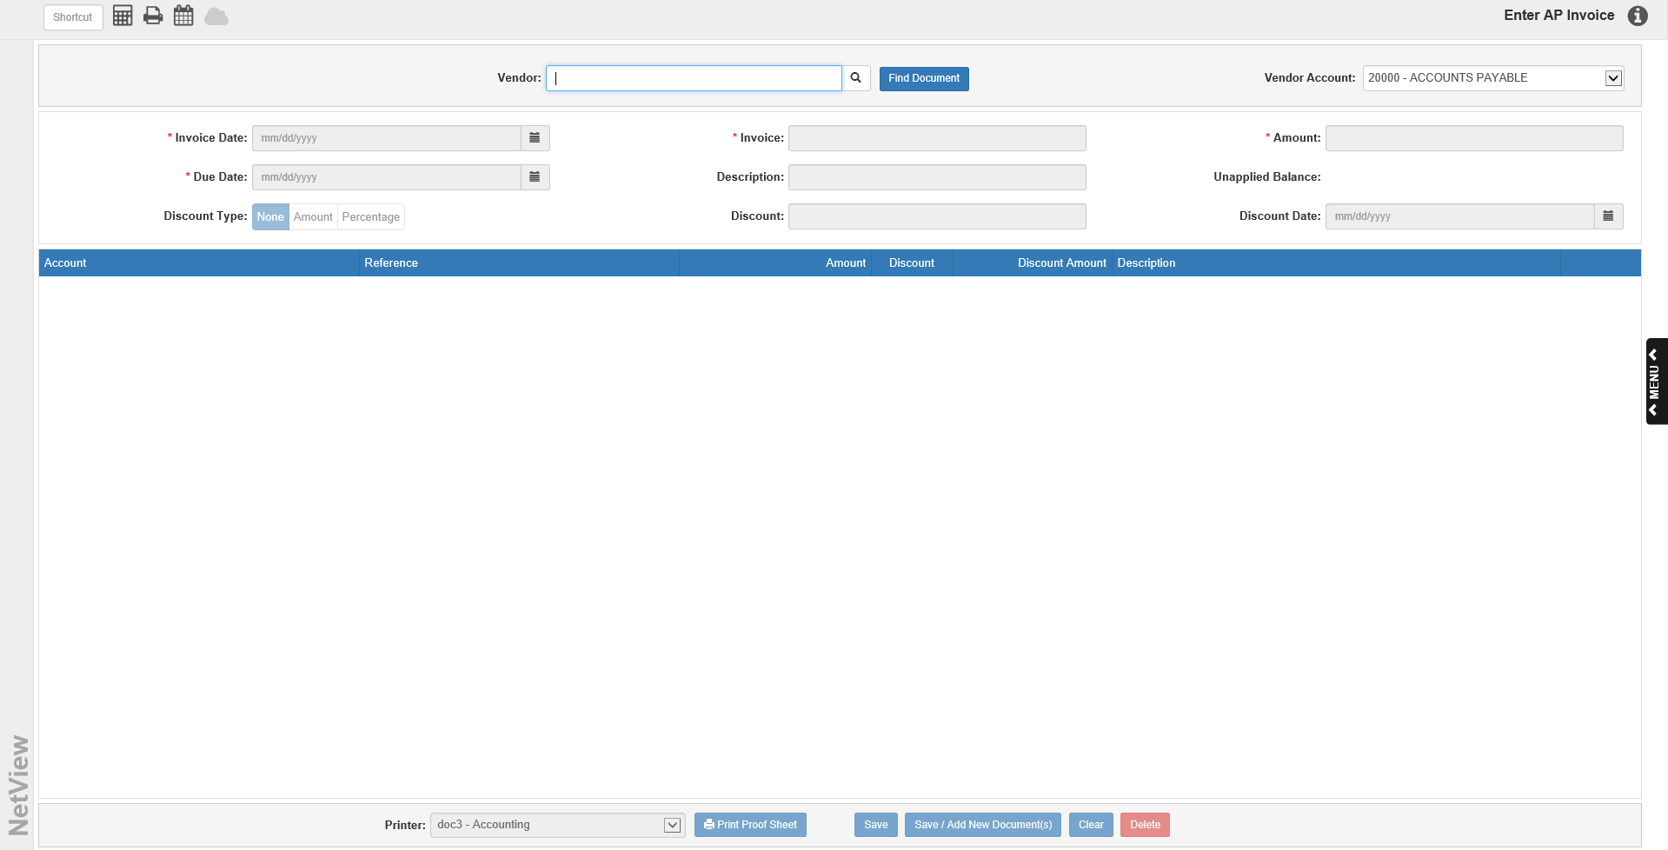

Enter A/P Invoices (EAPI) is the place to enter vendor invoices. To access this function, you can either:

- Select “Accounts Payable” from the menu and click “Enter Invoices.”
- Type “EAPI” in the Shortcuts Bar

Field Descriptions:

Vendor: Type in a vendor number or search for it by entering part of the vendor’s name. The Vendor Search will appear if your entry appears in multiple Active records. You can look for active and inactive vendors by selecting the “All” search.

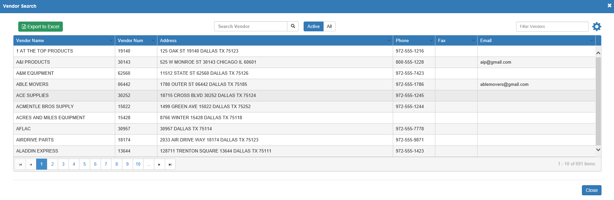

Locate the desired vendor and click on it. The vendor’s name and number will display to the left of the field. You can click on the vendor’s name to view their Vendor Insight (VI) page.

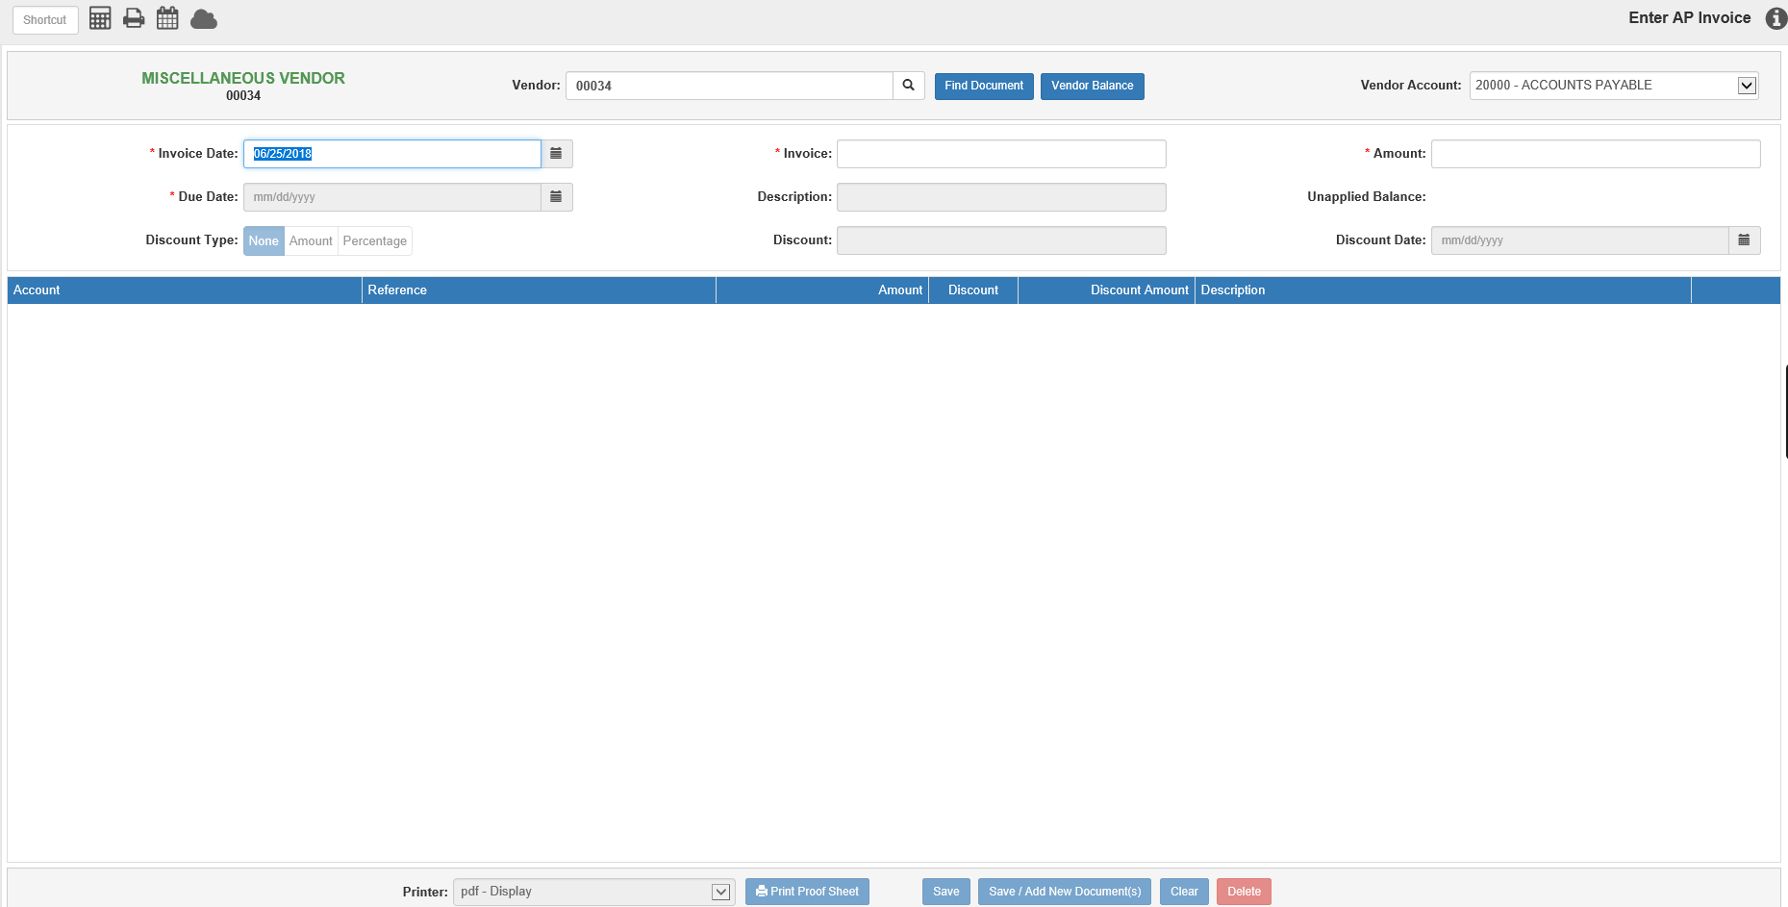

Vendor Balance: This button appears after you have selected a vendor. It opens the vendor’s information in Vendor History (VH), so you can view the vendor’s current balance, year-to-date paid amount, and other related information.

Find Document: If you want to look up an existing invoice, click this button. It will show you a list of all open invoices and their statuses.

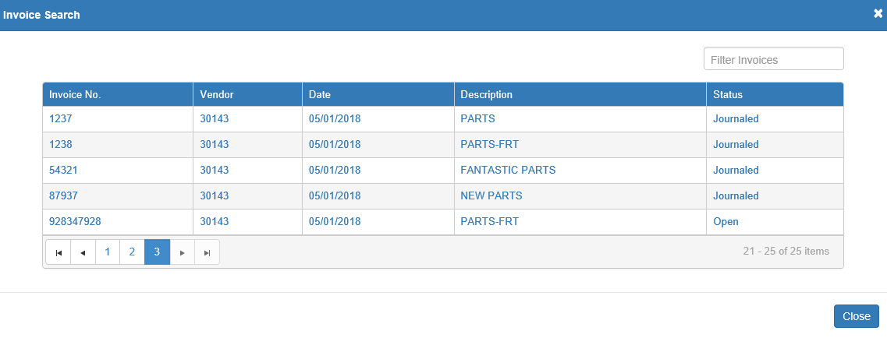

Click an invoice to display it.

NOTE: An invoice’s status determines how much of it can be edited.

- If it is Entered, you can edit any field.
- If it is Journaled with no payments made, you can only edit the Due Date field and the Discount fields.
- If it is Journaled with payments made, you can only edit the Due Date field.

Vendor Account: If you have the Multiple A/P Accounts feature turned on in Information Defaults (ID), you can use this field to select the specific A/P account you want to use on the invoice. The field will default to the account listed in the Vendor AP Account field on the vendor’s page in Vendor Information (VIM). If you do not have the feature turned on, the field will display the default A/P account (20000-ACCOUNTS PAYABLE).

Invoice Date: Enter the invoice date or select it from the calendar. This date determines the accounting period where the invoices will appear. Remember that you cannot enter an invoice into a closed accounting month.

Invoice: This field holds the invoice/reference number. If no number is available when entering a new invoice, create a UNIQUE document number. For example, you could use PHONE0718 for July’s phone bill or WATER0718 for July’s water bill.

You can create duplicate invoice numbers provided that the invoice dates are different. Remember though that you cannot create two invoices with the same number, vendor, and invoice date.

Amount: Enter the total amount of the invoice. This amount should be before any discounts are applied. Type a positive (+) amount in this field unless you are entering a credit (-) memo.

Due Date: Enter the due date for this invoice. If this vendor has a setting in Vendor Information (VIM) for Day of Month or Number of Days, a suggested due date will show based on that info. If none was entered, then a due date 30 days past the invoice date will be suggested. The suggested date can be accepted or changed as necessary.

Description: This field can hold a description for the invoice. This description is used for the A/P account line of the journal entry.

Unapplied Balance: This field displays the running invoice balance (normally a credit amount unless entering a credit invoice). Once you enter the invoice amount, this field will default to that value. As you specify the accounts where the invoice value is to go, this field will change.

Discount Type: This indicates what type of discount applies to the invoice. Click on None, Percent, or Amount. NOTE: This field can be edited after the invoice has been journaled, but only if no payments have been made on the invoice.

Discount Percentage/Amount: If Percent is chosen, the field will hold a percentage. If Amount is chosen, the field will hold a dollar amount. NOTE: This field can be edited after the invoice has been journaled, but only if no payments have been made on the invoice.

Discount Date: Enter the discount date here or select it from the calendar. If this vendor has a setting in VIM for Day of Month or Number of Days, a suggested discount date will show.

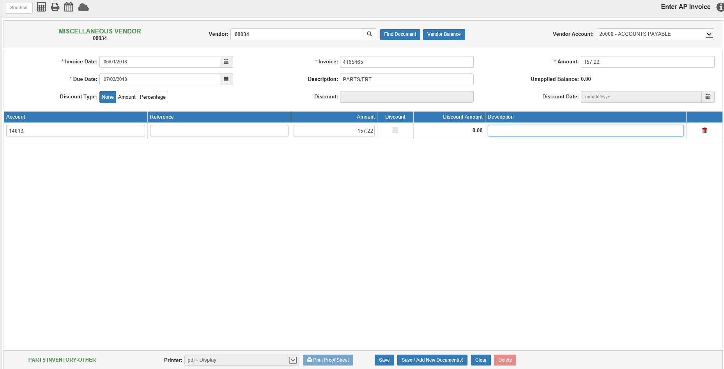

Invoice Details:

Account: This field holds the account where the invoice dollars are being sent. A default number may appear here if it is specified in VIM. NOTE: You may need multiple lines to cover all aspects of the invoice. For instance, if you are billed for parts and freight from ABC Company, your invoice entry has two lines: Parts Inventory and Cost of Freight/Freight Expense.

If you don’t have a default account set or want to use a different account, type in the desired account or search for it by partial account number or by description. You can click on a selection from the search results to use it.

Reference: This is an optional field and is not required, unless the account number for this line has a subledger or is related to a specific unit. For a subledgered account, enter the control number. For a Unit account, enter the stock number or look it up in Unit Search.

Amount: Type the amount for this line of the entry. The amount will default to the current Unapplied Balance amount, but can be changed as needed.

Discount/Discount Amount: When a discount percentage applies to the invoice, use the Discount field to determine which lines are eligible for this discount. A check will appear on the line if the discount applies to it. The Discount Amount field will then show the calculated discount for the line. Remove the check if this line does not qualify for the discount. NOTE: If the discount in the header is a flat dollar amount, the Discount field on the line will not be active and the line discount will remain at “0.00,” as the amount will be applied to the entire invoice instead of individual lines.

Description: This field pre-fills with the Vendor Name, but can be changed as needed. This description will print as part of the check details when you pay the invoice.

Delete Line: Click the trash can icon on the right to delete the line.

Tax Code: This field only appears on an invoice line when the selected vendor is Canadian. It will default to the tax code stored for the vendor in VIM. Edit the tax code as needed for the particular vendor and purchase.

General Information:

- If you have not run Purchase Journal (APPJ), you can edit the invoice in EAPI. You can also delete the invoice at that time, if needed.
- Once the invoice has been posted with APPJ, you may only edit the due date, discount type, discount date, or discount percentage/amount value. If you have made any payments on the invoice after posting it, you can only edit the due date. Any other changes would require you to create a credit invoice for the original amount and the entry of the new invoice with the corrected information.
- Once the invoice has been selected for payment, you cannot access it in EAPI.
- For invoices with multiple due dates, we recommend entering each due date as a separate invoice. For example, a parts invoice has terms and 3 installments. Create invoices for each of the 3 due dates with the appropriate amounts. Use a patterned invoice number like 12345A, 12345B, and 12345C so the original invoice number is part of each of the separate invoice numbers. Be sure to set the staggered due dates for each invoice.

Saving an Invoice: After all the invoice lines are entered, the Unapplied Balance should equal 0.00. Press the Save button to save the entry.

If you want to also attach a scan of the invoice to the invoice record, click Save/Add New Document(s) to both save the invoice and upload the scan to the invoice’s eDocs. The following window(s) will appear:

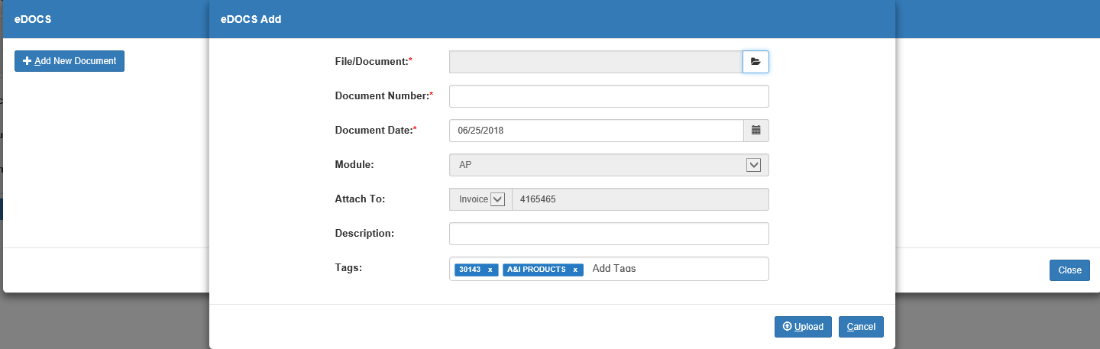

Upload the document using the File/Document field, then fill in the remaining required fields. The program will have automatically filled in the Module and Attach To fields with the specific invoice’s information, and will have also added descriptive tags specific to the invoice. Click Upload to finish uploading the document. It will then appear in the invoice’s main eDocs display once the Add window closes.

If you try to save an invoice when the Unapplied Balance does not equal “0.00,” you will receive the following warning:

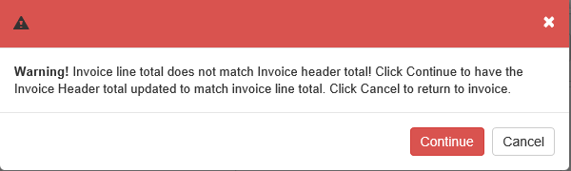

This means that if you click Continue, your invoice header total will be updated to match the invoice line total. Click Go Back to return to the main screen with the information the same, but without saving the invoice.

Clearing an Invoice: Click the Clear button to clear the current screen of all unsaved information. If you are in the progress of entering or changing an invoice, the following warning will appear:

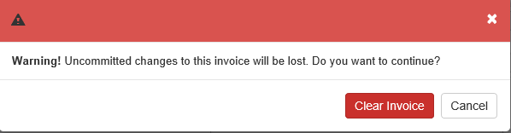

Click Clear Invoice to clear the invoice. Click Cancel to return to the main screen without clearing it.

Deleting an Invoice: You can only delete an invoice if it has already been created and saved, but not yet journaled. Open the invoice, then click the Delete button. The following warning will appear:

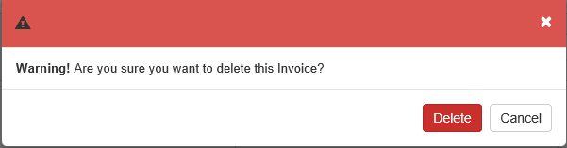

Click Delete to delete the invoice. Click Cancel to return to the main screen without deleting the invoice.

Importing a Kubota Invoice: If you are a Kubota dealer and have the Kubota Invoice Import feature set up in Kubota Connect (KUB), this button will appear in the header.

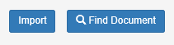

The button allows you to directly import downloaded Kubota invoices into the A/P system without having to manually enter the invoice data. Click it to view the Kubota invoices available for import.

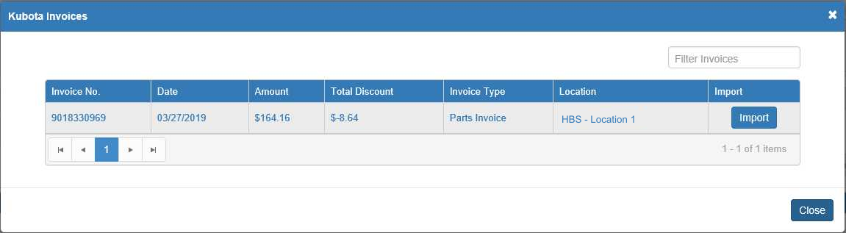

Each invoice entry lists the invoice’s number, date, amount, total discount, type, and what dealer location it belongs to. You can filter the list by using the sortable headers to reorder it or by entering specific information in the Filter Invoices field to narrow down your results. Additionally, you can click an invoice number to view a PDF of that invoice.

Once you find your desired invoice’s entry, click the Import button in the entry’s far right column to import the invoice. The program will return to the main screen and automatically populate with the invoice’s information, including automatically setting the vendor to Kubota. You can then make any adjustments as necessary before hitting Save to record the invoice. NOTE: You will not be able to change the Invoice Date field for imported invoices.

Proof Sheet Printout: You can generate a proof sheet recording of your actions in EAPI. To receive the printout, select a printer from the Printer drop-down menu and click Print Proof Sheet.
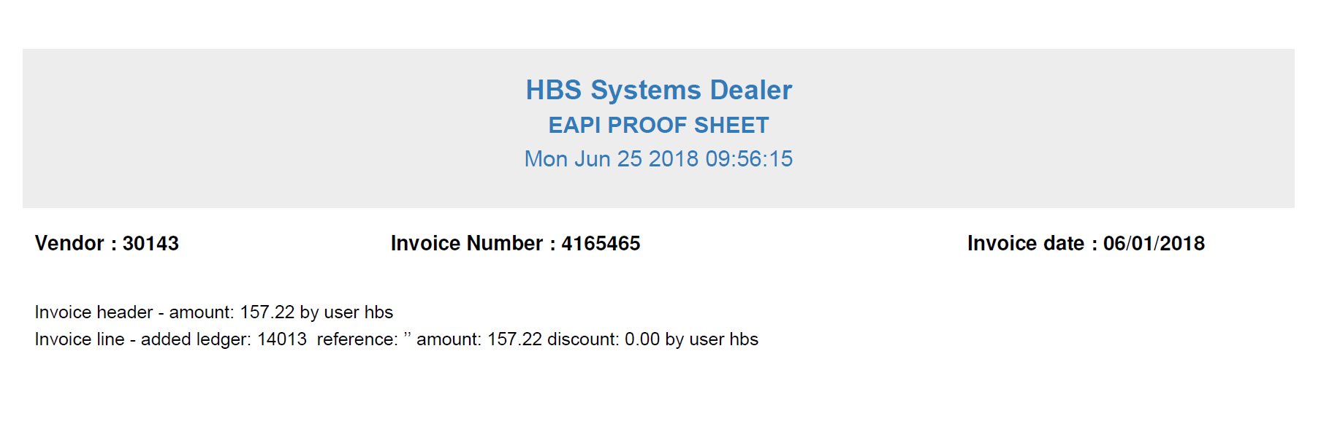

The printout contains the following information for each invoice:

- Vendor Number
- Invoice Number
- Invoice Date
- A description line for each action indicating:
  - Where in the invoice the action took place (header or line)
  - What action was performed
  - Who performed the action (user ID)

If you find errors on the Proof Sheet, return to EAPI to correct the entries before running APPJ.

