Enter Beginning A/R Balances (EBAR)

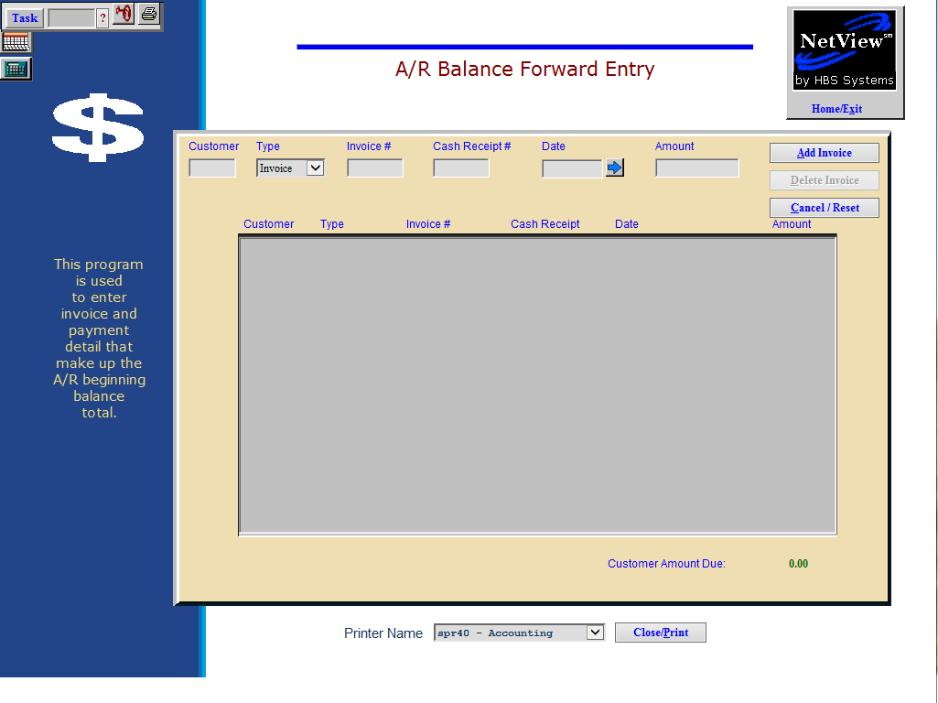

This area of the Accounts Receivable Module is primarily reserved for the initial building of the Accounts Receivable Records. Accessing A/R records in this portion of the programs AFTER the detail has been entered may cause out of balance errors in A/R.

No accounting entries are made when using this program, so it is not intended for everyday use. If you have any questions, check with an HBS Support Team Member before using this screen.

- To access this function, either:
  - Select “Accounts Receivable” from the menu and choose the “Data Entry” submenu. Click on “Enter Beginning Invoices.”
  - Type “EBAR” in the Shortcuts Bar.

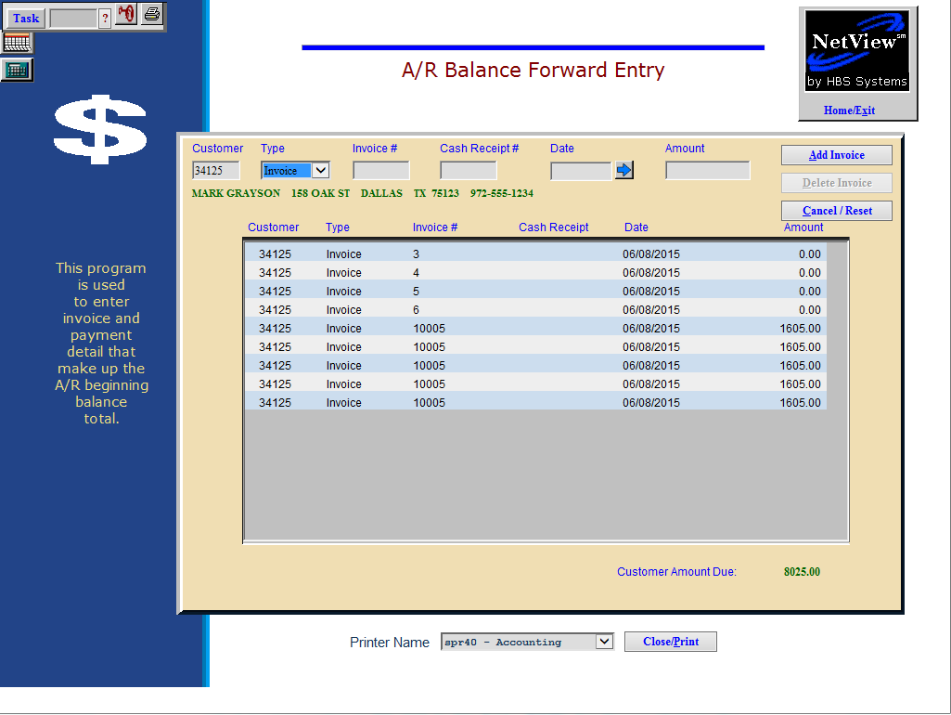

Field Definitions

Customer: You may type in a customer number or look it up.

To look it up:

Type in a few characters of the customer’s name or the business name.

Scroll through the choices.

Click on the customer desired.

Type: This field shows the type of transaction. You can select Invoice or Payment from the drop down menu.

Select “Invoice” for any debits or charges to the account.

Select “Payment” for any payments or credits to the account.

Invoice #: This is the invoice number or reference number for this transaction. You may use the actual invoice number or FIN CHG in this field. NOTE: For Finance Charges, the Invoice # field must be exactly FIN CHG, with the space in the middle so the system will recognize it as finance changes.

Cash Receipt #: This field only applies to Cash Receipts and payments. It is the invoice or reference number for the Cash Receipt. When initially building a record, you may enter the same information as entered in the Invoice # field.

Date: This is the date of the transaction. This field is used to determine the aging of the record. The arrow button next to the field will display a calendar to help you locate a certain date, if you so wish.

Amount: This is the amount of the transaction. NOTE: Enter the amounts without a sign. When you use a transaction type of payment, the system automatically makes the amount a credit “-”.

Customer Amount Due: This field shows the running total for the customer’s balance.

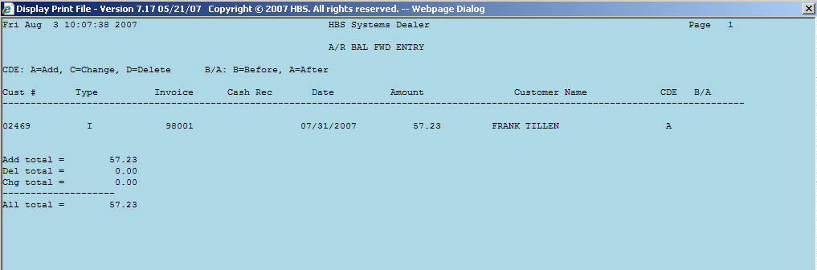

Field Definitions – Proof Sheet

Cust #: This field shows the customer number.

Type: This field shows the type of transaction.

I=Invoice

P=Payment.

Invoice: This field shows the invoice number used.

Cash Rec: This field shows the Cash Receipt number (payment only).

Date: This is the transaction date.

Amount: This is the transaction amount entered.

Customer Name: This field shows the customer name

CDE: This is the code for the type of transaction.

A=Added record

C=Change

D=Deleted record.

B/A: This column will have entries of “B” for “Before” or “A” for “After” when an invoice has been changed. The lines on the report will show the information on the invoice before and after the change was made.

