Enter Customer Comments (ECC)

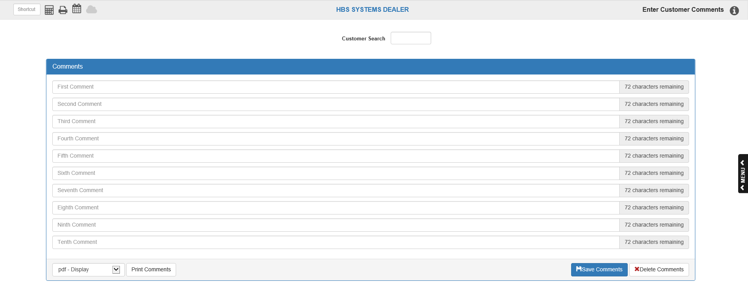

Enter Customer Comments is a place to keep additional information about your customers. You may store comments, payment arrangements, sales related data, and other information by individual customer account number.

- To access this function, you can:
  - Select “Accounts Receivable” from the menu, then the subcategory “Data Entry.” Choose the “Data Entry” submenu and click “Enter Customer Comments.”
  - Type “ECC” in the Shortcuts Bar.

Information entered here will automatically display in the POS and ROM invoicing screens when a new picking ticket, quote, repair order, or repair estimate

Field Definitions

Customer Search: Type the customer number, name, or business name into the Customer Search field. Once you have found the desired customer’s entry, click on their name.

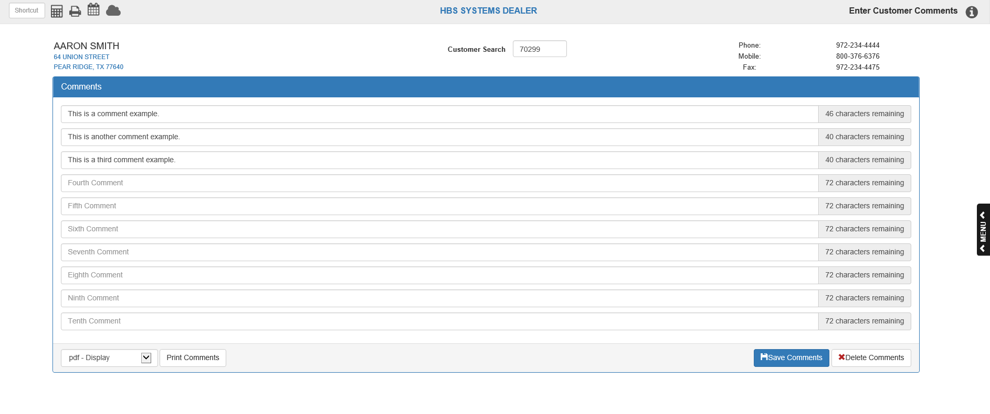

Customer Number: The Customer Search field will now display the customer’s number.

Customer Information: The customer’s name and address will appear to the left of the Customer Number field. The customer’s telephone number, mobile phone number, and fax number will appear to the right.

Comment Lines: There are ten free-form comment lines for each customer. You can use them to put messages about their account, the people who have charging privileges, additional phone numbers, and so on.

Save Comments (Alt S): This button saves the changes made on the screen.

Delete Record (Alt D): This button removes all comments for this customer.

Print Comments (Alt P): This button prints the comments for the customer on the screen.

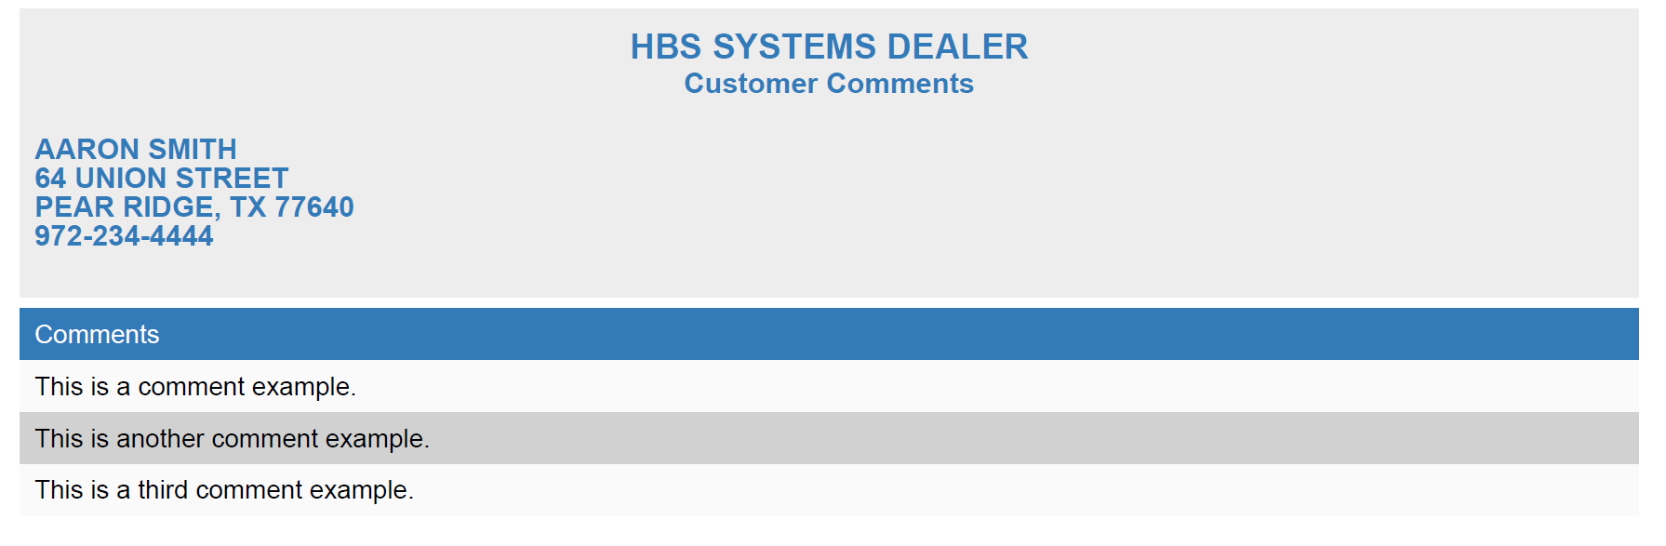

The printout shows the customer’s name, address, and phone number, plus the details of the comments entered for this customer.

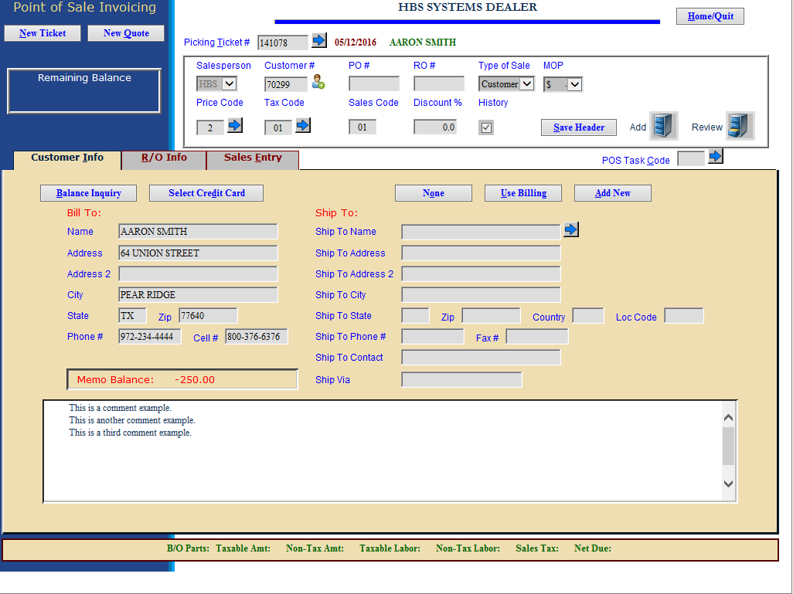

Example of comments in POS

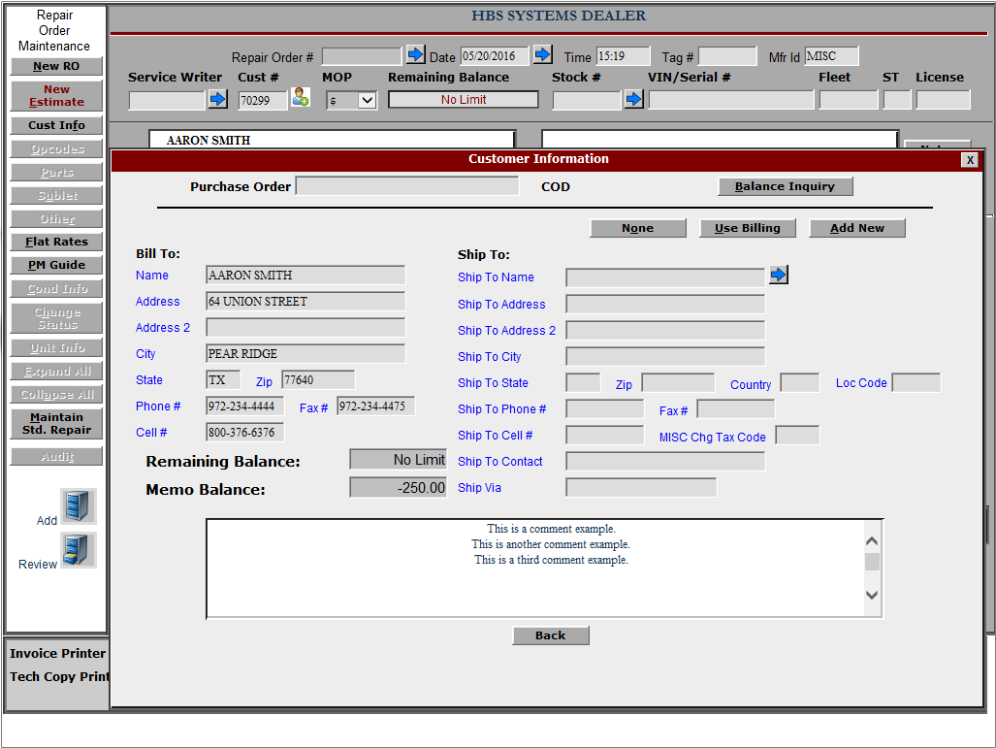

Example of comments in ROM

