Customer Credit Card Maintenance (ECCR)

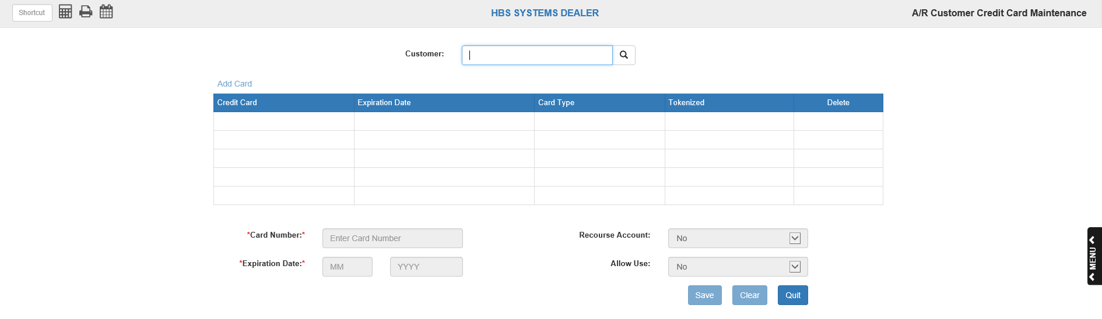

This feature lets you store credit card information for your customers. The information can then be used in POS Invoicing, ROM Invoicing, and Unit Sale Invoicing to pre-fill their personal credit card information. This maintenance screen can also be accessed from inside a Customer Master screen (ECI). Most dealerships no longer store customer credit card info in the system except for private label cards like CNH, Agco, Farm Plan, etc.
- To access this function, you can:
  - Select “Accounts Receivable” from the menu, then click on “Data Entry.” You will find “Customer Credit Card Maintenance” on the “Data Entry” submenu. Click it to open the program.
  - Type “ECCR” in the Shortcuts Bar.

Customer Search: Type either their customer number, name, or business name into the Customer Search bar above the information grid. Once you have found your desired customer’s entry, click on their name.

Field Definitions: The information grid lists the customer’s credit cards and information about them.

- Credit Card: This column lists the credit card numbers. All but the last four digits of each number are replaced by “X”’s, per the EMV security protocol.
- Expiration Date: This column lists the expiration date for each credit card by month and year.
- Card Type: This column lists what company issued the credit card (American Express, Visa, etc.).
- Tokenized: This column lists whether or not the card is tokenized.
  - True means the card is tokenized.
  - False means the card is not.
  - NOTE: Tokenized cards only work with GPEP processing systems.
- Delete: To delete a customer’s credit card from the system, click the red “X’ in the customer’s row under the “Delete” column header.
Editing Card Information: To edit a credit card’s information:

- Click on the card’s row in the grid.
- Make the desired changes in the fields, then click the “Save” button.
- NOTE: You cannot edit the card number of a tokenized card.
- The Recourse Account field gives the ability to identify this credit card as a recourse account. A recourse account is one that can “come back” to the dealer if not paid by the customer within a specified timeframe.
  - Type or choose N if the card is not a recourse account.
  - Type or choose Y to indicate if the card is a recourse account.
- The Allow Use field lets you set whether or not you will accept that particular card as payment. NOTE: This field must be set to “Yes” in order for the system to accept the card.

Adding a Card: To add a card to the customer’s account:

- Click “Add Card” above the top left-hand corner of the information grid.
- Enter the card number, the card type, and the card’s expiration date.
- Click the “Save” button to add the card.
- NOTE: The system only allows you to add credit cards as private credit cards (i.e. Case, New Holland, Connect 2, etc.). The system will correct this automatically if the card is ever charged using EdgePay Input (EPIN) (see “Charging a Credit Card in EdgePay Input” below).

