Enter Customer Information (ECI)

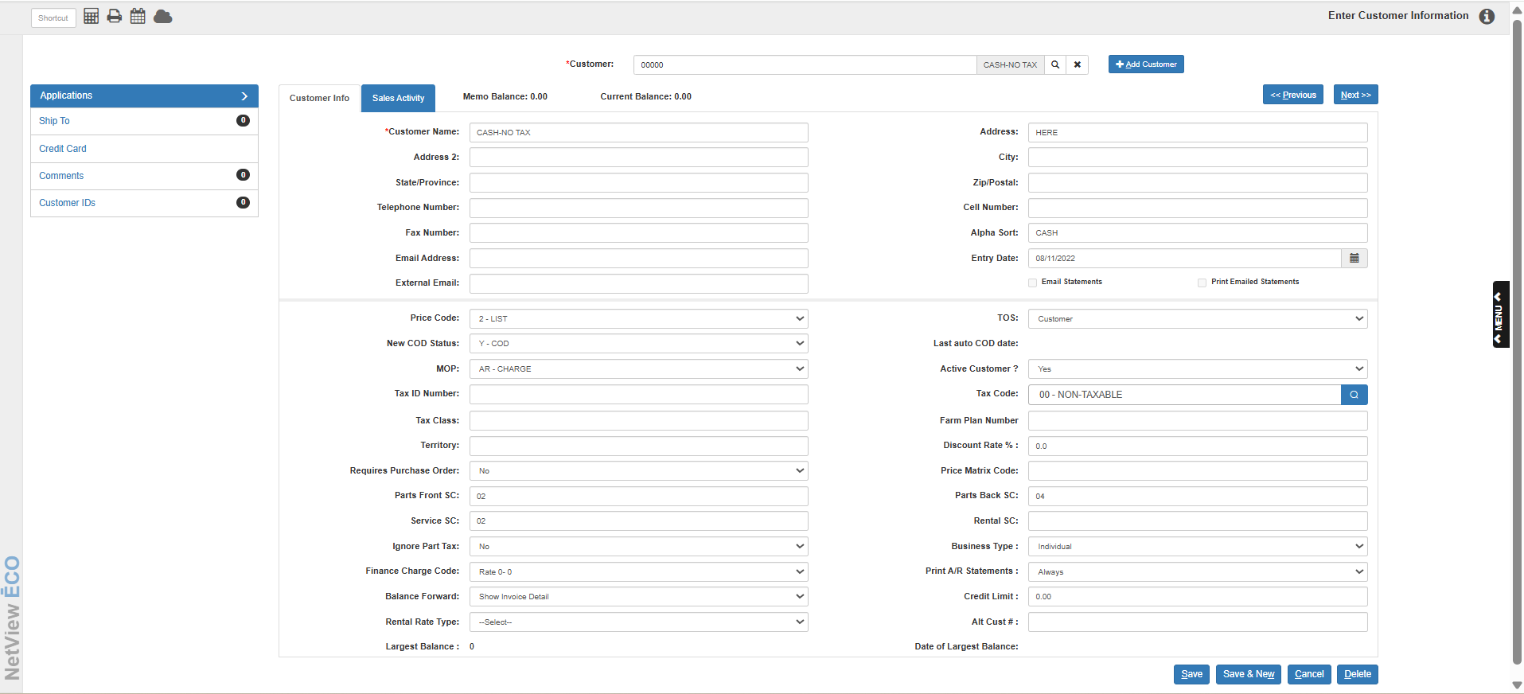

The Customer Master holds all the vital information about the individual customers. Here we find the basics like name and address as well as pricing considerations, credit rating, and typical type of sale.

To access this function:

- Select “Accounts Receivable” from the menu. Choose the “Data Entry” submenu and click “Enter Customer Information.”
- Type “ECI” in the Shortcuts Bar.

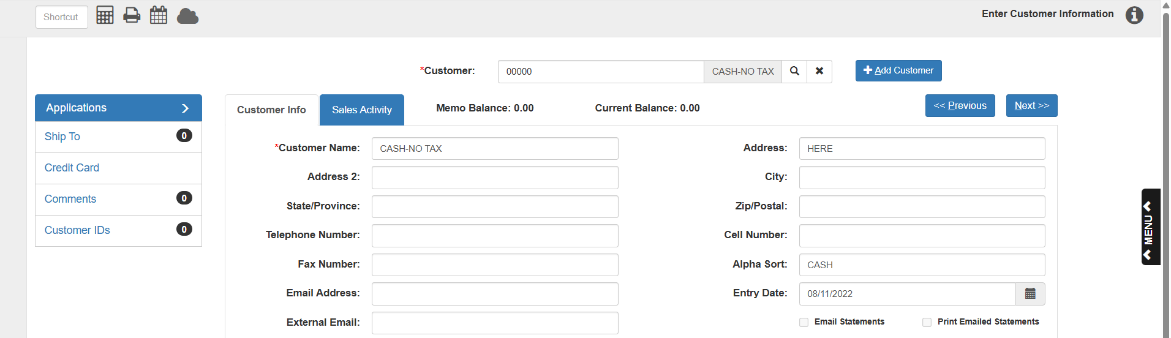

Customer Info Tab

Customer: This field holds a unique five-character number for this customer. You may type in a customer number or look it up. NOTE: This field remains visible above both tabs, so you can still access the search and view the customer number while in the Sales Activity tab.
To look up a customer:

- Type in all or part of the customer’s name or the business name. Any information you enter searches the Customer Name field for any matches.
- The search results are sorted in Alpha Sort order. Here are a couple of examples of how the search works:
  - If you type in a name in the Customer Number field and there is only one customer with that name, the fields will automatically fill with that customer’s information.
  - But generally, if you type a name, like “ROGER,” in the Customer Number field, you will get all customers who have that name somewhere in the Customer Name field:

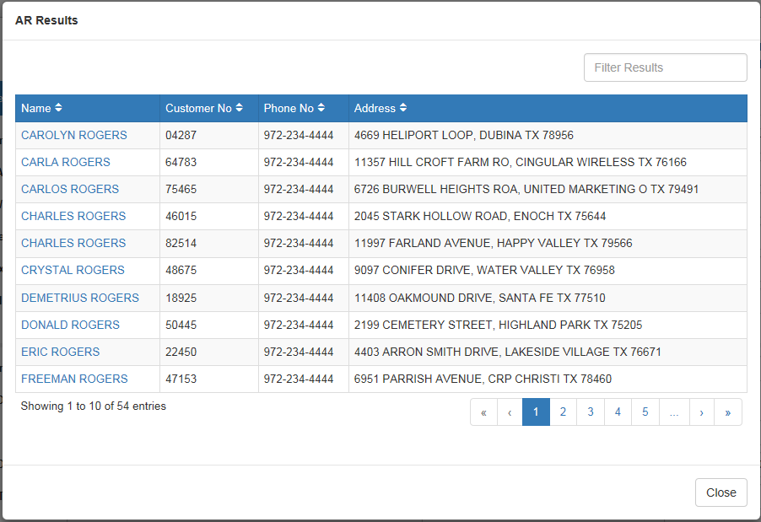

  - Similarly, if you type in “D,” you would get all customers who have the letter “D” in the Customer Name field:

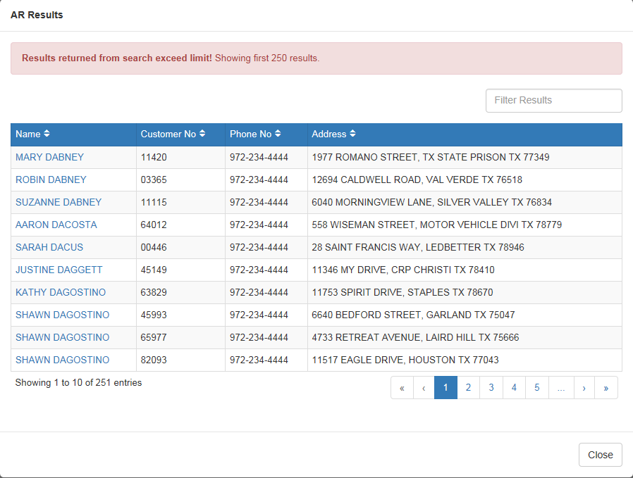

TIP: If you type in just a letter or two in the search field, you will probably see many more matches than you want because you will get all the names that contain the letter(s) somewhere in the Customer Name field, as with the last example.

TIP: The search field works closely with the Active Yes/No setting. If you set the customer to No, that record will not be included in the searches. However, it can still be retrieved by typing in the exact customer number.

Add Customer: To add a new customer on this screen, click “Add Customer” to the right of the customer number. If your system is set to generate a customer number, it will be supplied. If not, you must start the process by entering a customer number of your own.

Additionally, if you type in a name in for a customer search and no entry has that name in its Customer Name field, the following box will appear, giving you the option to create a new customer with that name.

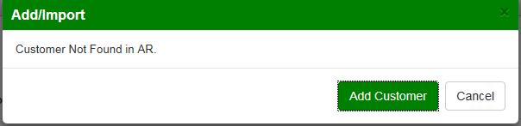

Import Prospects from CRM: If you have the CRM package and search for a customer who does not have an entry in ECI, but is a prospect in CRM, the following note will appear:

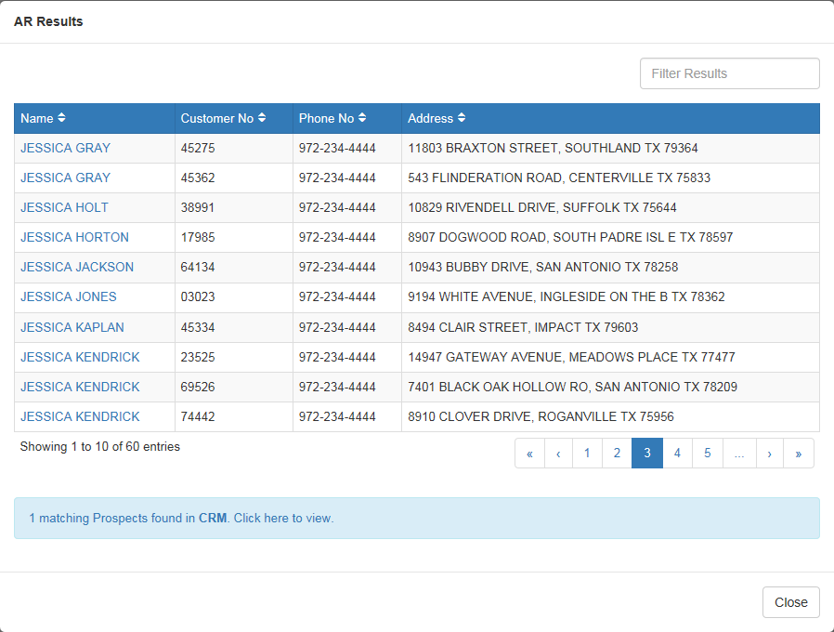

Click on the note to bring up the matching record:

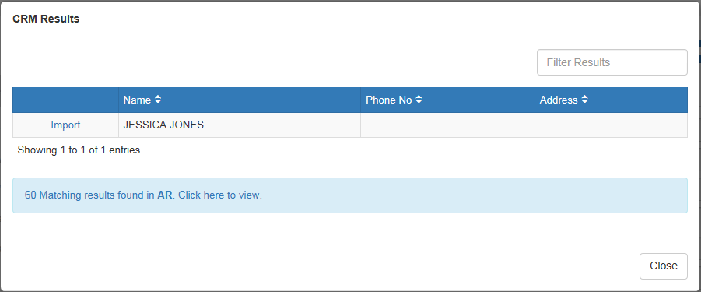

Click “Import” to import the client from CRM into ECI. The window will close and the fields will populate with the client’s information. The system will also automatically generate a customer number for the new customer.

Customer Info Tab—Continued

Customer Name: This field holds the customer name. Information should be entered exactly as you want to see it appear. If the customer’s name is James Park, type in “JAMES PARK.” The style and format of the information in this field is used for:

- A/R Statements
- POS Invoices
- Units Invoices
- Service Invoices
- Rental Invoices

Address: This space holds the customer’s mailing address. If you choose to use abbreviations, it is a good idea to be consistent.

Address 2: This field provides an additional line for the customer’s address. It may also be used for contact information or a company name.

City: This field holds the city where the customer is located.

State/Province: Enter the two character abbreviation for the customer’s state or province here. Use only the standard two character abbreviations.

Zip Code/Postal Code: This field holds nine positions and will accommodate both the expanded U.S. zip codes and Canadian postal codes. If you are using the SST sales tax tables, you must include the ZIP plus 4 for the US addresses.

Telephone Number: This field holds the telephone number of the customer including area code. Enter only numbers in this field (no dashes).

Cell Number: Here you can enter a cell phone number for the customer. Enter only numbers in this field (no dashes or parentheses).

Fax Number: Here you can enter the fax number for the customer. Enter only numbers in this field (no dashes).

Alpha Sort: This field provides the value used for sorting the customer names when a search is done.

If this account is an individual, enter the first 6 characters of the customer’s last name and the first 2 characters of the customer’s first name. For example, if the customer’s name is Brad Johnson, the correct entry for this field would be “JOHNSOBR.”

If this account is a business, fill in as much of the business name as will fit in the field.

Email Address: This field provides space to enter the customer’s email address. The information is viewable in the Customer Master and via Report Writer. This is the address used in Email Maintenance (EM) to email statements to the customer.

Entry Date: This field holds the date the customer record was added or when the customer first starting doing business with the dealership. This information can be useful for credit references and other purposes. You can use the calendar button next to the field to look up your desired date.

External Email: This field holds an email address (possibly identical to the customer’s primary email) that is used as an identifier for this customer in outside systems that integrate with NetView. For example, this email is used to create this customer’s login credentials to grant them access to your dealership via the DealerNow app. NOTE: This email must be unique in your system—no other customer can have this same address.

Email Statements: Check this box to have the customer’s A/R statements emailed to them if statement emailing is enabled.

Print Emailed Statements: If the customer’s statements will be emailed, check this box to have the statements print in addition to being emailed.

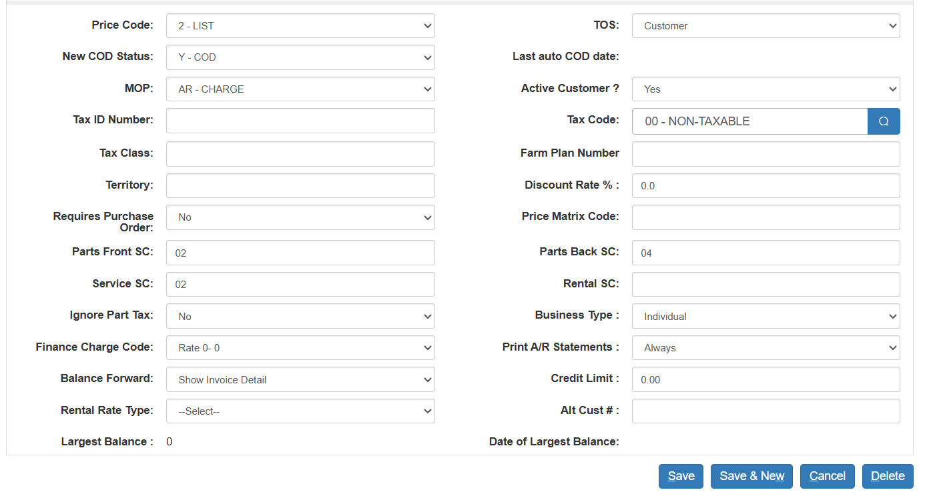

Price Code: This field holds the basis for pricing for the customer. It works with the Discount Rate % field to determine the selling price for pre-priced items in POS and SMS. A drop-down box shows the options for this field. The choices are:

- 1=Cost
- 2=List
- 3=Dealer Defined Pricing Level
- 4=Dealer Defined Pricing Level
- 5=Dealer Defined Pricing Level
- 6=MSRP (Manufacturer’s Suggested)

TOS (Type of Sale): This field shows the type of sale or pay type for this customer number. The choices are:

Customer: general customer pay account

Internal: internal pay account

Warranty: warranty pay account

Other: a different pay account

New COD Status: This field is used by our invoicing programs to determine if the customer has A/R charging privileges.

- Yes in this field means the customer is on COD and does not have A/R charging privileges.
- No in this field means that the customer has A/R charging privileges.

Last auto COD date: This field shows the last date the customer was automatically placed on COD.

MOP (Method of payment): This field holds the preferred or typical Method of Payment (MOP) for the customer. The drop-down menu provides a list of available methods of payment as defined by your dealership. Some typical MOP’s might include Cash, Check, Charge, MasterCard, Visa, Farm Plan, Case Card, NH Card, etc.

Active Customer: This field provides the ability to distinguish between Active and Inactive customers. The search field works closely with the Active Yes/No setting.

If you set the customer to No, that record will not be included in the searches done in any of the invoice routines (POS, ROM, US, etc.). However, it can still be retrieved by typing in the exact customer number.

Tax ID Number: This field provides a space for a tax exemption number. The value entered here may be printed on a POS invoice when an option in IPOS is selected or in ROM when the setting is chosen in SOD.

Tax Code: This field holds the typical tax code for this customer. A drop down box provides the available rates. This tax code provides a default tax code for POS, Service, and Unit invoicing, but this code may be changed for the entire invoice or a specific item.

Tax Class: This field works with the California Sales Tax package. If this optional package is in place, the field is filled with “A” when the customer is eligible for the reduced California Ag tax rate or a “2” if the customer is eligible for the reduced California Manufacturers tax rate. It is not applicable for any other states. The table interfaces with POS, ROM, US, and Rental, and automatically calculates the sales tax rate for in-house sales as well as those delivered or sent to a different location within California. This optional package provides the details for taxable dollars and tax collected by location code to Sales Tax Report (STXR). It also provides the details of the Schedule B assessment by location for reporting purposes.

Farm Plan Number: This field applies to Farm Plan or Agline customers only. It holds the Farm Plan/Agline credit card number. It is generally no longer used.

Territory: This field is one of the choices when printing customer address labels. There are no pre-defined codes for this field, so any codes used should be documented. You can use this field to categorize customers by any groups. You could create codes for the salesman responsible for them, their buying preferences, bulk mailing codes, special event mailings, etc.

Discount Rate %: This field provides a permanent discount from the stated price code for this customer. A percentage entered here will apply to all pre-priced items in POS, SMS, and NetView Service.

To enter a discount here, enter the desired percentage. This is a three digit field. For example, enter 100 or 10.0 to get a 10.0% discount, or 115 or 11.5 to get a 11.5% discount.

You may also enter negative percentages. These negative percentages actually bump the stated price codes. For example, if you want to set the pricing at cost plus 15%, enter 1 as the price code and –150 or -15.0 here to get a 15% bump over cost. Negative percentages are useful for pricing based on cost plus (like warranty reimbursement levels or employee pricing).

Requires Purchase Order: This field shows if the customer requires a PO number.

Yes means a PO number is needed for Parts and Service invoicing.

No means a PO number is NOT required.

Price Matrix Code: This field is used to point to a defined price matrix code. Price matrix codes can be defined to indicate a special pricing structure based on specific parts sources. This field will be blank unless a specific price matrix is appropriate for this customer.

Parts Front SC: This field holds the sales code used when the customer purchases at the Parts Counter. Typical codes are taxable or non-taxable. Sales codes point to the general ledger account number to receive the dollars from the parts sales transaction. The definitions of the sales codes are held in Source Master Maintenance (SMM).

Parts Back SC: This field holds the sales code used when the customer’s purchases is on a repair order. Sales codes point to the general ledger account number to receive the dollars from the service sales transaction. The definitions of the sales codes are held in Source Master Maintenance (SMM). Typical codes are

Taxable

Non-taxable

Service SC: This field holds the default sales code for the labor in the Netview Service package. In most cases, this code will be the same as the one in the Parts Front SC.

Rental SC: This field holds the default sales code for rental income in Rental. If that software is installed, a value should be present in the field. The field should be blank if it is not installed.

Sales Code Mapping (ECI & SMM)

Sales Code | Sample Acct # | Description
1 | 34003 | Parts Counter (formerly Taxable)
2 | 34003 | Parts Counter (formerly Nontaxable)
3 | 34043 | Shop Parts (formerly Taxable)
4 | 34043 | Shop Parts (formerly Nontaxable)
5 | 34003 | Parts Counter (formerly Resale)
6 | 34043 | Shop Parts (formerly Resale)
7 | 34003 | Parts Counter (formerly Government)
8 | 34043 | Shop Parts (formerly Government)
9 | 34083 | Internal Taxable
10 | 34083 | Internal Nontaxable
11 | 34093 | Warranty
12 |  | Dealer Defined
13 |  | Dealer Defined
14 |  | Dealer Defined
15 |  | Dealer Defined
16 |  | Dealer Defined
17 |  | Dealer Defined
18 |  | Dealer Defined
19 |  | Dealer Defined
20 |  | Dealer Defined

The Sales Codes are actually defined in Parts Source Master Maintenance (SMM). This table shows some typical examples of how the codes can be defined for a dealership. This table is just an example; the actual definition and general ledger account numbers will vary from dealership to dealership.

The Account Numbers shown are based on the following SAMPLE selection Chart of Accounts:

- 34003 – SLS Parts Counter
- 34043 – SLS Shop Parts
- 34083 – SLS Internal Parts
- 34093 – SLS Warranty Parts

In the past, we also often separated out the Sales and Cost accounts for Taxable, Nontaxable, Resale, and Government. We have stepped away from that approach because of the availability of STXR (Sales Tax Report) and its capability to separate information by tax code.

Common Tax Codes, Sales Codes, COD fields, TOS and MOP settings
 | Tax | Sales Code | Sales Code | Sales Code
Description | Code | FrontCounter | BackCounter | Service
Non-Taxable | 00 | 02 | 04 | 02
Taxable | 01 | 01 | 03 | 01
Internal | 00 | 10 | 10 | 10
Warranty | 00 | 11 | 11 | 11

These code combinations are common pairings for use in a Customer Master with the indicated characteristics. These are examples only.

Customer Info Tab—Continued

Ignore Part Tax: This field helps you specify the customer’s sales tax situation applying to parts and service transactions. Typically, most dealers have parts set up so that they follow the taxable status of the customer.

- There are situations where the part itself governs the sales tax rules. For instance, in some states oil products are taxable for anyone who purchases them. This might apply in a state where the average agricultural customer is tax exempt, except for oil products. In this case, the parts master is set to override the tax code in the customer’s record to comply with the mandated sales tax for all.
- However, there may be exceptions to the mandated sales tax on certain items. In most areas, governmental agencies, non-profit agencies, and sometimes churches have an exemption for sales tax even on items that are taxable to all. In this case, the tax choice would have to be driven from the customer’s taxable status rather than the override specified in the parts master.
  - When this situation occurs, the Ignore Part Tax Override field can be used to single out those customers whose taxable status has to match the one set in the Customer Master, regardless of any part tax overrides present on your system.
    - Yes in this field indicates that the tax code in the Customer Master takes priority over all taxing scenarios and locks in the taxable status for all items regardless of any part tax overrides.
    - No or a blank in this field means the parts will generally follow the customer’s taxable status except when the part tax override is in place, and in that case, the customer’s tax code surrenders to the one coded on the part.

Business Type: For Case dealers, this field defines the customer type of this customer record. This information is used for the Case Salesmaker Customer Extract program. For the Case dealers, the definitions are as follows:

- S = Sole Proprietor
- I = Individual
- C = Corporation
- G = Government
- P = Partnership
- R = Rental Yard
- TIP: This field can be used for non-Case dealers as well, if you creatively devise a coding system using the values shown to create different categories, which could be used as selection criteria for a report generated in Report Writer. For example, you could devise a coding system like the following that reflects buying habits:
  - S = Ag Customer
  - I = Industrial Customer
  - C = Outdoor Power Customer
  - G = Grain Customer
  - P = Milking Equip Customer
  - R = Rental Customer

Finance Charge Code: This field holds the preference for Finance Charges for this customer. You may define codes 00 through 09 for different rates of finance charges. A drop down box provides the defined codes. The code entered here will determine the appropriate finance charge rate (if any) to be used for this customer when statements are run.

- Typically, 00 indicates that no finance charges will be assessed.
- Code 01 is the one that defines the prevailing finance charge rate in effect.

Print A/R Statements: This field offers the choice to print or not to print an A/R statement for this customer. A drop-down menu provides the choices. This option can be useful when arrangements are made that the customer will not make payments until after a certain period of time has passed. In this case, you could suppress the printing of the statement until the payment time arrives or a payment is due.

- Never means that you do NOT want a statement for this customer.
- Always means that a statement WILL be printed for this customer.

Balance Forward: This field determines the type of detail to be shown on the customer’s statement. The type can vary from customer to customer, offering lots of flexibility to tailor the A/R statements to the customer’s needs. A drop-down box provides the choices.

Choose Show Balance Forward Line to list each invoice applied to the customer since the last statement was run, and lump all unpaid invoices prior to the last statement into a total labeled Previous Balance.

Choose Show Invoice Detail to list each outstanding invoice and unapplied credits for this customer until they are paid.

Credit Limit: This field refers to the maximum amount of credit extended to this customer.

If the customer exceeds his/her credit limit, a message appears in the invoicing programs notifying you that the limit has been exceeded.

The system provides a block when the customer reaches the credit limit.

When a customer has reached the maximum amount of credit, two options are available:

Change the type of sale to something other than A/R

Provide the password to override the credit limit and allow the transaction to finish

A zero in this field also equals an unlimited credit limit.

Rental Rate Type: This field shows the customer’s default rate schedule for Rental. If the field shows “Select” or “None,” you may not have Rental installed or set up at that location.

Alt Cust: This field can be used to list an alternate or previous customer number from a past business system.

Largest Balance: This is the first of several fields that acquires, updates, and keeps information about the customer that could be used for credit references and checks. The field holds the amount of the Largest Balance the customer has reached. This amount is updated each month when A/R Month End (statements) is run.

Date of Largest Balance: This is another field that can be used for credit references and checks. The field holds the date that corresponds to the Largest Balance shown in the previous field. This date is updated each month when A/R Month End (statements) is run.

Changes Warning: If you have a Customer Master up to make changes, and a Parts, Service, or Rental ticket is run that charges their account at the same time, you will receive a message box saying you need to reload the account to update it. Once you do so, you can continue making changes to the updated record.

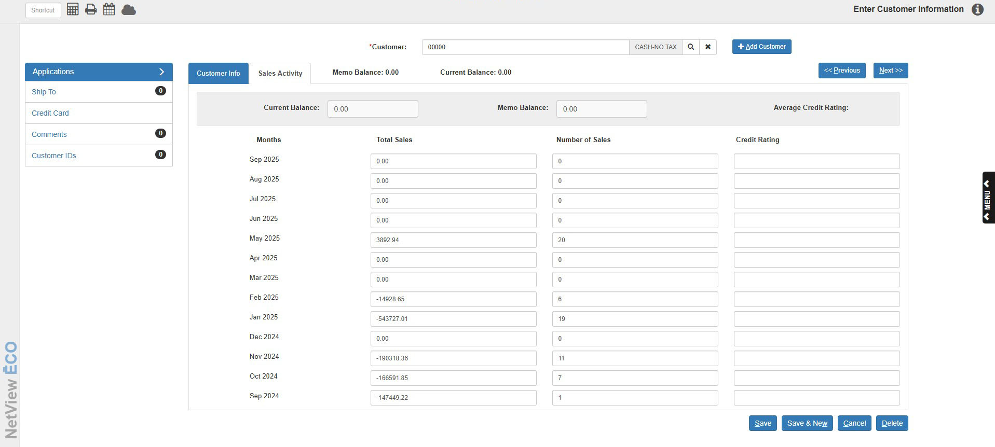

Sales Activity Tab

Current Balance: This informational field at the top of the screen shows the posted balance for this customer. It includes only transactions that have been posted from the Parts, Service, Units, and Rental Invoicing routines, and payments on account from Cash Applications or ARDI.

Memo Balance: This informational field at the top of the screen shows the total balance for this customer. This includes the balance (Current Balance) plus the unposted entries made through POS, Service, Units, and Cash Applications.

Average Credit Rating: This field shows the average credit rating for the customer calculated across the last 12 months. This information can be useful in evaluating the COD status of a customer. The field is updated each month when you run A/R Month End (statements). The system uses an alphabetical rating system, where the letters stand for:

A=current standing

B=30 days past due

C=60 days past due

D=90+ days past due

Months: This column shows the names of the last 12 months.

Total Sales: This column of dollar amounts shows the amount of purchases made by the customer during the month indicated. The amount shown includes transactions for the customer from one of the following:

Parts

Service

Units

Rental

Number of Sales: This column shows the number of individual sales (invoices) the customer made in the indicated month.

Credit Rating: This column shows the credit rating for the customer at each A/R Month End. This information can be useful for credit reference calls and in evaluating the COD status of a customer. The field is updated each month when you run A/R Month End (statements). The system uses an alphabetical rating system, where the letters stand for:

A=current standing

B=30 days past due

C=60 days past due

D=90+ days past due

General Screen Buttons



Save: This button lets you save information added or updated in a customer’s record.

Save and New: This button lets you save information added or updated in a customer’s record and clear the screen.

Cancel: This button lets you cancel any changes just made to the record.

Delete: This button permanently deletes the customer on the screen. If there is outstanding activity for this customer (i.e. open invoices or open account balance), you cannot delete the record.

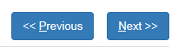

Previous: This button will take you back to the previous customer record (in numerical order).

Next: This button will advance you to the next customer record (in numerical order).

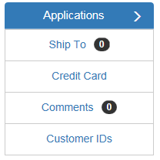

Applications Box

Ship To: Click this feature to access the Ship To Address information for this customer. A number next to the feature’s name indicates how many Ship To Addresses this customer has.

Credit Card: Click this feature to view the Credit Card information for this customer.

Comment: Click this feature to access the Customer Comments screen for this customer. A number next to the feature’s name indicates how many comments the customer has.

Customer IDs: Clicking this feature allows you to view and edit the client’s IDs.

