Environmental Charge Maintenance (ECM)

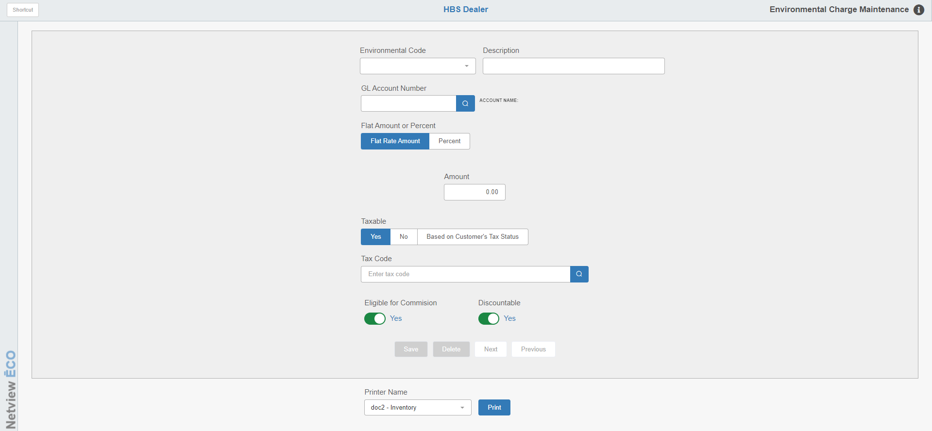

Environmental Charge Maintenance (ECM) sets up environmental fees that can be attached to a part. Then, when you use POS Invoicing (POS) and Repair Order Maintenance (ROM), these fees automatically display when you add the part. Since requirements are different from state to state, country to country, and so forth, this program is quite flexible to meet these various regulations.

To access this program, you can either:

- Select “System Maintenance” from the menu. Choose the “Company File” submenu and click “Environmental Charge Maintenance.”
- Type “ECM” in the Shortcuts Bar.

If the regulations in your area require environmental fees or disposal fees on certain products, use ECM to create these charges. Once created, these environmental or disposal charges may be attached to the Part Master record, so when the product is sold, the fee is automatically attached to the invoice (similar to a core charge).

Field Definitions:

Environmental Code: This five-character code identifies the particular environmental fee. Examples of codes may be OIL, BAT (battery), FREON, etc. You may also just number your environmental charges (i.e., 1, 01, A01, etc.). Either select an existing code from the dropdown to edit it, or type in a new code to start creating a new record.

Description: This field holds a brief definition of this environmental charge. This description displays on the picking ticket and prints on the invoice.

GL Account Number: Enter the General Ledger account number where the environmental charges will be collected, or look it up using the Search button. Usually, this is either a liability account (an account number that begins with 2), other income account (an account number that begins with a 58 or 59), or an expense account (an account which begins with 0). When the invoicing programs charge this environment fee, the amount is posted to the account set up here.

Flat Amount or Percent: Select Flat Rate Amount if the charge is a set dollar amount. Select Percent if the charge is going to be a calculated amount from the item's total sales amount. The field defaults to Flat Rate Amount.

Amount: If you choose Flat Rate Amount, enter the amount value here.

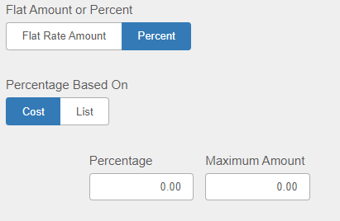

Percentage Based On: This field appears if you select Percent.

Choose Cost if the percentage is calculated from the cost.

Choose List if the percentage is calculated from the selling price.

Percentage: If you choose Percent, enter the percentage here.

Maximum Amount: If you choose Percent, enter the maximum dollar amount that can be assessed for this charge. If there is no maximum amount, enter “0.00.”

Taxable: This field determines if you will charge tax or not on the fee.

Select No if this charge is never taxable.

Select Yes if it is always taxable and enter the appropriate tax code in the next field.

If it is not always taxable or non-taxable, select Based On Customer’s Tax Status to have it follow the customer’s taxable status.

Tax Code: This field will only appear if you set the “Taxable” field to Yes. Enter the appropriate tax code for this environmental code or look it up to select it.

Eligible for Commission:

If your dealership allows commissions on environmental charges, choose Yes. When you print the Sales Commissions Report 2 (SCN), the report calculates the commission on the part sales that include this environmental charge.

If you do not want commissions on these items, select No here. The salesman commission file will still include the environmental charge sale entries, but commissions will not be calculated on these entries.

Discountable:

- Yes in this field means the charge can be discounted.
- Choose No if the charge should not be discounted.

Save: This button will only be active when you have a charge record open (new or existing). Click it to save any changes to the record.

Delete: This button will only be active when you have a charge record open (new or existing). Click it to delete the record. NOTE: You should only delete a record if the record is not currently listed on any Part Record.

Next/Previous: These buttons will only be active when you have a charge record open (new or existing). Use them to jump from one existing charge to the next without having to select them from the dropdown.

Printer Name: If you wish to print out an environmental charge record’s file, set this field to your desired printer.

Print: If you wish to print the environmental charge record that you currently have open, click this button to send the file printout to your chosen printer.

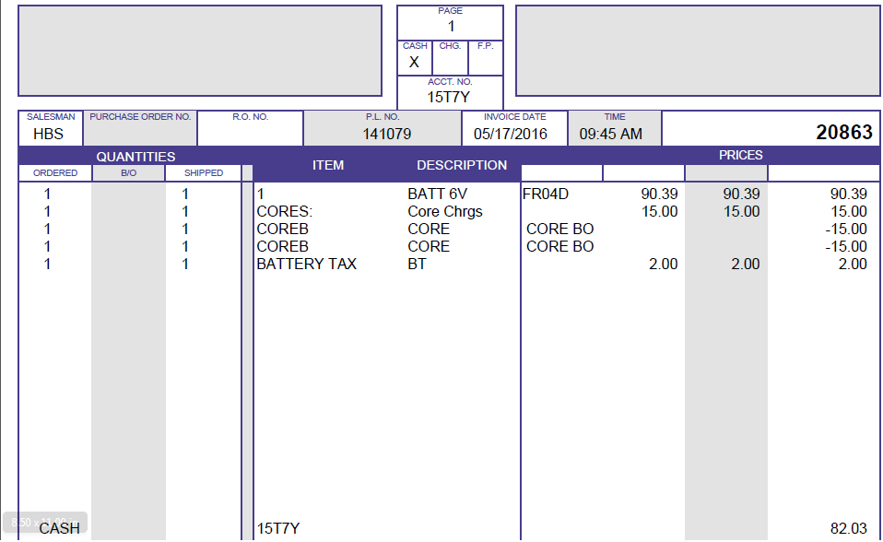

Writing the Invoice with Environmental Charges: If the picking ticket contains part number records with environmental charges, the invoice printout will look similar to the one shown above. Any environmental fees "collected" may be viewed or printed on the Environmental Charges Report (ECR).

