Environmental Charge Report (ECR)

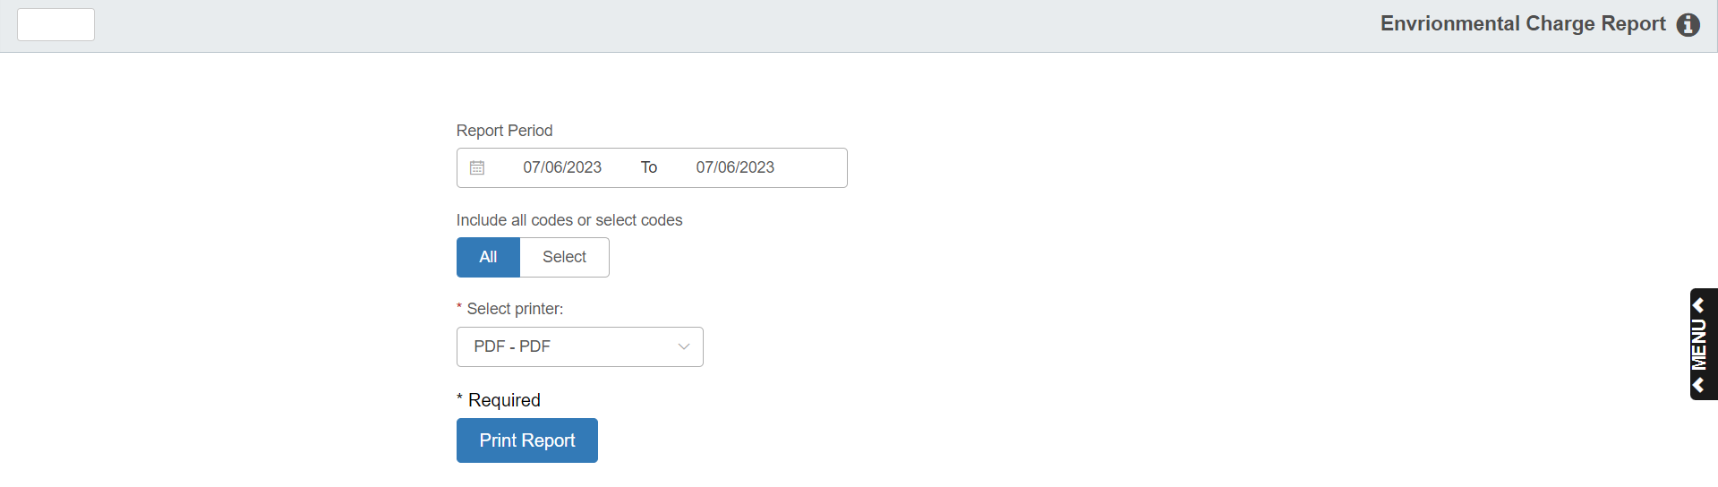

The Environmental Charges Report prints the total amount collected for all (or selected) environmental charge codes for the specified date range. The report identifies how much of the environmental fees were taxed and how much were not taxed. It also reports the total dollar sales of parts with environmental charges. This report may be useful for bookkeepers and parts personnel who need to know how much is being collected for environmental fees. The Environmental Charges Report is located on two report menus: G/L Memo Reports and POS Standard Reports.

To access this report, you can:

- Select “Inventory” from the menu. Choose the “Reports” submenu and click “Environmental Charge Report.”
- Type “ECR” in the Shortcuts Bar.

Field Definitions

Report Period: Enter the date range for the report or select it from the calendar.

Include all codes or select codes:

Choose “All” to run the report for all codes.

Choose “Select” to pick up to 25 specific codes to include on the report.

Printer Name: Select the printer to receive the printout. A default printer name is pre-filled but can be changed as necessary. Use the PDF printer to view the report on the screen without printing a copy of it.

Print Report: Pressing this button prints your report.

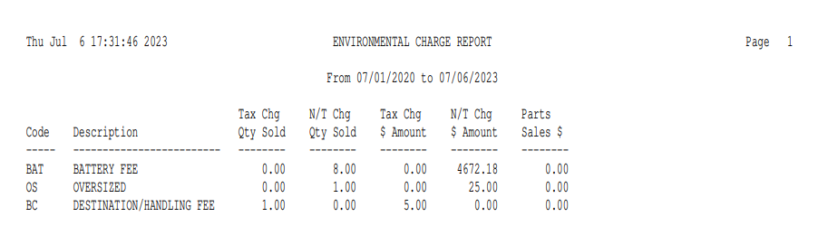

Report Detail: The Environmental Charge Report is drawn from the Environmental Charge transaction file and includes the following information for the time frame selected.

Code: This column shows the Environmental Charge Code.

Description: This field provides the description of the environmental charge from the maintenance program.

Tax Chg Qty Sold: The quantity shown here is the number of environmental charges sold that were taxable on the invoice.

N/T Chg Qty Sold: The quantity shown here is the number of environmental charges sold that were non-taxable on the invoice.

Tax Chg $ Amount: The amount here is the dollar amount of environmental charges sold that were taxable.

N/T Chg $ Amount: The amount here is the dollar amount of environmental charges sold that were non-taxable.

Parts Sales $: This displays the Parts Sales dollars that generated the Environmental fees shown.

