Customer Ship To Address Maintenance (ECSA)

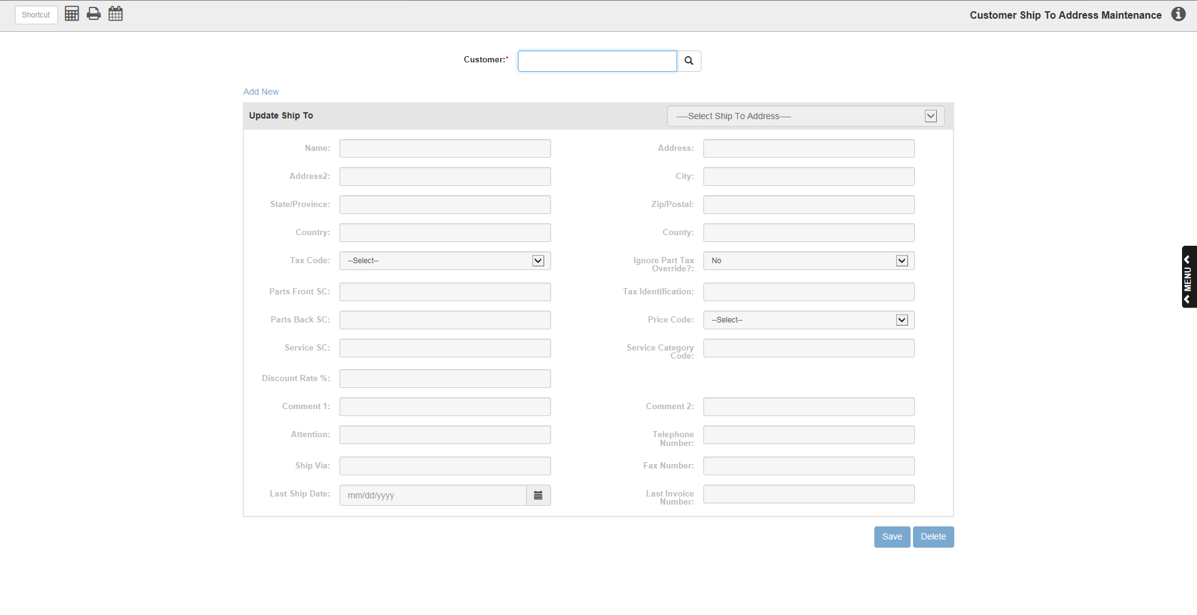

You can create up to 99 additional Ship To addresses for each customer. The records can be added on this maintenance screen or inside a POS/ROM/Units ticket itself (on the Customer Info tab).

- To access this function, either:
  - Select “Accounts Receivable” from the menu and click on the “Data Entry” submenu. Click “Customer Ship Address Maintenance.”
  - Type “ECSA” in the Shortcuts Bar

Field Definitions

Customer/Search Customer: This field holds a unique five-digit number for this customer. You may type in a customer number or look it up. Type in as many characters of the customer’s name or the business name. Any information you enter searches the Customer Name field for any matches. The search results are sorted in Alpha Sort order.

Select Ship To Address: Use this drop-down menu to select the Ship To address you wish to view and update. Once you select the address, the fields below will fill with information.

Name: This space holds the name of the customer for this shipping address. Note: The customer name for the original record is pre-filled here when you add a new Ship To address.

Address: This space holds the customer’s Ship To address.

Address (2nd): This field provides an additional line for the customer’s Ship To address. It may also be used for additional information or a company name, if appropriate.

City: This field holds the city where the customer receives their shipments.

State/Province: Enter the two character abbreviation for the customer’s state or province here. Use only the standard two character abbreviations.

Zip Code/Postal Code: Enter the zip code or postal code for this shipping address.

Country: Here you can enter the country for the Ship To address.

County: This field can hold the county where this address is located.

Tax Code: This field holds the primary or typical tax code for this ship to address. This selection is made from the tax codes set-up on the system. When a new Ship To address is added, the tax code of the main customer record is pre-filled here. However, the code may be any of the available tax codes 00 through 99.

Ignore Part Tax Override?: This field helps you specify the customer’s sales tax situation applying to parts and service transactions. Typically, most dealers have parts set up so that they follow the taxable status of the customer.

- There are situations where the part itself governs the sales tax rules. For instance, in some states oil products are taxable for anyone who purchases them. This might apply in a state where the average agricultural customer is tax exempt, except for oil products. In this case, the parts master is set to override the tax code in the customer’s record to comply with the mandated sales tax for all.
- However, there may be exceptions to the mandated sales tax on certain items. In most areas, governmental agencies, non-profit agencies and sometimes churches have an exemption for sales tax even on items that are taxable to all. In this case, the tax choice would have to be driven from the customer’s taxable status rather than the override specified in the parts master.
  - When this situation occurs, the Ignore Part Tax Override field can be used to single out those customers whose taxable status has to match the one set in the Customer Master, regardless of any part tax overrides present on your system.
    - Yes in this field indicates that the tax code in the Customer Master takes priority over all taxing scenarios and locks in the taxable status for all items regardless of any part tax overrides.
    - No in this field means the parts will generally follow the customer’s taxable status except when the part tax override is in place, and in that case, the customer’s tax code surrenders to the one coded on the part.

Parts Front SC: This field holds the sales code used when the customer purchases at the Parts Counter. Sales codes point to the general ledger account number to receive the dollars from the parts sales transaction. The definitions of the sales codes are held in Source Master Maintenance (SMM). Typical codes are:

Taxable

Non-taxable

Parts Back SC: This field holds the sales code used when the customer’s purchases is on a repair order. Sales codes point to the general ledger account number to receive the dollars from the service sales transaction. The definitions of the sales codes are held in Source Master Maintenance (SMM). Typical codes are:

Taxable

Non-taxable

Service SC: This field holds the default sales code for the labor in the NetView Service package. In most cases, this code will be the same as the one in the Parts Front SC.

Discount Rate: This field provides a permanent discount from the stated price code for this customer. A percentage entered here will apply to all pre-priced items in POS and SMS.

To enter a discount here, enter the desired percentage. This is a three-digit field. For example, enter “100” to get a 10.0% discount or “115” to get a 11.5% discount.

You may also enter negative percentages. These negative percentages actually bump the stated price codes. For example, if you want to set the pricing at cost plus 15%, enter “1” as the price code and “–150” here to get a 15% bump over cost. Negative percentages are useful for pricing based on cost plus (like warranty reimbursement levels or employee pricing).

Tax Identification: This field provides a space for a tax exemption number. The value entered here may be printed on a POS or ROM invoice when an option in IPOS or SOD is selected. It is pre-filled from the main customer record when you add a new one.

Price Code: This field holds the basis for the pricing for the customer at this ship to address. It is pre-filled from the main customer record when you add a new one. The choices for this field are:

- 1=Item
- 2=List
- 3=Price 2
- 4=Price 3
- 5=Price 4
- 6=MSRP (Manufacturer’s Suggested)

Service Category Code: This field is for use for shipping addresses in Service Management (SMS). It is generally no longer used.

Comment Line 1: Here you can enter comments about this address, like additional information or special shipping instructions.

Comment Line 2: Here you can enter more comments about this address, like additional information or special shipping instructions.

Attention: This field can be used to designate a specific department or person to receive merchandise.

Telephone Number: This holds the telephone number for the Ship To address.

Ship Via: Here you can enter the shipping method preferred by the customer.

Fax Number: If the Ship To address has a different fax number than the billing address, you can enter it here.

Last Ship Date: This field is automatically updated each time an invoice is written that uses this Ship To address. It holds the date of the last invoice sent to this address.

Last Invoice Number: This field is automatically updated each time an invoice is written that uses this Ship To address. It holds the number of the last invoice number sent to this address.

Other Features

Save: Press this button to save any changes you have made to the record.

Cancel: Press this button to cancel changes made to the record.

Delete: Press this button to delete the Ship To address currently displayed.

Add New: Click “Add New” to create a new Ship To address record for the customer.

