Equipment Price Reports (EPR)

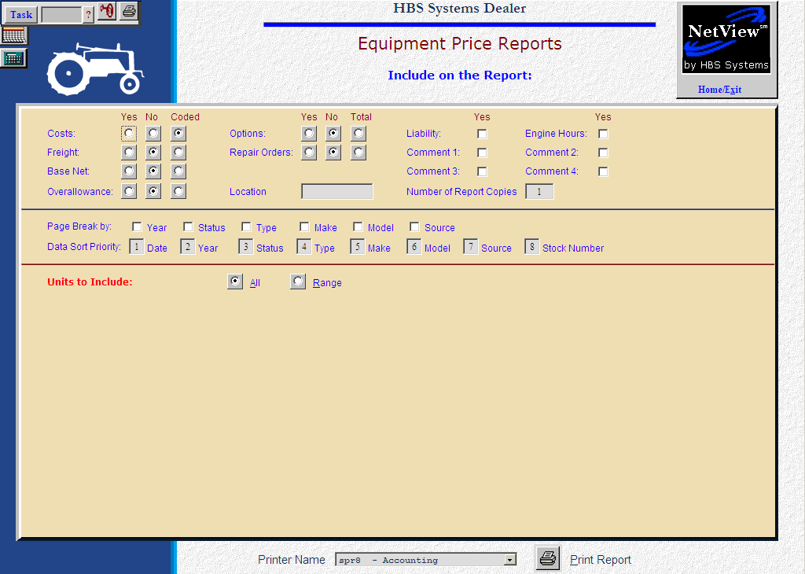

Equipment Price Reports (EPR) provides your sales staff with up-to-the-minute information of:

- What units are available for sale
- What options are included
- Their current costs

The report specifications are broad enough to help you create reports that meet a variety of needs. You may also use this function to print liability information in both Accounts Payable and in Notes Payable.

- To access this function, you can either:
  - Select “Units” from the menu. Choose the “Reports” submenu and click “Equipment Price Reports.”
  - Type “EPR” in the Shortcuts Bar.

Info to include on the report:

Costs: You may choose whether you wish to include the costs on the printout by checking off the correct box.

- Yes will print the equipment costs.
- No excludes the costs from the printout.
- Coded gives cost in a coded format (i.e., $5,000.00 prints as 005C000).

Freight: You may choose whether you wish to include the freight costs on the printout by checking off the correct box.

- Yes will print the freight.
- No will exclude it.
- Coded prints the freight amount in a coded format (i.e., $350.25 as 253K50).

Base Net: You may choose whether you wish to include the base net on the printout by checking off the correct box.

- Yes will print the base net.
- No will exclude it.
- Coded prints the base net amount in a coded format (i.e. $16,150.25 prints as 2516P150).

Overallowance: You may choose whether you wish to include the over-allowance on the printout by checking off the correct box.

- Yes will print the over-allowance.
- No will exclude it.
- Coded prints the over-allowance amount in a coded format (i.e. $1500.00 prints as 001Q500).

Options: You may choose whether you wish to include the options on the printout by checking off the correct box.

- Yes will print the options.
- No will exclude them.
- Total includes the Options Net Total line on the report.

Repair Orders: You may choose whether you wish to include the repair orders on the printout by checking off the correct box.

- Yes will print the orders.
- No will exclude them.
- Total includes the Repair Orders Total line on the report.

Location: You may type in the value for a location to restrict the printout to that site’s units. It reads the location field on the stock number record.

Liability: You may choose whether you wish to include the liability on the printout. Checking Yes in this field will include them while leaving the space blank will exclude them.

Engine Hours: You may choose whether you wish to include the engine hours on the printout. Checking Yes in this field will include them while leaving the space blank will exclude them.

Comment 1 – 4: You may choose whether you wish comment lines to be included on the printout. Checking Yes in this field will include them while leaving the space blank will exclude them.

Number of Report Copies: You may designate any one digit number. This can be helpful for printing a copy for the sales team.

Page Break By: If you want to include page breaks after certain sorting selections, choose those in this section of the screen.

Date Sort Priority: The report can sort up to 8 layers deep. Rank the choices in the order you want to see them sorted: 1 for your first choice, 2 for your second, and so on, up to 8. Each field has to have a unique number.

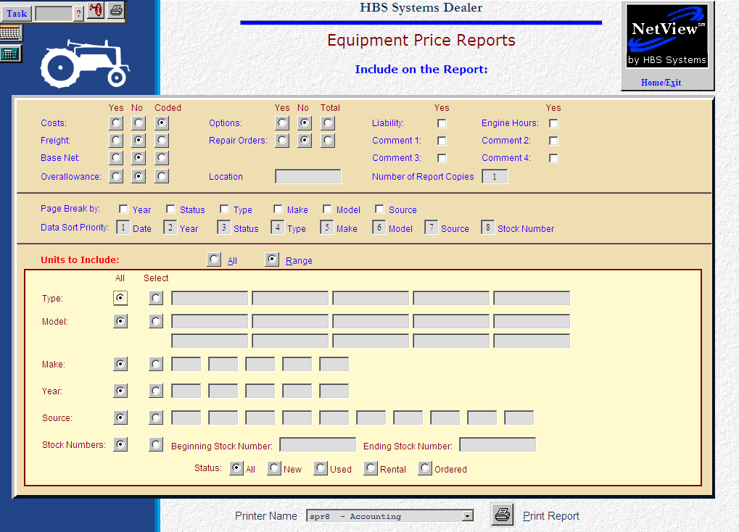

Units to Include:

- Select All to include all items in your inventory.
- Select Range to limit the selections for your report using the following criteria:

Type: Choose All or Select to enter up to 5 types.

Model: Choose All or Select to enter up to 10 models.

Make: Choose All or Select to enter up to 5 makes.

Year: Choose All or Select to enter up to 5 model years.

Source: Choose All or Select to enter up to 10 sources.

Stock Numbers: Choose All or enter a Beginning and Ending stock number to include on the report.

Status: Choose one of the following:

All (Alt A)

New

Used

Rental

Ordered

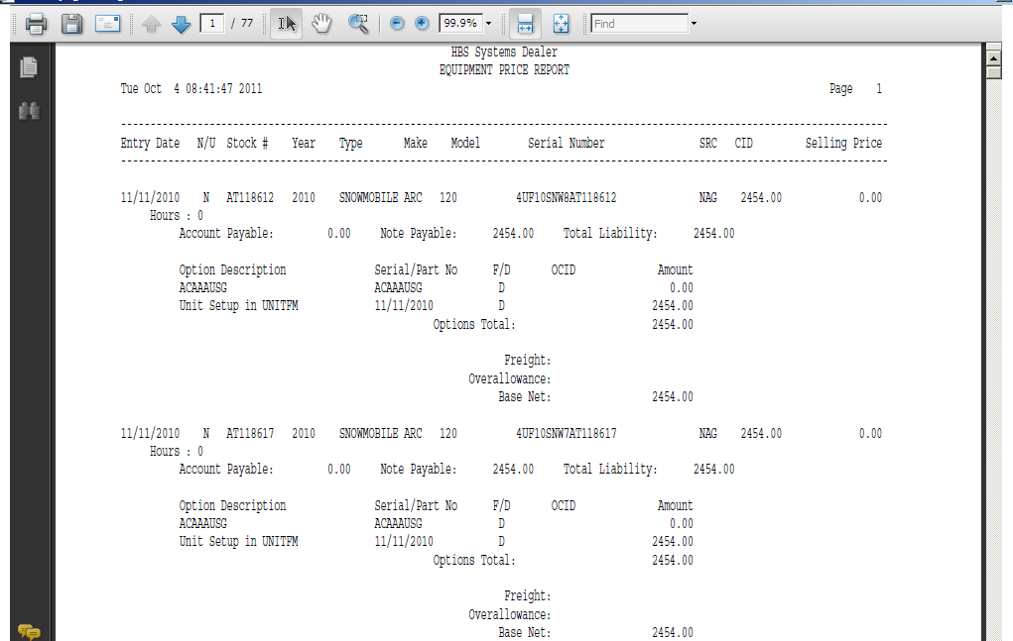

Report Printouts: The styles of the Equipment Price Reports will vary greatly from selection to selection. The one above shows most fields selected for all units.

This report below shows a slight variation and makes use of the coded format available for the dollar amounts.

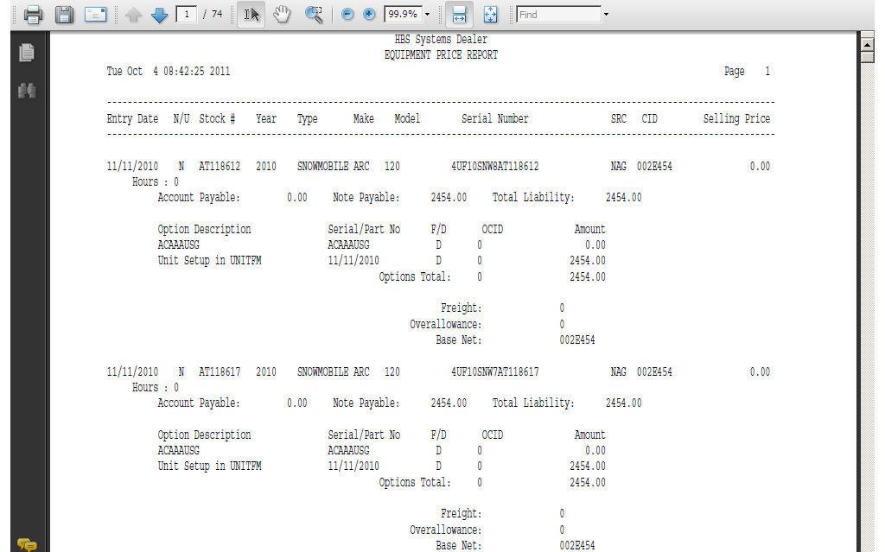

This variation below produces a single line for each unit on the report.

