Email Maintenance (EM)

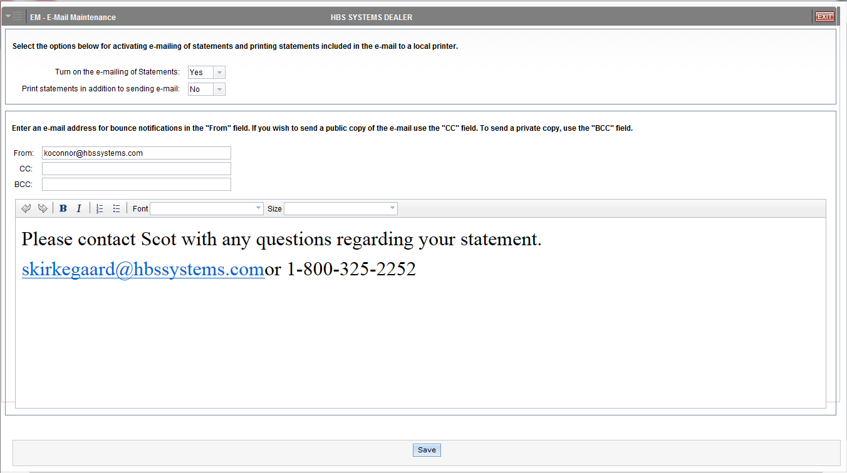

Email Maintenance (EM) allows you to manage your settings regarding emailing statements to customers, such as whether or not they receive emailed statements and whether they also get a paper copy or not.

To access this application, you can either:

- Select “System Maintenance” from the menu. Choose the “Company File” submenu and click “Email Maintenance.”
- Type “EM” in the Shortcuts Bar.

Field Definitions

Turn on the e-mailing of Statements:

- Select Yes to turn on statement emailing.
- Select No to turn it off.

Print statements in addition to sending e-mail:

- Select Yes to print a hard-copy statement for the customer when the statement is emailed.
- Select No to have the customer only receive the emailed statement.

From: Enter an e-mail address for bounce notifications in this field.

CC: If you wish to send a public copy of the emailed statement, type the address(es) in this field.

BCC: If you wish to send a private copy of the emailed statement, type the address(es) in this field.

Text Box: Optionally, enter a message in the text box to accompany the emailed statement copies. Use the contact information in the email text box if you have any questions regarding your statement

Save: Click this button to save any changes made to your email settings.

