Stock Order Reprint (RPO)

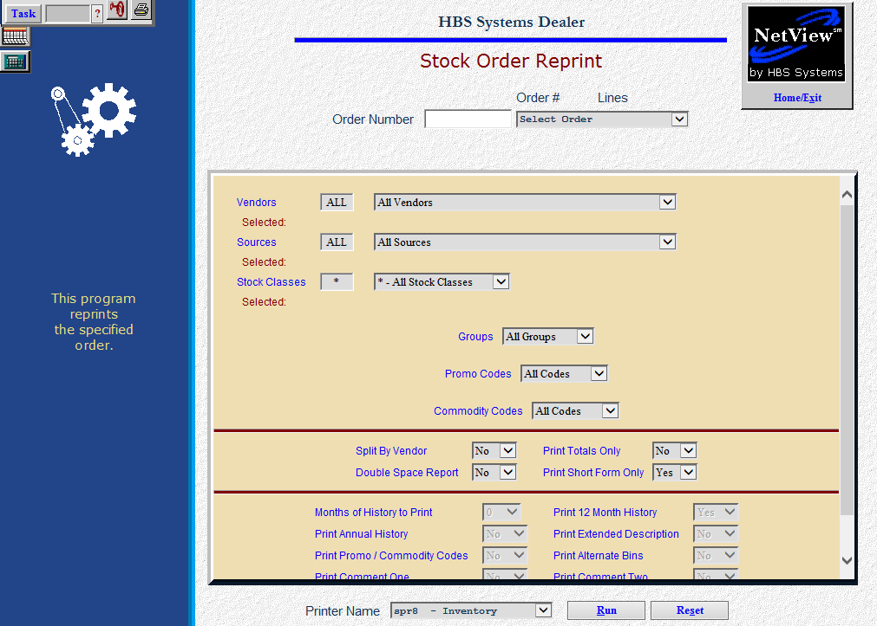

After you make your adjustments in Quick Order Adjustments, you should print a revised copy of the order. If you didn’t generate a new copy from QOA, you can get the copy here.

- To access this function, you can:
  - Select “Inventory” from the menu. Choose the “Orders” submenu and click
“Reprint Parts Order.”
  - Type “RPO” in the Shortcuts Bar.

Field Definitions

Order Number: Type or select the order number to be reprinted.

Vendors: Choose “All vendors” or select up to 25 individual vendor numbers. Your choices will display as chosen.

Sources: Choose “All sources” or select up to 25 sources from the drop-down menu. Your choices will display as chosen.

Stock Classes: Choose “All stock classes” or select specific ones for the Vendor and Source selections you made. Use the drop-down menu to make your choices and they will display as chosen.

Groups: Choose “All codes” or select codes for specific Vendor, Source, and Stock Class selections.

Promo Codes: Choose “All codes” or select codes for specific Vendor, Source, and Stock Class selections. CNH dealers may use this to retrieve the parts with a PMC (Parts Market Codes).

Commodity Codes: Choose “All codes” or select codes for specific Vendor, Source, and Stock Class selections.

Split By Vendor:

- Select Yes to create the order split into pages by vendor.
- Select No for a printout of the order with no breaks by vendor.

Print Totals Only:

Choose Yes to receive a printout of just the totals for each selection.

Choose No to receive a full printout of the order.

Double Space Report:

- Select Yes to double space the report.
- Select No for a single spaced report.

Print Short Form Only: This option only prints the necessary information to place an order. This format is an easy-to-read, faxable printout.

It includes the following information:

Part Number

Qty

Mfr ID

Type

Amax Code

Description

Weight

Cost

Extended Cost

Choose Yes to receive this style of order printout.

Select No to continue making selections on the setup screen.

Amax Parts Only: If you are a CNH dealer, this prompt will be on the SSO screen to offer the options of only looking at AMAX parts.

- Choose Yes to limit the order to AMAX parts only.
- Leave it at No to include any parts.

Months of History to Print: This field offers the choice of how much month-by-month sales history to include on your printout. Detailed sales history can be useful when evaluating the system’s suggested order quantity and to provide further insight for the person reviewing the order. For instance, if you have based the order on 12 months demand, you may find it helpful to have it display that year’s data plus the previous year’s data for comparison.

Answer 0 to print no detailed sales history.

Answer 12, 24, 36, or 48 to print that number of months of detailed sales history.

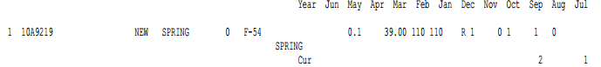

Print 12 Month History: This option lets you print totals only for 12 month sales history counts.

Select Yes here to receive a total for the last 12 months and a total for 3 more 12-month periods to cover the full 48 history months.

Choose No to leave these off.

Print Annual History: This option lets you print sales history count totals by year.

If you choose Yes here, you will receive a total for the current calendar year and the eight previous years.

Select No to leave these off your printout.

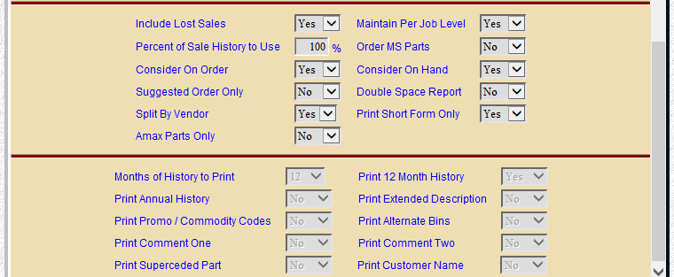

Print Extended Description:

- Select Yes to print the extended description.
- Select No to leave this description off.

Print Promo/Commodity Codes:

- Select Yes to include the promo and commodity codes.
- Select No to exclude this info.

Print Alternate Bins:

- Choose Yes to have the alternate bin 1 and 2 for this part number print on the order.
- Select No to leave this information off the printout.

Print Comment One: This field lets you print the first line of comments from the part master on the printout.

Choose Yes to have the first line of comments appear on the order printout.

Choose No to ignore any comment line 1 information.

Print Comment Two: This field lets you print the second line of comments from the part master on the printout.

Choose Yes to have the second line of comments appear on the order printout.

Choose No to ignore any comment line 2 information.

Print Superseded Part: Here you can have the old or superseded part number appear on the order printout. The program does make use of the sales history from the old part number when calculations for BSL and BRP are made.

Choose Yes to show the old part number on the order printout.

Choose No to leave off any “old” part number information present.

Print Customer Name: This field lets you show the customer’s name on the printout.

- Choose Yes to print the name.
- Choose No to exclude it.

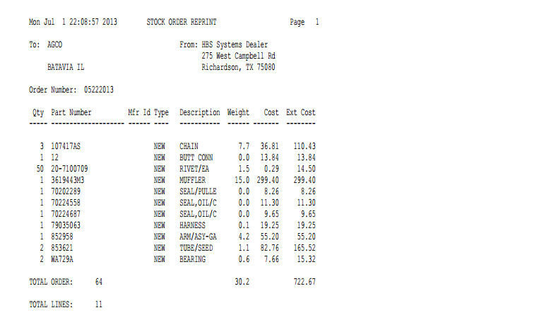

Short Form: RPO gives you the option to either print a short or long form, regardless of how your original print request. The Short Form lists the vendor name and address, along with your dealership name and address. It contains the following information:

Order Number: This is the order number that was either assigned by you or provided by the system when the order was created.

Qty: Here you will find the suggested order quantity for the part.

Part Number: This is the part number to be ordered.

Mfr ID: This is the manufacturer ID of the part.

Type: This field shows the part type. This could be:

N=New

U=Used

R=Reman

C=Core

M=Memo

AX: This column shows the CNH Amax code, if any.

Description: Here you will see the description of the part number listed on the order.

Weight: This field shows the weight of the part number listed.

Cost: The cost is the manufacturers cost for this part.

Ext Cost: This is the Extended Cost for the part number (cost times suggested order quantity).

Totals: Totals on this version of the printout include:

Total piece count

Extended weight

Extended cost

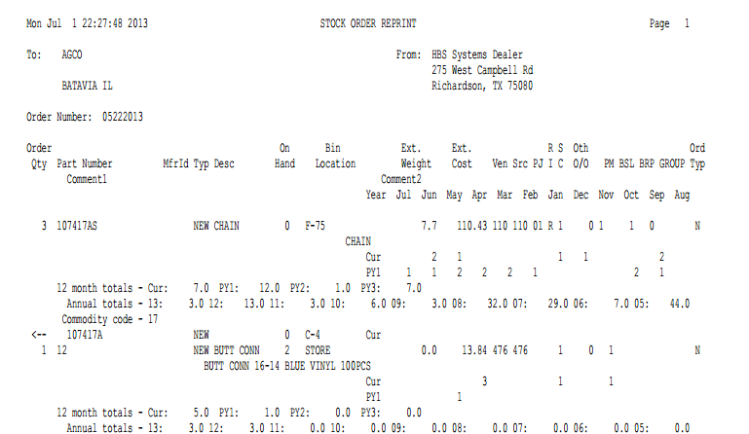

Long Form: The Long Form shows the vendor name and address that the order is issued to, the order number, and your dealership name and address. It contains the following order information:

Order Qty: Here you will find the suggested order quantity for the part.

Part Number: This is the part number suggested for the order.

Mfr ID: This is the manufacturer ID.

Typ: This field shows the part type from the part master. This could be:

N=New

U=Used

R=Reman

C=Core

M=Memo

Desc: Here you will see the description of the part number.

On Hand: This field shows the current quantity on hand.

Bin Location: Here you will find the primary bin location of the suggested part.

Ext. Weight: Here you will find the extended weight for the part number (weight times suggested order quantity).

Ext Cost: This is the extended cost for the part number (cost time suggested order quantity).

Ven: This is the vendor number for this part.

Src: This is the source code of the part number.

PJ: This is the per job quantity from the part master.

RI: This is the return indicator or return code from the part master.

SC: Here you will find the stock class for this part number.

Prv O/O: This field lists the previous on order quantity, which is the quantity on order prior to this order.

PM: This indicates the package multiple or package quantity from the part master.

BSL: The best stocking level is from the part master.

BRP: The best re-order point is from the part master.

Group: This shows the group ID from the part master.

Comment 1: This field lists any comments that are in the comment 1 field of the part master.

Comment 2: This field lists any comments that are in the comment 2 field of the part master.

Month History: This optional area may show up to four lines of monthly history by year, depending on the history you selected for the printout (0/12/24/36/48). They are titled by month names.

12 month totals: This optional area shows totals only for 12 month sales history counts. They are titled:

Cur

PY1

PY2,

PY3

PY4

The columns are calculated from the date of the printout/order (the 1st shows the last 12 months, PY1 shows the 12 months prior to that, and so on).

Annual totals: This optional area shows totals by calendar year. Years are shown by the last two digits of the year (i.e. 13 for 2013, 12 for 2012, 11 for 2011, etc.).

Superseded: These “old” part numbers will print immediately below the number that has replaced them. They are shown with a left arrow <-- before their numbers.

Vendor/Total Order: This line shows the following totals on this order:

The total piece count

The total extended weight

The total extended cost

Vendor/Total Lines: This is the total number of lines (unique parts numbers) on this order.

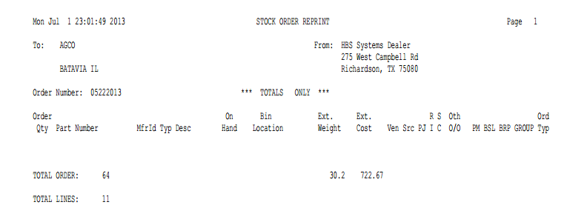

Totals Only: The Totals Only form shows the vendor name and address that the order is issued to, the order number, and your dealership name and address. It contains the following order information:

Total Order: This shows the following totals on the order:

The total number of part numbers (piece count)

The total extended weight

The total extended cost

Total Lines: This is the total number of lines (unique part numbers) on this order.

