Reprint Stock Return (RPR): RPR offers the option to reprint an existing return. This is especially useful when you make adjustments to a Return and want a complete, new copy of the Return.

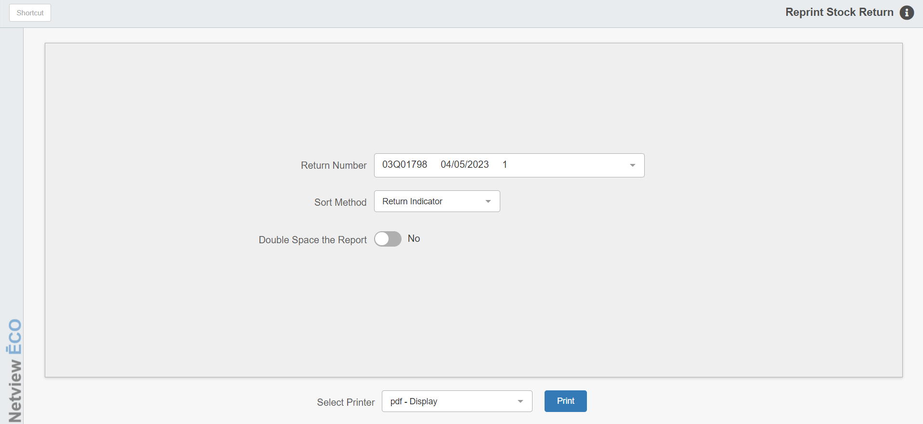

STEP 3—Reprint the Return through Reprint Return

To access this function, you can either:

- Select “Inventory” from the menu. Choose the “Returns” submenu and click “Reprint Return.”
- Type “RPR” into the Shortcuts Bar.

Screen Fields

Return Number: Choose the Return to reprint.

Sort Method: Choose how you want the Return sorted:

Return Indicator

Part Number

Bin Location

Double Space the Report:

- Choose Yes to double space the report.
- Choose No to get a single space printout.

Printer Name: Select the printer to receive the printout. A default printer name is pre-filled, but can be changed as necessary using the drop-down menu. Use the pdf printer to view the report on the screen without printing a copy of it.

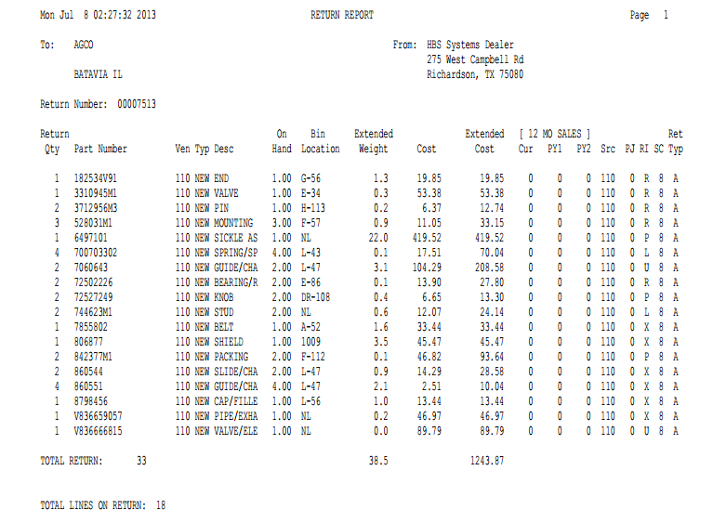

Report Columns

Ret Qty: This column shows the Return Quantity for the part number - the full amount of any currently on hand.

Part Number: This column lists the numbers of the parts selected for this return.

Ven: This lists the Vendor Number.

Typ: This column lists Part Types for the part numbers listed. It could be:

New

Used

Reman

Core

Memo

Desc: This column lists the Description of the selected part.

Bin Location: The Primary Bin Location shows here.

Extended Weight: This column lists the extended weights for the items returned (returned quantity x individual item weight).

Cost: This column shows individual Cost for the part number.

Extended Cost: This column lists the extended costs for the items returned (returned quantity x individual item cost).

12 MO SALES: These columns list sales quantities in 12-month increments.

Cur: This column lists sales quantities for the Current 12 months.

PY1: This column lists Prior Year sales quantities for months 13-24.

PY2: This column lists Prior Year sales quantities for months 25-36.

Src: This column lists the Parts Source.

PJ: This column lists the Per Job quantity.

RI: This column lists the Return Indicator.

SC: The Stock Class for the part shown.

Ret Typ: This column shows the type of Return:

A=Annual

C=Closeout

S=Special

T=Dealer Trade

