Print Rental Proof Sheet (RPS)

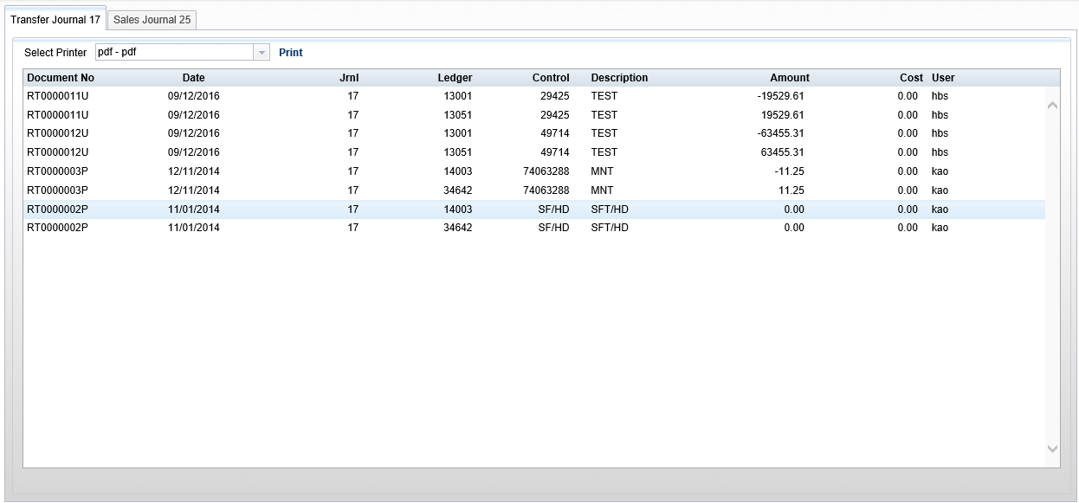

Print Rental Proof Sheet (RPS) allows you to preview the data from your Rental Journals before posting them.

To access this function, you can either:

- Select “Rental” from the menu and click “Rental Proof Sheet.”
- Type “RPS” in the Shortcuts Bar.

Each tab in the program represents a Rental Journal in the system. In the case of the example above, the open tab previews the dealership’s Rental Transfer Journal, while the second tab would preview the dealership’s Rental Sales Journal.

Select Printer: If you wish to print a Journal’s proof sheet, select the desired printer here. Use the pdf printer to preview the proof sheet.

Print: Click Print to print the proof sheet.

Sample Proof Sheet

