Rental Post Sales Journal (RPSJ)

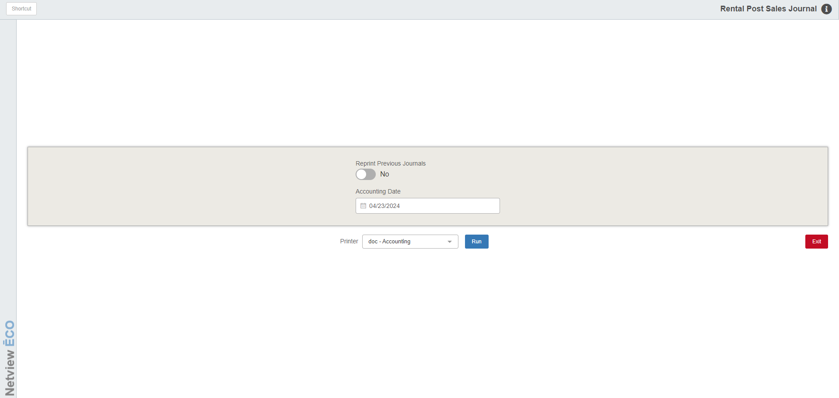

Rental Post Sales Journal (RPSJ) posts the sales transactions for Rental to the system.

To access this function, you can either:

- Select “Rental” from the menu and click “Rental Post Sales Journals.”
- Type “RPSJ” in the Shortcuts Bar.

Field Definitions:

Reprint Previous Journals:

- Set the option to Yes to reprint previous Sales Journals.
- Set it to No to post the current Journal.

Accounting Date: Enter the accounting date or select it from a calendar. The current date fills as default. NOTE: The field will be disabled if you choose to reprint a previous Journal.

Printer Name: Select the printer to receive the Journal printout. Choose the pdf printer to preview the Journals.

Run: Click Run to post the Journal.

Sample Sales Journal

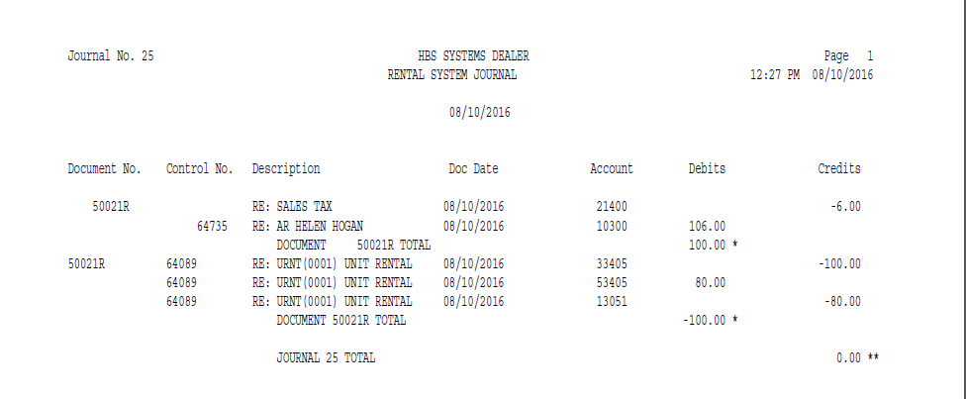

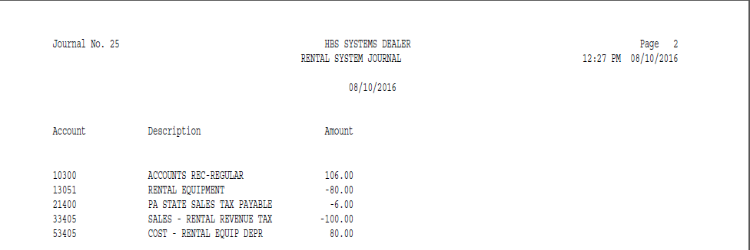

Exception Report: Sometimes, after running the Journal, the application will generate an Exception Report after the Journal is run. This occurs if there are documents that were unable to be journalized when the Journal ran. The following information will show on the report:

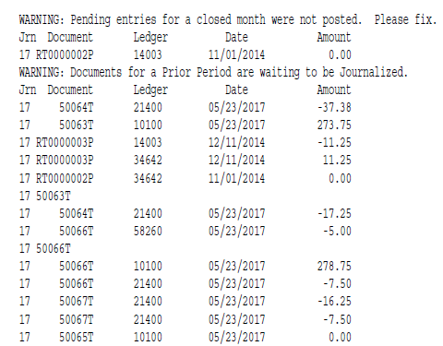

Jrn: This is the Journal number where the exception error occurred.

Document: This is the document number of the un-journalized document.

Ledger: This is the General Ledger account number associated with the document.

Date: This is the document date.

Amount: This is the dollar amount (debit or credit) of the document.

