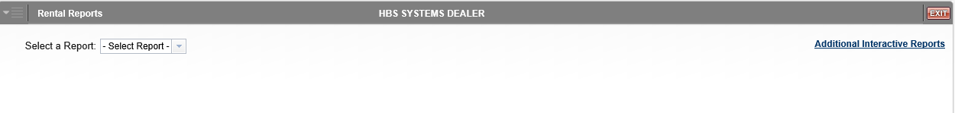

Rental Rates Report: This creates a report of the Rental Rates set up in your Rental system.

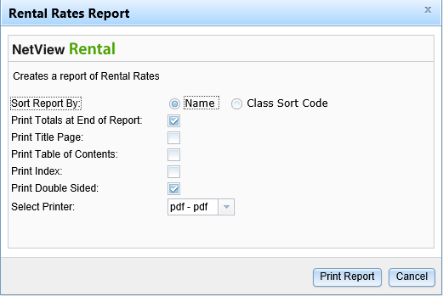

Field Definitions:

Sort Report By: Choose one of the following:

- Name
- Class Sort Code

Print Totals at End of Report:

- Check this box to include a total count at the end of the report.
- Leave the box unchecked to omit the totals.

Print Title Page:

- Check this box to print a title page with the report.
- Leave the box unchecked to print the report without one.

Print Table of Contents:

- Check this box to print a table of contents with the report.
- Leave the box unchecked to print the report without one.

Print Index:

- Check this box to print an index with the report.
- Leave the box unchecked to print the report without one.

Print Double Sided:

- Check this box to print the report pages double-sided.
- Leave the box unchecked to print the report pages single-sided.

Select Printer: Select the printer to receive the report. Use the pdf printer to preview the report.

Print Report: Click Print Report to print the report.

Cancel: Click Cancel to return to the main screen without printing the report.

Sample Report

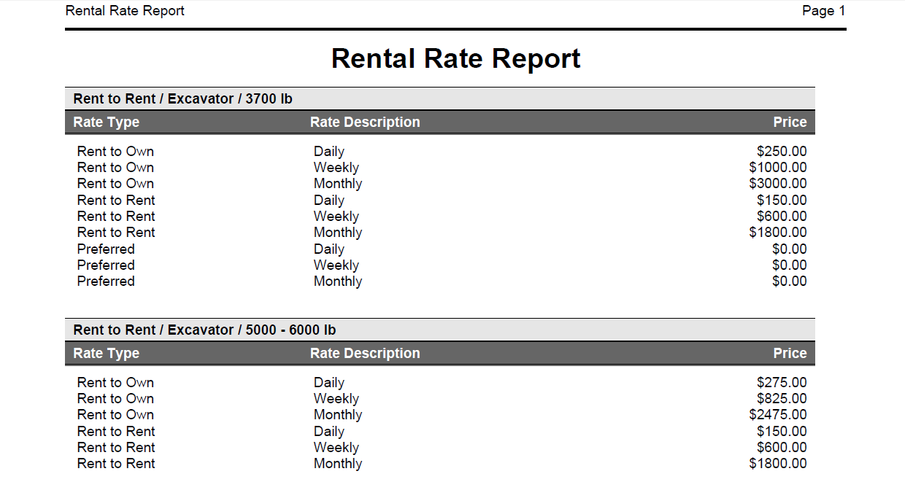

This example is sorted by Name. The rates are grouped by class and listed by type, with a description and price provided for each.

