Rental Recurring Billing (RRB)

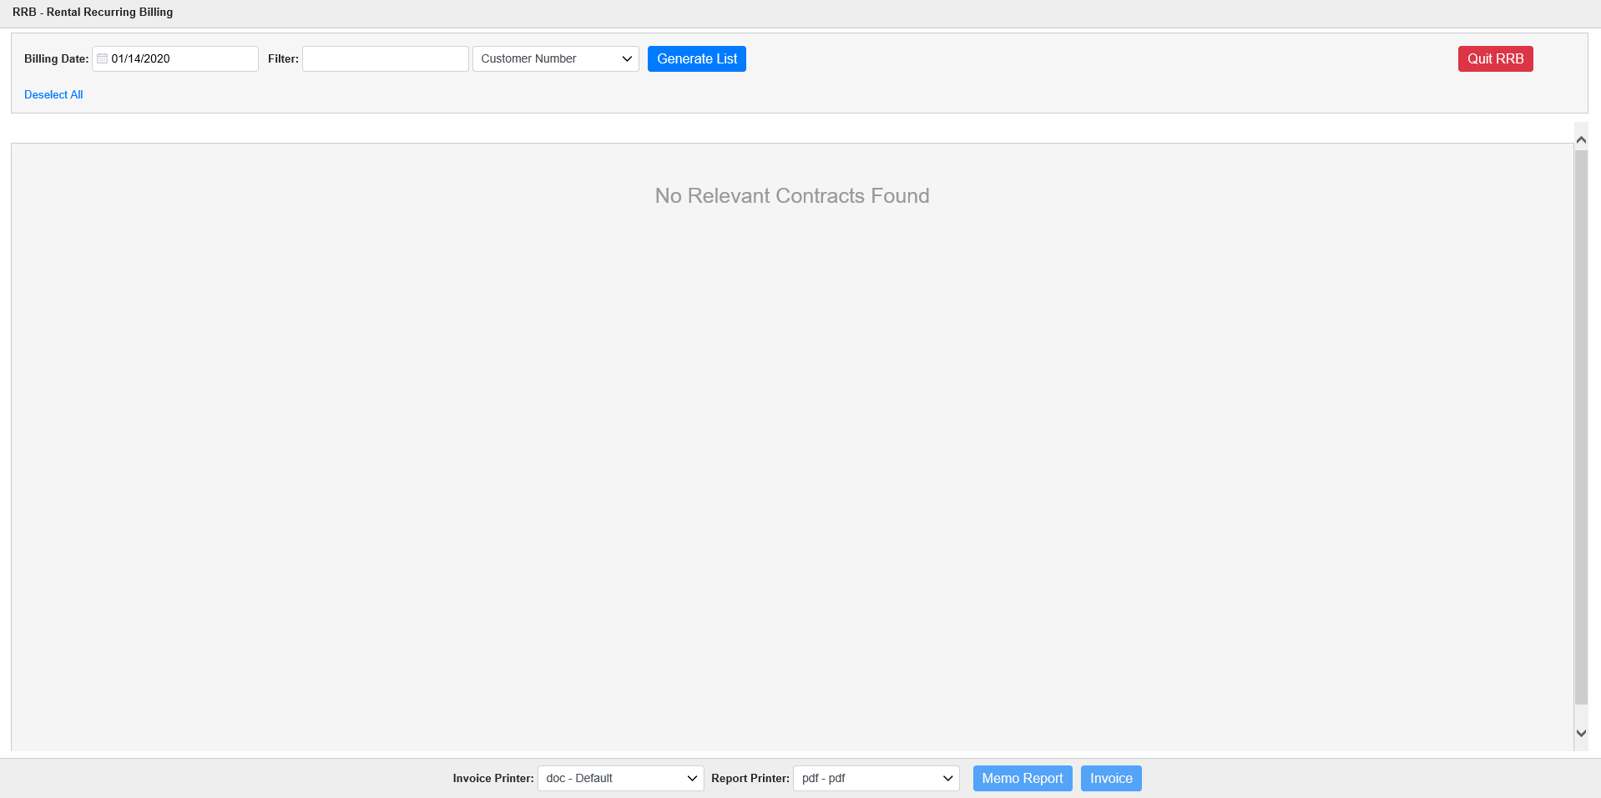

Rental Recurring Billing (RRB) is the process where invoices are generated for units that have not been returned and now are eligible to be billed. This is a common process for units in long-term rental contracts.

To access this function, you can either:

- Select “Rental” from the menu and click “Rental Recurring Billing.”
- Type “RRB” in the Shortcuts Bar.

Opening the application takes you to the main screen. Choose the Billing Date to examine and use the Filter fields to look for specific results. Once you have your criteria set, click on Generate List. The initial list shows on the screen, with all contracts selected by default.

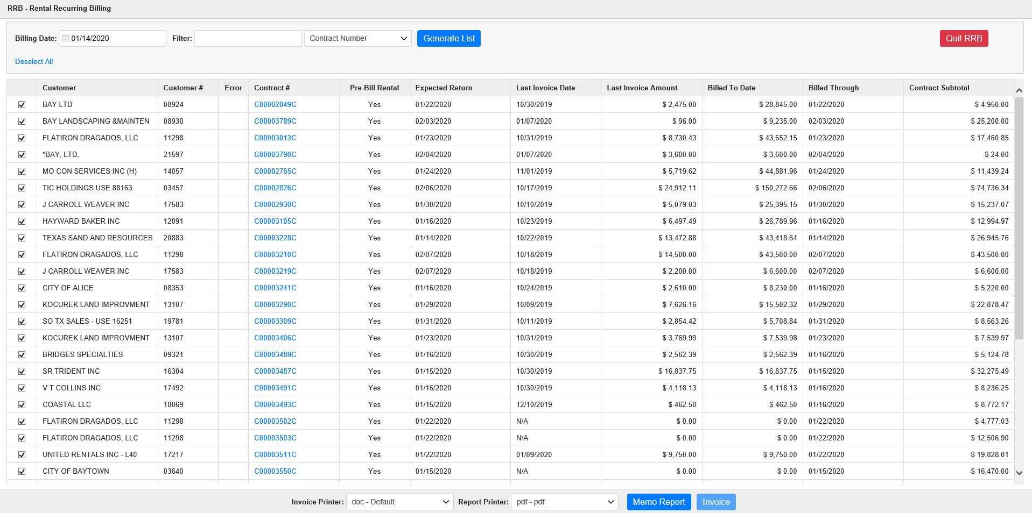

Once you’ve located the desired contracts for the billing run, make sure only those contracts are selected. You can use Deselect All to undo the default selection and then manually the specific contracts you want (use Select All to re-select all the listed contracts if desired).

Memo Report: You can generate a memo report to preview the invoice run before you actually make it. Use the Report Print drop-down menu to direct the printout to your printer of choice. Use the pdf printer to review it on the screen before printing.

Sample Memo Report:

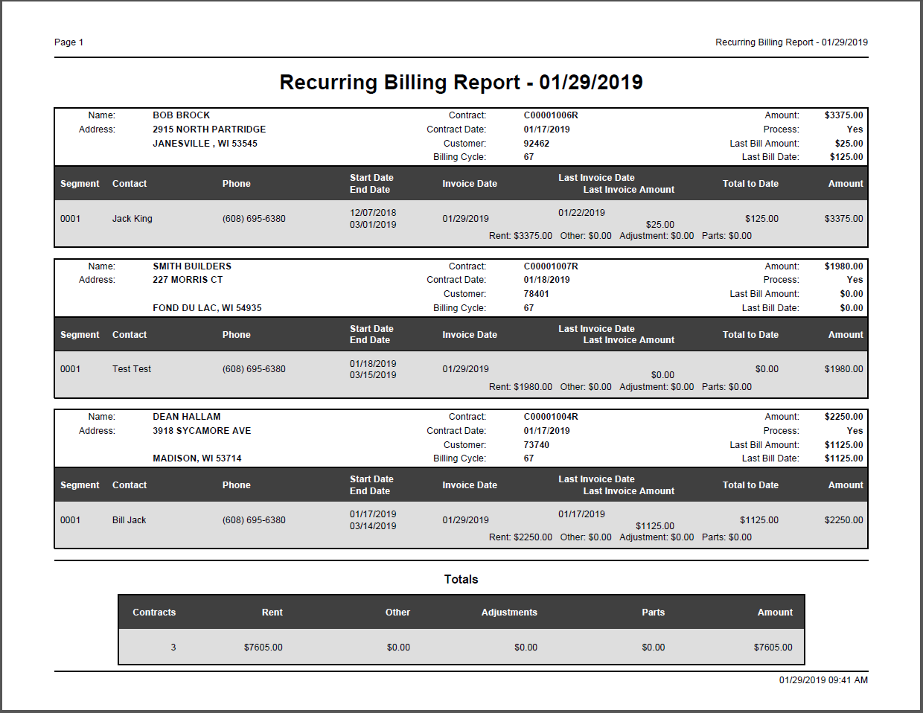

Printing Invoices: Once you have selected the contracts to bill, verify the Invoice Printer in the drop-down menu and click Invoice to generate invoices. Be sure to post them to the General Ledger with Rental Post Sales Journal (RPSJ) when they have completed.

