Rental Rates Report: The Rental Rates Report in Rental Reports (RR) creates a report of the Rental rates.

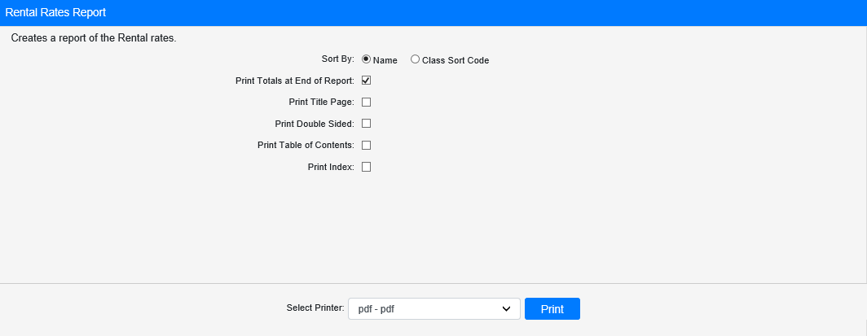

Field Definitions:

Sort By: Choose to sort the report by

- Name
- Class Sort Code

Print Totals at End of Report:

- Check this box to print a total class count at the end of the report.
- Leave it unchecked to omit the totals.

Print Title Page:

- Check this box to print a title page with the report.
- Leave it unchecked to print the report without one.

Print Double Sided:

- Check this box to print the report double-sided.
- Leave it unchecked to print the report single-sided.

Print Table of Contents:

- Check this box to print a table of contents with the report.
- Leave it unchecked to print the report without one.

Print Index:

- Check this box to print an index with the report.
- Leave it unchecked to print the report without one.

Select Printer: Select the printer to receive the report. Use the pdf printer to preview the report.

Click “Print” to print the report.

Sample Report:

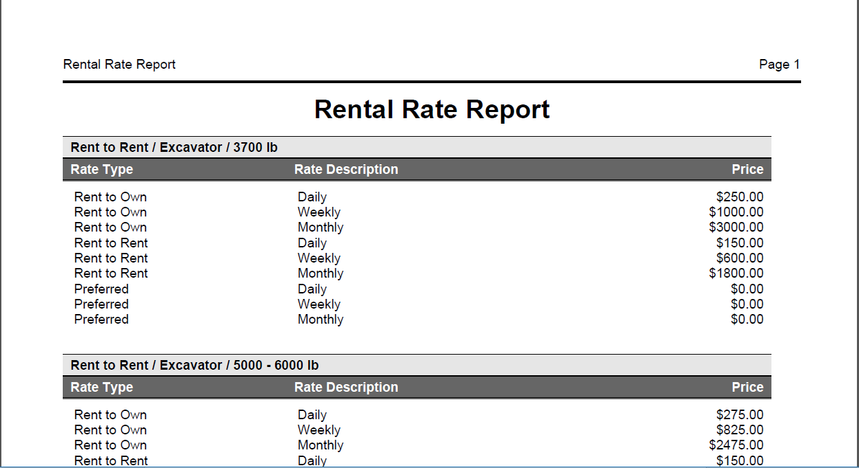

This example of the report is sorted by Name. The rate types are listed with their description and price.

