Rental Transfer Assets (RTA)

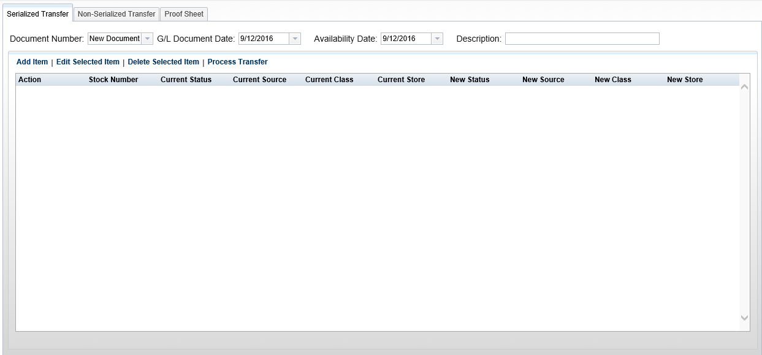

Anytime you need to rent a unit, serialized or non-serialized, that unit must be in the Rental system. This program allows you to move units, serialized and non-serialized, in and out of the Rental system.

You can access this program by either:

- Selecting “Rental” from the menu and clicking “Rental Transfer Assets.”
- Type “RTA” in the Shortcuts Bar.

From this screen, you can perform a number of transfer variations:

- Transfer a unit to Rental
- Transfer a unit from Rental back to New Inventory
- Transfer a unit from Rental back to Used Inventory
- Transfer a part from Inventory to Rental
- Transfer a Rental part back to Parts Inventory

Serialized Transfer:

Document Number: Choose New Document to begin a new transfer or choose a document number from the drop-down menu to review an existing unprocessed transfer.

GL Document Date: Enter the date to be used for the accounting transaction created from the transfer. It must be a date in an open accounting period. The current date appears as a default.

Availability Date: Enter the date the unit will first be available for rental here. No rental activity can occur prior to the dated noted here. It does NOT have to be in an open accounting period. The current date appears as a default.

Description: Fill in a brief description of the transfer.

Add Item: Once that information is completed, click Add Item to open the transfer box.

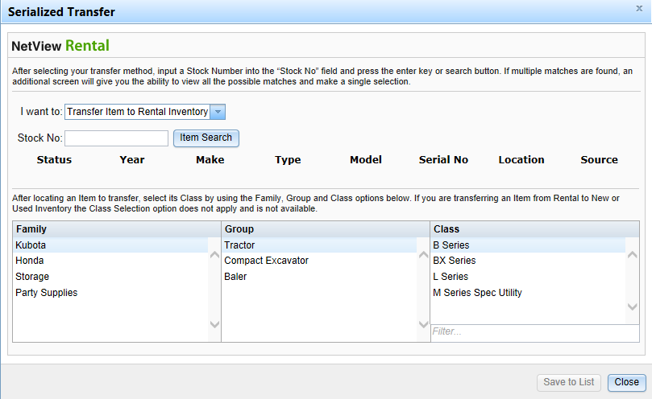

Choose the type of transfer from the drop-down menu. NOTE: For multi-location dealers with a Consolidated location, only the Consolidated location can make inter-store transfers; the final option, “Transfer Item to Another Store Location,” will thus only be available in the Consolidated location.

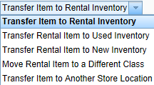

Enter the stock number to transfer or search for it.

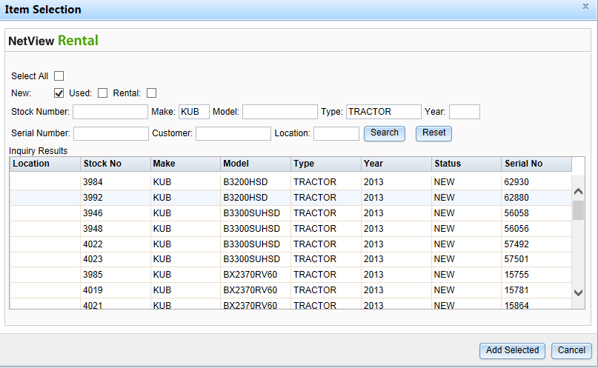

Find the unit, click on its line, and click on Add Selected to include it in the transfer. NOTE: If that unit cannot be transferred by the method you selected, the program will show a warning notification explaining why.

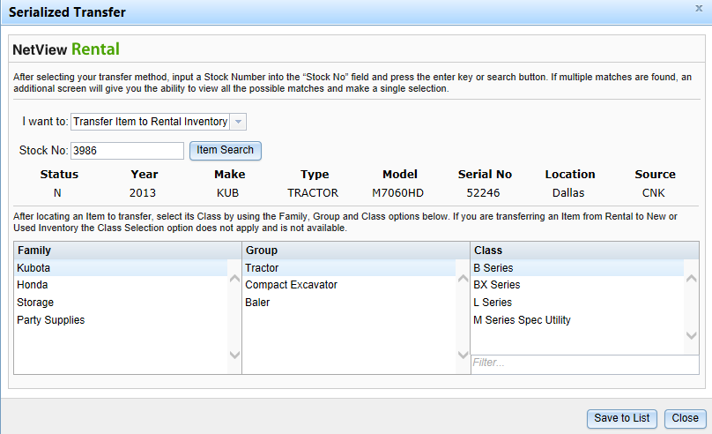

Click Save to List to add it to the transfer. Click Close when all units have been added to the transfer.

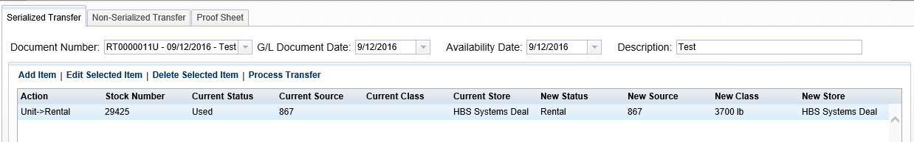

Edit Selected Item: This function lets you adjust the Family, Group, or Class. Highlight the unit to be changed, click on Edit Selected Item, and highlight the new Family, Group, and/or Class. Click on Save to List to finalize your changes.

Delete Selected Item: Highlight the unit to remove and click Delete Selected Item.

Process Transfer: Click Process Transfer to finalize the transfer and create the G/L entry.

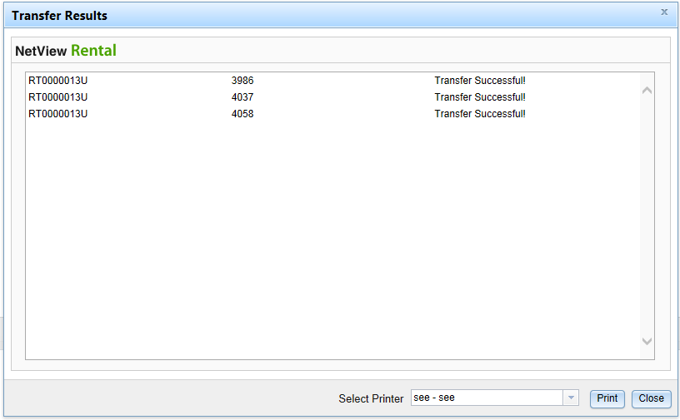

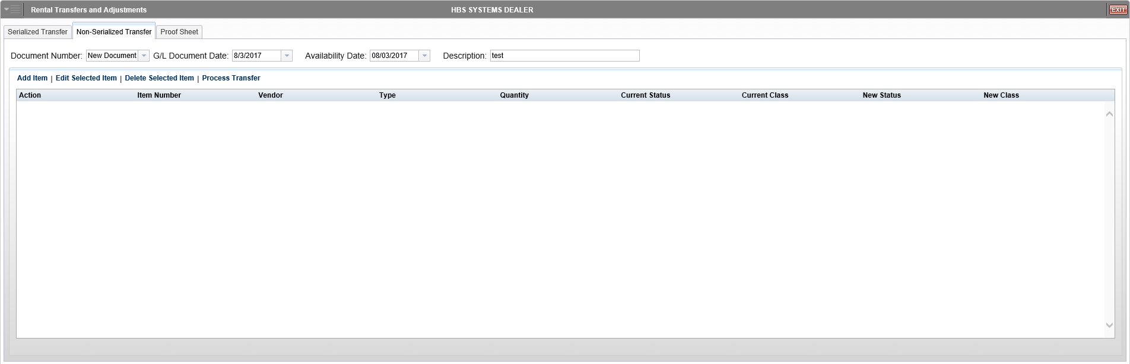

Non-Serialized Transfer: Non-serialized transfers work similarly to serialized transfers, except that instead of transferring units in or out of Rental, you are transferring parts. NOTE: For multi-location dealerships, this tab will be deactivated in a Consolidated location, as non-serialized transfers can only be performed within individual locations.

Document Number: Choose New Document to begin a new transfer or choose a document number from the drop-down menu to review an existing unprocessed transfer.

GL Document Date: Enter the date to be used for the accounting transaction created from the transfer. It must be a date in an open accounting period. The current date appears as a default.

Availability Date: Enter the date the part will first be available for rental here. No rental activity can occur prior to the dated noted here. It does NOT have to be in an open accounting period. The current date appears as a default.

Description: Fill in a brief description of the transfer.

Add Item: Once that information is completed, click Add Item to open the transfer box.

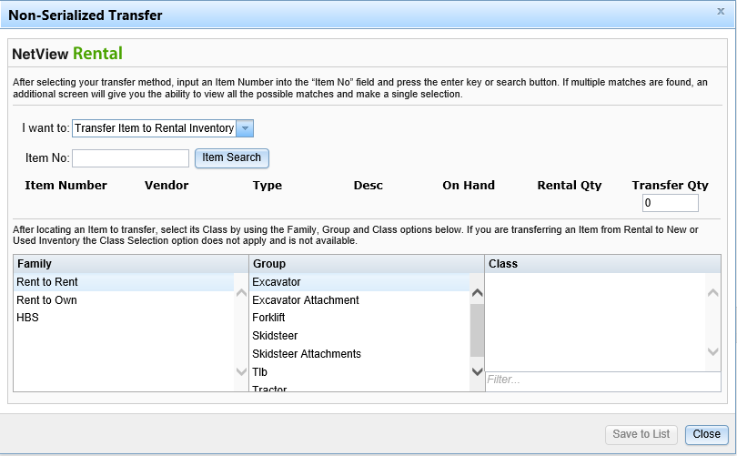

Choose the type of transfer from the drop-down menu.

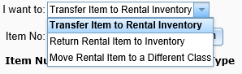

Enter the stock number to transfer or search for it.

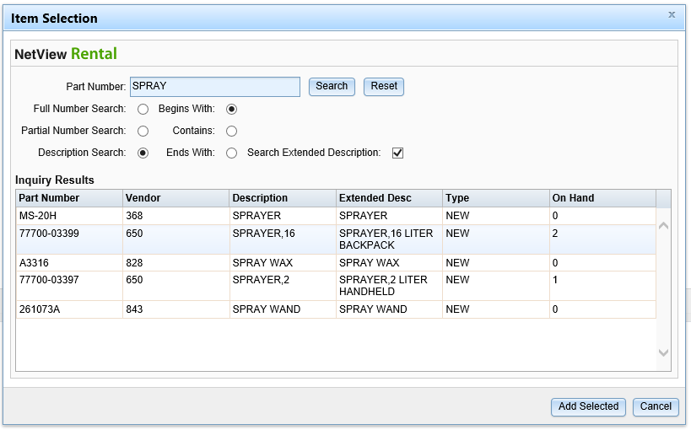

Find the part, click on its entry to select it, then click Add Selected to include it in the transfer. NOTE: The search results will only include parts belonging to the current location.

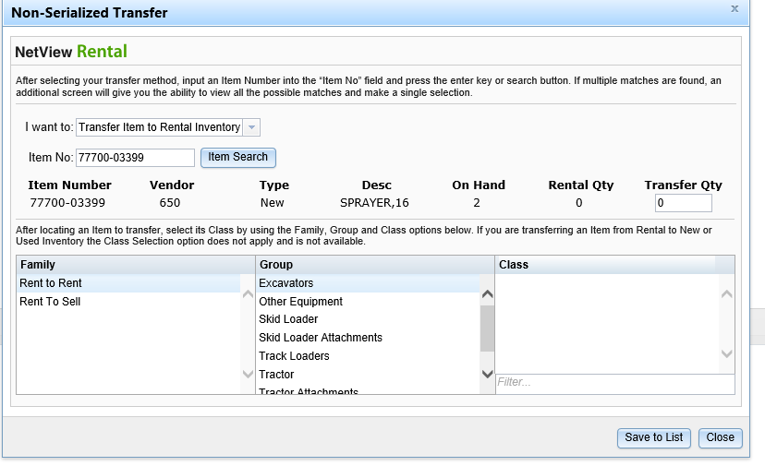

Click Save to List to add it to the transfer. Click Close when all units have been added to the transfer.

Edit Selected Item: This function lets you adjust the Family, Group, or Class. Highlight the unit to be changed, click on Edit Selected Item, and highlight the new Family, Group, and/or Class. Click on Save to List to finalize your changes.

Delete Selected Item: Highlight the unit to remove and click Delete Selected Item.

Process Transfer: Click Process Transfer to finalize the transfer and create the G/L entry.

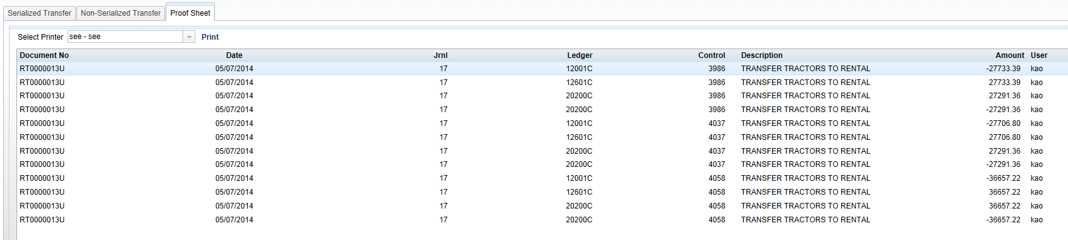

Proof Sheet: Click the Proof Sheet tab to view the entries before they are posted. When posted, the Journal entry may look something like this:

