Reason Type Maintenance (RTM)

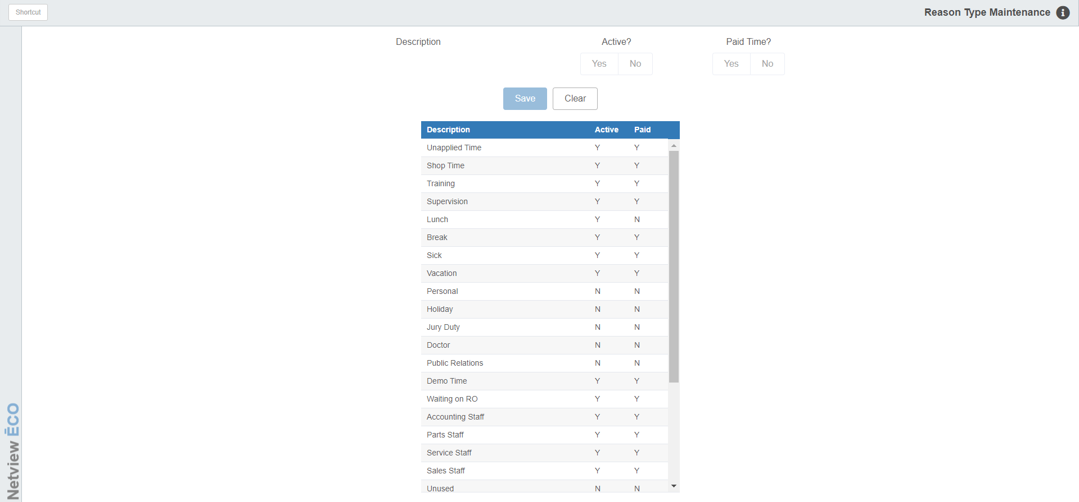

This program is used to maintain Service technicians’ unapplied time reasons.

To access this function, type “RTM” in the Shortcuts Bar.

Editing/Adding Codes:

- To edit an existing reason code, click on its entry in the table to activate the fields at the top of the screen.
- To add a new reason code, click on an Unused entry to modify.

Description: Change the reason description here.

Active?: Select Yes to mark the code as “Active” or available for selection by technicians clocking out on unapplied time. Select No to make the code inactive and unavailable to technicians.

Paid Time?: Select Yes or No to indicate whether this reason code represents paid unapplied time.

Save: Click this button to save your changes, which will appear in the grid list.

Clear: Click this button to clear selected information from the fields without saving any changes.

