Rate Variance Report: The Rate Variance Report in Rental Reports (RR) shows all instances during a set time period where a variance occurred between the expected and actual rental rates charged for a serialized or non-serialized unit. This is particularly useful for seeing what units were rented at a discounted rate, how that affected the unit’s revenue, and which salesperson charged the different rate.

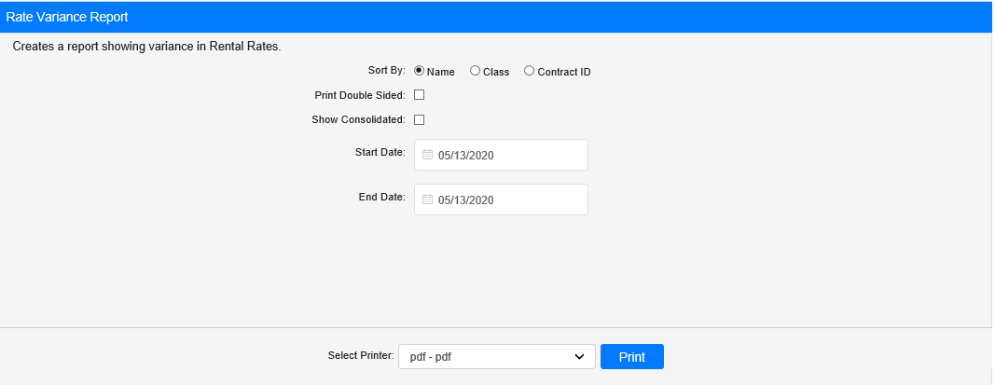

Field Definitions:

Sort By: Choose what to sort the report by:

- Name
- Class
- Contract ID

Print Double Sided:

- Check this box to print the report pages double-sided.
- Leave it unchecked to print the report pages single-sided.

Show Consolidated: If you are a multi-location dealership with a Consolidated location, check this box to include the Consolidated location’s information on your report. Uncheck it to only print a report for your individual location. NOTE: If running the report in the Consolidated location, you must check this box to receive a report.

Start Date: Enter the start date for the report here.

End Date/Time: Enter the end date/time for the report here.

Select Printer: Select the printer to receive the report. Use the pdf printer to preview the report.

Click “Print” to print the report.

Sample Report:

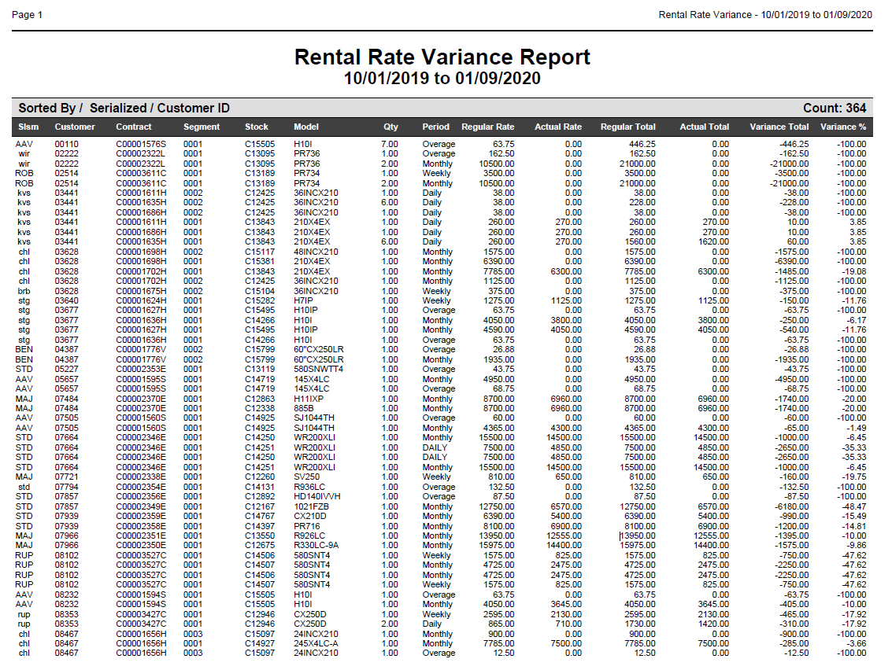

This sample report is sorted by Name. It lists the following:

- Renting salesperson
- Rental customer
- Rental contract and segment numbers
- Rental unit’s stock and model numbers
- Quantity of the unit rented
- Rate type charged (Overate, Monthly, Daily, etc.)
- Regular rate for that unit/type
- Actual rate charged in this instance
- Total revenue amount expected from charging the unit/type’s regular rate for the time period covered by the report
- Actual total revenue amount earned from charging the different rate over the time period covered by the report
- Total amount of variance between the two revenue amounts
- Percent variance amount

A totals line will appear at the bottom of the report. This will list:

- Total number of variances listed on the report
- Total value of the Regular Total column (representing the revenue expected)
- Total value of the Actual Total column (representing the revenue actually earned)
- Total amount of all variances on the report
- Total percent variance for the entire report

