RW: Check Register Report

This handy Report Writer report can be run each day you produce a series of Accounts Payable checks. This report will capture activity from Print Checks (PC), On Demand Checks (ODC), and Manual Checks (MC). The report prompts for the date or for a range of dates as it prints the following information:

JN: This is the journal number for the check.

Check#: This is the check number used.

Payee: This field shows the vendor name or payee on the written check. It will also print the “VOIDED” or “WRITE-OFF” description.

Check Date: This is the journal date of the check.

Check Amt: The column prints the amount of the check.

Credit (-) amounts are written checks.

Debit (+) amounts indicate corrections or voided checks.

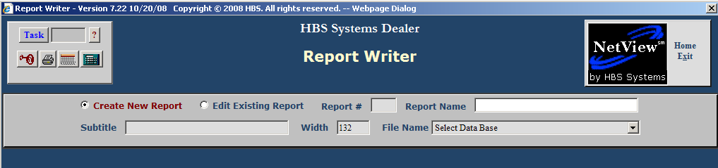

Creating the Check Register Report: To create the Check Register Report on your system, select “Create New Report” in Report Writer (RW).

To access Report Writer, you can either:

- Select “Report Writer” and click on “Maintain Database Reports.”
- Type “RW” into the Shortcuts Bar.

Report Name: Type A/P CHECK REGISTER.

Subtitle: Press “Enter.”

Width: Press “Enter” as it is pre-filled with “132.”

Filename: Choose General Ledger History Detail File from the drop-down menu.

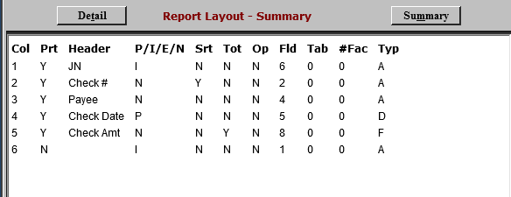

Use the above parameters to define the Check Register Report. Line 6 limits the report to checks generated from 10200. If you need a different bank account or more than one account, you will have to adjust it accordingly.

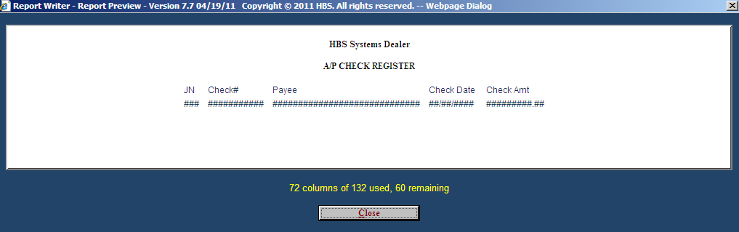

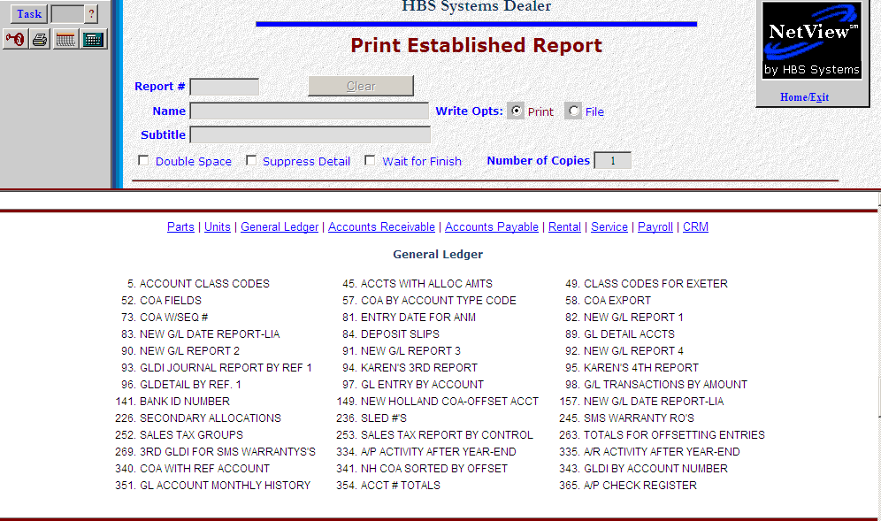

Printing the Check Register Report: Type in PER in the Shortcuts Bar. Click on General Ledger to see the reports’ names in this category. Look for the A/P Check Register and click on it.

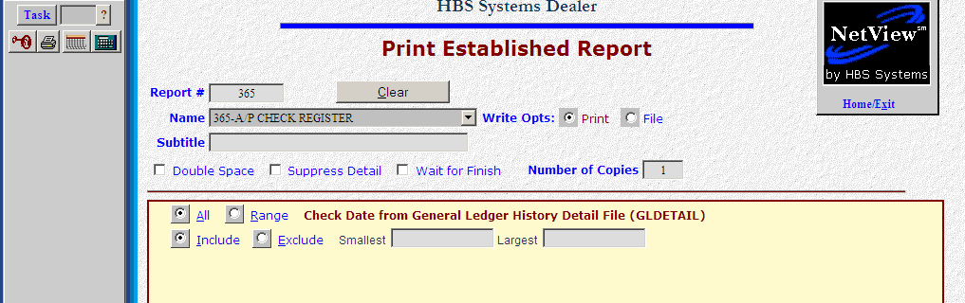

You have a couple of options here:

- Double Space: Click on this box if you want to double space the report.
- Suppress Detail: Click on this box if you only want to have subtotals and totals on your report, not line by line details
- Wait for finish: This can be checked if you are generating a report to a file or other output besides the printer.
- Report prompt: This report prompts for a Check Date. Click on “Range” and enter a range of dates to examine.
- Printer: Choose the printer or display option from this drop-down menu.

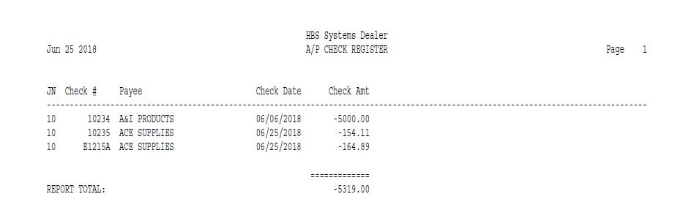

The report shows the information that matches the date entered.

