PER: G/L Transactions by Amount

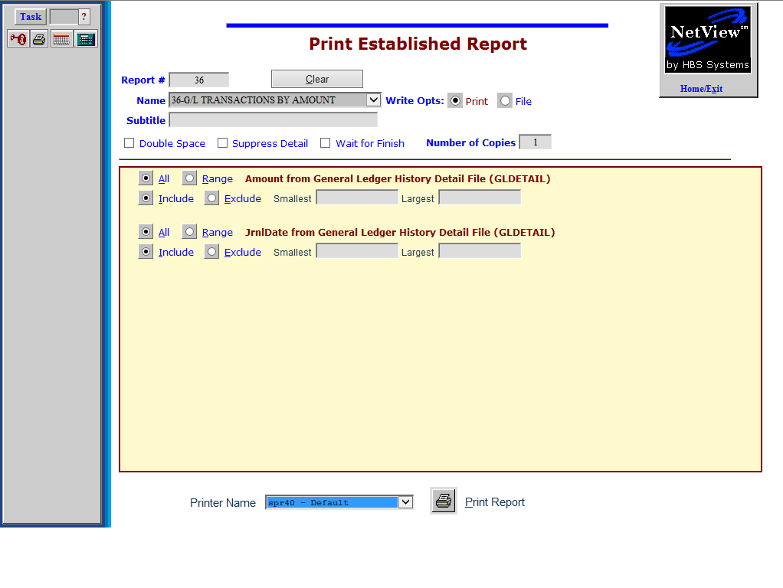

G/L Transactions by Amount is a useful Report Writer (RW) report that helps you find General Ledger transactions by dollar amount. It prompts for the amount and a date range. The columns for this report include:

- Amount
- Acct #
- Transaction Date
- Journal Date
- Journal #
- Reference 1
- Reference 2
- Description
- User Name
- Actual Date

To access this function, you can either:
- Select “Report Writer” from the menu and click “Print an Established Report.” Select the report.
- Type “PER” in the Shortcuts Bar and select the report

Amount from General Ledger History Detail File (GLDETAIL): Click on Range for Amount. Fill in the amount desired in both the Smallest and Largest fields (without decimal points).

JrnlDate from General Ledger History Detail File (GLDETAIL): Click on Range for JrnlDate. Fill in the beginning and ending dates in the Smallest and Largest fields.

HBS SYSTEMS DEALER
May 20 2013 G/L TRANSACTIONS BY AMOUNT Page 1

Amount Acct# JrnlDate TransDate JN Ref 1 Ref 2 Description User Name ActualDate
-------------------------------------------------------------------------------------------

11.31 02619 04/15/2013 04/14/2013 15 DEP041413 023 CASH SHORT james 04/15/2013
11.31 10100 04/15/2013 04/14/2013 09 2857 A12 CAL-PAC DEV. james 04/15/2013
11.31 10100 04/15/2013 04/14/2013 09 3712 KUNO'S GRADI james 04/15/2013

Report Columns

Amount: This is the amount of the transaction.

Acct#: Here you will find the General Ledger Account Number that was affected by this entry.

JrnlDate: This is the date that this item was journaled.

TransDate: This is the document date that was entered when the transaction was created.

JN: This is the Journal number that was used when the document was entered.

Ref 1: This reference field is information from the system such as invoice number, check number, or document number.

Ref 2: This is the Control number for the transaction, and is usually a stock number, customer number, vendor number, or other unique reference.

Description: This field contains the description that was entered for this document.

User Name: This field shows the name of the person who ran the journal when the transaction was posted.

Actual Date: The actual date is the physical date this entry was entered into the system.

