PER: A/P Activity After Year-End

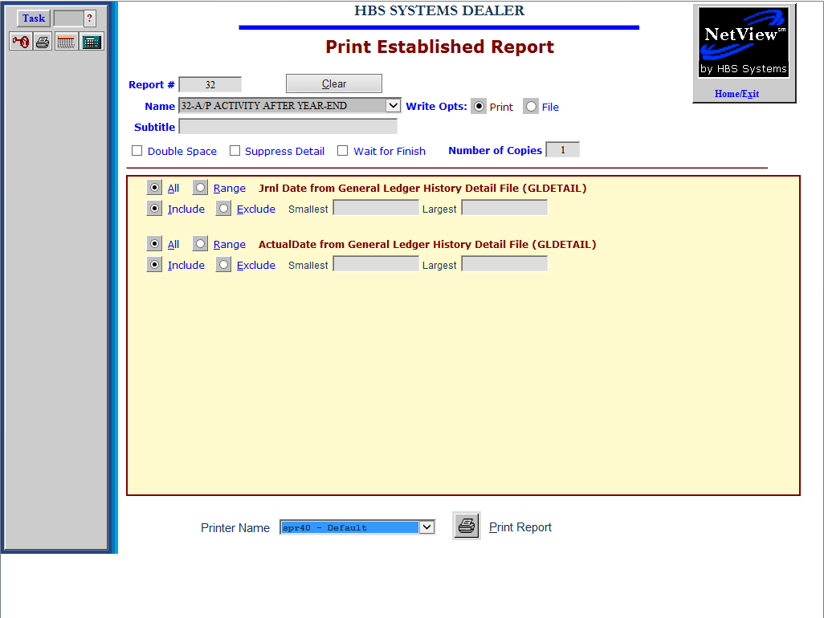

The A/P Activity After Year-End report helps you audit the activity in your Accounts Payable account after the last day of your fiscal year. It works in coordination with an A/P Open Invoice Report (OIR) that was run at the close of business on the last day of your fiscal year. You may then use this report to track any subsequent activity made to the A/P accounts as it applies to that year of business.

The report prompts you to type values for two items:

- Journal Date
- Actual Date/Timestamp

To access this function, you can either:

- Select “Report Writer” from the menu. Click “Print an Established Report” and choose the report.
- Type “PER” in the Shortcuts Bar and select the report.

Jrnl Date from General Ledger History Detail File (GLDETAIL): Click on Range for Jrnl Date and enter the first and last business days of your fiscal year on the Smallest and Largest fields. Your entries simply define the boundaries of the entire fiscal year.

ActualDate from General Ledger History Detail File (GLDETAIL): Click on “Range” for Actual Date. Fill in the day after your fiscal year end in the Smallest field and today’s date in the Largest field.

This report is best run with “no details” and will provide a total dollar amount of activity in your A/R account since the end of your Fiscal Year. It will help you validate the figure on your year end Trial Balance.

The report will provide details and a subtotal by vendor number for all transactions within the timeframe and helps to provide detail to match the balance on your year-end Trial Balance.

Report Columns: This report contains the following information:
HBS SYSTEMS DEALER
May 20 2013 A/P ACTIVITY AFTER YEAR END Page 1

Acct# Doc# Vend# Description Amount JN Jrnl Date ActualDate
--------------------------------------------------------------------------------------------

20000 1245864 11224 AGCO -161.48 12 12/31/2012 01/09/2013
20000 1246207 11224 AGCO -62.77 12 12/31/2012 01/09/2013
20000 1246476 11224 AGCO -13.50 12 12/31/2012 01/09/2013
20000 1246529 11224 AGCO -110.18 12 12/31/2012 01/10/2013
20000 9243173 11224 AGCO -800.72 12 12/31/2012 01/09/2013
20000 9245420 11224 AGCO -14.70 12 12/31/2012 01/09/2013
20000 9249865 11224 AGCO -1177.54 12 12/31/2012 01/06/2013
20000 9252109 11224 AGCO -166.68 12 12/31/2012 01/08/2013
20000 0452766 11224 AGCO -43.07 12 12/31/2012 01/09/2013
20000 9231675 11224 AGCO -410.14 12 12/31/2012 01/07/2013
20000 9234252 11224 AGCO -312.92 12 12/31/2012 01/09/2013
20000 0452993 11224 AGCO -150.29 12 12/31/2012 01/19/2013
20000 0453186 11224 AGCO -120.60 12 12/31/2012 01/09/2013
20000 0453284 11224 AGCO -110.16 12 12/31/2012 01/22/2013
20000 0453406 11224 AGCO -47.59 12 12/31/2012 01/30/2013
20000 0453432 11224 AGCO -19.30 12 12/31/2012 01/30/2013
20000 1246609 11224 AGCO -101.53 12 12/31/2012 01/30/2013
20000 1683621 11224 AGCO -6.16 12 12/31/2012 01/31/2013
20000 0453044 11224 AGCO -7.57 12 12/31/2012 01/31/2013
20000 0453283 11224 AGCO -38.91 12 12/31/2012 01/09/2013
20000 0453345 11224 AGCO -32.45 12 12/31/2012 01/10/2013
20000 0453410 11224 AGCO -185.90 12 12/31/2012 01/10/2013
20000 0453471 11224 AGCO -98.22 12 12/31/2012 01/09/2013
------------
Total for Vend# 11224: -3195.95

20000 85597793 11550 APPLICATION TECH -36.50 12 12/31/2012 01/07/2013
------------
Total for Vend# 11550: -36.50

20000 9243 42201 PTS WHSE -135.00 12 12/31/2012 01/01/2013
------------
Total for Vend# 42201: -135.00

============
REPORT TOTAL: -3367.45

Acct#: This shows the general ledger account for Accounts Payable (20000 in this case).

Doc #: This is the document number that was entered when the entry was made.

Vend#: This is the accounts payable vendor number that had activity.

Description: Here you will find a description of what this entry represents. Often it will include the name of the vendor.

Amount: This is the dollar amount of the entry.

JN: This is the journal number that was used when this entry was made.

Jrnl Date: This field contains the journal date.

Actual Date: This field is the actual date that the entry was posted in the system.

Totals: The report provides totals for each vendor as well as a grand total for all vendors reported. NOTE: If you are strictly interested in only the totals by vendor and not all the line-by-line detail, click the Suppress Detail box.

