PER: A/R Activity After Year-End

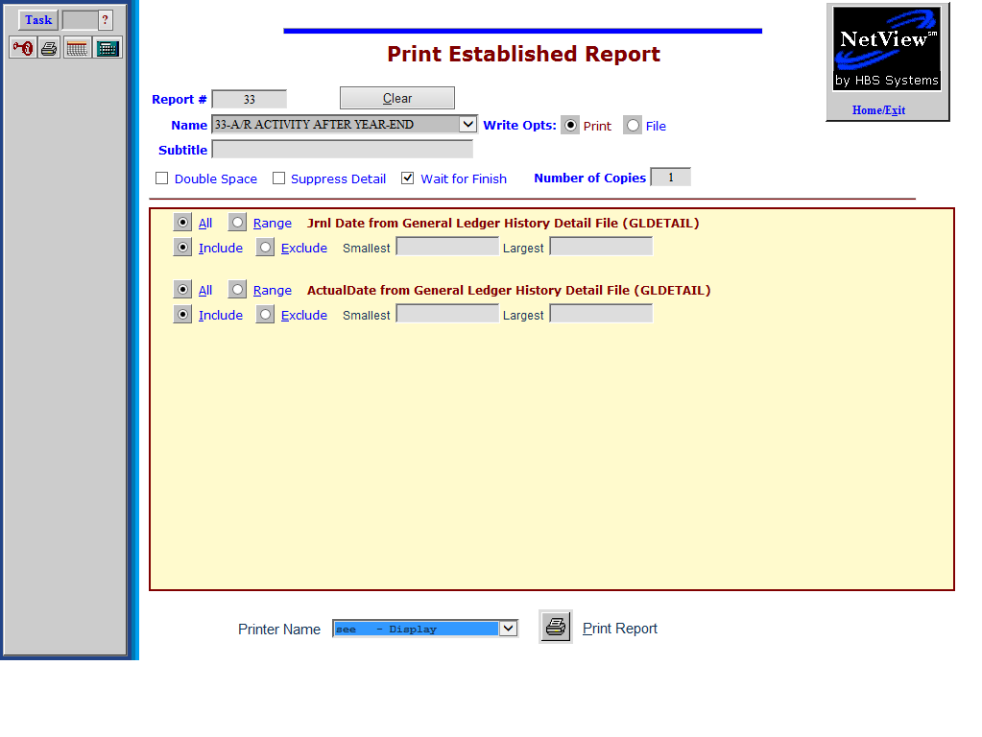

The A/R Activity After Year-End report helps you audit the activity in your A/R account after the last day of your fiscal year. It works in coordination with an A/R Aging Report that was run at the close of business on the last day of your fiscal year. You may then use this report to track any subsequent activity made to the A/R accounts as it applies to that year of business.

The report will prompt for two items:

- The Journal Date
- The Actual Date or Timestamp

To access this function, you can either:

- Select “Report Writer” from the menu. Click “Print an Established Report” and choose the report.
- Type “PER” in the Shortcuts Bar and select the report.

Jrnl Date from General Ledger Histoyr Detail File (GLDETAIL): Click on Range for Jrnl Date and enter the first and last business days of your fiscal year on the Smallest and Largest fields. Your entries simply define the boundaries of the entire fiscal year.
ActualDate from General Ledger Histoyr Detail File (GLDETAIL): Click on Range for Actual Date. Fill in the day after your fiscal year end in the Smallest field and today’s date in the Largest field.

This report is best run with “no details” and will provide a total dollar amount of activity in your A/R account since the end of your Fiscal Year. It will help you validate the figure on your year end Trial Balance.

HBS SYSTEMS DEALER
Jan 31 2013 A/R ACTIVITY AFTER YEAR-END Page 1

Acct# Doc# Cust# Description Amount JN Jrnl Date ActualDate

10300 29549 37620 INGA RANDALL 65.61 01 12/31/2012 01/27/2013
------------
Total for Cust# 37620: 65.61

10300 29532 43500 CANTON RACE COURSE -150.18 09 12/31/2012 01/07/2013
------------
Total for Cust# 43500: -150.18

10300 29533 44500 AMY MURPHY -110.62 09 12/31/2012 01/20/2013
------------
Total for Cust# 44500: -110.62

10300 29534 45145 MAJOR RANCH INC 112.64 01 12/30/2012 01/02/2013
------------
Total for Cust# 45145: 112.64

10300 29523 45700 MARK SLANTE 40.57 01 12/20/2012 01/03/2013
------------
Total for Cust# 45700: 40.57

10300 29515 47050 STAN MELROSE -17.15 09 12/31/2012 01/02/2013
------------
Total for Cust# 47050: -17.15

============
REPORT TOTAL: -60.33

Report Columns: This report contains the following information:

Acct#: This shows the general ledger account for Accounts Receivable (10300 in this case).

Doc #: This is the document number that was entered when the entry was made.

Cust#: This is the accounts receivable customer number that had activity.

Description: Here you will find a description of what this entry represents. Often it will include the name of the customer.

Amount: This is the dollar amount of the entry.

JN: This is the journal number that was used when this entry was made.

Jrnl Date: This field contains the journal date.

Actual Date: This field is the actual date that the entry was posted in the system.

Totals: The report provides totals for each customer as well as a grand total for all customers reported. NOTE: If you are strictly interested in only the totals by vendor and not all the line-by-line detail, click the Suppress Detail box.

