PER: Wholegoods Sources—Numeric

This Report Writer report prints a list of your wholegoods sources in numerical order by Source Number.

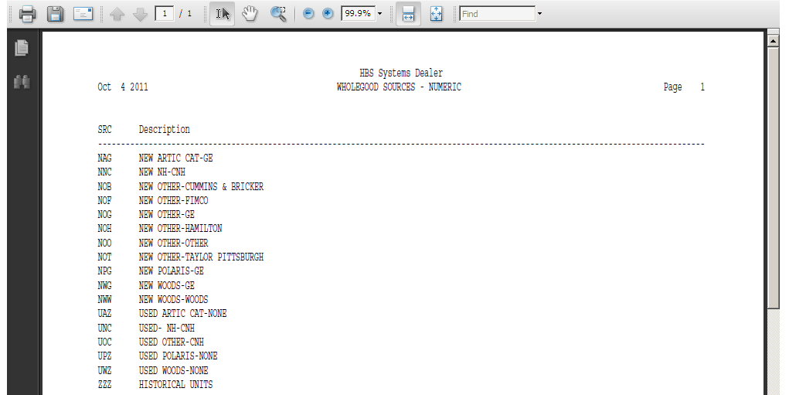

To access this report, you can either:

- Select “Report Writer” from the menu. Click “Print an Established Report” and choose the “Wholegoods Sources—Numeric” report.
- Type “PER” in the Shortcuts Bar and select the report number.

Report Columns: The report shows the following information:

Src: This column shows the Wholegoods Source number or abbreviation. It is a three-character alphanumeric value.

Description: This area shows the description given to this source. Depending on your set-up, it could include the name of the manufacturer, source of financing, special terms, etc.

