PER: Sales Commissions

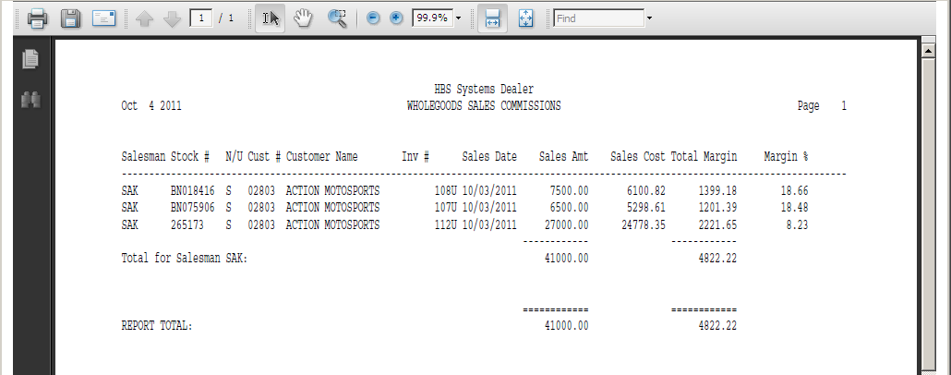

This Report Writer report shows details of unit sales history for a selected time period. The report also prompts for a Sales Person number or identification so you examine the details for one or more of sales staff.

- To access this report, you can either:
  - Select “Report Writer” from the menu. Click “Print an Established Report” and choose the “Wholegoods Sales Commissions” report.
  - Type “PER” in the Shortcuts Bar and choose the report number.

Report Columns: The report is sorted and subtotaled by salesman. It shows the following information:

Salesman: This column shows the initials or number of the salesman who had the sale.

Stock #: This field shows the stock number of the unit.

N/U: This field is actually the status of the item itself. For this report, only the Sold status (S) will show.

Cust #: This field shows the customer number of the person or company that made the purchase.

Customer Name: This field shows the name of the person or company that made the purchase.

Inv #: This field holds the invoice for the sales ticket of this sale.

Sales Date: This field shows the date of the sale.

Sales Amount: This value is the actual selling price for the unit sold.

Sales Cost: This value is the cost at the time it was sold.

Total Margin: This calculation (margin or gross profit) is the difference between the Selling Price and the Cost of the unit when sold. The result could be positive or negative.

Margin %: This shows the percent of profit on the sale of the unit. It is calculated by dividing the Total Margin by the Selling Price. Percentages are shown extended to two places past the decimal point.

Totals: Totals are provided by Salesman and a Grand Total for the Sales Amount, Sales Cost, and Total Margin columns.

