PER: Wholegood Serial Number Lookup

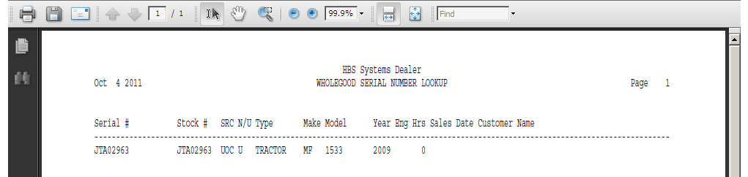

This Report Writer (RW) report can be handy when you are searching for information about a piece of equipment and all you have is the serial number. An added bonus with this report is that it actually does a partial serial number search. It takes the characters you enter and displays or prints all units that have serial numbers beginning with the characters you entered. The report prompts for serial number when it runs. You can also simply print a report for all serial numbers.

- To access this report, you can either:
  - Select “Report Writer” from the menu. Click “Print an Established Report” and choose the “Wholegood Serial Number Lookup” report.
  - Type “PER” in the Shortcuts Bar and select the report number.

Report Columns: The report shows the following information:

Serial #: This field shows the serial number of the units selected for the report.

Stock #: This field shows the stock number of the unit.

Src: This area shows the Wholegoods Source assigned to the unit shown.

N/U: This field is actually the status of the wholegoods item itself. It could be:

N=New

U=Used

S=Sold

O=Ordered

H=Historical

T=Transfer

R=Rental

Type: The Type field tells you about the piece of equipment (i.e. Tractor, Snow Plow, Chainsaw, etc).

Make: This field identifies the manufacturer or Make of the unit.

Model: This field holds the equipment’s Model Number.

Year: This field holds the four digit model year of the unit.

EngHrs: Here you will find the number of Engine Hours that the equipment has accumulated.

Sales Date: If the unit shown is sold, you will see the Sales Date here.

Customer Name: If the unit shown is sold, this field shows the name of the person or company that made the purchase.

