PER: Wholegood Make Lookup

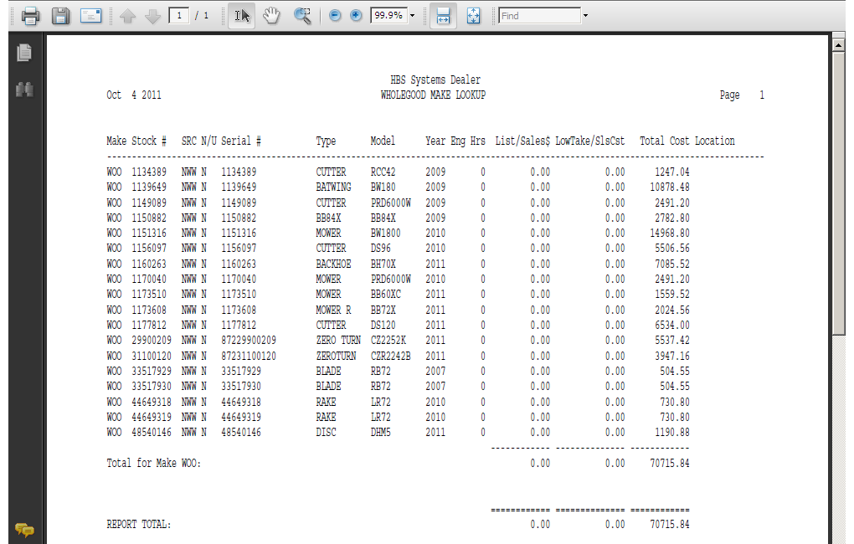

This Report Writer report helps you examine a particular line or make of wholegoods. It could be helpful when doing inventory of wholegoods or just checking stock. The report prompts for N/U status and Make when it runs. You can also print a report that lists all makes.

- To access this report, you can either:
  - Select “Report Writer” from the menu. Click “Print an Established Report” and choose the “Wholegood Make Lookup” report.
  - Type “PER” in the Shortcuts Bar and select the report number.

Report Columns: The report shows the following information:

Make: This field identifies the manufacturer or Make of the unit.

Stock #: This field shows the stock number of the unit.

Src: This area shows the Wholegoods Source assigned to the unit shown.

N/U: This field is actually the status of the wholegoods item itself. It could be:

N=New

U=Used

S=Sold

O=Ordered

H=Historical

T=Transfer

R=Rental

Serial #: This field shows the serial number of the units selected for the report.

Type:
The Type field tells you about the piece of equipment (i.e. Tractor, Snow Plow, Chainsaw, etc.).

Model: This field holds the equipment’s Model Number.

Year: This field holds the four digit model year of the unit.

EngHrs: Here you will find the number of Engine Hours that the equipment has accumulated.

List/Sales$:

- If this unit is in inventory, the field can show the List price if it has been filled in.
- For sold or non-inventory units, the value here is the actual selling price for the wholegood.

LowTake/SlsCst:

If this unit is in inventory, the field can show the Low Take price if it has been filled in.

For sold or non-inventory units, the value here is the cost of the wholegood at the time it was sold.

Tot Cost: This field provides the total cost of the inventory unit. Typically it includes the following:

Base Net

Freight

R/O Total

Options Net Total

Location:

- If the unit is in inventory, this field can show the physical location of the unit if it has been filled in.
- For sold or transferred units, the word “Delivered” shows here.

Totals: Totals are provided by Make and a Grand Total for the List/Sales$ Amount, Low Take/Sales Cost, and Total Cost columns.

