PER: Wholegood Model Number Lookup

This Report Writer report helps you locate a particular unit via the model number. The report can be helpful in doing the following:

- Searching for a specific model number for a customer
- Tracking sale of one model
- Checking the scope of a warranty recall

The report prompts for N/U status and model number when it runs. You can also print a version that includes all units of all models.

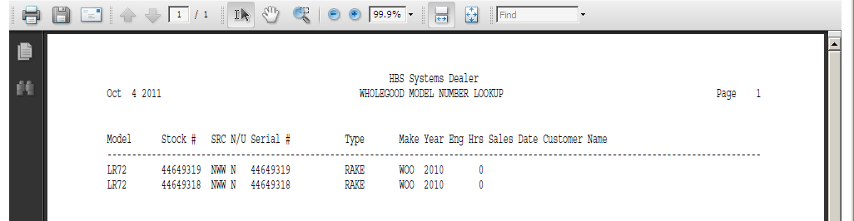

To access this report, you can either:

- Select “Report Writer” from the menu. Click “Print an Established Report” and choose the “Wholegood Model Number Lookup” report.
- Type “PER” in the Shortcuts Bar and select the report number.

Report Columns: The report shows the following information:

Model: This field shows the Model Number you searched for.

Stock #: This field shows the stock number of the unit.

Src: This area shows the Wholegoods Source assigned to the unit shown.

N/U: This field is actually the status of the wholegoods item itself. It could be:

N=New

U=Used

S=Sold

O=Ordered

H=Historical

T=Transfer

R=Rental

Serial #: This field holds the unit’s main Serial Number.

Type: The Type field tells you about the piece of equipment (i.e. Tractor, Snow Plow, Chainsaw, etc.).

Make: This field identifies the manufacturer or Make of the unit.

Year: This field holds the four-digit model year of the unit.

EngHrs: Here you will find the number of Engine Hours that the equipment has accumulated.

Sales Date: If the unit shown is sold, you will see the Sales Date here.

Customer Name: If the unit shown is sold, this field shows the name of the person or company that made the purchase.

