PER: Wholegoods Inventory Report

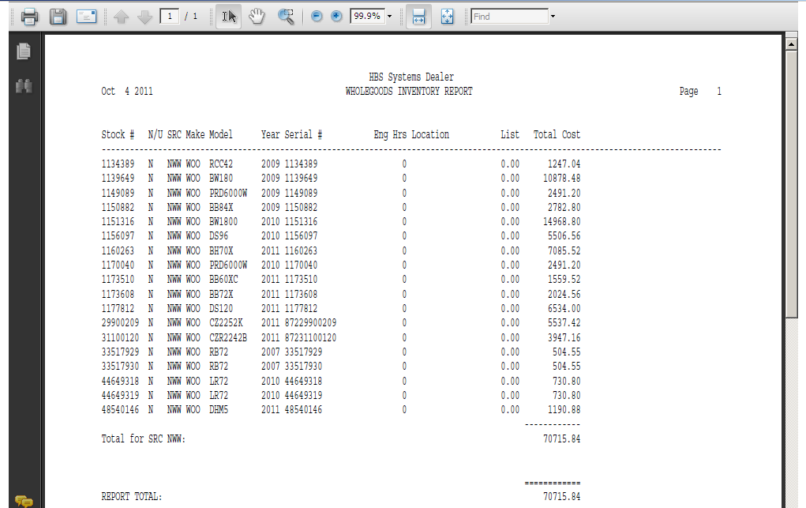

This Report Writer report provides a quick, easy to read list of items in inventory. It prompts for N/U status so you can choose the inventory to include. It also asks which source(s) to include on the report.

- To access this report, you can either:
  - Select “Report Writer” from the menu. Click “Print an Established Report” and choose the “Wholegoods Inventory Report.”
  - Type “PER” in the Shortcuts Bar and select the report number.

Report Columns

Stock #: This field shows the stock number of the unit.

N/U: This field is actually the status of the wholegoods item itself. It could be:

N=New

U=Used

S=Sold

O=Ordered

H=Historical

T=Transfer

R=Rental

Src: This area shows the Wholegoods Source assigned to the unit shown.

Make: This field identifies the manufacturer or Make of the unit.

Model: This field shows the Model Number you searched for.

Year: This field holds the four digit model year of the unit.

Serial #: This field holds the unit’s main Serial Number.

EngHrs: Here you will find the number of Engine Hours that the equipment has accumulated.

Location:

- If the unit is in inventory, this field can show the physical location of the unit if it has been filled in.
- For sold or transferred units, the word “Delivered” shows here.

List: If this unit is in inventory, the field can show the List price if it has been filled in.

Tot Cost: This field provides the total cost of the inventory unit. Typically it includes the following:

Base Net

Freight

R/O Total

Options Net Total

Totals: Totals are provided by Source and a Grand Total for the Total Cost column.

