PER: WG Make Listing—Finance Mgr

This Report Writer report helps prepare your Unit information for the Finance Manager unit inventory extract. The extract program takes the New, Used, and Rental status units from your inventory and attempts to organize them by specific Manufacturer and Type. A master table of Manufacturers and Types is provided from AGCO for Finance Manager, and your inventory units MUST fall into one of the provided Manufacturer and Type definitions.

Since the setup process potentially affects a large portion of your existing unit records, it is a good idea to involve the key personnel in your dealership who handle all aspects of the unit life cycle: accounting and sales. Any changes made as a result of this process will affect existing records, but you will want to make sure any choices made apply to ANY new unit records added in the future (such as purchases, trade-ins, historical units, and so on).

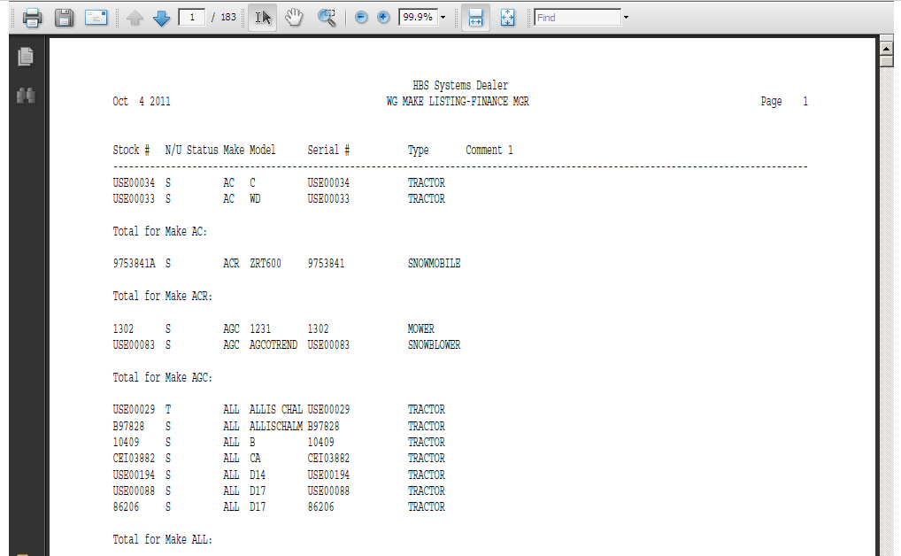

This report will print a listing of your wholegoods sorted by Make so you can determine if you need to make changes in any existing records, for consistency. The goal is to have the SAME manufacturer or make identified with the SAME abbreviation for ALL units of that brand. Ultimately you will be cross referencing every Make used in your HBS System to one defined in Finance Manager.

The report will prompt for N/U/S Status so you can examine N (new), U (used), and R (rental) for consistency to extract to Finance Manager. Ideally, you should probably examine ALL status settings (N, U, S, O, R, T, H) for the same consistency.

- To access this report, you can either:
  - Select “Report Writer” from the menu. Click “Print an Established Report” and choose the “WG Make Listing—Finance Mgr” report.
  - Type PER in the Shortcuts Bar and select the report number.

Report Columns: The report information includes:

Stock #: This field shows the stock number of the unit.

N/U Status: This field is actually the status of the item itself. It could be:

N=New

U=Used

S=Sold

O=Ordered

H=Historical

T=Transfer

R=Rental

Make: This field identifies the manufacturer or Make of the unit. This is the field you are concentrating on for this printout. Examine ALL pages for consistency in this column. For instance, you might find values like MF, MAS, MFE, or AMF, which are all designations for Massey Ferguson. You’ll then want to choose ONE value to be used for all Massey Ferguson units.

Model: This field shows the Model Number of the unit.

Serial #: This field holds the unit’s main Serial Number.

Type: This field shows the type or a brief description of the unit.

Comment 1: This column of the report shows any additional comments you have entered on line 1 of the comment lines in the Unit Master.

