PER: Type Listing—Finance Mgr

This Report Writer report helps prepare your Wholegoods information for the Finance Manager unit inventory extract. The extract program takes the New, Used, and Rental status units from your inventory and attempts to organize them by specific Manufacturer and Type. A master table of Manufacturers and Types is provided from AGCO for Finance Manager, and your inventory units MUST fall into one of the provided Manufacturer and Type definitions.

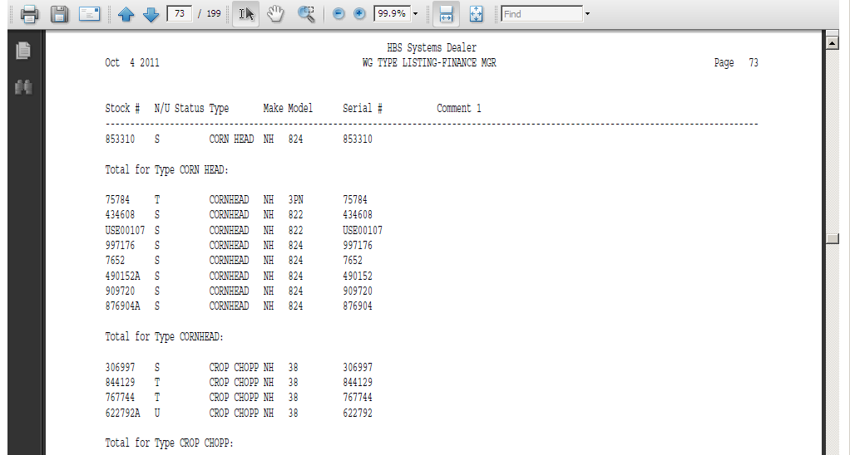

This report will print a listing of your wholegoods sorted by Type, then Make and Model so you can determine if you need to make changes in any existing records for consistency. The goal is to have only ONE Type spelling or abbreviation for ALL units of that Type. Ultimately, you will be cross referencing every Type used in your HBS System to one defined in Finance Manager.
The report will prompt for N/U/S Status so you can examine N (new), U (used), and R (rental) for consistency to extract to Finance Manager. Ideally, you should probably examine ALL status settings (N, U, S, O, R, T, H) for the same consistency.

- To access this report, you can either:
  - Select “Report Writer” from the menu. Click “Print an Established Report” and choose the “WG Type Listing—Finance Mgr” report.
  - Type “PER” in the Shortcuts Bar and select the report number.

Report Columns: The report information includes:

Stock #: This field shows the stock number of the unit.

N/U Status: This field is actually the status of the item itself. It could be:

N=New

U=Used

S=Sold

O=Ordered

H=Historical

T=Transfer

R=Rental

Type: This field shows the type or a brief description of the unit. This is the field you are concentrating on for this printout. Examine ALL pages for consistency in this column. The sample printout above shows three variations for Loader: LDR, LOA, and LOADER. You will want to look for instances like this and then choose ONE value to be used for all units of that type.

Make: This field identifies the manufacturer or Make of the unit.

Model: This field shows the Model Number of the unit.

Serial #: This field holds the unit’s main Serial Number.

Comment 1: This column of the report shows any additional comments you have entered on line 1 of the comment lines in the Unit Master.

