PER: WG Type Listing—IRON Solutions

This Report Writer report will print a listing of your units sorted by Type, then Make and Model, so you can determine if you need to make changes in any existing records, for consistency. The goal is to have only ONE Type spelling or abbreviation for ALL units of that Type. Ultimately, you will be cross referencing every Type used in your HBS System to one defined in Iron Solutions.

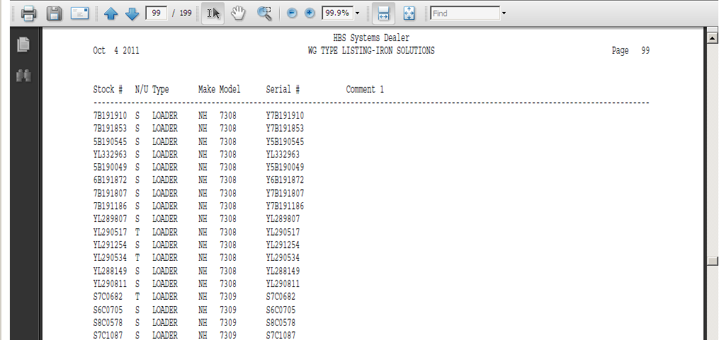

The report will prompt for N/U/S Status so you can examine N (new), U (used), and R (rental) for consistency to extract to Iron Solutions. Ideally, you should probably examine ALL status settings (N,U,S,O,R,T,H) for the same consistency.

- To access this report, you can either:
  - Select “Report Writer” from the menu. Click “Print an Established Report” and choose the “WG Type Listing—IRON Solutions” report.
  - Type “PER” in the Shortcuts Bar and select the report number.

Report Columns: The report information includes:

Stock #: This field shows the stock number of the unit.

N/U Status: This field is actually the status of the item itself. It could be

N=New

U=Used

S=Sold

O=Ordered

H=Historical

T=Transfer

R=Rental

Type: This field shows the type or a brief description of the unit. This is the field you are concentrating on for this printout. Examine ALL pages for consistency in this column. The sample printout above shows three variations for Loader: LDR, LOA, and LOADER. You will want to look for instances like this and then choose ONE value to be used for all units of that type.

Make: This field identifies the manufacturer or Make of the unit.

Model: This field shows the Model Number of the unit.

Serial #: This field holds the unit’s main Serial Number.

Comment 1: This column of the report shows any additional comments you have entered on line 1 of the comment lines in the Unit Master.

