Select A/P Accounts (SAPA)

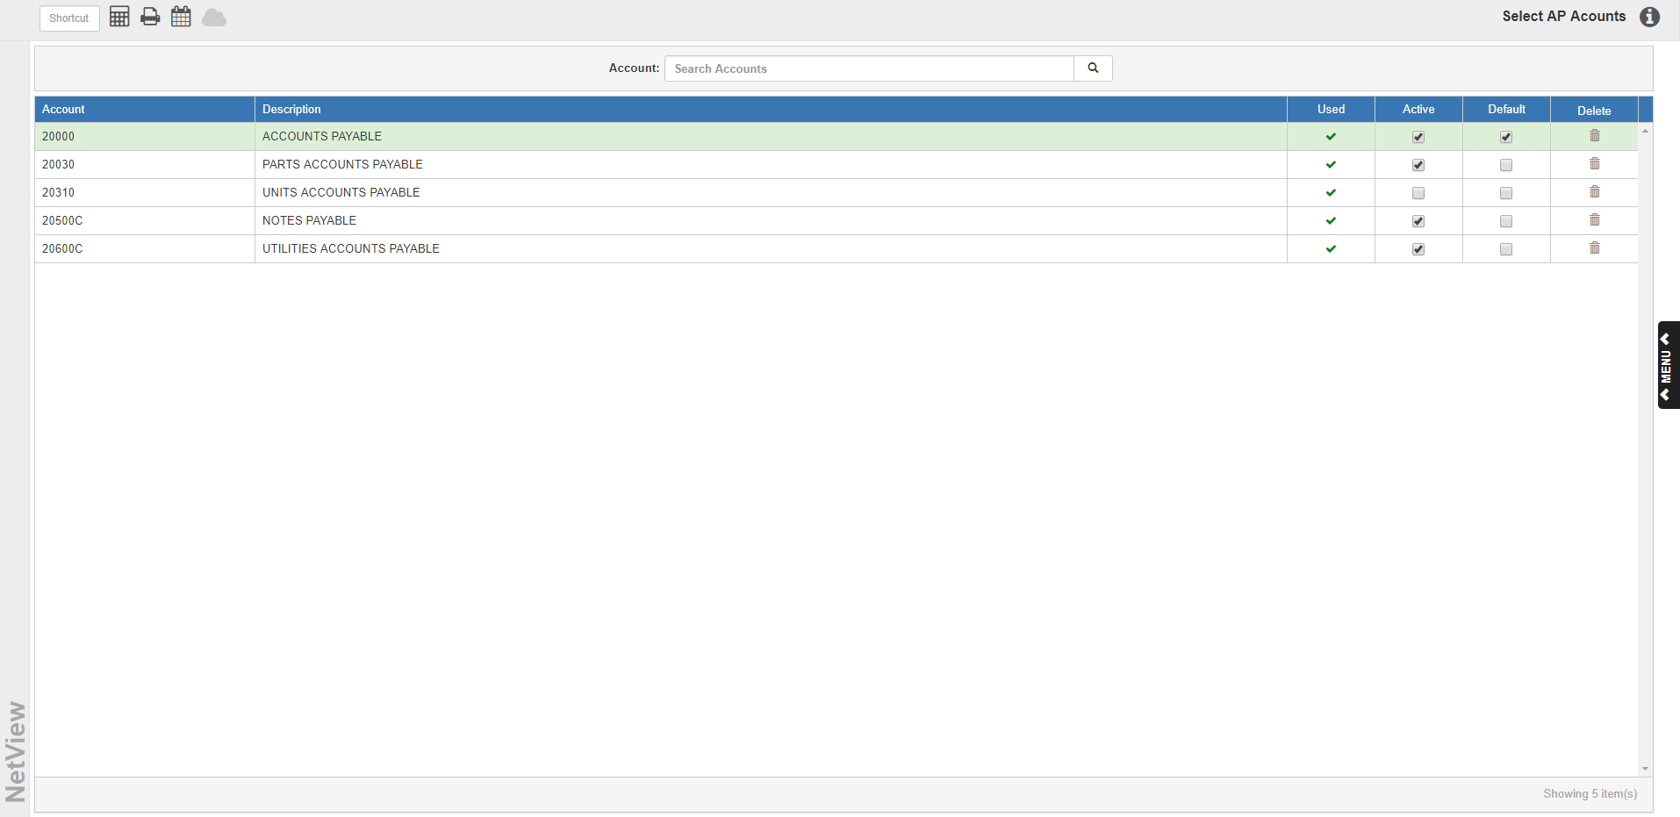

Select A/P Accounts (SAPA) allows you to select accounts to use on Accounts Payable invoices. To access this function, type “SAPA” in the Shortcuts Bar.

NOTE: To have A/P accounts other than the default account (20000-Accounts Payable) available for use on A/P invoices, you must have the “Use Multiple AP Accounts” option in Information Defaults (ID) set to “Yes.” Otherwise, you will only be able to use the default account.

NOTE: Only non-subledger accounts with an Account Type Code between G and L are available for use as A/P accounts. We also recommend you create new accounts to use as extra A/P accounts rather than repurpose existing accounts.

Add an Account: To add a new A/P account, enter the account’s name or number in the Accounts field and click the Search icon. If you enter the full account name or number, clicking the icon will automatically add the account to the list of available A/P accounts.

If you enter only a partial account name or number, clicking the icon will open a list of matching results in a new window (see below).

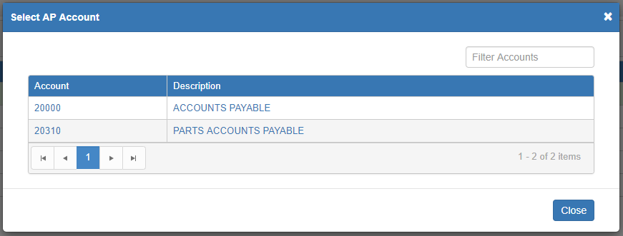

Select the desired account to close the window and add the new account to the list on the main screen.

A/P Account List Grid: The grid on the main screen lists all system accounts currently selected for use on A/P invoices.

Account: This column shows the account number.

Description: This column shows the account name.

Used: This column indicates whether or not the account has actually been used to pay an invoice.

- If it shows a green checkmark, then the account has been used.
- If it shows a red “x,” then the account has not yet appeared on an invoice.

Active: Check the box in this column to activate the account for use on invoices. Uncheck the box to mark the account inactive. NOTE: If the box is unchecked, the account cannot be used on any future invoices. For any invoices it’s already been used on, the system will automatically change the listed account to the default account marked in this program.

Default: This column indicates which account is set as the A/P default account in Account Numbers (ACCN). It cannot be changed to a different account in this program.

Delete: You can only delete an A/P account if it has never been used (shows the red “x” in the Used column). Click the icon in this column to delete the unused account.

