Service Connect (SC)

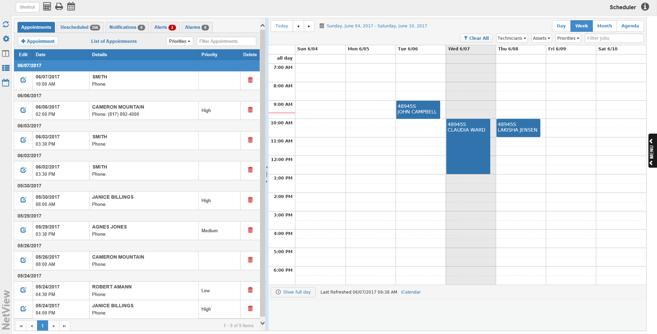

The Service Connect program allows you to create and maintain a detailed Event schedule for your Service department. Among other features, this program will help you keep track of:

- How many repairs are scheduled in a given time period, and which repairs still need scheduling.
- Which technicians and departmental assets are currently assigned to which repairs.
- Any activity inside and outside the Service department that might affect a scheduled Service Event.

To access this function, type SC in the Shortcuts Bar.

Sidebar Icons: Use the icons pictured below to modify the settings and screen view in this program.

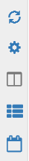

Refresh All: Click the icon to refresh the program.

Service Connect Settings: Click the icon to open Service Connect Settings (SCS), the setup program for Service Connect. See “Service Connect Settings (SCS)” for more information.

Switch to Split View: Click the 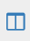 icon to switch the program screen to a split-screen view where both the Appointments Panel and the Event Calendar are visible. This is the default screen view that appears when you open the program. When this view is selected, the icon will turn grey 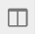.

Switch to Grid View: Click the icon to switch the program screen to a full-screen view of the Appointments Panel. When this view is selected, the icon will turn grey .

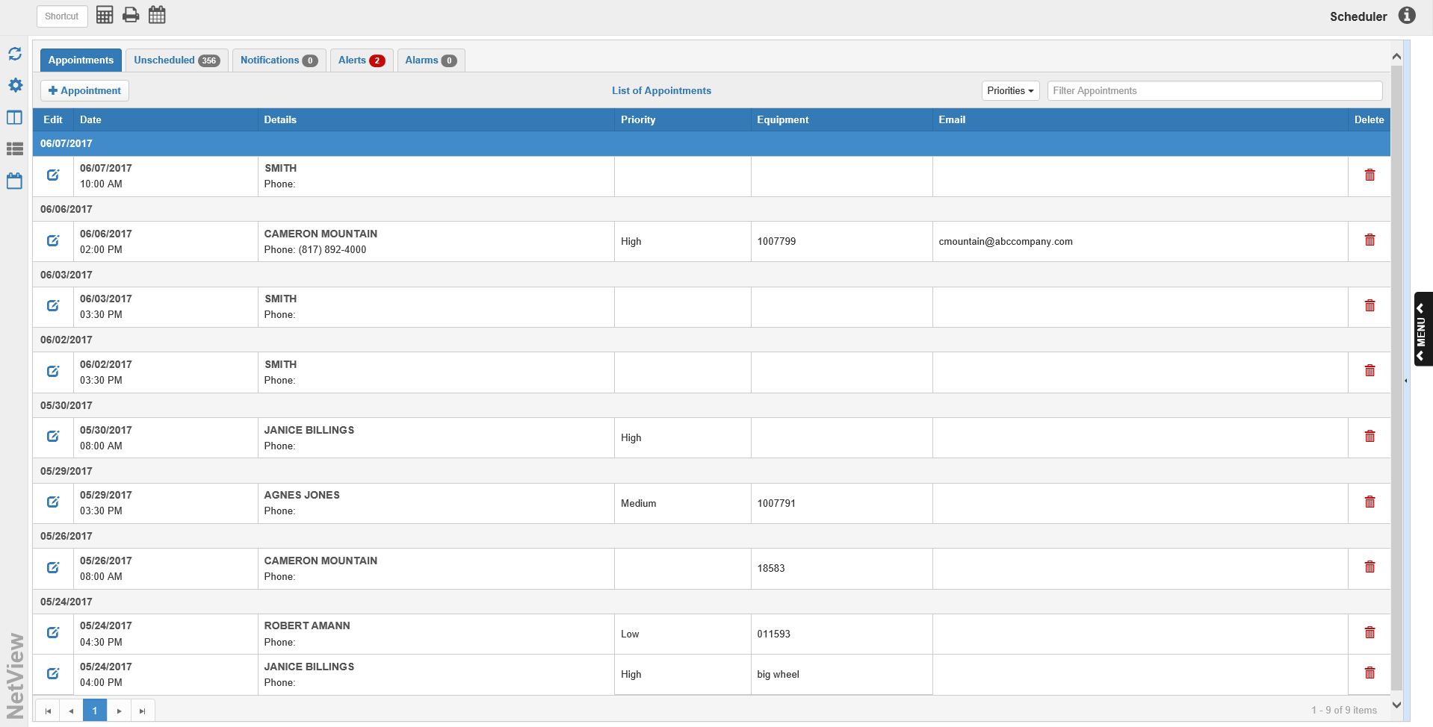

Switch to Calendar View: Click the icon to switch the program screen to full-screen view of the Event Calendar. When this view is selected, the icon will turn grey .

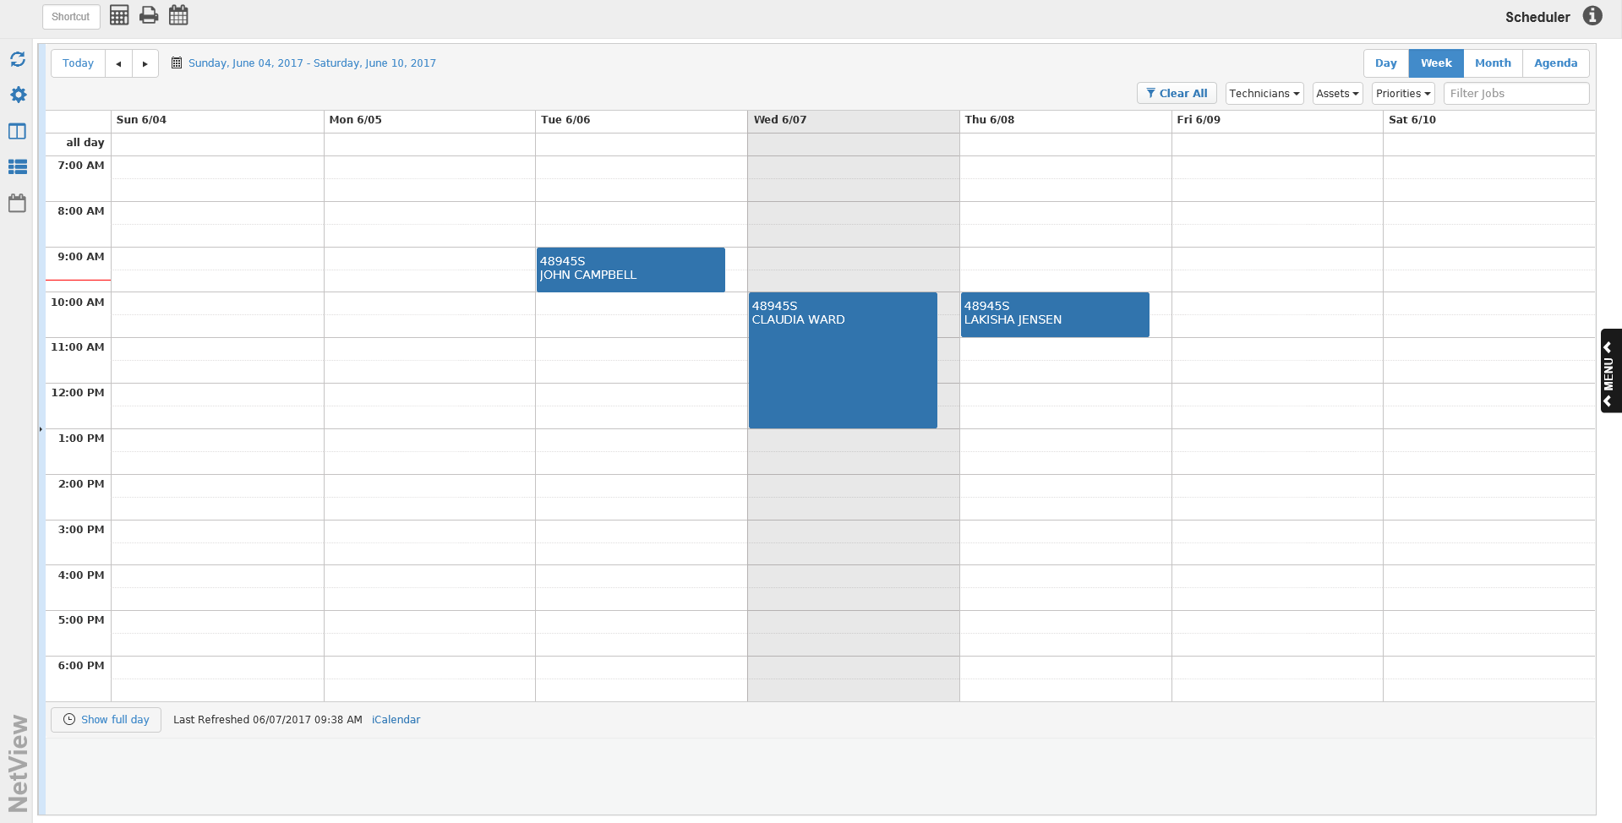

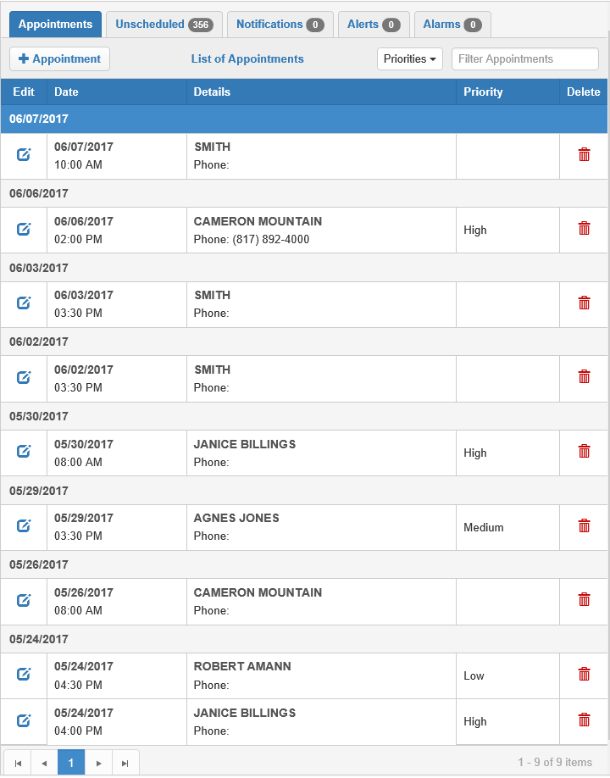

Appointments Panel: This panel’s tabs list a variety of information to help a Service department’s management stay organized and up-to-date on repair activity.

- The panel is dynamic, meaning it can be hidden or adjusted using the right-hand edge.
- Clicking the Switch to Grid View icon will also expand the panel to fill the whole screen.

Appointments Tab: This tab contains a list of Service Appointments, which are different from Service Events in that they are not connected to a repair order. Customers make Appointments with the Service department to determine if any repairs are actually needed on their piece of equipment. If repairs are needed, then the Appointment will be assigned an RO number and become an Event.

+ Appointment: Click the 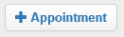 button to add a new Appointment to Service Connect. The following window will open:

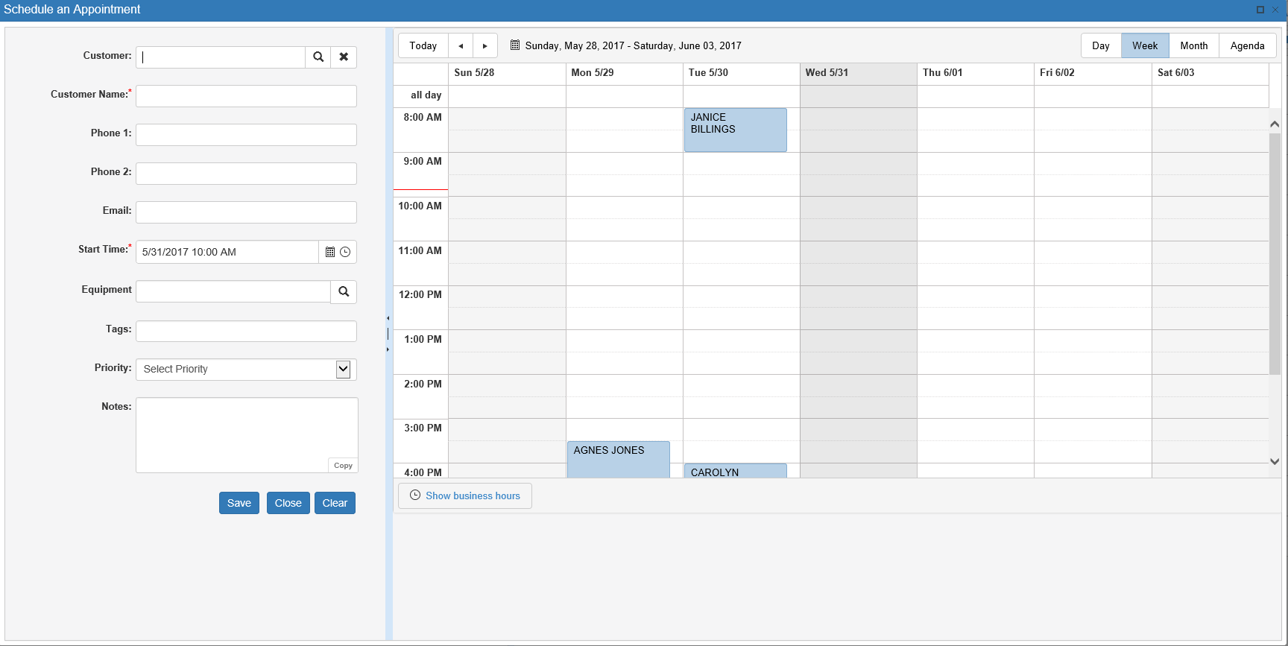

- New Appointment Entry Panel: Enter information about the Appointment in the panel on the left side of the window. This panel is dynamic, meaning it can be hidden or expanded.
  - Customer: If the customer is already in your system, enter their customer number in this field or use the Search feature to look it up.
  - Customer Name: Enter the customer’s name here. This is a required field.
  - Phone 1: Enter a contact phone number for the customer here.
  - Phone 2: Enter an alternate contact phone number for the customer here.
  - Email: Enter a contact email address for the customer here. If the text entered in this field does not appear in proper email format (Ex.: hbs@yahoo.com), the field will outline in red and you will not be able to create the appointment until the field’s content is corrected or cleared.
  - Start Time: Set the date and time for the appointment in this field by using the calendar feature to select a date and the clock drop-down menu to select a time. This is a required entry field.
  - Equipment: If the equipment being brought in is already recorded in your system, enter the unit stock number here or use the Search feature to look it up. If you have entered a customer number and that customer has units recorded in the system, the search will automatically bring up the units belonging to that customer that match your search criteria.
  - Tags: Enter any tags you want to attach to the Appointment. Tags are user-created labels that can help group similar records together. The system will divide your text entries into a new tag every time you hit the “Enter” key.

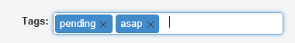

    - To remove a tag from an Appointment record, click the “x” on the right side of the tag.
    - As you type, the field will offer tag suggestions based on tags you have previously added in Service Connect Setup (SCS) as you type in this field.
    - When you enter a new tag, i.e. one not already recorded in the system, the following window opens:

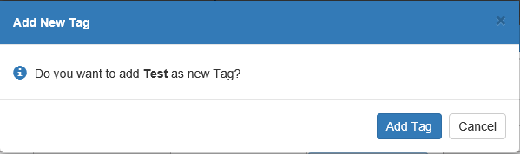

      - Click Add Tag to add the tag to both the system and the Appointment record.
      - Click Cancel to discard the tag.
  - Priority: Select the Appointment’s priority level from the drop-down menu in this field. Priority levels are customizable per dealership, and will reflect the options you create in Service Connect Setup (SCS).
  - Notes: Add any additional notes about the Appointment here. NOTE: The Copy feature, located in the lower right-hand corner of the field, lets you copy the text in this field to your computer’s Clipboard for use in another window/program/etc.
  - Save: Click this button to save the Appointment record. The new Appointment will be visible on the Appointments Calendar the next time you view it.
  - Close: Click this button to close the window without saving the Appointment record.
  - Clear: Click this button to clear the data from all the fields in the panel.
- Appointments Calendar: This part of the Schedule an Appointment window shows the current Appointments schedule. The default view is the Week view.
  - Date Change Buttons: Use these 3 buttons in the top left-hand corner of the Calendar to change the date(s) visible on the calendar.
    - Left Arrow: Click this button to go back one day/week/month on the Calendar view.
    - Right Arrow: Click this button to go forward one day/week/month on the Calendar view.
    - Today: Click this button to automatically return the Calendar view to the current day/week/month view. For example, if you click this button in Day view while looking at the calendar on Friday, June 2nd, the Calendar will switch to show the schedule for Friday, June 2nd.
  - Timeframe: This display next to the Date Change buttons shows the period of time covered by current calendar view. For example, in Day view it will show the day of the week and the specific date of the month, while in Week view it will show the beginning and ending days of the week/dates of the month that span the week shown.
  - View Selection Buttons: Use these buttons in the top right-hand corner of the Calendar to switch between the different Calendar views.

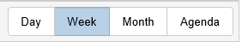

    - Day: Select this view to see the Appointments schedule for a single day.

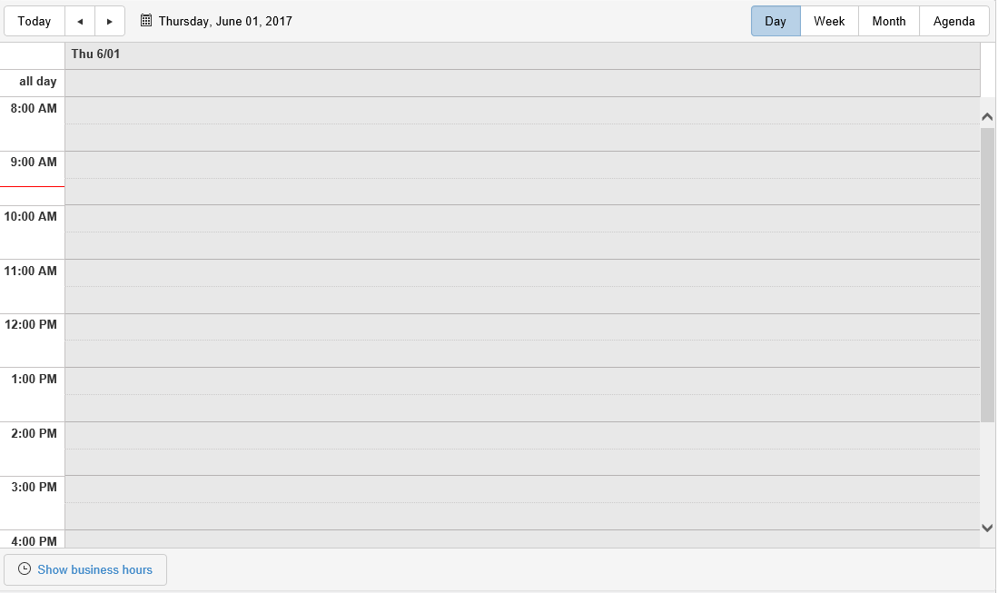

      - The Calendar is divided into rows by hour, with the earliest time at the top of the screen and the rows proceeding in chronological order as you scroll down.
        - The rows are also divided at the half-hour mark to allow for scheduling by the half-hour.
        - The default display for this view shows the hours from 8:00 AM to 7:00 PM (last hour row displayed is 6:00 PM). This range of hours generally extends beyond a Service department’s typical business hours, which allows for scheduling of Appointments that might need to occur fully or partially outside of business hours.
      - If the date visible is the current one, the rows will be darkened and a red line on the column listing the hours will indicate the current time of day.
      - All Day: The first row on the Calendar in this view is labeled “all day.” It allows you to schedule an Appointment that will take the full length of operating hours on that date.
      - Show Business Hours/Show Full Day: This button appears at bottom of view screen, and lets you change the range of hours shown on that day.
        - Show Business Hours: Click the button when it has this label to change the Calendar view to only show the business’s hours of operation as recorded in Service Connect Settings (SCS).
        - Show Full Day: Click the button when it has this label to change the Calendar view to show the hours for the full day, i.e. the default hours for the Day view.
    - Week: Select this view to see the schedule for a single week, ranging from Sunday to Saturday.

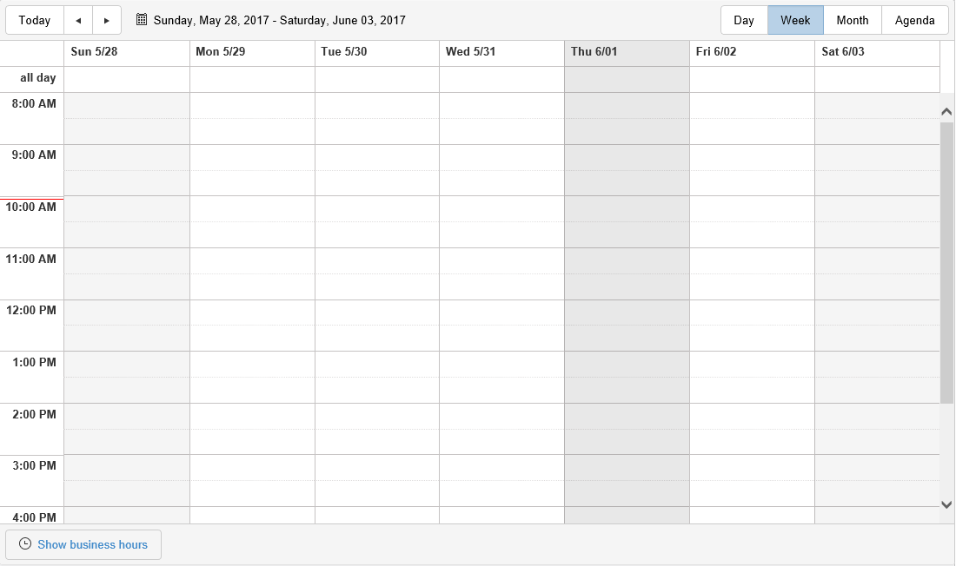

      - The Calendar is divided into columns by day of the week, i.e. one column is for Sunday, one for Monday, etc. The column headers will show the day of the week and the specific date of the month.
      - The Calendar is divided into rows by hour, with the earliest time at the top of the screen and the rows proceeding in chronological order as you scroll down.
        - The rows are also divided at the half-hour mark to allow for scheduling by the half-hour.
        - The default display for this view shows the hours from 8:00 AM to 7:00 PM (last hour row displayed is 6:00 PM). This range of hours generally extends beyond a Service department’s typical business hours, which allows for scheduling of Appointments that might need to occur fully or partially outside of business hours.
      - If the week visible contains the current date, the date will be darkened and a red line on the column listing the hours will indicate the current time of day.
      - All Day: The first row on the Calendar in this view is labeled “all day.” It allows you to schedule an Appointment that will take the full length of operating hours on that date.
      - Show Business Hours/Show Full Day: This button appears at bottom of view screen, and lets you change the range of hours shown on that day.
        - Show Business Hours: Click the button when it has this label to change the Calendar view to only show the business’s hours of operation.
        - Show Full Day: Click the button when it has this label to change the Calendar view to show the hours for the full day, i.e. the default hours for the Day view.
    - Month: Select this view to see the schedule for a single month.

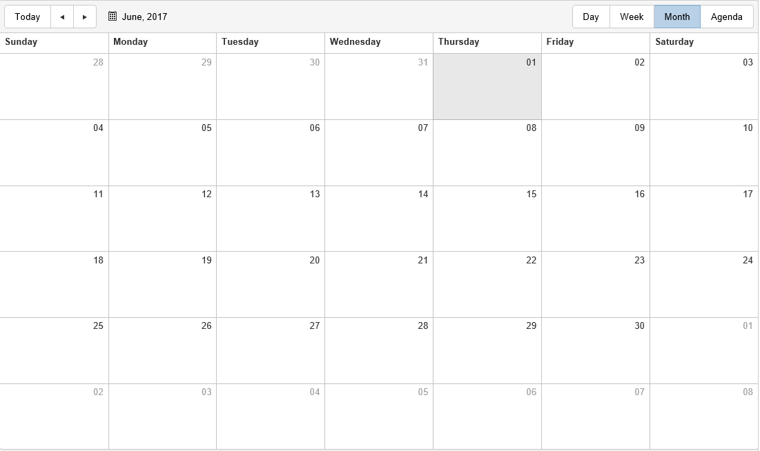

      - This is the most traditional calendar layout, where the rows are weeks and the columns are the days of the week.
      - The current day of the month will be darkened in comparison to the other dates.
    - Agenda: Select this view to see all Appointments listed out in chronological order over the course of a week (Monday-Monday, Tuesday-Tuesday, etc.). If any Appointments listed are scheduled for the current date, the entry row for each Appointment will be darkened.

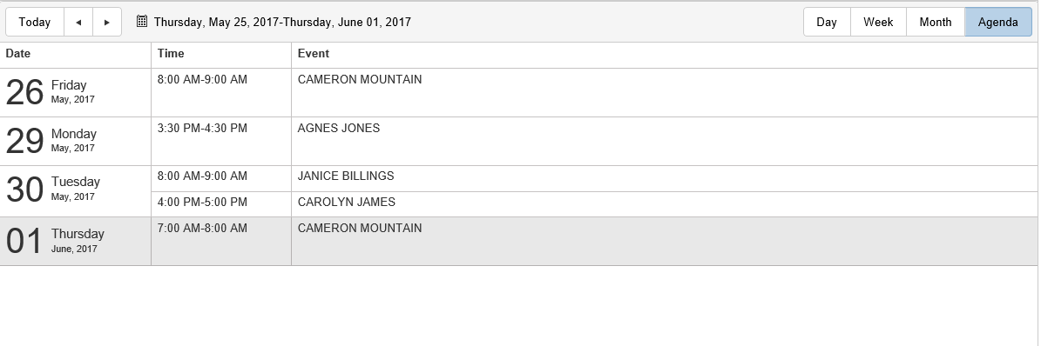
      - Columns:
        - Date: This column shows the date of the Appointment.
        - Time: This column shows the duration of the Event, generally the start and end times. If an Appointment is scheduled for “all day,” that will be noted instead of a start and end time.
        - Event: This column shows details about the Appointment, such as the name of the customer.

Priorities Filter: This drop-down menu in the Appointments Tab allows you to filter the Appointments Grid by the Appointment’s assigned priority. Check one or more of the boxes listed to filter the results by those specific priorities.

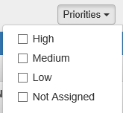

Filter Appointments: Use this field to filter the Appointments by other information that might appear in their entries, such as date, time, customer, phone number, etc. Type your desired criteria in the field and the Appointments listing will change to show only those Appointments that contain your entered text.

Appointments Grid: This is the full list of all Appointments made with the Service department using Service Connect.

- The Appointment listings are grouped by date, which is indicated by a header above the relevant listings. If any Appointments are scheduled on the current date, the date header will be blue.
- Columns:
  - Edit: This column contains a blue icon. Click the icon to edit the Appointment information in the Schedule an Appointment window (see “+ Appointment” above). You will be able to change all fields except the following:
    - Customer Name
    - Phone 1
    - Phone 2
    - Email
  - Date: This column shows the date and start time of appointment.
  - Details: This column shows the customer’s name and contact phone number.
  - Priority: This column shows the Appointment’s priority, if one has been assigned.
  - Delete: This column contains red trash can icon. Click the icon to delete the Appointment. The following window will open:

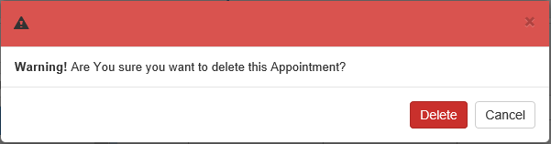

    - Delete: Click this button to delete the Appointment.
    - Cancel: Click this button to keep the Appointment.
- Page Number Indicators: These icons in the lower-right hand corner of the grid will show the page numbers of the Appointment listing.
  - The indicator for the current page will be highlighted in blue.
  - You can switch between pages by clicking on a different page indicator.
  - The number of indicators will vary depending on the number of Appointments.
- Previous Page/Next Page: Use the two single arrow buttons on either side of the Page Number Indicators to move forward or back a single page.
  - Click the left-pointing arrow to go back 1 page.
  - Click the right-pointing arrow to go forward 1 page.
- First Page/Last Page: Use the two buttons showing an arrow pointing to a vertical line to move to the first or last page of results.
  - Click the left-pointing arrow to go to the first page of results.
  - Click the right-pointing arrow to go to the last page of results.

Turning an Appointment into a Scheduled Event: Each Appointment entry can be dragged from Appointments Grid and dropped in a time slot on Schedule Calendar to create a Scheduled Event. A new Event window will open when the Appointment is dropped on the Calendar (see below image). Enter the necessary information to create the event.

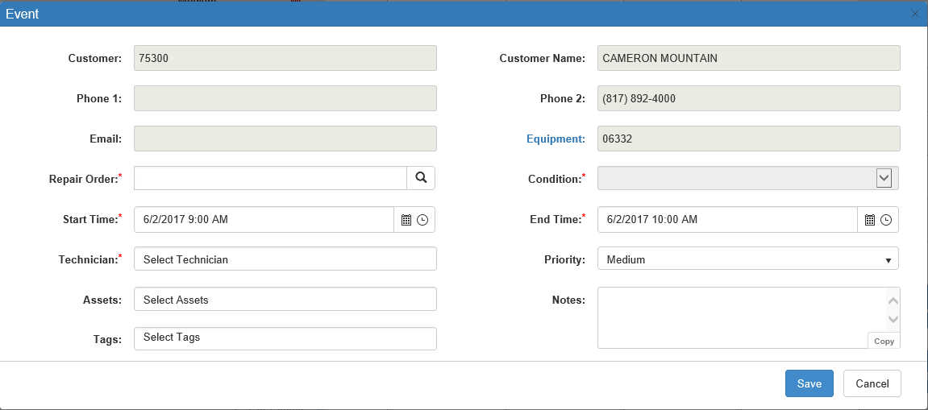

- The following fields will be pre-filled with information from the Appointment, if it was entered, and cannot be changed in this screen.
  - Customer
  - Customer Name
  - Phone 1
  - Phone 2
  - Email
  - Equipment: This field title will be highlighted in blue. Click it to open Unit Inquiry (UI) and view the unit record for the stock number in the field (if present).
- Repair Order: Enter an RO number for the Event or use the Search feature to look one up. This is a required field.
- Condition: This field only activates after the Repair Order field is filled in. Select the condition on the repair order associated with this event from the drop-down menu, if any are listed on the RO chosen. This is a required field.
- Start Time: Choose the start date and time for the Event using the Date and Time selection features. This field defaults to the date/time slot where you have placed the Appointment on the Events Calendar. This is a required field.
- End Time: Choose the end date and time for the Event using the Date and Time selection features. This field defaults to 1 hour after the date/time slot where you have placed the Appointment on the Events Calendar. This is a required field.
- Technician: Enter the technician for this Event or select it from the drop-down menu in the field.
  - This is a required field.
  - The menu will appear with matching options after you click in the field, and will change the available options to match any text you enter in the field.
  - The menu will only list technicians recorded in your Service system.
- Priority: Select a priority for the Event from the drop-down menu in this field.
- Assets: Enter any assets required for this Event in this field or select them from the drop-down menu.
  - The menu will appear with matching options after you click in the field, and will change the available options to match any text you enter in the field.
  - You can put more than one asset in the field, similar to the Tags field function (see below).
  - To remove an asset from the Event, click the “x” on its right side.
  - You will only be able to add an asset that you have added to the system through Service Connect Setup (SCS). Any other options entered will be rejected by the program.
- Tags: Enter any tags you want to apply to the Event. Type in the tag and press “Enter” to apply it.
  - To remove a tag, click the “x” on its right side.
  - As you type, the field will offer suggestions based on tags recorded in Service Connect Setup (SCS).
  - When you enter a new tag, i.e. one not already recorded in the system, the following window opens:

    - Click Add Tag to add the tag to both the system and the Appointment record.
    - Click Cancel to discard the tag.
- Notes: Enter any notes about the Event in this field. NOTE: The Copy feature, located in the lower right-hand corner of the field, lets you copy the text in this field to your computer’s Clipboard for use in another window/program/etc.
- Save: Click this button to save the Scheduled Event. It will now appear on the Event Calendar in the designated date/time slot.
- Cancel: Click this button to cancel the creation of the Event.

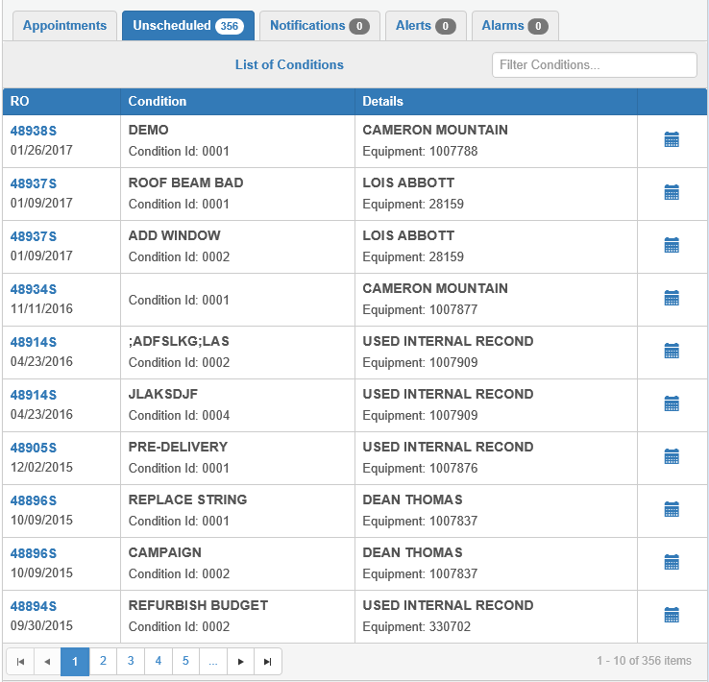

Unscheduled Tab: This tab contains a list of unscheduled Events that need to be placed on the Event Calendar. A number next to the tab title will indicate how many unscheduled Events are recorded in the program.

NOTE: In order for individual technicians to view the information in this tab, they must be set as a Service Writer in Technician Maintenance (TM). Open the technician's record in TM and do the following:

- Make sure the Service Writer box at the top of the screen is checked.

- Make sure the technician's NetView ID is entered in the relevant field.



Filter Conditions: Use this field to filter the unscheduled Events by information that might appear in their entries, such as date, time, customer, condition number, etc. Type your desired criteria in the field and the listing will change to show only those entries that contain your entered text.

Unscheduled Event Grid:

- Columns:
  - RO: This column shows the number and date of the repair order assigned to the event. If the RO number is colored blue, you can click on it to view the repair order in Repair Order Maintenance (ROM).
  - Condition: This column shows the name (if applicable) and ID number of the condition on the RO assigned to the Event.
  - Details: This column shows the customer name and the stock number of the equipment associated with the Event.
  - Add Event: Click on the blue icon in this column to schedule an Event. A new Event window will open. Fill in the required fields to schedule the Event. You can also schedule an Event by dragging and dropping the unscheduled Event in a date/time slot on the Event Calendar, as with Appointments.

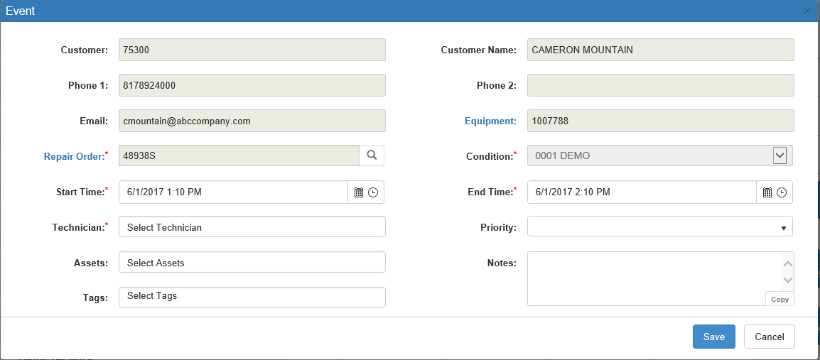

    - The following fields will be pre-filled with information recorded in the unscheduled Event and cannot be changed.
      - Customer
      - Customer Name
      - Phone 1
      - Phone 2
      - Email
      - Equipment: Click the blue field title to open the stock number record in Unit Inquiry (UI).
      - Repair Order: Click the blue field title to open the repair order in Repair Order Maintenance (ROM).
      - Condition
    - Start Time: Choose the start date and time for the Event using the Date and Time selection features. This field defaults to the date/time slot where you have placed the Event on the Events Calendar. This is a required field.
    - End Time: Choose the end date and time for the Event using the Date and Time selection features. This field defaults to 1 hour after the date/time slot where you have placed the Event on the Events Calendar. This is a required field.
    - Technician: Enter the technician for this Event or select it from the drop-down menu in the field.
      - This is a required field.
      - The menu will appear with matching options after you click in the field, and will change the available options to match any text you enter in the field.
      - The menu will only list technicians recorded in your Service system.
    - Priority: Select a priority for the Event from the drop-down menu in this field.
    - Assets: Enter any assets required for this Event in this field or select them from the drop-down menu.
      - The menu will appear with matching options after you click in the field, and will change the available options to match any text you enter in the field.
      - You can put more than one asset in the field, similar to the Tags field function (see below).
      - To remove an asset from the Event, click the “x” on its right side.
      - You will only be able to add an asset that you have added to the system through Service Connect Setup (SCS). Any other options entered will be rejected.
    - Tags: Enter any tags you want to apply to the Event. Type in the tag and press “Enter” to apply it.
      - To remove a tag, click the “x” on its right side.
      - As you type, the field will offer suggestions based on tags recorded in Service Connect Setup (SCS).
      - When you enter a new tag, i.e. one not already recorded in the system, the following window opens:

      - Click Add Tag to add the tag to both the system and the unscheduled Event.
      - Click Cancel to discard the tag.
    - Notes: Enter any notes about the Event in this field. NOTE: The Copy feature, located in the lower right-hand corner of the field, lets you copy the text in this field to your computer’s Clipboard for use in another window/program/etc.
    - Save: Click this button to save the Scheduled Event. It will now appear on the Event Calendar in the designated date/time slot.
    - Cancel: Click this button to cancel scheduling the Event.
- Page Number Indicators: These icons in the lower-right hand corner of the grid will show the page numbers of the listing.
  - The indicator for the current page will be highlighted in blue.
  - You can switch between pages by clicking on a different page indicator.
  - The number of indicators will vary depending on the number of unscheduled Events.
- Previous Page/Next Page: Use the two single arrow buttons on either side of the Page Number Indicators to move forward or back a single page.
  - Click the left-pointing arrow to go back one page.
  - Click the right-pointing arrow to go forward one page.
- First Page/Last Page: Use the two buttons showing an arrow pointing to a vertical line to move to the first or last page of results.
  - Click the left-pointing arrow to go to the first page of results.
  - Click the right-pointing arrow to go to the last page of results.

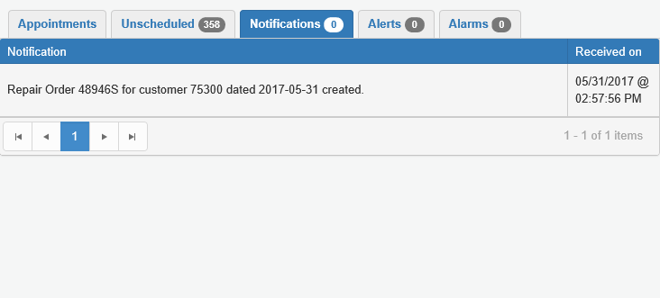

Notifications Tab: This tab shows any changes to scheduled Events (adjustments to ROs, technician clock-in/clock-out, etc.) which occur within the Service system, listed in chronological order starting with the most recent.

- A green number will appear next to the tab name showing the number of Notifications received since you last viewed the tab. Opening the tab will reset the number to “0.”
- Newly-received Notifications will also have a white background with bold writing, while the older notifications will have a grey background with normal writing. If you switch to a different tab and then reopen this one, the newer Notifications will now be colored the same as the others, since you have viewed them.
- Notifications will expire after 7 days, at which time they will disappear from the tab.
- Columns:
  - Notification: This column shows the Notification details.
  - Received on: This column shows the date and time you received the Notification.
- Page Number Indicators: These icons in the lower-right hand corner of the grid will show the page numbers of the listing.
  - The indicator for the current page will be highlighted in blue.
  - You can switch between pages by clicking on a different page indicator.
  - The number of indicators will vary depending on the number of unscheduled Events.
- Previous Page/Next Page: Use the two single arrow buttons on either side of the Page Number Indicators to move forward or back a single page.
  - Click the left-pointing arrow to go back one page.
  - Click the right-pointing arrow to go forward one page.
- First Page/Last Page: Use the two buttons showing an arrow pointing to a vertical line to move to the first or last page of results.
  - Click the left-pointing arrow to go to the first page of results.
  - Click the right-pointing arrow to go to the last page of results.

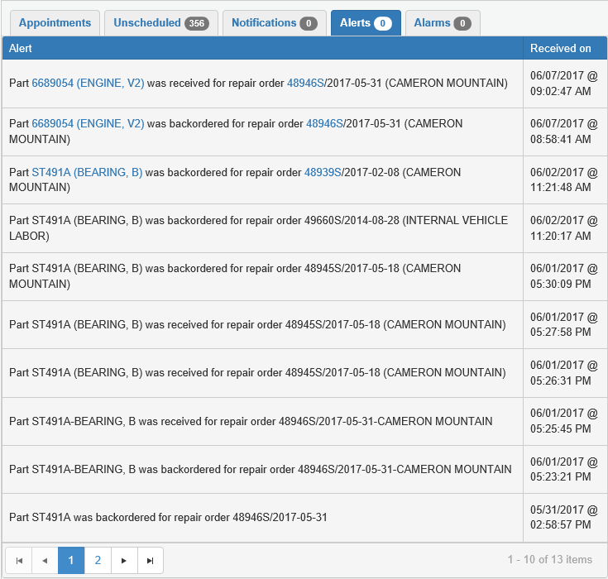

Alerts Tab: This tab shows alerts from outside the Service system (orders, outside units, etc.) that affect scheduled Events, listed in chronological order starting with the most recent.

- A red number will appear next to the tab name showing the number of Alerts received since you last viewed the tab. Opening the tab and then switching to a different tab will reset the number to “0.”
- Newly-received Alerts will also have a white background with bold writing, while the older notifications will have a grey background with normal writing. If you switch to a different tab and then reopen this one, the newer Alerts will now be colored the same as the others, since you have viewed them.
- Alerts will expire after 30+ days, at which time they will disappear from the tab.
- Columns:
  - Alert: This column shows the Alert details. If any information in this column is highlighted in blue, then it serves as a hyperlink to a file associated with the Alert, such as Part Master records in Parts Inquiry (PI), repair orders in Repair Order Maintenance (ROM), etc. Click the link to open the file in its original program.
  - Received on: This column shows the date and time you received the Alert.
- Page Number Indicators: These icons in the lower-right hand corner of the grid will show the page numbers of the listing.
  - The indicator for the current page will be highlighted in blue.
  - You can switch between pages by clicking on a different page indicator.
  - The number of indicators will vary depending on the number of unscheduled Events.
- Previous Page/Next Page: Use the two single arrow buttons on either side of the Page Number Indicators to move forward or back a single page.
  - Click the left-pointing arrow to go back one page.
  - Click the right-pointing arrow to go forward one page.
- First Page/Last Page: Use the two buttons showing an arrow pointing to a vertical line to move to the first or last page of results.
  - Click the left-pointing arrow to go to the first page of results.
  - Click the right-pointing arrow to go to the last page of results.

Alarms Tab: This tab is reserved for future use.

Event Calendar: The remainder of the main Service Connect screen shows a calendar displaying the current Service department Events schedule.

- The default view is the Week view.
- Clicking the Switch to Calendar View icon will expand the Calendar to fill the whole screen.

Date Change Buttons: Use these 3 buttons in the top left-hand corner of the Calendar to change the date(s) visible on the calendar.

- Left Arrow: Click this button to go back one day/week/month on the Calendar view.
- Right Arrow: Click this button to go forward one day/week/month on the Calendar view.
- Today: Click this button to automatically return the Calendar view to the current day/week/month view. For example, if you click this button in Day view while looking at the calendar on Friday, June 2nd, the Calendar will switch to show the schedule for Friday, June 2nd.

Timeframe: This display next to the Date Change buttons shows the period of time covered by current calendar view. For example, in Day view it will show the day of the week and the specific date of the month, while in Week view it will show the beginning and ending days of the week/dates of the month that span the week shown.

View Selection Buttons: Use these buttons in the top right-hand corner of the Calendar to switch between the different Calendar views.

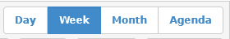

Day: Select this view to see the Events schedule for a single day.

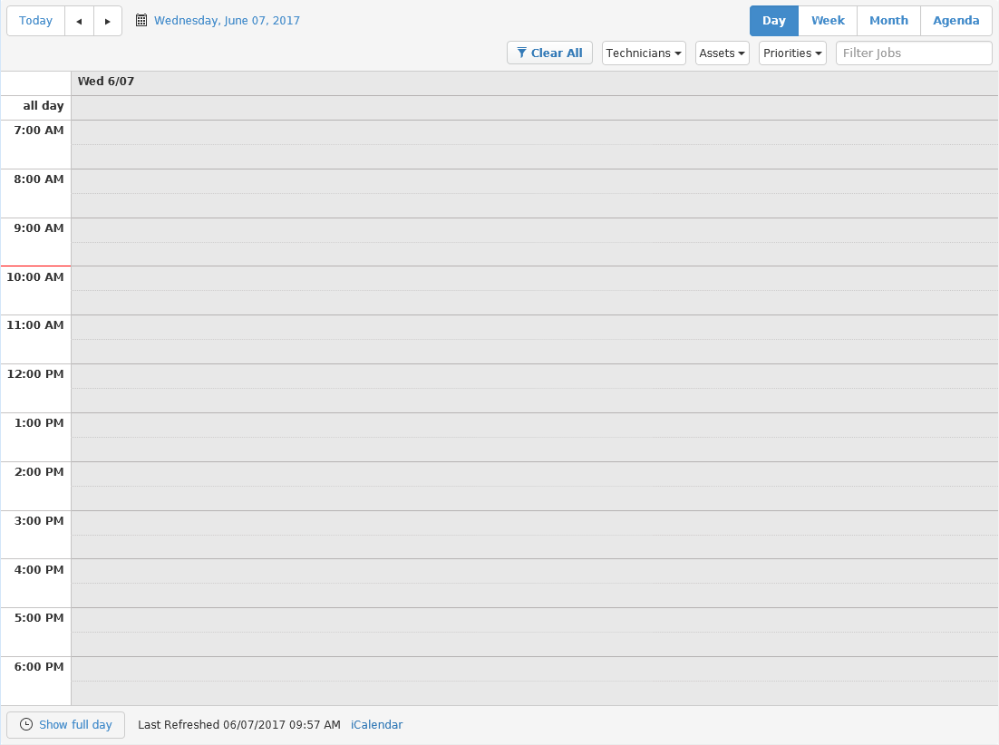

- The Calendar is divided into rows by hour, with the earliest time at the top of the screen and the rows proceeding in chronological order as you scroll down.
  - The rows are also divided at the half-hour mark to allow for scheduling by the half-hour.
  - The default hour range for this view is the Service department’s hours of operation.
- If the date visible is the current one, the rows will be darkened and a red line on the column listing the hours will indicate the current time of day.
- All Day: The first row on the Calendar in this view is labeled “all day.” It allows you to schedule an Event that will take the full length of operating hours on that date.
- Show Business Hours/Show Full Day: This button appears at bottom of view screen, and lets you change the range of hours shown on that day.
  - Show Full Day: Click the button when it has this label to change the Calendar view to show the hours for the full day, which in the Day view ranges 24 from 12:00 AM-12:00 AM the next morning (last hour range is 11:00 PM-12:00 AM). This allows you to view and schedule Events that might need to occur or extend outside of the Service department’s normal business hours.
  - Show Business Hours: Click the button when it has this label to change the Calendar view to only show the business’s hours of operation as recorded in Service Connect Settings (SCS). Again, the hours of operation show by default in this view on the Events Calendar.

Week: Select this view to see the schedule for a single week, ranging from Sunday to Saturday.

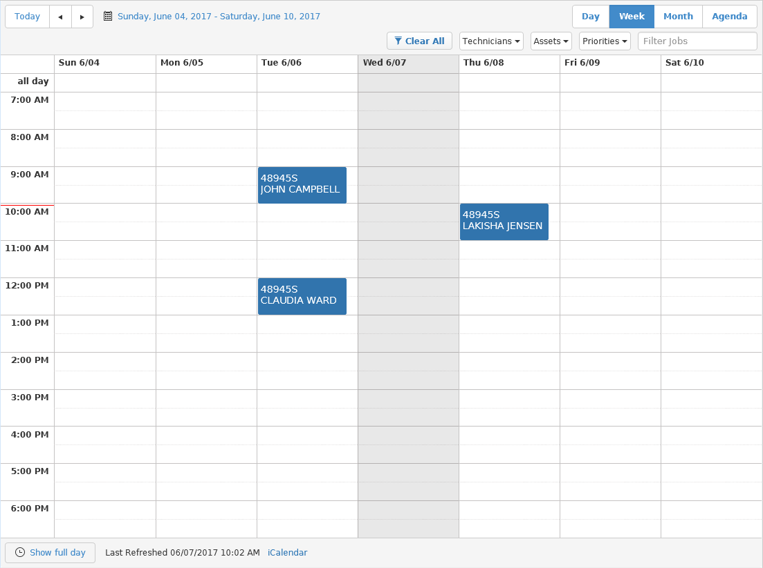

- The Calendar is divided into columns by day of the week, i.e. one column is for Sunday, one for Monday, etc. The column headers will show the day of the week and the specific date of the month.
- The Calendar is divided into rows by hour, with the earliest time at the top of the screen and the rows proceeding in chronological order as you scroll down.
  - The rows are also divided at the half-hour mark to allow for scheduling by the half-hour.
  - The default hour range for this view is the Service department’s hours of operation.
- If the week visible contains the current date, the date will be darkened and a red line on the column listing the hours will indicate the current time of day.
- All Day: The first row on the Calendar in this view is labeled “all day.” It allows you to schedule an Event that will take the full length of operating hours on that date.
- Show Business Hours/Show Full Day: This button appears at bottom of view screen, and lets you change the range of hours shown on that day.
  - Show Full Day: Click the button when it has this label to change the Calendar view to show the hours for the full day, which in the Day view ranges 24 from 12:00 AM-12:00 AM the next morning (last hour range is 11:00 PM-12:00 AM). This allows you to view and schedule Events that might need to occur or extend outside of the Service department’s normal business hours.
  - Show Business Hours: Click the button when it has this label to change the Calendar view to only show the business’s hours of operation as recorded in Service Connect Settings (SCS). Again, the hours of operation show by default in this view on the Events Calendar.

Month: Select this view to see the schedule for a single month.

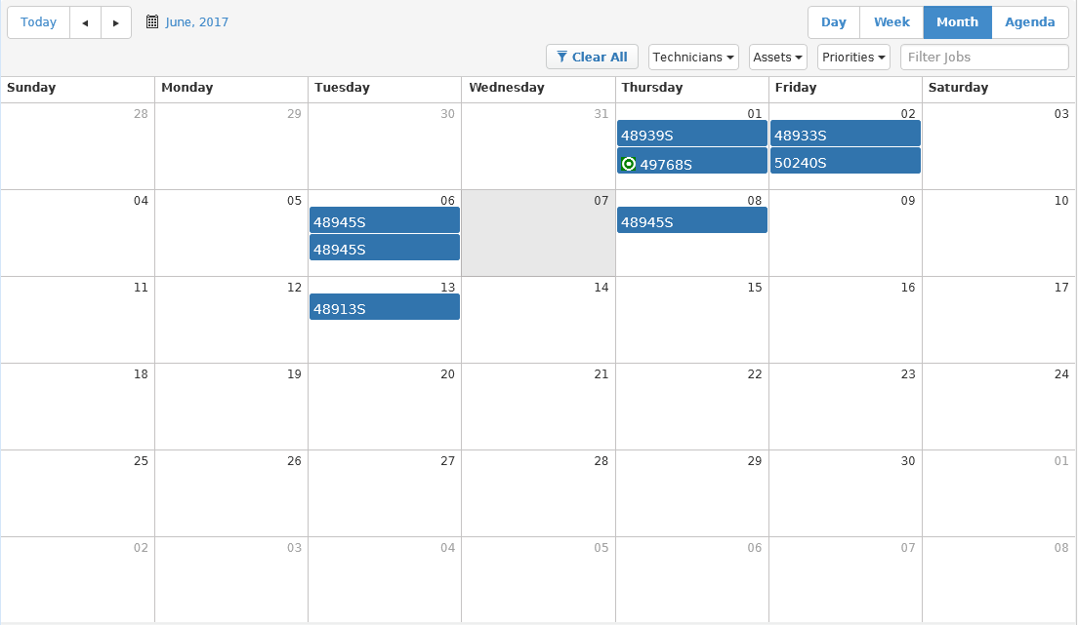

- This is the most traditional calendar layout, where the rows are weeks and the columns are the days of the week.
- The current day of the month will be darkened in comparison to the other dates.
- If there are more Events scheduled on a single day then can be seen on the Month view, a bar with “…” will appear at the bottom of a day’s field. Click it to switch to Day view and see all Events for that day.

Agenda: Select this view to see all Events listed out in chronological order over the course of a week (Monday-Monday, Tuesday-Tuesday, etc.).

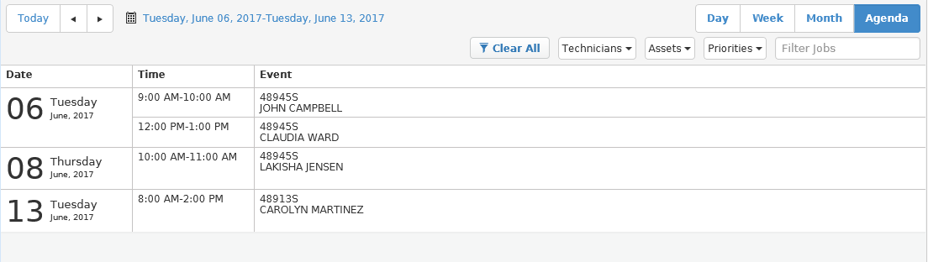

- If any Events listed are scheduled for the current date, the entry row for each Event will be darkened.
- Columns:
  - Date: This column shows the date of the Event.
  - Time: This column shows the duration of the Event, generally the start and end times.
    - If an arrow appears instead of a start or end time, that means the repair extends beyond that particular date.
    - If an event is scheduled for “all day,” that will be noted instead of a start and end time.
  - Event: This column shows details about the Event, such as the assigned RO number and the name of the assigned technician.

Filter Options: Use these options under the View Selection buttons to filter what Events are displayed on the Event Calendar.

Technicians: This drop-down menu shows a checklist of all technicians currently employed by your Service department. Check one or more boxes to have the Calendar only show Events that the particular technicians are assigned to.

- If the technician is not currently assigned to any Events, the Calendar will be blank.
- You can also filter for Events that do not yet have a technician assigned by checking the Unassigned box.

Assets: This drop-down menu shows a checklist of all Event assets that have been added to the program via Service Connect Settings (SCS). Check one or more boxes to have the Calendar only show Events that the particular assets are assigned to. If the asset is not currently assigned to any Events, the Calendar will be blank.

Priorities: This drop-down menu shows a checklist of the priority levels you set up for the program via Service Connect Settings (SCS). Check one or more boxes to have the Calendar only show Events that have that particular priority. If no Events on the Calendar have that particular priority, the Calendar will be blank.

Filter Jobs: Use this field to filter the Events for any information not covered by the menus, like RO number. Type your filter in the field, and the calendar will display only those Events that contain matching information.

Clear All: Click this button to clear all filters on the Events Calendar.

Event Indicators: Each Event scheduled on the Calendar is indicated by a blue square/rectangular block that covers the time frame on the Calendar set aside for the Event. The block will show the RO number assigned to the Event, as well as the name of the assigned technician.

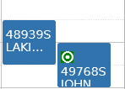

If a technician has logged into the Event, a yellow double-circle will appear in the Indicator (see image above). If you hover your mouse cursor over it, it will show, “In Progress: [technician name].” NOTE: Any technician can log into an Event; it does not have to be the one assigned when the Event was created.

Last Refreshed: This display under the Events Calendar shows the date and time that the Calendar was last refreshed, thus giving an indicator of how up-to-date the schedule is. The information will update every time the Calendar gets refreshed.

iCalendar: If you want to export the Event Calendar to an outside program, such as an email program with a calendar feature, click this link below the Calendar and to the right of the Last Refreshed display. The Events Calendar will then export to the program you have designated as the recipient.

- You can also right-click on the link and select either “Copy link address” or “Copy shortcut” (whichever appears) to copy the address for the Calendar server and export it that way. The programs you are likely to export a schedule to, such as Microsoft Outlook or Excel, will have a method to create a new calendar using an Internet link. Paste the link address in the relevant field and complete the particular program’s process to create a version of the schedule in that program.
- This feature is compatible with all Microsoft and Apple software products, as well as mobile devices such as cell phones (see “Accessing Service Connect on Mobile Devices” for more information).
- The exported Calendar is view-only. You cannot edit it outside the program.

Editing a Scheduled Event: To edit a scheduled Event on the Calendar, either click on the Event Indicator or, if specifically changing the time of the Event, drag-and-drop the Indicator into a new space. The following window will appear:

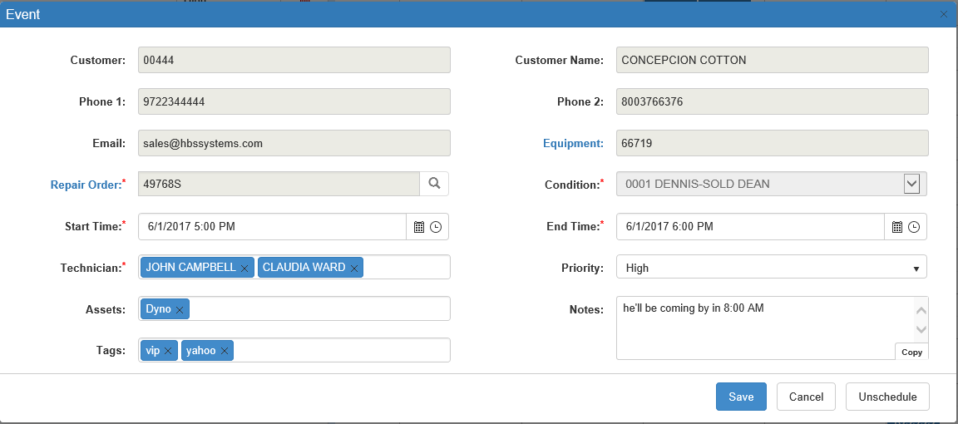

- The following fields cannot be changed:
  - Customer
  - Customer Name
  - Phone 1
  - Phone 2
  - Email
  - Equipment: The blue field title serves as hyperlink. Click it to open the stock number record in Unit Inquiry (UI).
  - Repair Order: The blue field title serves as hyperlink. Click it to open the repair order in Repair Order Maintenance (ROM).
  - Condition
- Start Time: Change the start date and time for the Event using the Date and Time selection features. If you have dragged and dropped the Event to a new time slot on the Calendar, this field defaults to the starting date/time of the new slot.
- End Time: Change the end date and time for the Event using the Date and Time selection features. If you have dragged and dropped the Event to a new time slot on the Calendar, this field defaults to the ending date/time of the new slot.
- Technician: Change the technician for this Event by typing in a new name or selecting it from the drop-down menu.
  - The menu will appear with matching options after you click in the field, and will change the available options to match any text you enter in the field.
  - The menu will only list technicians recorded in your Service system.
- Priority: Change the Event priority by selecting the new priority from the drop-down menu.
- Assets: Add or remove assets from the Event using this field.
  - Add new assets by typing them in the field and clicking “Enter,” or selecting them from the drop-down menu.
    - The menu will appear with matching options after you click in the field, and will change the available options to match any text you enter in the field.
    - You will only be able to add an asset that you have added to the system through Service Connect Setup (SCS). Any other options entered will be rejected.
  - Remove an asset by clicking the “x” on its right side.
- Tags: Add or remove tags from the Event using this field.
  - Add new tags by typing them in the field and clicking “Enter.”
    - As you type, the field will offer suggestions based on tags recorded in Service Connect Setup (SCS).
    - When you enter a new tag, i.e. one not already recorded in the system, the following window opens:

      - Click Add Tag to add the tag to both the system and the Event.
      - Click Cancel to discard the tag.
  - Remove a tag by clicking the “x” on its right side.
- Notes: Add or change any notes about the Event in this field. NOTE: The Copy feature, located in the lower right-hand corner of the field, lets you copy the text in this field to your computer’s Clipboard for use in another window/program/etc.
- Save: Click this button to save your changes. If you changed the date/time of the Event, it will now appear on the Event Calendar in the new time slot.
- Cancel: Click this button to cancel your changes and return to the main screen.
- Unschedule: Click this button to remove the Event from the schedule. It will be moved from the Calendar to the Unscheduled tab.

Service Connect on Mobile Devices

The iCalendar feature discussed earlier in this topic makes it possible for users to access a view-only version of the Events Calendar on mobile devices which can access the Internet, such as smart cell phones. Once enabled on your device, the Calendar will show you the current schedule and allow you to view details of specific Events on the Calendar when you select them. Your device should also now allow you to automatically dial numbers recorded in program, i.e. customer contact phone numbers recorded in the Event data, by selecting the number on your device screen.

Adding the Event Calendar to a Mobile Device:

- Begin by opening a version of Service Connect through your phone’s Internet browser. Find the iCalendar icon and copy the link address.
- Open your device’s settings and locate the section that lets you customize your device’s calendar functions (a calendar application is standard for modern smart phones).
- Typically, your device will allow you to create a custom calendar on your phone by linking it to an outside server, though the exact procedure will vary depending on the type of device (iPhone, Samsung Galaxy, etc.). When asked for the server address, paste the iCalendar link in the relevant field.
- Name the server, put in your NetView user name and password, and save the calendar. You should now be able to view the Events Calendar on your device by simply by opening this calendar.

This feature should be accessible via the method detailed above on all mobile devices except Android phones, which require a third-party app in order to link the Calendar to the phone.

Adding the Event Calendar to an Android Device:

- Open Service Connect through your phone’s Internet browser. Find the iCalendar icon and copy the link address.
- Open the third-party app. Compatible apps for this procedure are:
  - ISCdroid
  - ICSsync
  - Icalsync
- When asked for the server address or URL by the app, paste the iCalendar link in the relevant field.
- Name the calendar, put in your NetView user name and password if requested, and save the calendar. The Calendar should now be available on your device through its calendar app.

