Sales Commissions Report 2 (SCN)

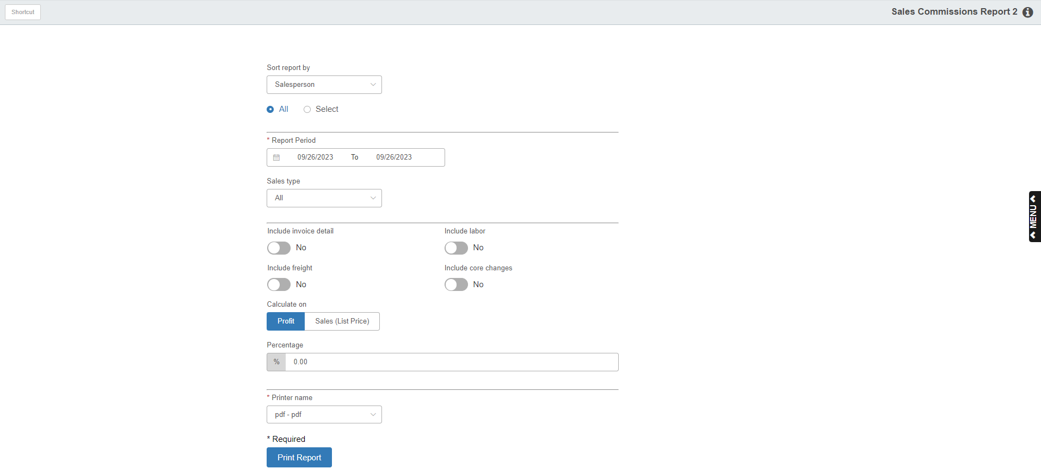

This variation of the Sales Commission Report offers a wide variety of selections for the type of information to appear on the report. The report shows activity in POS and Service.

To access this report, you can:

- Select “Inventory” from the menu. Choose the “Reports” submenu and click “Sales Commissions Report 2.”
- Type “SCN” in the Shortcuts Bar.

Field Definitions

Sort Report By: This field determines the sorting order for the report.

Choose Salesman to sort the report by salesman.

Choose Territory to sort the report by territory code.

All or Select: Click on the desired selection.

Click on All to include all salespersons or all territories on your report.

Click on Select to choose the salespersons or territory codes to include on the report.

Enter Salesperson Initials/Territory Codes: These field activate if you choose “Select.” Enter up to six initials/codes for the report in the first field, which will then populate the second field when selected.

Report Period: Enter the beginning and ending dates for the report, or select them from the calendar.

Sales Type: Select the type of activity to include on the report:

All

Parts

Rental (this refers to the original Rental package which is no longer in use)

Service

Units

Include Invoice Detail:

- Choose Yes to print the invoice details on the report.
- Choose No to print a summary by salesman or territory.

Include Labor:

- Choose Yes to have labor amounts part of the commission calculation.
- Choose No to exclude them.

Include Freight:

- Select Yes to include freight in the calculation of the commission.
- Select No to exclude it from the calculation.

Include Core Charges:

- Select Yes to include core charges in the calculation of the commission.
- Select No to exclude them from the calculation.

Calculate on: Choose the base for the commission calculation, which could be:

Sales amount (List Price)

Profit

Percentage: Enter the percentage to use for the calculation of commission on the report.

Printer Name: Select the printer to receive the printout. A default printer name is pre-filled but can be changed as necessary. Use the pdf printer to view the report on the screen without printing a copy of it.

Print Report: Press this button to print your report.

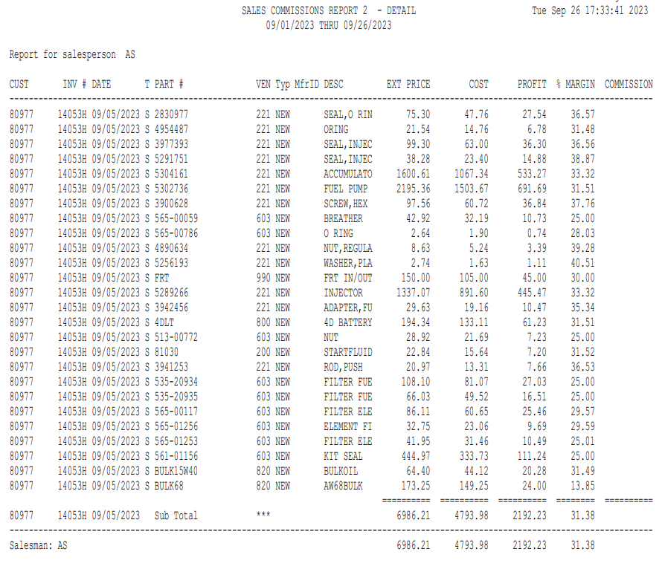

Detail Version: The detailed version prints the following for each invoice:

Part number

Description

Subtotals

CUST: This is the customer’s account number.

INV #: This is the invoice number of the transaction.

Date: Here you will find the invoice date.

T: This field shows the type of invoice that was run: P=Parts, W=Units, or S=Service invoices from POS, SMS (historical only), or NetView Service.

PART #: If you selected to print the invoice detail, the part number that was sold will appear here.

VEN: This is the vendor number for this part number.

Typ: This is the Part Type from the Part Master, which could be:

- New
- Used
- Core
- Reman
- Memo

MfrID: This is the Manufacturer ID from the Part Master.

DESC: Here you will find a description of the part number sold, if you selected to print the invoice detail.

EXT PRICE: This is the extended Selling Price for this part (sales price x quantity sold).

COST: This is the extended cost of the part number sold (cost x quantity sold).

Profit: Here you will find the profit margin on this part (extended selling price minus extended cost).

% MARGIN: This is the profit percentage for the item (margin divided by the extended selling price).

COMMISSION: This is the amount of commission calculated for the salesperson. It is based on the commission percentage that you entered times the profit or sales amount.

Recap Totals are provided for each of the areas of the report:

- Parts
- Service (POS, SMS, and Netview Service)
- Units

There is also a Total section for All Sales. The following information is provided for each set of totals:

- Salesperson
- Extended Price
- Cost
- Profit
- % Margin
- Commission

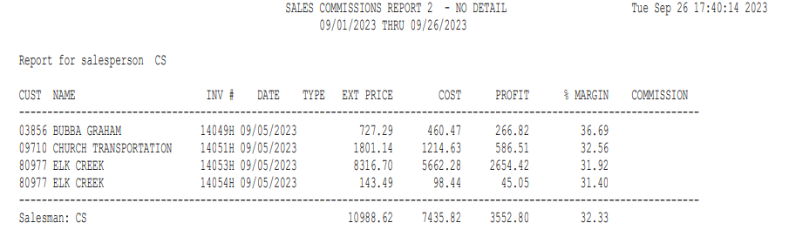

No Detail Version: The no detail version shows the following information:

CUST: This is the customer’s account number.

NAME: This is the customer’s name.

INV #: This is the invoice number for the transaction.

DATE: Here you will find the invoice date.

TYPE: This field shows the type of invoice that was run: P=Parts, W=Units, or S=Service invoices from POS, SMS, or Netview Service.

EXT PRICE: This is the extended selling price for this invoice (sales price x quantity sold).

COST: This is the extended cost for the invoice (cost x quantity sold).

PROFIT: Here you will find the profit margin for the invoice (extended selling price minus extended cost).

% MARGIN: This is the profit percentage for the invoice (margin divided by the extended selling price).

COMMISSION: This is the amount of commission calculated for the salesperson. It is based on the commission percentage you entered times the profit or sales amount.

Recap Totals are provided for each of the areas of the report:

- Parts
- Service (POS, SMS, and Netview Service)
- Units

There is also a Total section for All Sales. The following information is provided for each set of totals:

- Salesperson
- Extended Price
- Cost
- Profit
- % Margin
- Commission

