Sales Commissions Report 1 (SCR)

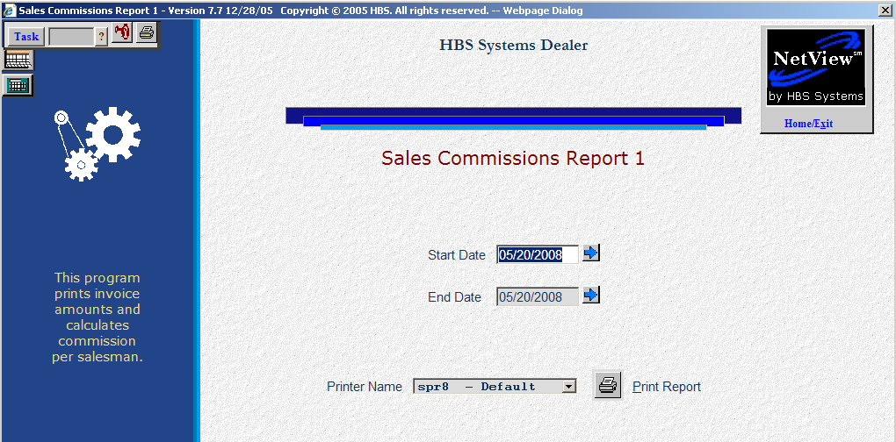

If you are interested in tracking your staff’s sales or if your dealership pays commissions/bonuses based on parts and shop sales, the Sales Commissions Report may be helpful. This report contains up to three sections one for each of the following:

- POS Invoices (Parts)
- POS Repair Orders (Service)
- Service Invoices from SMS (Misc).

In each section, the report sorts by salesperson and lists all POS or SMS invoices for the salesperson during the date range of the report. This parts portion of the report separates invoices according to the information entered in the Picking Ticket header's Salesperson field. Your salespeople should always enter the same initials or numbers in the Salesperson field to get the best results from this report.

- To access this report, you can:
  - Select “Inventory” from the menu. Choose the “Reports” submenu and click “Salesman Commission Report 1.”
  - Type “SCR” in the Shortcuts Bar.

Field Definitions

Start Date: Type in the beginning date for the report or use the blue arrow icon to select a date from a calendar.

End Date: Type in the ending date for the report or use the blue arrow icon to select a date from a calendar.

Printer Name: Select the printer to receive the printout. A default printer name is pre-filled but can be changed as necessary. Use the see printer to view the report on the screen without printing a copy of it.

Print Report: Press this button to print your report.

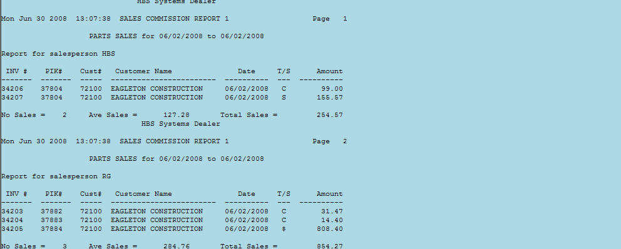

Parts Sales: The Parts Sales section of the report contains the following information:

Inv #: This is the invoice number that the salesperson sold parts or service on.

PIK #: This is the picking ticket number that was assigned when the ticket was opened.

Cust #: This is the account number assigned to your customer.

Customer Name: This is the customer that the POS invoice was written to.

Date: Here you will find the date the invoice was printed.

T/S: This field lists how the customer paid for this invoice. A “$” sign indicates the customer paid cash. A “C” indicates this invoice was charged to the customers’ A/R account. Other codes that might be listed include “V” (Visa), “M” (MasterCard), “D” (Discover), etc.

Amount: Here you will find the total amount that was charged to or paid for by the customer.

No. Sales: This field is the number of sales this salesperson has made during the specified time range.

Avg Sale: The Average Sale is the Total Sales amount for the salesperson divided by the number of sales.

Total Sales: Here you will find the total dollar amount of sales made by this salesperson.

The last page of the Parts Sales section is a Totals section that contains the following information:

Total Salespersons: This is the total number of parts salespersons that are included on this report.

Number of Sales (total invoices written in the specified date range): This is the total number of parts invoices that are included on this report.

Total Sales (from all invoices listed in this section of the report): This is a total amount of all of the parts invoices that are included on this report.

Average Sales (Total Sales divided by the Number of Sales): This figure represents the average sale. This is calculated by dividing the Total Sales amounts by the Number of Sales.

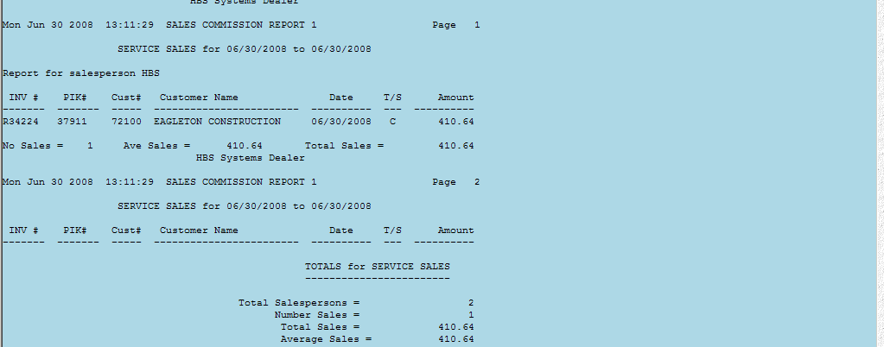

POS Repair Order: The next section of the report shows the POS Repair Order invoices per salesperson. It contains the following information:

Inv #: This is the invoice number that the salesperson sold parts on.

PIK #: This is the picking ticket number that was assigned when the ticket was opened.

Cust #: This is the account number assigned to your customer.

Customer Name: This is the customer that the POS Repair Order invoice was written for.

Date: Here you will find the date the invoice was printed.

T/S: This field lists how the customer paid for this invoice. A “$” sign indicates the customer paid cash. A “C” indicates this invoice was charged to the customers’ A/R account. Other codes that might be listed include “V” (Visa), “M” (MasterCard), “D” (Discover), etc.

Amount: Here you will find the total amount that was charged to or paid for by the customer.

No. Sales: This field is the number of sales this salesperson has made during the specified time range.

Avg Sale: The Average Sale is the Total Sales amount divided by the number of sales for this salesperson.

Total Sales: Here you will find the total dollar amount of sales made by this salesperson.

The last page of the Service Sales section is a Totals section that contains the following information:

Total Salespersons: This is the total number of POS salespersons that are included on this report.

Number of Sales (total invoices written in the specified date range): This is the total number of POS Repair Order invoices that are included on this report.

Total Sales (from all invoices listed in this section of the report): This is a total amount of all of the POS Repair Order invoices that are included on this report.

Average Sales (Total Sales divided by the Number of Sales): This figure represents the average sale. This is calculated by dividing the Total Sales amount by the Number of Sales.

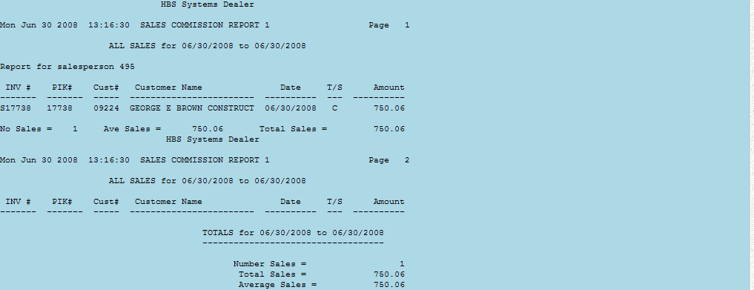

SMS: The next section of the report is all of the SMS invoices per salesperson (service writers). It contains the following information:

Inv #: This is the invoice number for SMS Repair Order.

PIK #: This is the SMS Repair Order number.

Cust #: This is the account number assigned to your customer.

Customer Name: This is the customer that the SMS invoice was written for.

Date: Here you will find the date the invoice was printed.

T/S: This field lists how the customer paid for this invoice. A “$” sign indicates the customer paid cash. A “C” indicates this invoice was charged to the customers’ A/R account. Other codes that might be listed include “V” (Visa), “M” (MasterCard), “D” (Discover), etc.

Amount: Here you will find the total amount that was charged to or paid for by the customer.

No. Sales: This field is the number of sales this salesperson has made during the specified time range.

Avg Sale: The Average Sale is the number of sales for this salesperson divided by the Total Sales amount.

Total Sales: Here you will find the total dollar amount of sales made by this salesperson.

The last page of the SMS Invoice section is a Totals section that contains the following information:

Total Salespersons: This is the total number of SMS salespersons (service writers) that are included on this report.

Number of Sales (total invoices written in the specified date range): This is the total number of SMS invoices that are included on this report.

Total Sales (from all invoices listed in this section of the report): This is a total amount of all of the SMS invoices that are included on this report.

Average Sales (Total Sales divided by the Number of Sales): This figure represents the average sale. This is determined by dividing the Total Sales amount by the Number of Sales.

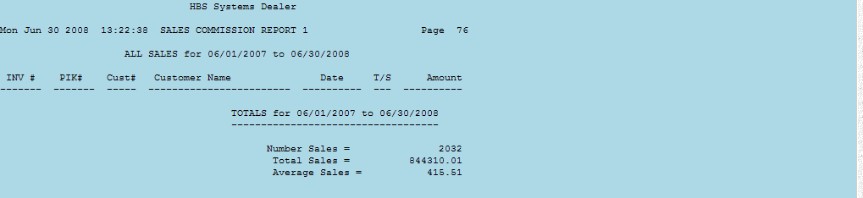

Grand Totals: The last page of the report is the Grand Totals for POS Invoices, POS Repair Orders and SMS Repair Orders, with the following information:

Number of Sales: This is a total of all POS and SMS invoices written in the specified date range.

Total Sales: Here you will find the total sales of all POS and SMS invoices for the specified date range.

Average Sales: This is the average sale based on all POS and SMS invoices for the specified time range. It is the total sales amount divided by the number of sales.

