Service Connect Settings (SCS)

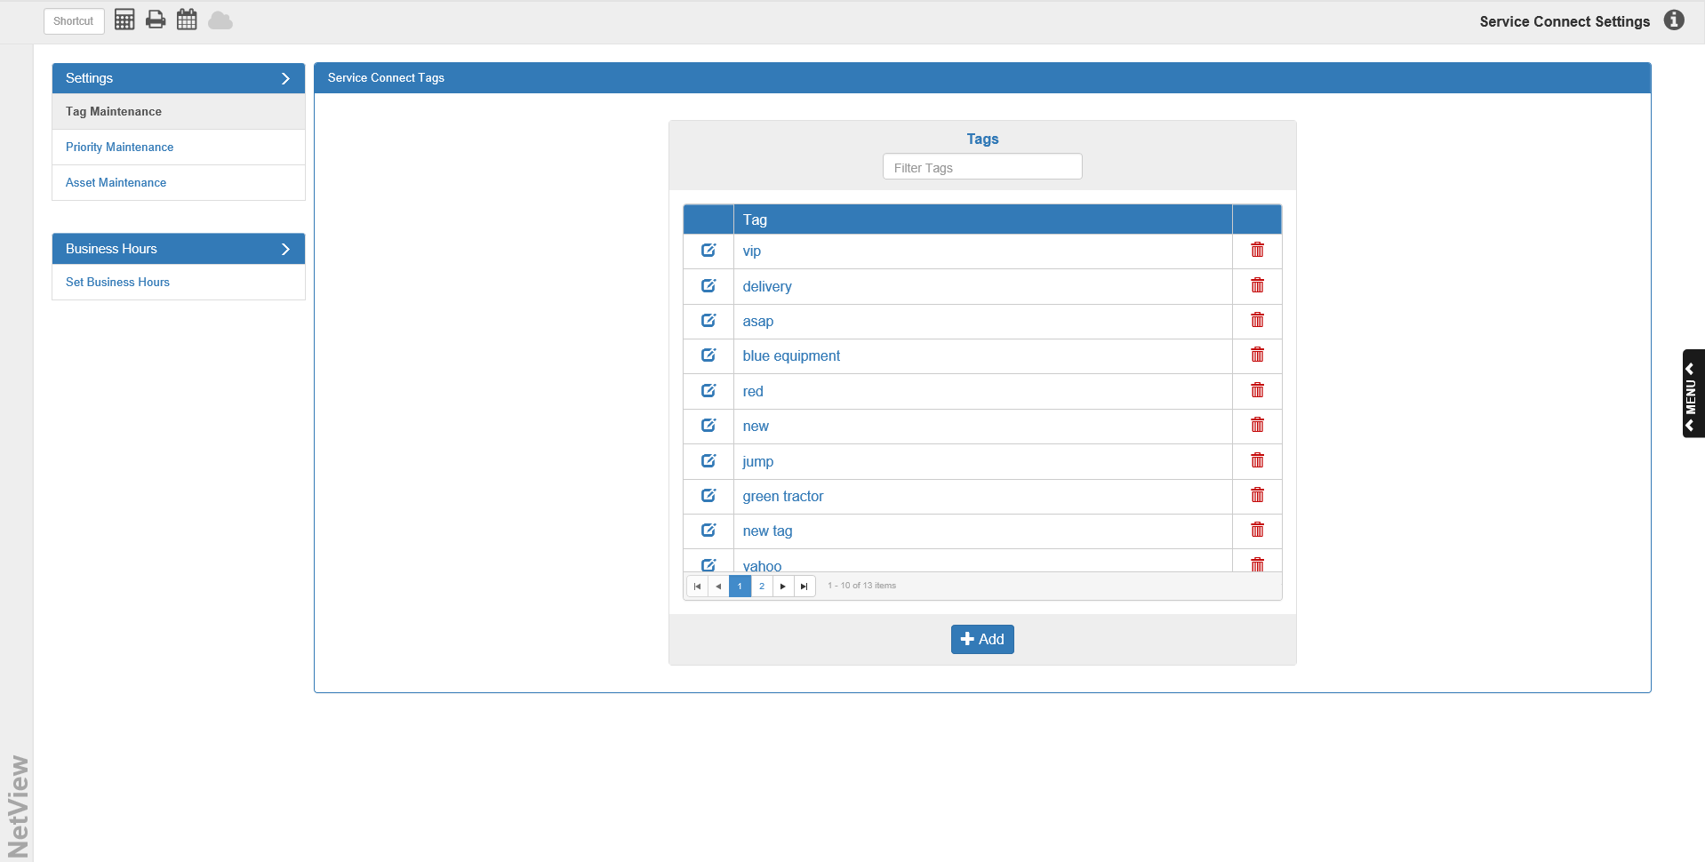

Before you use NetView Service Connect (SC), you will need to set your options for the program in Service Connect Settings.

To access this function, type “SCS” in the Shortcuts Bar.

Tag Maintenance: This tab under the Settings header allows you to view and manage your tags for Service Connect. Tags are user-created labels that can help group similar records together. Selecting this option displays a list of all tags currently available for use in Service Connect. You will be able to add as many tags to the system as you want.

Filter Tags: If you want to locate a particular tag, use this field at the top of the list to filter the tags. Type in the name of the tag you want, and the list will display all tags that match what you entered. If the tag does not exist in the system, no entries will display.

Columns:

Tag: This center column shows the name of the tag.

Edit Tag: The left column contains a blue icon. Click the icon to edit the tag. The window below will open:

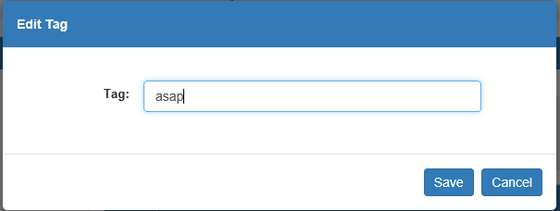
- Tag: Make your desired changes to the tag name here.
- Save: Click this button to save your changes.
- Cancel: Click this button to cancel your changes.

Delete Tag: The right column contains red trash can icon. Click it to delete the tag from the system. The following warning will appear:

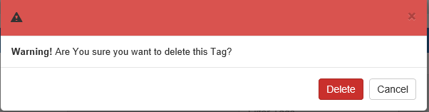

- Delete: Click this button to delete the tag.
- Cancel: Click this button to keep the tag.

Page Number Indicators: These icons in the lower-right hand corner of the grid will show the page numbers of the Tags listing.

- The indicator for the current page will be highlighted in blue.
- You can switch between pages by clicking on a different page indicator.
- The number of indicators will vary depending on the number of Tags.

Previous Page/Next Page: Use the two single arrow buttons on either side of the Page Number Indicators to move forward or back a single page.

- Click the left-pointing arrow to go back one page.
- Click the right-pointing arrow to go forward one page.

First Page/Last Page: Use the two buttons showing an arrow pointing to a vertical line to move to the first or last page of results.

- Click the left-pointing arrow to go to the first page of results.
- Click the right-pointing arrow to go to the last page of results.

+Add: Click this button to add a tag to the system. The following window will appear:

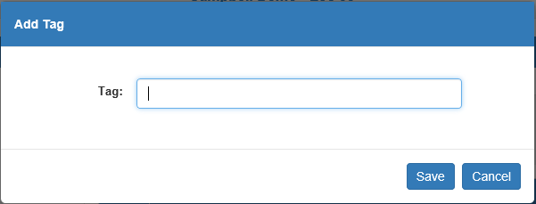

- Tag: Enter the tag name here.
- Save: Click this button to save the new tag.
- Cancel: Click this button to cancel your changes.

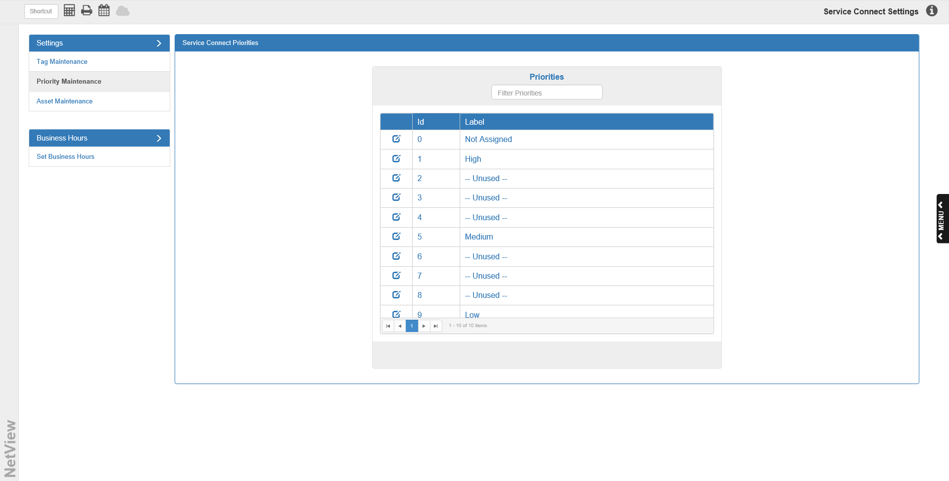

Priority Maintenance: This tab under the Settings header allows you to view and manage your priority levels for Service Connect. Selecting this option displays a list of the 10 predefined priority levels (0-9). The program enables you to set how many priority levels are available for use in Service Connect based on how many levels you have made custom labels for. You can use as many or as few of the levels as desired.

Columns:

Id: This center column holds the level ID for the priority level (0-9). These are defined by the system and cannot be edited. The only thing you can change is the label through which your Service department will identify the label.

Label: This right column, the largest of the three, contains the dealer-assigned label for the level. In order to use a level, you must give it a label. If the column contains the word “Unused,” then you have not assigned a label to that level, and so it will not be available for use in Service Connect.

Edit Priority: This column on the left contains a blue icon. Click the icon to edit the priority label. The window below will open:

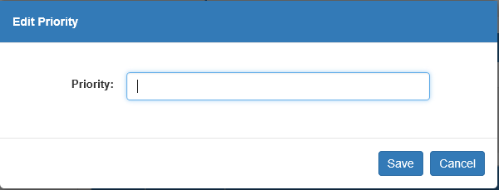

- Priority:
  - If you have not named this level yet, this field will be blank, as in the image above. Enter the label in this field.
  - If you have already named this level, the current label will appear in this field. Edit the label as desired.
- Save: Click this button to save your changes.
- Cancel: Click this button to leave the priority label as it is.

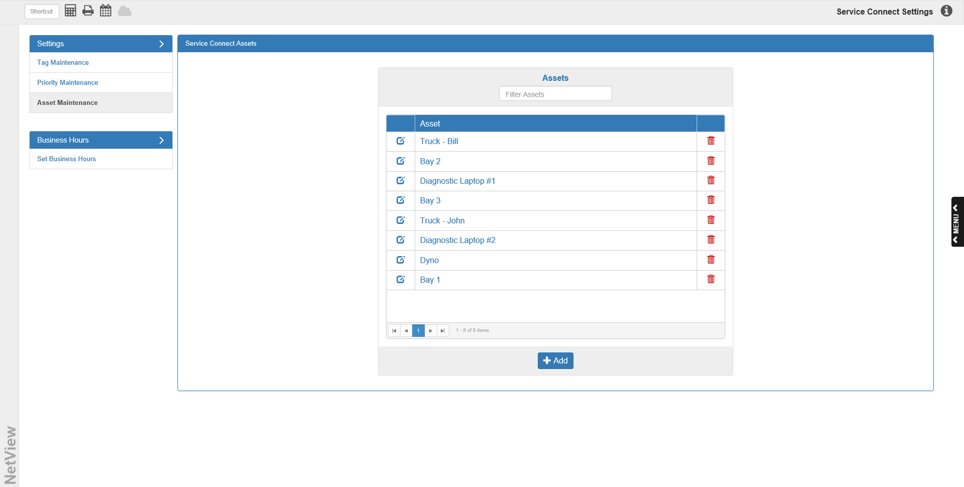

Asset Maintenance: This tab under the Settings header allows you to view and manage your assets for Service Connect. Assets are any resources your dealership uses for Service Events, such as trucks, bays, laptops, etc. Selecting this option displays a list of all assets that can currently be assigned to Events in Service Connect. You will be able to add as many assets to the system as you want.

Filter Assets: If you want to locate a particular asset, use this field at the top of the list to filter the assets. Type in the name of the asset you want, and the list will display all assets that match what you entered. If the asset does not exist in the system, no entries will display.

Columns:

Asset: This central column shows the name of the asset.

Edit Asset: This column on the left contains a blue icon. Click the icon to edit the asset. The window below will open:

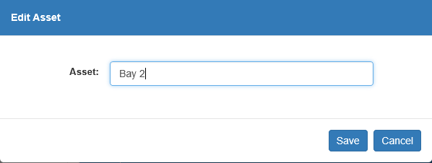

Asset: Edit the asset name in this field.
Save: Click this button to save your changes.
Cancel: Click this button to cancel your changes.

Delete Asset: The right column contains red trash can icon. Click it to delete the asset from the system. The following warning will appear:

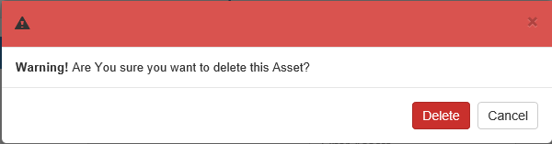

- Delete: Click this button to delete the asset.
- Cancel: Click this button to keep the asset.

Page Number Indicators: These icons in the lower-right hand corner of the grid will show the page numbers of the asset listing.

- The indicator for the current page will be highlighted in blue.
- You can switch between pages by clicking on a different page indicator.
- The number of indicators will vary depending on the number of assets.

Previous Page/Next Page: Use the two single arrow buttons on either side of the Page Number Indicators to move forward or back a single page.

- Click the left-pointing arrow to go back one page.
- Click the right-pointing arrow to go forward one page.

First Page/Last Page: Use the two buttons showing an arrow pointing to a vertical line to move to the first or last page of results.

- Click the left-pointing arrow to go to the first page of results.
- Click the right-pointing arrow to go to the last page of results.

+Add: Click this button to add an asset to the system. The following window will appear:

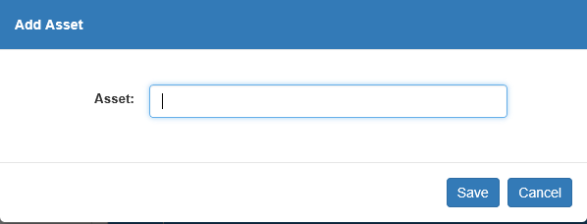

- Asset: Type the asset name in this field.
- Save: Click this button to save the new asset.
- Cancel: Click this button to cancel the new asset.

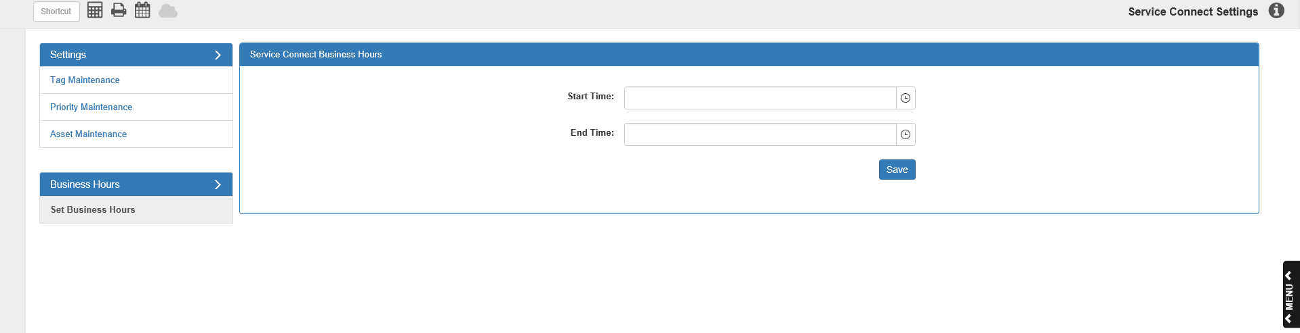

Set Business Hours: This is the only tab under the Set Business Hours header. It allows you to set your hours of operation so that you can view only those hours on the Calendars in Service Connect. You can change the starting and ending time at any point using this program.

Start Time: Use the Time selection feature in this field to select the hour when your business begins daily operations.

End Time: Use the Time selection feature in this field to select the hour when your business stops daily operations.

Save: Click this button to save your set business hours (or any changes made to them).

