Parts Upgrade/Downgrade Process (SCUD)

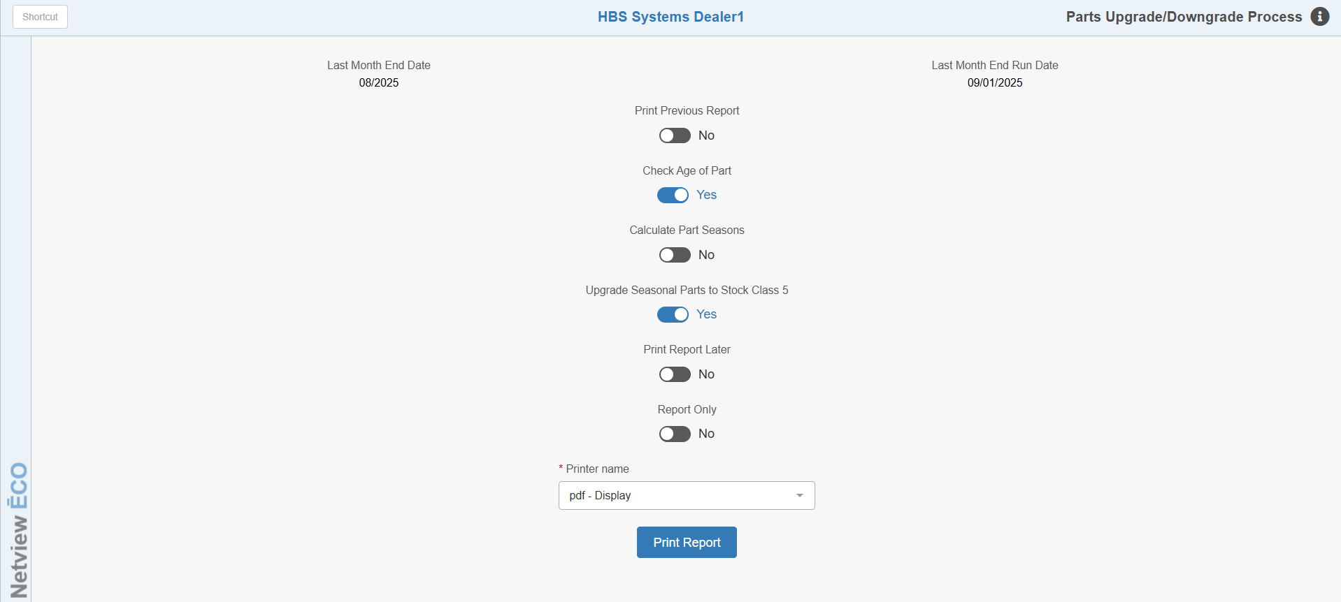

The Part Stock Class Upgrade/Downgrade program (SCUD) is used to re-classify the stocking status on your parts in between Month End runs. For example, if you need to just reset one or more Parts source fields such as NS Months and NS Sales, you may not want to wait until you run the Month End process for these changes take place. Also, if you are about to process a large promotional/seasonal stock order, you may want the system to re-evaluate the stock class criteria on items that have been sold in the current month, especially those sold parts that currently show a slow-moving stock class like 8 or 9. These current month sales may be just enough to push these parts back to a fast-moving status such as Stock Class 5 or 1.

This program only upgrades/downgrades the stock classes for parts currently showing one of the following stock class codes. All other codes that have been used MUST BE MANUALLY MAINTAINED.

Stock Class Code Definition
1 Fast-Moving Annually
5 Fast-Moving Seasonal
6 New Stocking Part (No Prior Sales History - Stock Class to be Determined)
U Customer/Special Ordered (slow-moving)
8 Slow-Moving (Standard Parts)
9 Slow-Moving (Surplus Parts)

To access this program, either:

- Select “Inventory” from the menu. Choose the “Parts/Source Update” submenu and click “Stock Class Upgrade/Downgrade.”
- Type “SCUD” in the Shortcuts Bar.

Field Definitions

Last Month End Date / Last Month End Run Date: The dates shown at the top of the screen show the last time you ran the Inventory Month End (INME) and for which month/year. From these dates, you know when the stock class codes were last updated.

Print Previous Report:

Choose Yes at this option if you want a printout of a Part Upgrade/Downgrade Report from a previous process run that was not printed at the time of the original run. This will deactivate the other option fields and replace them with a single field asking you to select which report you wish to reprint. The reports will be listed by the date and time they were created, with the most recent report listed first. NOTE: Once you print the report, it will be removed from the Which Report selection option and you will not be able to print it again.

Leave the option set to No to run a new iteration of the process and create a new report.

Check Age of Part:

- Choose Yes to check the entry date for all parts, especially Stock Class 6 or new stocking parts that have not been in the system long enough to build adequate sales history for either a fast-moving or slow-moving classification.
- Choose No to upgrade/downgrade all Stock Class 6 parts regardless of the age of the part. This might be useful if you want to rid the system of all Stock Class 6 classifications.

Calculate Part Seasons: This setting will have the system determine the seasons for any qualifying part. We recommend discussing the seasonal settings with a member of the HBS Support Team before implementing them. NOTE: You can optionally run SCUD in Report Only mode by specifying that on this screen to get a preview first (see the Report Only field below for more information).

Upgrade Seasonal Parts to Stock Class 5:

- If you have parts identified as seasonal parts, choose Yes to have them evaluated and potentially upgraded back to Stock Class 5.
- Choose No if you do not have seasonal parts or don’t want them to be evaluated.

Print Report Later:

- Select No to print the Part Upgrade/Downgrade Report now.
- Choose Yes to run the upgrade/downgrade process without printing a report. You can then print the report later with the Print Previous Report option (see that field above for more information).

Report Only:

- Select Yes if you want to find out what part numbers would be affected without actually running the program. You still receive a report but no stock classes are changed.
- Choose No to run the program and get a report.

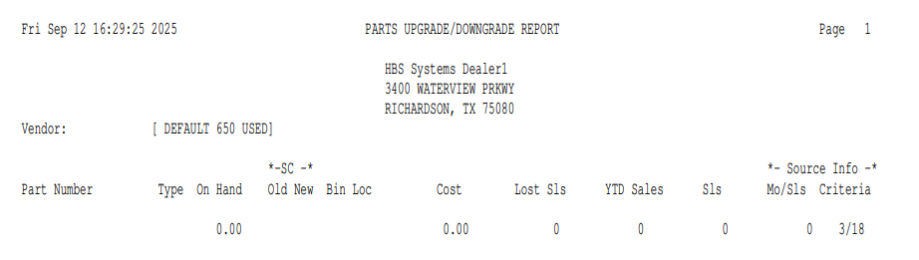

Parts Upgrade/Downgrade Report: This report prints in Vendor Number order and lists the part numbers with stock class changes. The following fields appear on the report:

Vendor and Name: This is the vendor number and name.

Part Number: This is the part number that had a stock class change.

Type: This code explains the kind of stock class change. These are:

- S: Upgrade to Stocking (Either changed to Stock Class 1 or 5)
- L: Lost Sales
- D: Downgraded to Non-Stocking (Changed to Stock Class 8)
- F: Stock Class Corrections

On Hand: This is the quantity currently in stock for this part number.

Old SC: This is the stock class BEFORE the part number was upgraded/downgraded.

New SC: This is the new stock class AFTER you ran the program. For parts listed as lost sales (Type = L), the program may upgrade their stock class to "stocking." Lost sales are treated as actual sales when the program looks at the stock class.

Bin Loc: This is the primary bin location of the part number.

Cost: This is the part number's current dealer cost.

Lost Sls: This shows the quantity you have recorded as "lost sales" for this part number record during the current month. This information helps the program determine if the part number's stock class can be upgraded.

YTD Sales: This is the Year-To-Date quantity sold for this part number. The figure is based on the calendar year (January 1 through December 31).

Sls: The Sales column is the quantity sold for this part during the time range set up in the Part source. For example, if the NS Months field of this part’s source is 24 months, the column would show the quantity sold in the last 24 months.

Mo/Sls: Month/Sales shows how many months had sales, as defined in the Part source. For example, the part may have sold a total of 5 during the past 24 months, yet, all of these sales may have occurred in just 1 month of those 24 months.

Criteria: This column repeats the stock class information from the Part source. (NS Months, NS Sales, New Months, and New Sales).

The number before the slash (/): This is the number of months that sales are required during the specified time range (NS Months/New Months).

The number after the slash (/): This is the time range for sales to occur in. For example, if the Criteria column lists 2/24, the part must be sold during 2 months out of the 24-month time range to be classified as a fast-moving (Stock Class 1 or 5) part.

New Parts: The Criteria column also reports the stock class criteria for new parts. If the status change is for a part number with a Stock Class 6 then this column refers to the information in the New Sales/New Months fields of the Source.

Total by Each Vendor: At the end of each vendor list, a total line shows all the stock class changes for that vendor. It includes the total number of parts whose stock class was upgraded, downgraded, showed lost sales, or had their stock classes changed.

Grand Totals ALL Vendors: This is a summary of all of the stock class changes that were made, which appears at the very end of the report.

