POS Screen-Sales Entry Tab

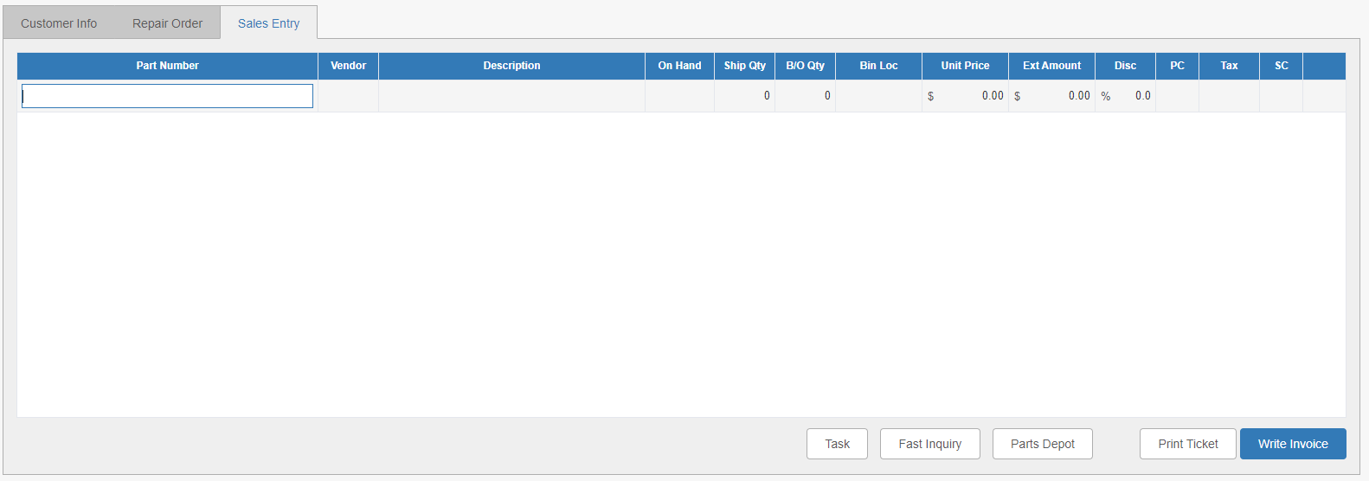

The Sales Entry tab is where you list the items and their charges for inclusion on the ticket invoice.

NOTE: The charge calculations now appear outside the tab, on the bottom right-hand corner of the program screen:

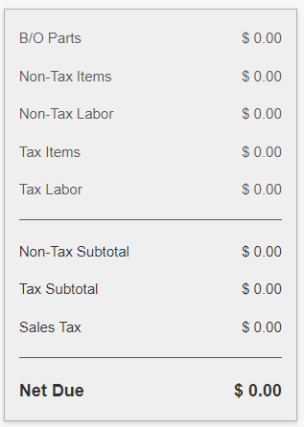

This way they are always visible even when you are not looking at the Sales Entry tab.

Field Definitions—Sales Entry Grid:

Part Number: Enter the number of the part being purchased here.

Vendor: The part’s vendor number fills here.

Description: The part’s description fills here.

On Hand: The on-hand quantity of the part will show here.

Ship Qty: Enter the quantity purchased/to be shipped here.

B/O Qty: If you need to back-order any parts to fill the customer’s order, enter that quantity here.

Bin Location: The item’s bin location appears here.

Unit Price: The price of one unit of the item appears here.

Ext Amount: The exact amount of the line (unit price multiplied by quantity purchased) goes here.

Disc: Any discounts on the line item go here.

PC: This field holds the price code for the line.

Tax: This field holds the tax code for the line.

SC: The sales code from the ticket customer’s Master record fills here.

Src | Sales Code | Description
 | 01 | Parts Ctr Taxable
 | 02 | Parts Ctr Nontaxable
 | 05 | Parts Ctr Nontaxable-Resale
 | 07 | Parts Ctr Nontaxable-Govt.
 | 09 | Parts Internal Taxable
 | 10 | Parts Internal Nontaxable
 | 11 | Parts Warranty Nontaxable
 | 03 | Parts Shp Taxable
 | 04 | Parts Shp Nontaxable
 | 06 | Parts Shp Nontaxable-Resale
 | 08 | Parts Shp Nontaxable-Govt
 | 09 | Parts Internal Taxable
 | 10 | Parts Internal Nontaxable
 | 11 | Parts Warranty Nontaxable

Fast Inquiry: If you have any Kubota or CNH parts on your ticket, you can use the Fast Inquiry button at the bottom of the tab to quickly look up the manufacturer’s information on the parts.

Sample Kubota Fast Inquiry

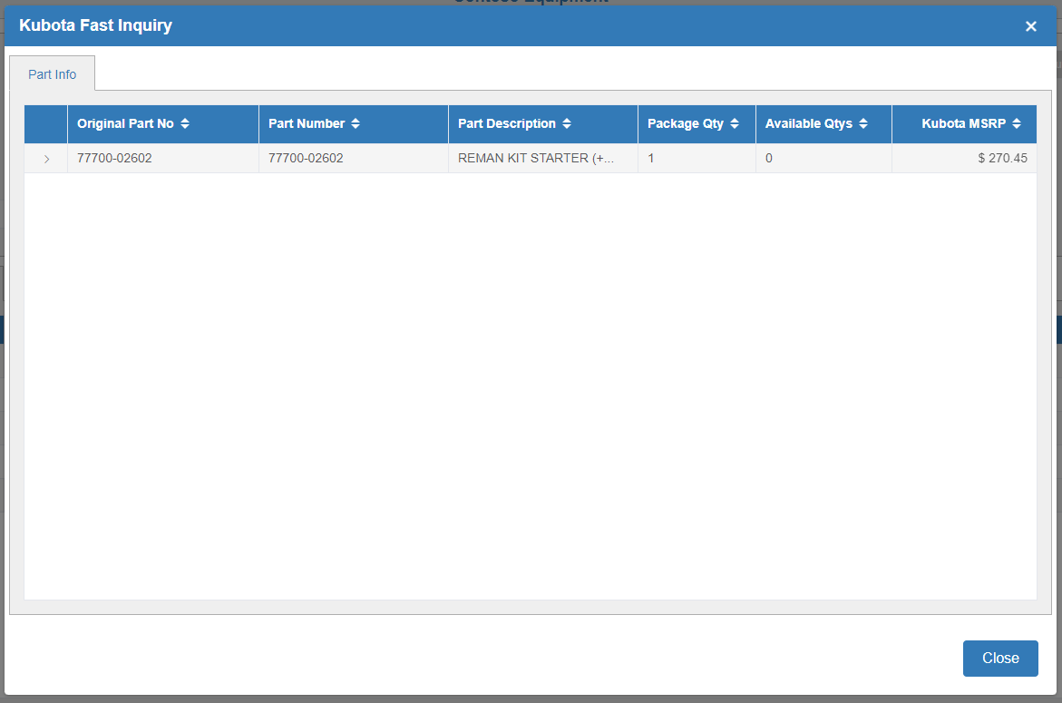

Sample CNH Fast Inquiry

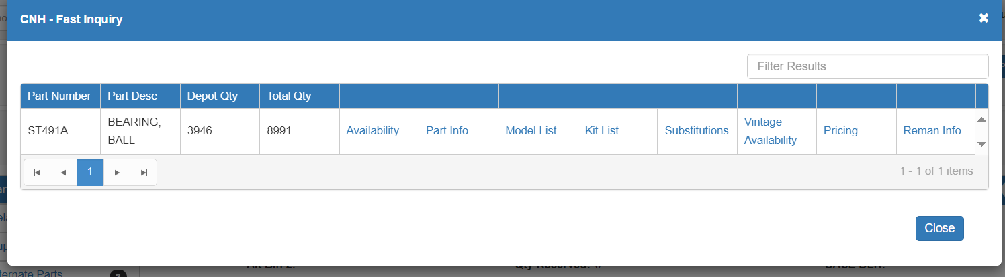

Parts Depot: This button is reserved for future use.

Print Ticket: Click this button to print a copy of the picking ticket. The following window will open:

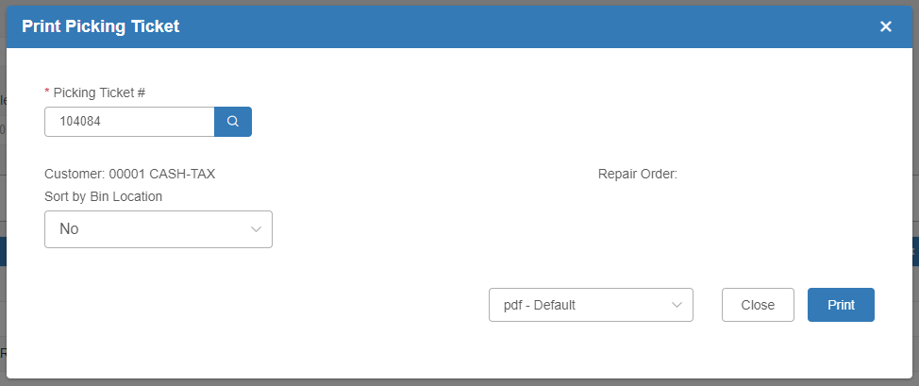

Picking Ticket #: The ticket number will fill in here.

Customer: The customer’s number and name will show here.

Repair Order: If the ticket includes a repair order, the RO number will show here.

Sort by Bin Location:

- Choose Yes here if you want the parts on the ticket to sort by bin location.
- Choose No if you want them to print in the order they were added to the picking ticket.

Print: Choose the printer to receive the ticket and click Print to receive the printout.

Sample Picking Ticket

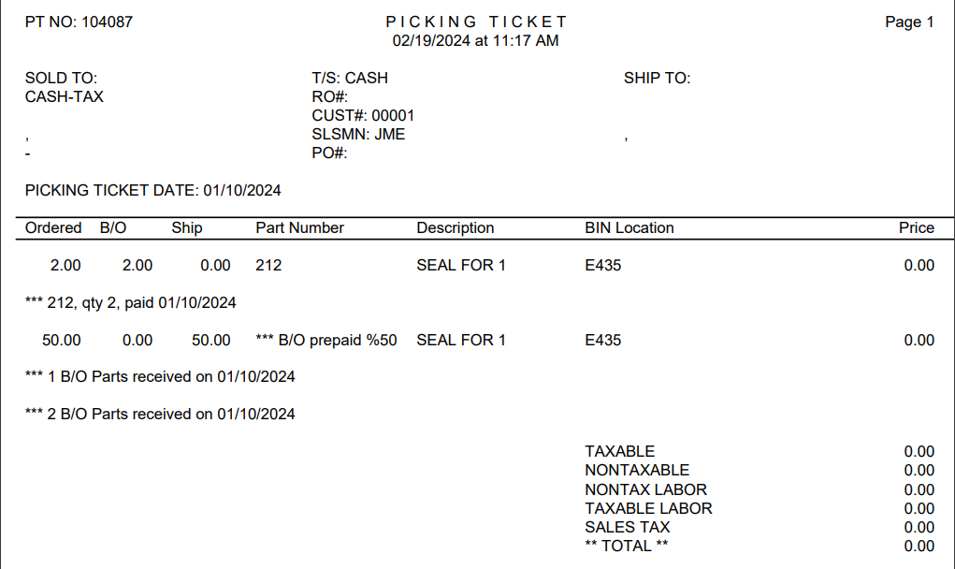

Write Invoice: Click this button to complete the sale and write the invoice. See the “POS-Making a Sale” topic for more information.

Line Entry Tasks: To speed up ticket creation, you can enter Line Entry Task commands in the Part Number field to help auto-fill the ticket lines. Line Entry Tasks quickly identify parts requested by customers, enter non-stocked parts, enter comments, or apply per-ticket discounts and charges. You can also select commands by pressing the Task button to access the Select Line Entry Task screen.

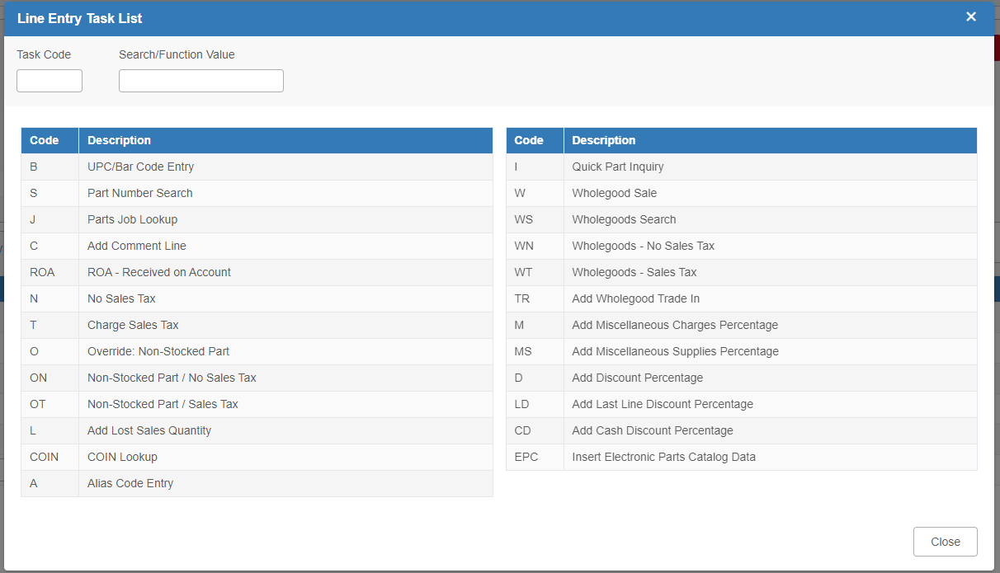

This screen offers a shortcut from the Sales Entry tab to complete line entries by performing searches and allowing changes to sales taxes, discounts, etc. The following pages will explain the different task codes.

B - UPC Bar Code Entry: To add a part number to the ticket by scanning the part’s bar code, type a space and then the code “B” in “Part Number” field on a blank line in the Sales Entry tab. Hit the “Enter” key, then scan as desired. NOTE: The program is also set up so that you do not have to use Task Code B to scan—you can just put the focus in the Part Number field and scan the barcode to have the part number fill in.

S - Part Number Search: To locate a part number to add to the picking ticket:

- On the Line Task Entry Screen: Enter a full/partial part number or description of the part in the “Search/Function Value.” Click or type “S” in the “Task Code” field. NOTE: If the part number is not known, click or enter “S” in the “Task Code” field and enter your search criteria in the resulting pop-up.
- On the Main Sales Entry Tab: Enter the full or partial part number, a space, and the letter “S” in an empty “Part Number” field.

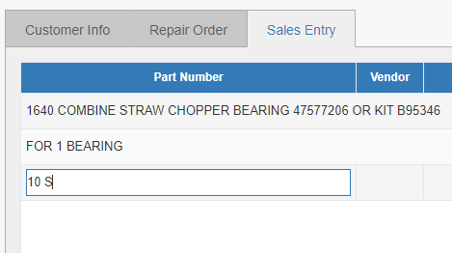

If you entered a full part number and the system found an exact match, the number should fill in the “Part Number” field automatically.

If you entered a partial number or a description, the Part Search Select screen will open to display all matching search results:

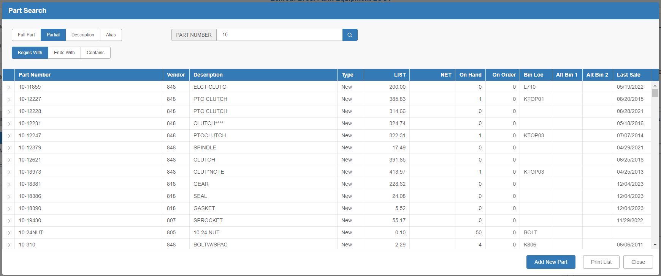

Choose the part you want from the results to close the Search screen and add the part to the ticket.

J - Parts Job Lookup: Adds a Parts Job List to the picking ticket. Parts Jobs are dealer-defined codes for standard services such as tire repairs, oil changes, brake checkups, standard equipment maintenance work, etc. Any of these job codes may be used on a POS picking ticket.

To find the job:
- On the Line Task Entry Screen: Enter the job number in the “Search/Function Value” field. Click or type “J” in the “Task Code” field. NOTE: If the job number is not known, click or enter “J” in the “Task Code” field to view a list of all available jobs.
- On the Main Sales Entry Tab: Enter the job number (if known), a space, and the letter “J” in a blank “Part Number” field. NOTE: If you don’t know the job number, just enter the space and “J.”

If you enter the job number and the system finds an exact match, the parts (and labor) required for the job will automatically add to the picking ticket.

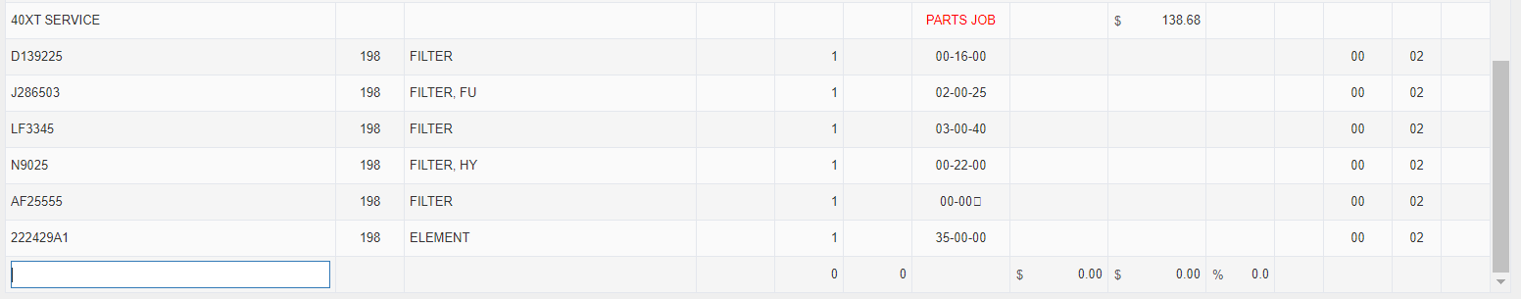

If you just use code “J” to look up the existing jobs, the following screen will appear listing all available jobs:

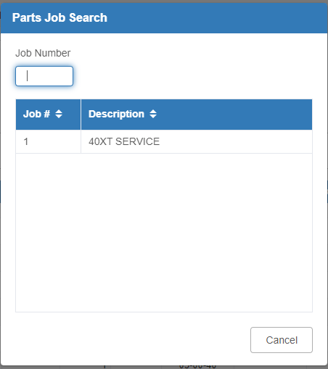

Either type the job number into the “Job Number” field or select it from the list to add it to the ticket.

C - Add Comment Line: When creating parts and/or shop counter tickets, you might need to add description lines or comments to explain the reasons for particular charges or describe what the repairs entail. Comments can be valuable to the dealer as well as to the customer. If the POS History package is installed on the dealers’ system, comments can serve as reminders of what was done on a repair or why a particular charge was added to a sale.

To add a comment line:

- On the Line Task Entry Screen: Enter the comment in the “Search/Function Value” field. Click or type “C” in the “Task Code” field.
- On the Main Sales Entry Tab: Press the “Enter” key while the focus is in the “Part Number” field on the main Sales Entry grid.

The system replaces the normal ticket line with a 50-character Comment line. This field accepts alpha and numeric characters as well as punctuation.

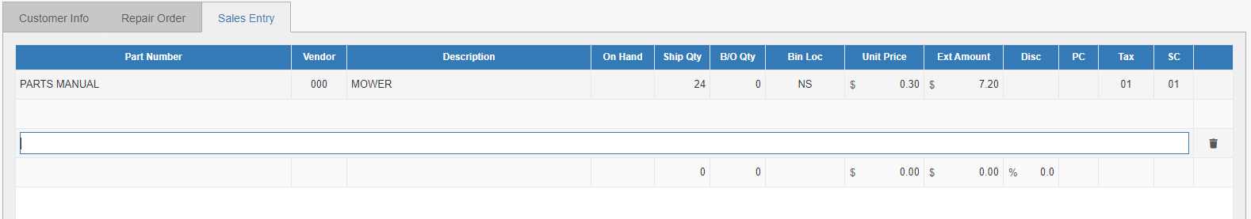

After entering the comment, press the “Enter” key again to close the Comment line and move to a new Part Number line. You can add as many Comment lines as needed to a ticket. These comments will print on the invoice.

Delete Comment: To delete a Comment or blank Comment line, click the Void icon at the end of the line, which is shaped like a trash can.

ROA - Received on Account: The Received on Account (ROA) feature allows the dealership the option of receiving cash payments on account from the parts counter and offering a printed receipt to the customer. This procedure can only be used for CASH transactions. At the end of day when Journals are run, the payment will post to the customer’s A/R account.

To add an ROA payment:

- On the Line Task Entry Screen: Enter “ROA” in the “Task Code” box.
- On the Main Sales Entry Tab: Type a space and then “ROA” in an empty “Part Number” field.

If the dealership has this type of sales entry password protected, a Password prompt will display first. Once you enter the password, the following window will appear:

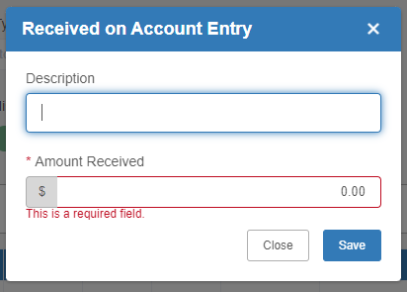

In the “Description” field, enter the check number and/or the customer invoice number to which this payment is applied. Enter the payment amount in the “Amount Received” field. Press Save to apply the payment.

ROA On A Credit Card: POS does allow for receipt of payment on account using a credit card. To perform this action, start the ticket as a cash sale. Set up the ROA line and the rest of the ticket as desired, then click the Write Invoice button.

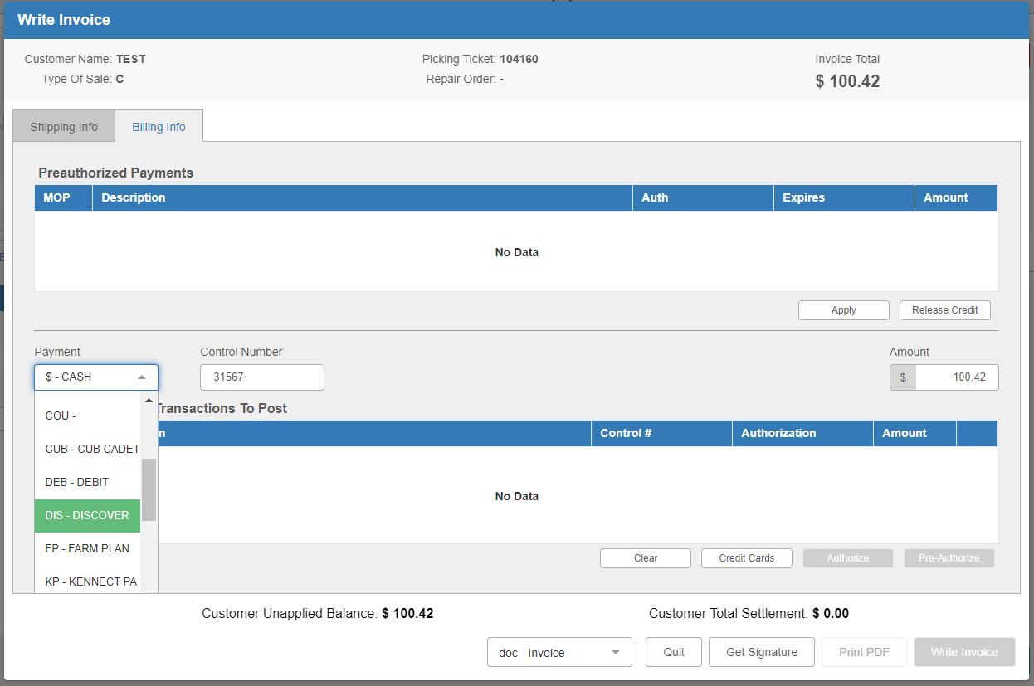

Change the payment from cash to a credit card type. Tab through the remaining fields to run the card in our credit card processing program, EdgePay Input (EPIN).

N - No Sales Tax: If no sales tax is to be charged on a particular part, do one of the following to use Task Code “N:”

- On the Line Task Entry Screen: Enter the part number in the “Search/Function Value” field. Click or type “N” in the “Task Code” field.
- On the Main Sales Entry Tab: Type the part number in a blank “Part Number” field, make a single space, enter “N,” and press “Enter.”

Result shows Tax Code 00 (Nontaxable). In the “Ship To” field, enter the quantity to be sold. The system displays the total price in the “Ext Amount” field.

T - Charge Sales Tax: To charge sales tax on a specific part, enter the part number in the Part Number field, make a space, type “T,” and hit “Enter.”

Result shows Tax Code 01 (taxable). In the “Ship To” field, enter the quantity to be sold. The total is displayed in the “Amount” field and auto-fills the tax code in the “Tax” field. When the picking ticket or invoice is printed, the taxes charged (or not charged) are included in the Total portion of the document.

O - Override Non-Stocked Part: Override functions allow for the sale of non-stocked parts and control whether a customer is charged sales tax for particular parts (both stocked and non-stocked) on a ticket.

To add a non-stocked part to a ticket:

- On the Line Task Entry Screen: Enter the part number in the “Search/Function Value” field. Click or type “O” in the “Task Code” field, then hit the “Enter” key.
- On the Main Sales Entry Tab: Type the part number in the “Part Number” field, add a space, type “O,” and hit “Enter.”

When quantity and price are entered, the remaining fields will auto-fill. Next, enter the cost. If nothing is entered in the “Cost” field, the system will calculate the cost for the part based on a default percentage. Press “Enter” to complete. The “Bin Location” field will auto-fill with NS (non-stocked).

NOTE: Failure to enter the costs of non-stocked parts can result in accounting errors which falsely inflate or reduce the dealership’s costs and profits.

ON - Override Non-Stocked Part – No Sales Tax: To allow for the sale of non-inventoried items with no sales tax:

- On the Line Task Entry Screen: Enter the part number in the “Search/Function Value” field. Enter “ON” in the “Task Code” field.
- On the Main Sales Entry Tab: Type the part number in the “Part Number” field, add a space, type “ON,” and hit “Enter.”

After entering the description, ship quantity, and selling price, enter the cost and press “Enter.” The system will auto-fill in the remaining pertinent information:

Take note that you can perform this function for a taxable customer.

TIP—Override Functions and Standard Discount Rates: POS does not apply customer standard discounts to items entered on a ticket using override functions. To apply the standard discount, enter a discounted price at the Enter Selling Price prompt. In this case, also enter the actual cost of the item at the Enter Cost prompt.

OT- Non-Stocked Part – Sales Tax: Allows for the sale of non-inventoried items with sales tax. To charge sales tax on a non-stocked part:

- On the Line Task Entry Screen: Enter the part number in the “Search/Function Value” field and enter “OT” in the “Task Code” field.
- On the Main Sales Entry Tab: Type the part number in the “Part Number” field, add a space, type “OT,” and hit “Enter.”

In the “Description” field, enter the description for the non-stocked part. In the “Ship To” field, enter the quantity to be sold. Then enter the selling price and cost. Press “Enter” after entering the cost. The system auto-fills the “Tax” field with the appropriate tax code, and the bin location will auto-fill as “NS.”

NOTE: You can perform this function for a tax-exempt customer.

L - Add Lost Sales Quantity: Lost sales may be recorded by typing a part number, a space, and the letter “L.” This will trigger the Part Search to show all matching parts to your entry.

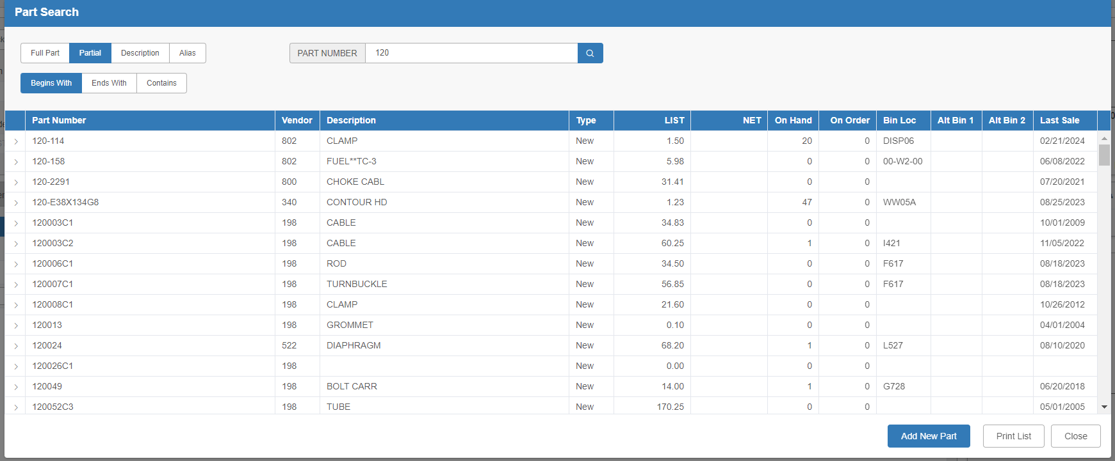

Choose the part you want to record the sale for to open the Lost Sale Entry modal with the part’s information pre-filled:

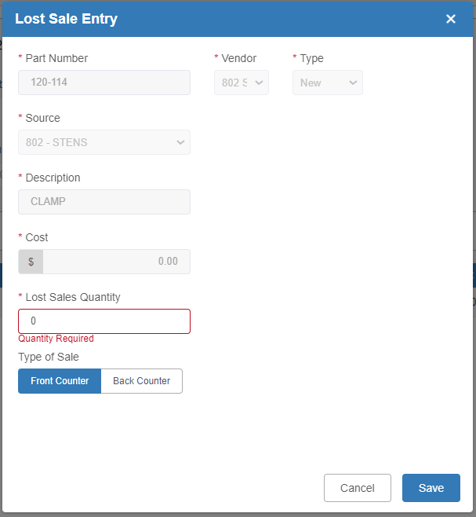

Enter the quantity the customer wanted in the Lost Sale Entry screen and identify whether it was a Front or Back Counter sale. This information is recorded in the Parts Inventory system. NOTE: If creating a Lost Sale record and the part does not exist (or is not found), you will need to create a new part number using the Add Part button in the Part Search screen.

COIN- COIN Lookup: COIN (Cross Over Information Network) Lookup provides vendor crossover replacement information for out-of-stock parts such as batteries, bearings, filters, belts, o-rings, spark plugs, seals, flat belts, and u-joints.

To find sources for out-of-stock items:

- On the Line Task Entry Screen: Enter the part number in the “Search/Function Value” field and enter “COIN” in the “Task Code” field.
- On the Main Sales Entry Tab: Type the part number in the “Part Number” field, add a space, type “COIN,” and hit “Enter.”

This will open COIN Inquiry (COIN), which will automatically show all matching results for the part number.

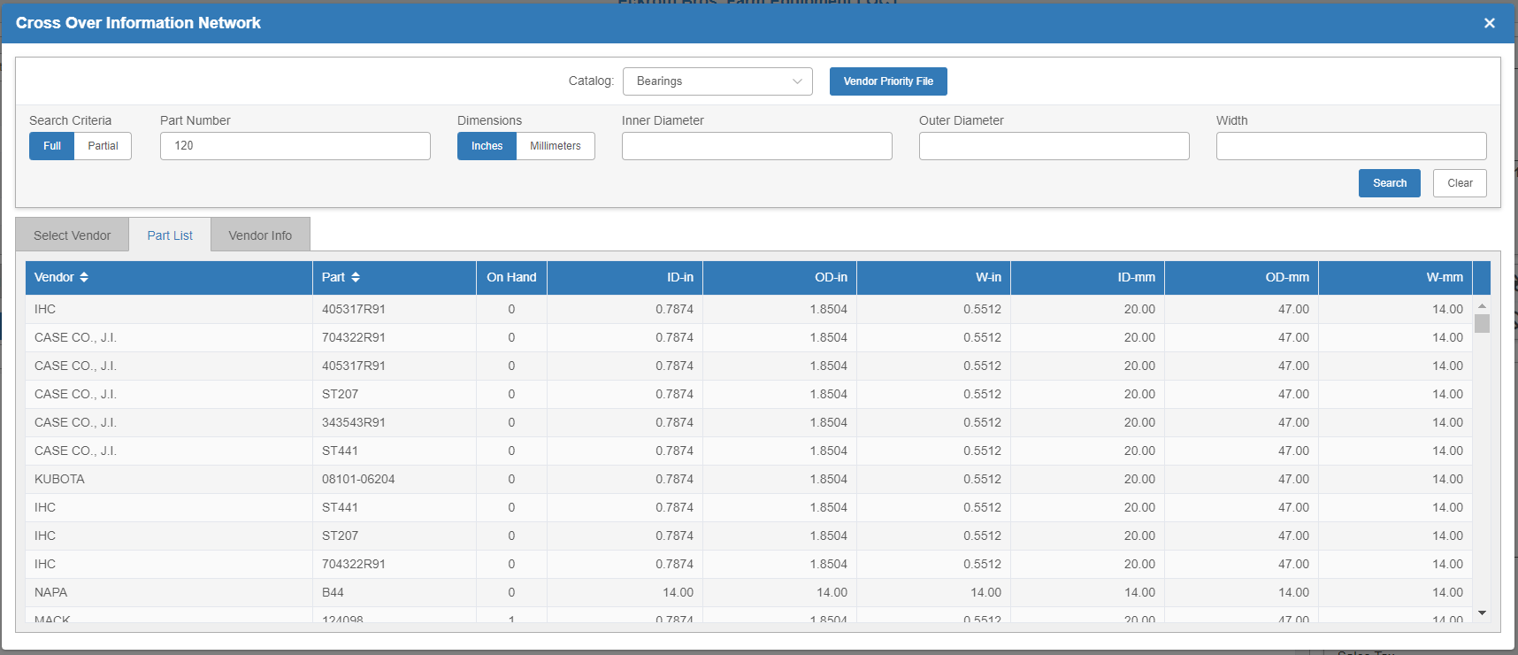

Select a part to open the Quick Part Inquiry screen:

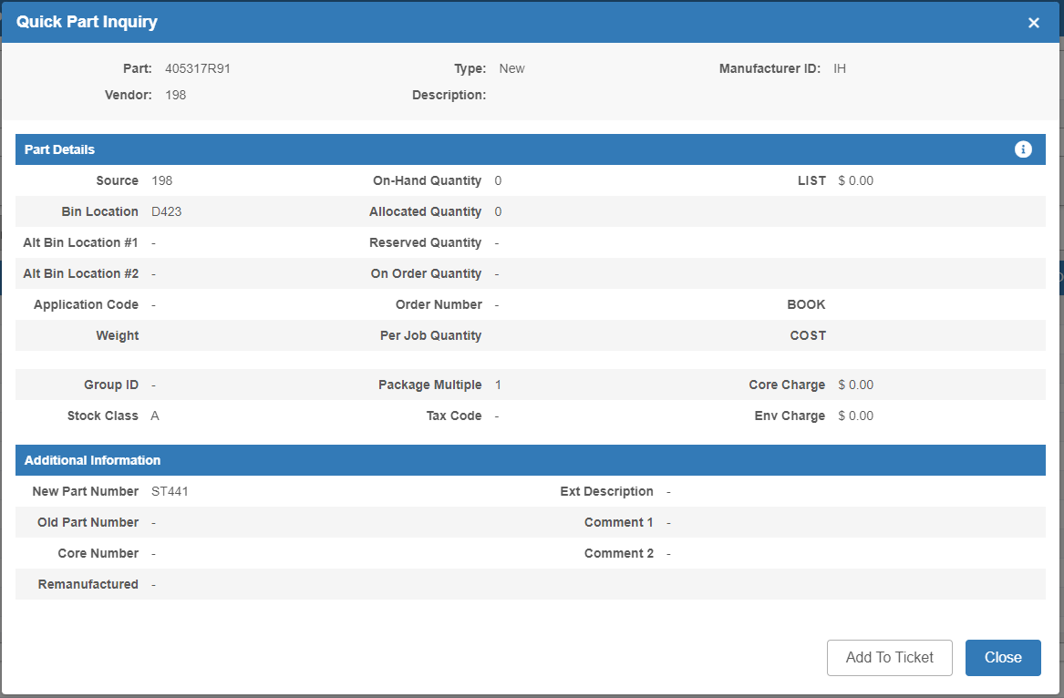

Add this part to the picking ticket by clicking the Add To Ticket button.

A – Alias Code Entry: Looks for the part number associated with the entered alias code.

- On the Line Task Entry Screen: Type the alias code in the “Search/Function Value” field, then click or type the letter “A” in the “Task Code” field.
- On the Main Sales Entry Tab: Type in the alias, a space, and the letter “A,” then press “Enter.”

This will trigger the Part Search for all matching aliases:

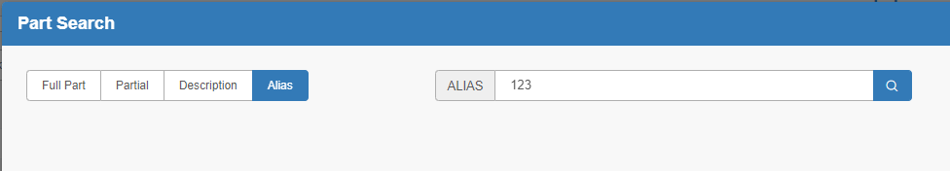

Select the desired part from the search results. The information will auto-fill the line.

I - Quick Part Inquiry: The Quick Part Inquiry checks how many pieces of a particular part are on hand to sell.

- On the Line Task Entry Screen: Type the part number in the “Search/Value Function” field, then click or type the letter “I” in the “Task Code” field.
- On the Main Sales Entry Tab: Type the part number, add a space, type the letter “I”, and press “Enter.”

The Quick Part Inquiry screen will open showing the part’s information:

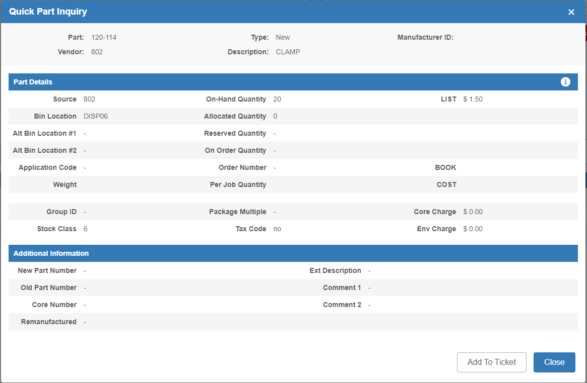

If adding this part to the picking ticket, press Add To Ticket. If not, press Close.

LINE ENTRY TASK CODES-UNIT FUNCTIONS: POS provides the capability to sell equipment. It is convenient to sell small unit items (lawn mowers, chain saws, cutters, etc.) with fixed retail prices, providing the flexibility of combining parts sales with the unit sale on the same picking ticket/invoice.

W – Unit (Wholegood) Sale: To enter a unit to sell in POS, you must know the exact Stock Number.

- On the Line Task Entry Screen: Type the stock number in the “Search/Value Function” field, then click or type the letter “W” in the “Task Code” field.
- On the Main Sales Entry Tab: Type the stock number, a space, and the letter “W,” then press “Enter.”

If the stock number entered is incorrect, not available at the dealer location, or already sold, an error message will appear. Below is a successful result:

WS - Unit Search: To search for a stock number:

- On the Line Task Entry Screen: Enter the search information (such as a partial stock number) in the Search/Function Value field, then click or type “WS” in the Task Code field.
- On the Main Sales Entry Tab: Type the search info, a space, and the letters “WS,” then press “Enter.”

The Unit Search screen will open, displaying all matching results.

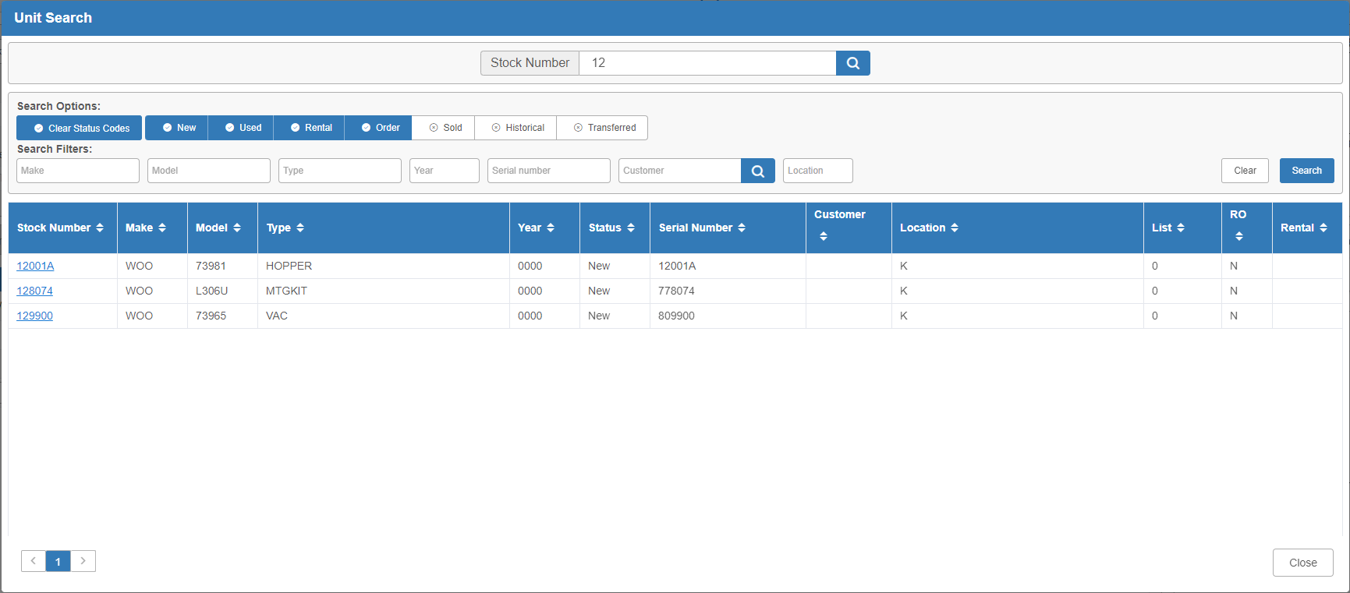

Click the unit you want to add it to the ticket.

WN – Wholegoods-No Sales Tax: Allows for the sale of units with no sales tax. If entering parts in Tax Code 01 and also selling a unit not to be taxed, change the tax code for the unit sale. If the tax code is to be used in the header, change the tax code on the line item.

- On the Line Task Entry Screen: Enter the stock number at the “Search/Function Value” field. Click or type “WN” at the “Task Code” field.
- On the Main Sales Entry Tab: Type in the stock number, a space, and the letters “WN,” then press “Enter.”

Result:

WT-Wholegoods – Sales Tax: Sells units with sales tax. If entering parts that are in Tax Code 00 and also selling a unit to be taxed, the tax code must be changed for the unit sale. If the tax code is to be used in the header, the tax code must change on the line item.

- On the Line Task Entry Screen: Enter the stock number at the “Search/Function Value” field. Click or type “WT” at the “Task Code” field.
- On the Main Sales Entry Tab: Type in the stock number, a space, and the letters “WT,” then press “Enter.”

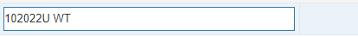

Result:

TR - Add Wholegood Trade In: This function allows for accepting a unit trade-in while processing a unit sale on a picking ticket in POS.

- On the Line Task Entry Screen: Click “TR” or type it in the “Task Code” field.
- On the Main Sales Entry Tab: Type a space and the letters “TR,” then press “Enter.”

This will open the Wholegood Trade In Entry Screen:

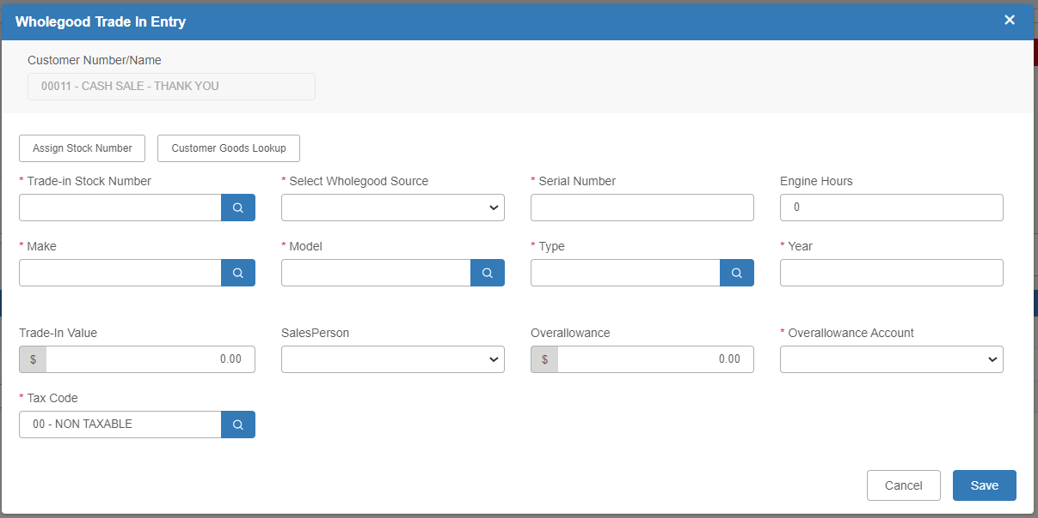

- Active Buttons – Wholegood Trade In Entry Screen

Assign Stock #: When the Assign Stock # button is clicked, the system will auto-fill the “Trade-In Stock Number” field with next available sequential stock number. The following fields will set up the Unit Master for each trade identified. NOTE: If the dealership has its own stock number scheme, the desired stock number should be entered manually.

Customer Goods Lookup: The Customer Goods search may be used to obtain all the information needed to accept a trade-in if the equipment is recorded in the dealership’s system as belonging to the current customer. The Customer Equipment Maintenance (CEM) screen opens for any search data.

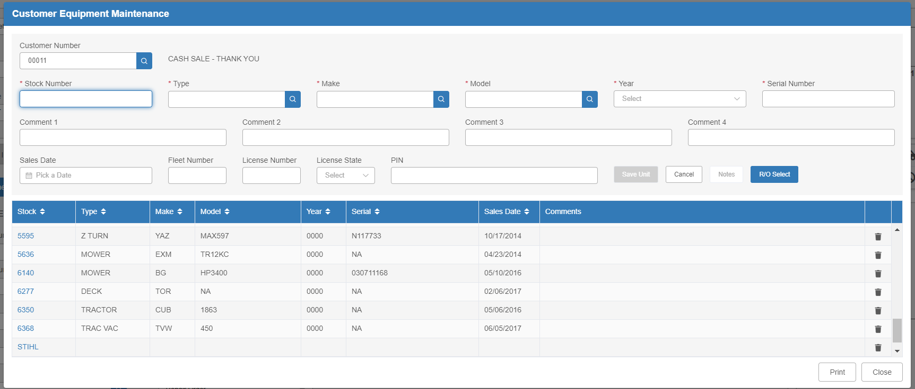

Cancel: Pressing this button will return the user to the previous screen.

Save: Press this button to save the entry.

Field Definitions – Wholegood Trade In Entry Screen
  - Trade In Stock Number: Number assigned by dealership or system for stock number. You can look up an existing stock number by using the Search icon to access the Unit Search.
  - Select Wholegood Source: Choose the Units source to receive this trade-in.

Serial Number: Enter the unit’s main serial number here. If the unit does not have one, the stock number may be used.

Engine Hours: If the unit has an hour meter and the reading is available, include the number of hours in this field.

Make: Fill in the make or manufacturer here. Use the standard 3-character abbreviations established by the dealership. Use the Search icon to look up existing makes.

Model: Enter the model number of the trade-in. Use the Search icon to look up existing models.

Type: Indicate the type of unit being traded (i.e., TRACTOR, MOWER BALER, etc). Use the Search icon to look up existing types.

Year: Enter the model year of this unit. If the model year is unknown or there is no appropriate value for this field, we recommended the dealership consistently use a year unlikely to be in inventory. For example, use 1950 for all units where the year is unknown, unimportant, or inappropriate.

Trade In Value: Enter the amount the customer will be given for the trade-in. This amount will become the inventory value for this unit.
  - Salesperson: If you have a Salesperson database, select the Salesperson ID from the drop-down menu. Otherwise, you can type the ID in this field.

Overallowance: This field is for the over-allowance of trade-ins. Any amount entered will reduce the value of the trade-in in Used inventory and will increase the Over-allowance account specified in the Unit source for the trade-in unit.

Overallowance Account: This is the G/L account pre-set to allocate over allowances. Such amounts will “debit” the account number shown in this field. Typically, this is a sales or cost account in the Units section of the Chart of Accounts (COA). Select the desired account from the drop-down menu.

Tax Code: The tax code in this field reads from the tax code in the ticket header.

If both tax codes are the same, the tax is calculated on the net after the trade-in (if taxable).

If the tax is to be calculated on the gross, enter “00” in this field so the trade-in is excluded from the tax calculation.

M - Add Miscellaneous Charges Percentage: Adds a percentage for Miscellaneous Charges calculated from every line item above this entry.

To add a miscellaneous charge to a ticket:

- On the Line Task Entry Screen: Enter the percentage of the charge (including a decimal point, if the percentage is fractional) into “Search/Function Value” field, then click on or type the letter “M” in the “Task Code” field.
- On the Main Sales Entry Tab: Type the percentage in the “Part Number” field (including a decimal point, if the percentage is fractional), press the space bar, type “M,” and press “Enter.”

The system calculates and auto-fills the amount of the charge in the “Ext Amount” field.

MS - Add Miscellaneous Supplies Percentage: Adds a percentage for Miscellaneous Supplies calculated from every line ABOVE this entry. Many dealers use this function on shop tickets.

To add a miscellaneous sales charge to a ticket:

- On the Line Task Entry Screen: Enter the percentage (including a decimal point, if the percentage is fractional) into “Search/Function Value” field, then click on or type “MS” in the “Task Code” field.
- On the Main Sales Entry Tab: Type the percentage (including a decimal point, if the percentage is fractional), press the spacebar, type “MS,” and press “Enter.”

The system calculates and auto-fills the amount of the charge in the “Ext Amount” field.

TASK CODES- DISCOUNTS AND CHARGES: Per ticket discount functions let the dealership apply discounts to individual items or all items on a particular ticket. Each discount function also prints a distinctive message on the sales invoice to indicate the type of discount applied.

D - Add Discount Percentage: This code will apply a discount to all items ABOVE the entry line.

To apply the discount:

- On the Line Task Entry Screen: Enter the percentage (i.e., 10.0 for 10%) at the “Search/Function Value” field and click or type “D” at the “Task Code” field.
- On the Main Sales Entry Tab: Type the percentage (i.e., 10.0 for 10%) in the “Part Number” field, make a space, type “D,” and hit “Enter.”

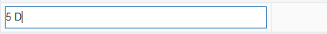

Parts or services entered on the line following this discount entry will not be discounted. Only those above it become affected.

LD - Add Last Line Discount Percentage: This code will apply a discount to the final line entry only.

To apply the discount:

- On the Line Task Entry Screen: Enter the percentage at the “Search/Function Value” field and click or type “LD” at the “Task Code” field.
- On the Main Sales Entry Tab: Type the percentage in the “Part Number” field, make a space, type “LD,” and hit “Enter.”

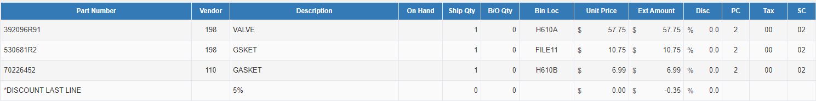

CD - Add Cash Discount Percentage: To apply a cash discount to some or all items on a picking ticket:

- On the Line Task Entry Screen: Enter the discount percentage at the “Search/Function Value” field and click or type “CD” at the “Task Code” field.
- On the Main Sales Entry Tab: Type the discount percentage in the “Part Number” field, make a space, type “CD,” and hit “Enter.”

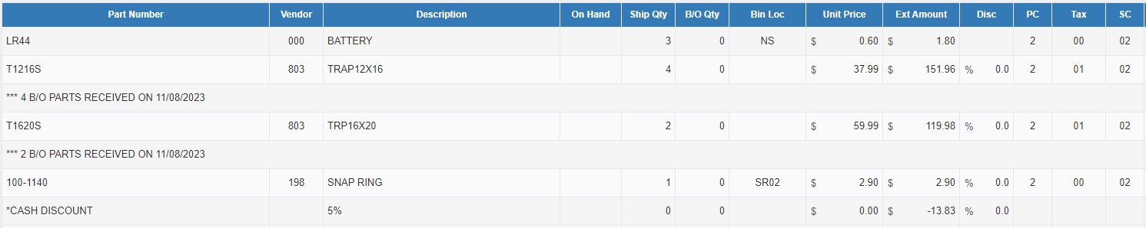

This code will discount all items listed above this entry.

EPC - Insert Electronic Parts Catalog Data: Inserts Electronic Parts Catalog parts list, which can be either the Bin Check List from Parts Inquiry (PI) or imported orders from the E-Commerce (ECOM) program, specifically from Kubota, into picking ticket.

To use the code:

- On the Line Task Entry Screen: Click or type “EPC” at the “Task Code” field.
- On the Main Sales Entry Tab: Type a space in the “Part Number” field followed by “EPC.”

The following window will open:

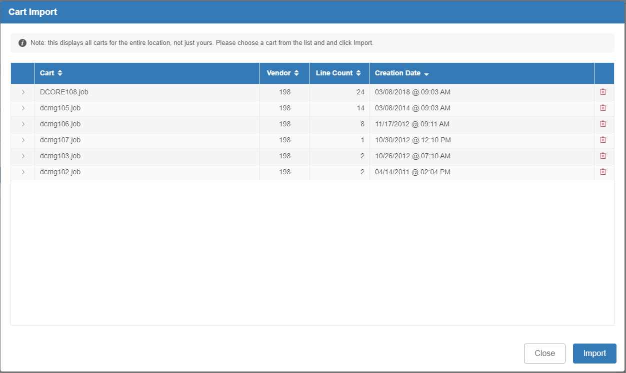

The screen lists all available ECOM orders and/or Bin Check List(s) that can be imported onto the ticket. Select the desired ticket, then click “Import.”

This screen will close and a prompt will open asking you to put in the order number and prepaid precent (if applicable):

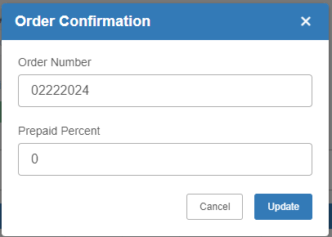

Make sure the information is correct, then hit the Update button. The information will auto-fill on the main screen, as seen below:

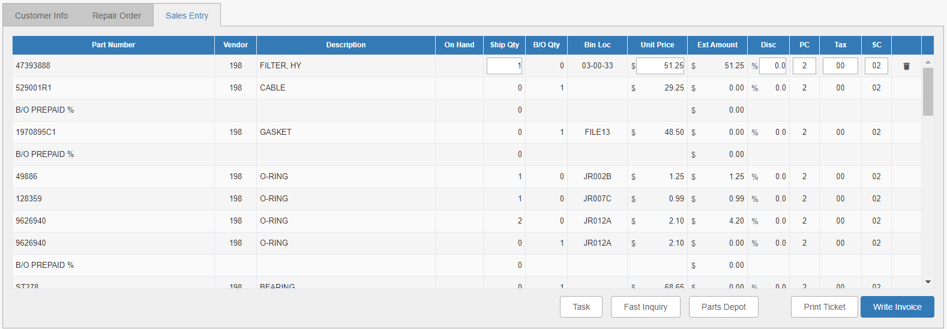

NOTE: The system will automatically create back orders for parts from the list that are not on hand.

