Setup for the Purchase Order System:

There are three areas that contain selections for the Purchase Order system:

- PO Defaults (PODF): Print format and selections
- Service Options and Defaults (SOD): Closing options for repair orders and purchase orders
- Unit Defaults (WGDF): Closing options for Unit Sales invoices and purchase orders

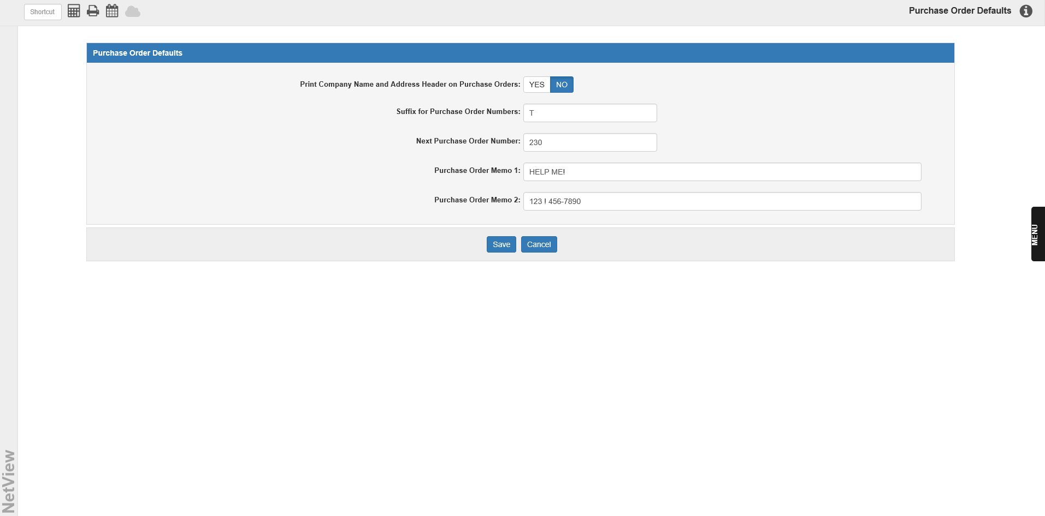

PO Defaults (PODF): This screen sets several defaults for the Purchase Order system. To access this function, you can either:

- Select “System Maintenance” from the menu. Choose the “Company File” submenu and click “Purchase Order Defaults.”
- Type “PODF” in the Shortcuts Bar.

Print Company Name and Address Header on Purchase Orders:

- Select Yes to print your company’s name and address header on your purchase orders.
- Select No to leave them off the order (default).

Suffix for Purchase Order Numbers: This field can hold a 1-character suffix for purchase order numbers.

Next Purchase Order Number: This field shows the next unused purchase order number in the system, and can be changed as desired.

Purchase Order Memo 1: This field can hold a message that will appear on a memo line on the purchase order.

Purchase Order Memo 2: This field can hold a second memo line message for the purchase order.

Save: Click this button to save your defaults.

Cancel: Click this button to cancel any changes before saving.

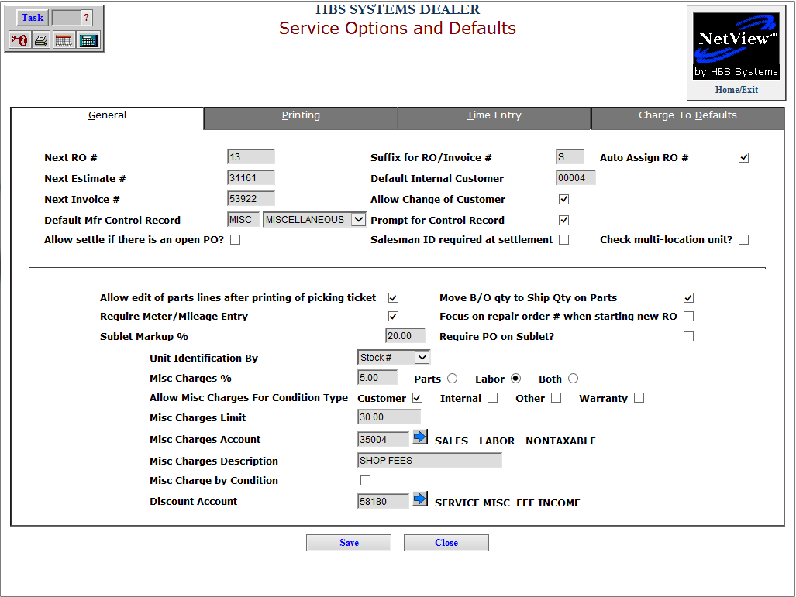

Service Options and Defaults (SOD): The General Tab has a question that affects how Repair Orders interact with Purchase orders. To access this function, you can either:

- Select “Service” from the menu. Choose the “Data Entry” submenu and click “Service Options and Defaults.”
- Type “SOD” in the Shortcuts Bar.

Allow settle if there is an open PO?: Click this box if you want to be able to close and settle a repair order if there is an OPEN Purchase Order. If left unchecked, it will stop you from closing a repair order when there is an OPEN Purchase Order.

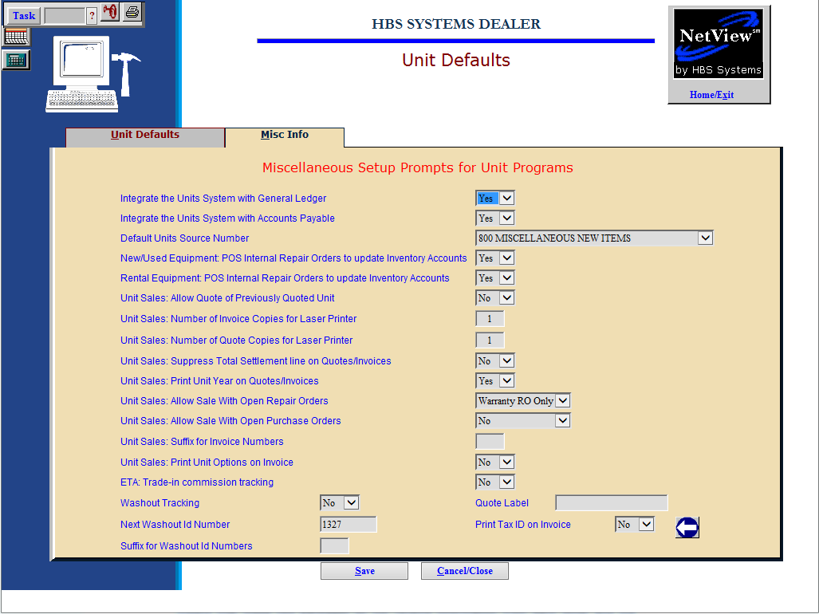

Unit Defaults (WGDF): The Misc Info Tab has a question that affects how Unit Sales Invoices interact with Purchase orders. To access this function, you can either:

- Select “System Maintenance” from the menu. Choose the “Company File” submenu and click “Unit Defaults.”
- Type “WGDF” in the Shortcuts Bar.

Unit Sales: Allow Sale With Open Purchase Orders: This setting offers the option to sell Units with Open POs.

- If you set this to Yes, you will be able to process Sales in US or POS for units that have open POs. When the unit is sold, it will be costed with the values present on the unit at that point.
  - If the outstanding Purchase Order has an impact on the unit (via an RO or POS ticket), the value of the RO/POS Invoice will be posted according to the RO type:
    - Internal will post to the G/L account number designated in the After Sales field in the Unit Source.
    - Warranty will post to the Warranty Receivable account.
- Choose No to prevent the sale if there are open POs.
- Choose Warranty RO only to allow the sale when there is an open PO/RO that is Warranty pay.

