Service History Report (SHR)

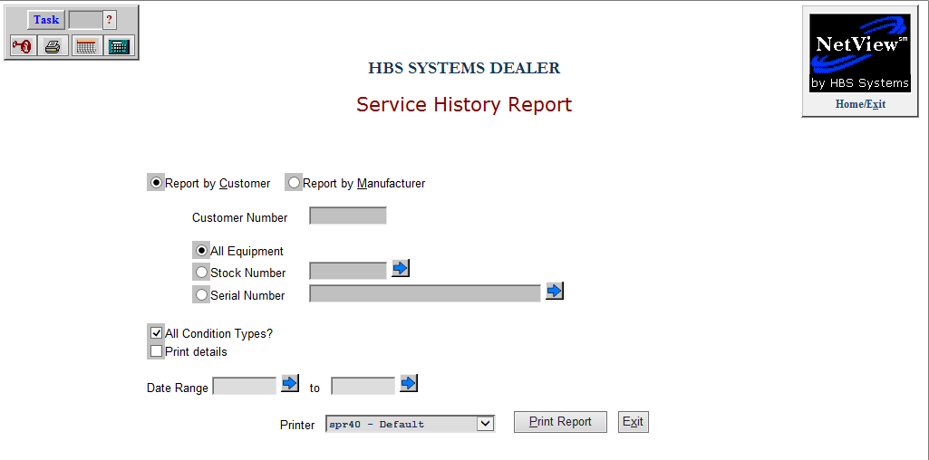

This program allows you to view and print a Service History report by either customer or manufacturer.

To access this function, type “SHR” in the Shortcuts Bar.

Report by Customer: Select this option to sort the report by customer.

Customer Number: If you want to print a report for a single customer, type in their customer number. You can also look it up by typing part or all of the customer’s name.

All Equipment: Select this option to include all equipment on the report. This is the default option.

Stock Number: If you want to print a report for a specific stock number, select this option and type in the number. You can also use the Arrow button to look up the stock number using the Unit Search.

Serial Number: If you want to print a report for a specific serial number, select this option and type in the number. You can also use the Arrow button to look up the stock number using the Unit Search.

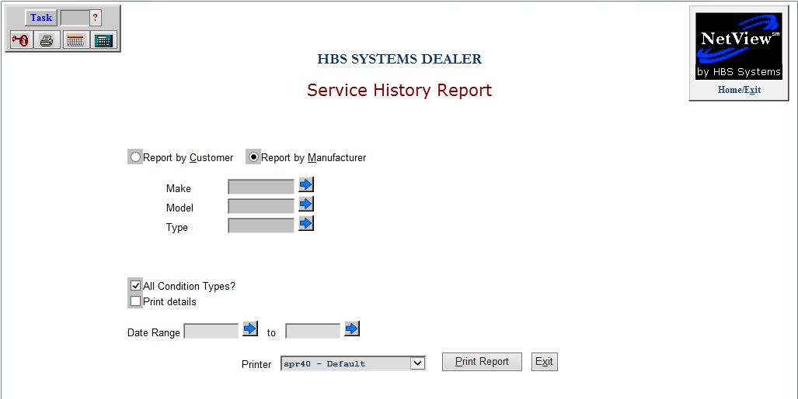

Report by Manufacturer: Select this option to sort the report by Manufacturer. NOTE: You MUST use at least one of the three fields listed below to indicate what will be on the report. It WILL NOT simply print a report of all units organized by Manufacturer. However, you can use up to all three of these fields in specifying what will be included on the report.

Make: Enter a unit’s Make in this field to restrict the report to that specific Make. You can also use the Arrow button to look up the Make using the Unit Search.

Model: Enter a unit’s Model in this field to restrict the report to that specific Model. You can also use the Arrow button to look up the Model using the Unit Search.

Type: Enter a unit’s Type in this field to restrict the report to that specific Type. You can also use the Arrow button to look up the Type using the Unit Search.

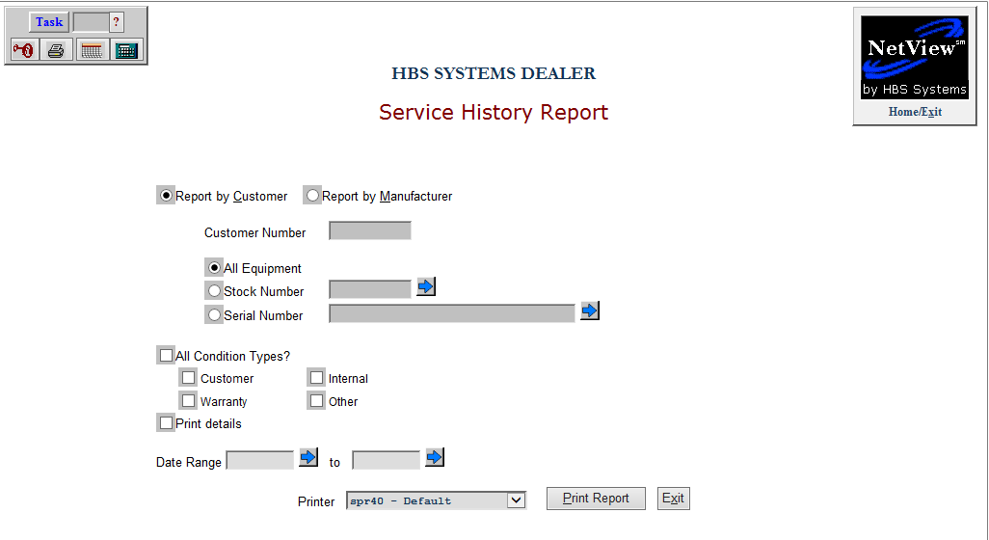

All Condition Types: Check this box to include all condition types on the report. When unchecked, the image above appears, allowing you to specify which conditions to include. The options are:

- Customer
- Warranty
- Internal
- Other

Print Details: Check this box for a Detail version of the report. Leave it blank to omit the details.

Date Range to: If you want the report to only cover a specific range of dates, type the starting and ending dates in these fields. You can also use the Arrow buttons to select the dates from a calendar.

Exit: You can leave the program at any time by clicking this button.

Printer: Select a printer from the drop-down menu. Select either the see or pdf printers to view a copy of the report.

Print Report: Click this button to print the report.

Sample Customer Report without Detail

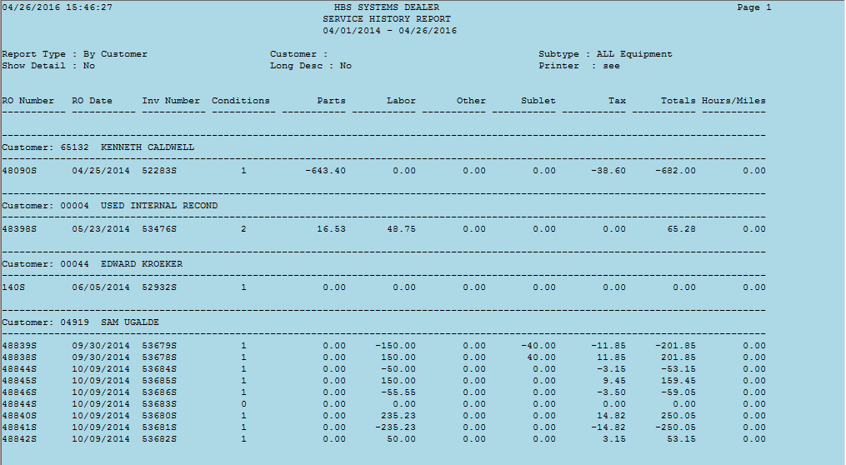

Sample Customer Detail Report

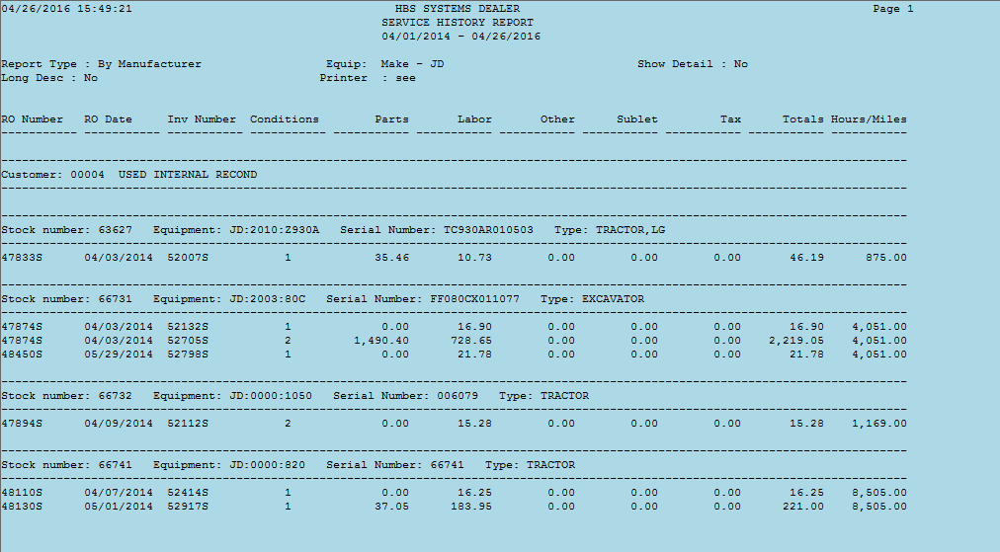

Sample Manufacturer Report (Make) without Detail

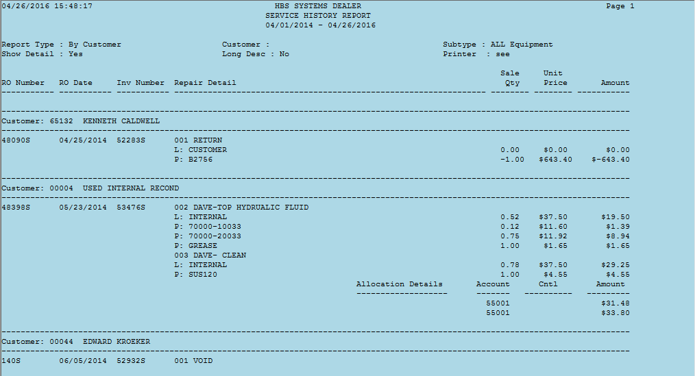

Sample Manufacturer Detail Report (Make)

