Parts Sales History Via Customers (SHVC)

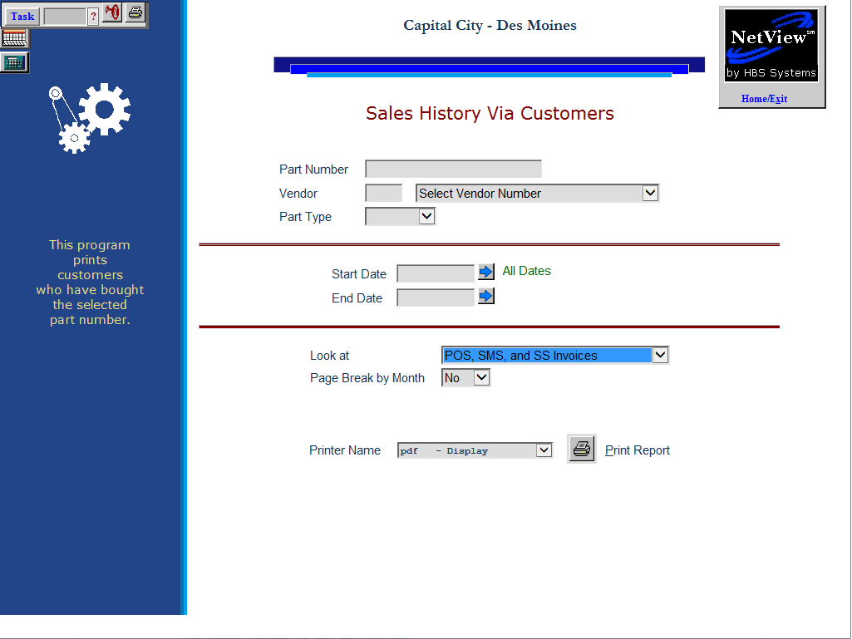

This report is useful in tracking sales activity on high volume parts. It also lists the customers who bought the part, Invoice Numbers, and Dates, as well as the quantity sold and the extended sales price.

- To access the Part Sales History via Customer Report, you can either:
  - Select “Inventory” from the menu. Choose the “POS History” submenu and click “Parts Sales History via Customers.”
  - Type “SHVC” in the Shortcuts Bar.

Field Definitions

Part Number: Enter a part number to include on the report.

Vendor: The vendor number for this part pre-fills, but you can select a different vendor using the drop-down menu in the Select Vendor Number field.

Part Type:
The part type is pre-filled from the part master. It could be:

- New
- Used
- Reman
- Core
- Memo

Start Date/End Date: Choose the starting and ending dates for the report, or leave both blank to run the report for “All Dates.”

Look At: The report can include information from:

POS

SMS

SS

All three (Default)

Page Break by Month:

- Choose Yes to have the report page break when a new month of activity begins.
- Choose No to produce a continuous report of the part’s activity.

Printer Name: Select the printer to receive the printout. A default printer name is pre-filled but can be changed as necessary. Use the see printer to view the report on the screen without printing a copy of it.

Print Report: Press this button to print your report.

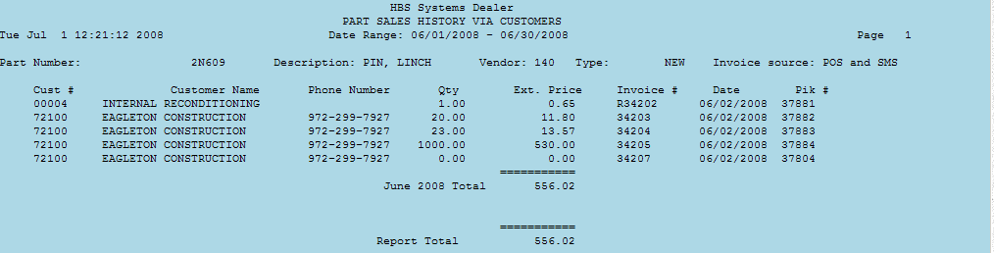

Report Detail

Part Number: This line of the report shows the following information about the item selected:

Part number

Description

Vendor

Type

Invoice Source: This indicates if the invoices came from

POS

SMS

SS

Two of those

All three

Cust#: The customer’s account number is shown here.

Customer Name: The customer’s name is printer in this field.

Phone Number: The customer’s phone number is shown here.

Qty: This field holds the quantity sold of the part number shown.

Ext. Price: This is the extended selling price for this item (selling price times quantity sold).

Invoice #: Here you will find the invoice number for the customer.

Date: The date shown is the invoice date.

Pik #: This field will show the original picking ticket number.

Month Total: This is a total of all invoices for this customer for the month indicated.

Report Total: This is a grand total of all sales for the specified dates and part numbers.

