Select A/P Invoices (SIBD/SIBN)

Select A/P Invoices (SIBD/SIBN) allows you to select which invoices to pay with the next check run. The program has two selection modes:

- By Date (SIBD)
- By Vendor (SIBN)

To access this function, you can either:

- Select “Accounts Payable” from the menu and choose the “Process Checks” submenu. Open the “Select Invoices” header and click on either “By Date (For SIBD)” or “By Vendor (For SIBN).”
- Type “SIBD” or “SIBN” in the Shortcuts Bar.

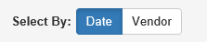

Select By: This prompt lets you switch between the two selection modes. While the rest of the header will change depending on the selection mode chosen, this field will always remain.

- Click Date to use By Date/SIBD.
- Click Vendor to use By Vendor/SIBN.

NOTE: If you make changes in one selection mode and then try to switch modes without saving your changes, a warning similar to the following will appear:

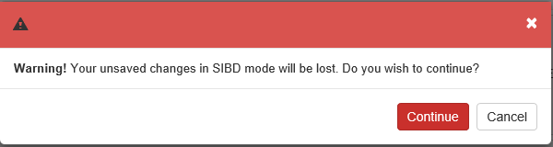

- Click Continue to discard your changes and switch to the other mode.
- Click Cancel to return to the main screen and save your changes before switching.

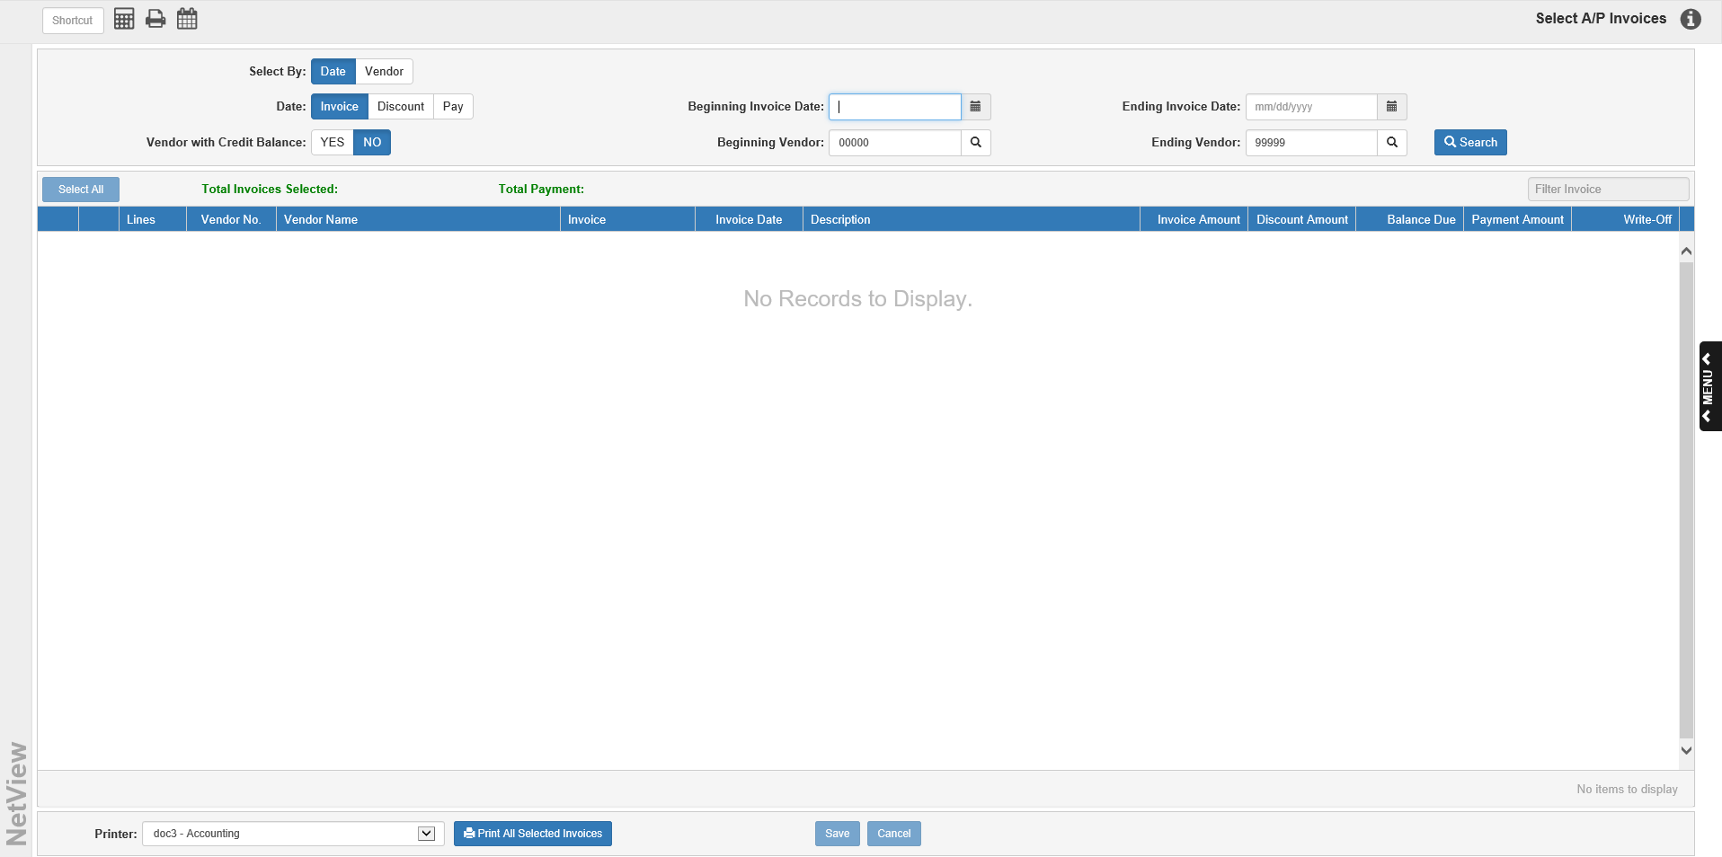

By Date Selection Screen: The By Date (SIBD) selection mode lets you select invoices for payment by a range of Invoice Dates, Discount Dates, or Pay Dates. This screen also allows you to select invoices for as many different vendors as you wish.

Date:

- If you want to select by the invoice creation date, choose Invoice.
- If you want to select by the invoice’s discount date, choose Discount.
- If you want to select by the invoice’s due date, choose Pay.

Beginning Date: Enter the first date of your selection range or select it from the calendar. If looking for a specific date, enter it in both this field and the Ending Date field. You could use 01/01/1987 in this field to b sure you don’t miss any unpaid invoices.

Ending Date: Enter the last date of your selection range or select it from the calendar. If looking for a specific date, enter it in both this field and the Beginning Date field.

Vendors with Credit Balance: Set whether or not you wish to include invoices belonging to vendors with a credit balance for payment.

- The field defaults to No, which excludes those vendors’ open invoices from selection.
- Choose Yes to include the vendors.

Beginning Vendor: This field and the Ending Vendor field let you select a specific vendor or a range of vendors. To begin your range of vendors for invoice selection, type the first (lowest number) vendor number in this field.

- You may type in a vendor number here or search for it by entering all or part of the vendor’s name in this field. Click the Search icon to trigger the Vendor Search. Locate the vendor and click on it to select it.
- Leave 00000 as the first vendor account to select all vendors.

Ending Vendor: Type the highest vendor number to complete the range of vendors for invoice selection.

- You may type in a vendor number here or search for it by entering all or part of the vendor’s name in this field. Click the Search icon to trigger the Vendor Search. Locate the vendor and click on it to select it.
- Leave 99999 as the last vendor account to select all vendors.

AP Account: If you have the Multiple A/P Accounts feature turned on in Information Defaults (ID), this selection field will appear in the header. It will only appear on the By Date selection mode screen.

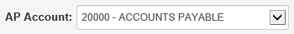

If you only want to select invoices paid using a specific A/P account, select the account from the drop-down menu.

Click “Search” to begin the selection process. The Invoice Selection Grid will populate with all invoices that fall within the selected date/vendor ranges, letting you see what you have selected, and will be automatically selected for payment in full.

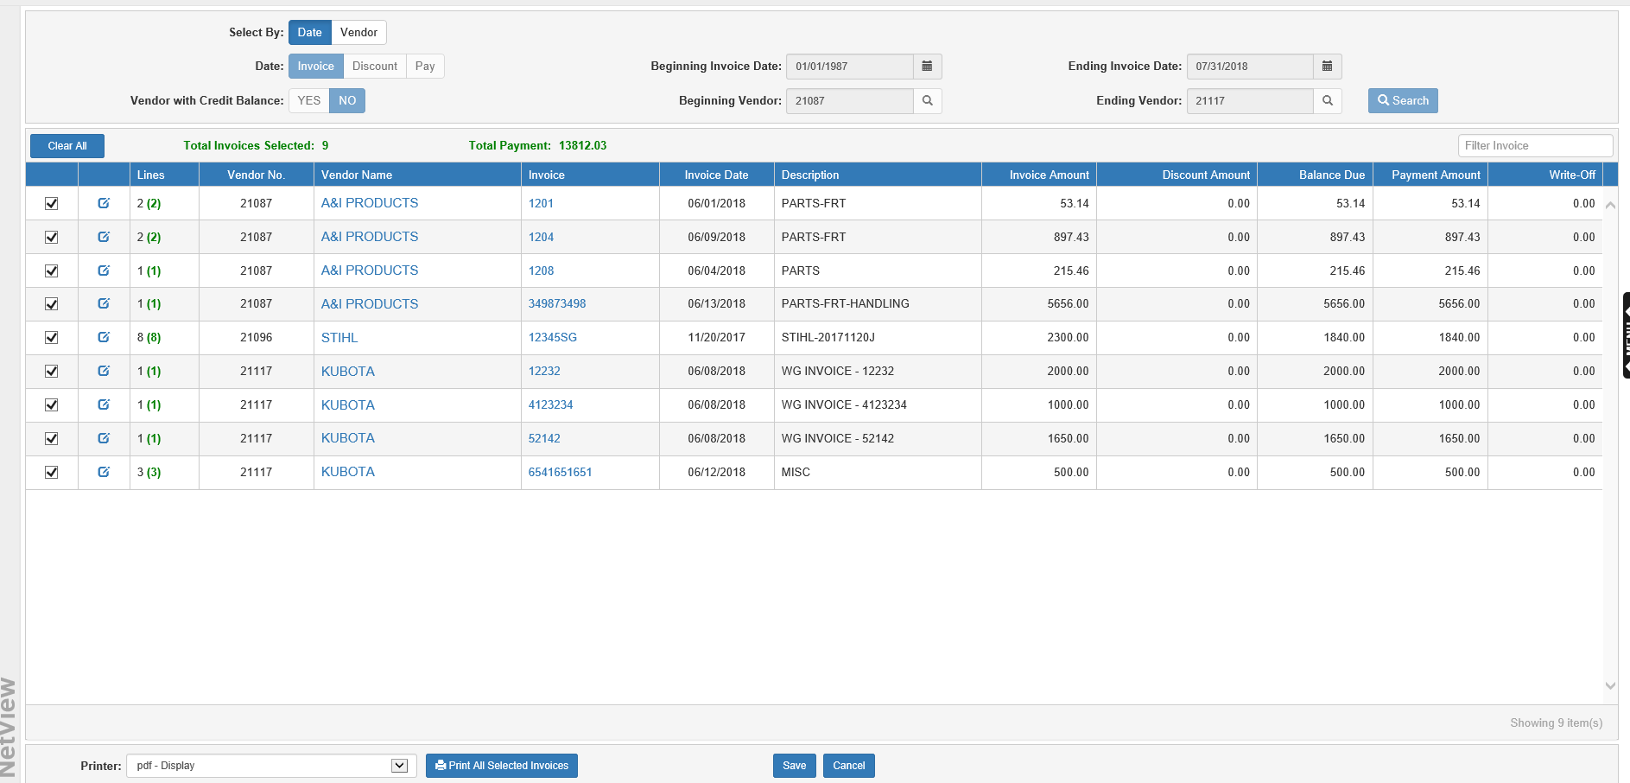

Total Invoices Selected: After you click Search, the total number of invoices currently selected for payment will display here. The display will update every time you select or deselect invoices for payment.

Total Payment Amount: After you click Search, the total amount of all currently selected invoices (minus any discounts) displays here. The display will update every time you select or deselect invoices for payment.

Filter Invoices: Use this field to filter the grid by entering specific invoice information (invoice number, vendor number, amount, etc.). The grid will then only show entries with matching information. This is particularly useful if you only want to select a specific invoice or set of invoices for payment, like ones due on the same date or with the same remaining balance amount.

Clear/Select All: Click this button to clear or select all the open invoices displayed in the grid results. The button’s function will switch depending on whether any invoices are selected or not. NOTE: All invoices found by the By Date selection search will be automatically selected to be paid in full.

Invoice Selection Grid Columns-By Date:

Clear/Select: Check this box to select the invoice for payment. Uncheck it to clear the invoice from the selection. NOTE: A check indicates that some or all of the invoice has been marked to be paid or written-off.

Edit Selection: Click this blue icon next to the Clear/Select check to edit the invoice selection.

Lines: This column shows:

- The number of lines on the invoice (in black)
- The number of those lines currently selected for full or partial payment/write-off (in green)

Vendor No.: This column shows the vendor number for the invoice.

Vendor Name: This column shows the vendor name for the invoice.

Invoice: This column shows the invoice number.

Invoice Date: This column shows the invoice’s date.

Description: This column shows the invoice’s header description from EAPI.

Invoice Amount: This column shows the invoice’s original amount (before discounts, payments, or write-offs).

Discount Amount: This column shows the invoice’s discount amount, if any. NOTE: Discounts are only applied if the invoice is selected to be paid in full; a partial payment will receive no discounts.

Balance Due: This column shows the remaining balance due on the invoices after previous payments/write-offs.

Payment Amount: This column shows the amount of the invoice currently selected for payment. The value will update when the invoice is selected or cleared, and will reflect whether or not the line is set to pay in full or just partially.

Write-Off: This column shows the amount of the invoice currently selected for write-off. The value will update when the invoice is selected or cleared, and will reflect whether or not the line is written off in part or in full.

Editing a Payment Selection-Date Grid: This feature allows you to select invoices for partial payments or write-offs instead of full payment. You can access the window by clicking on the Edit Selection icon.

The following window will appear when you click the icon:

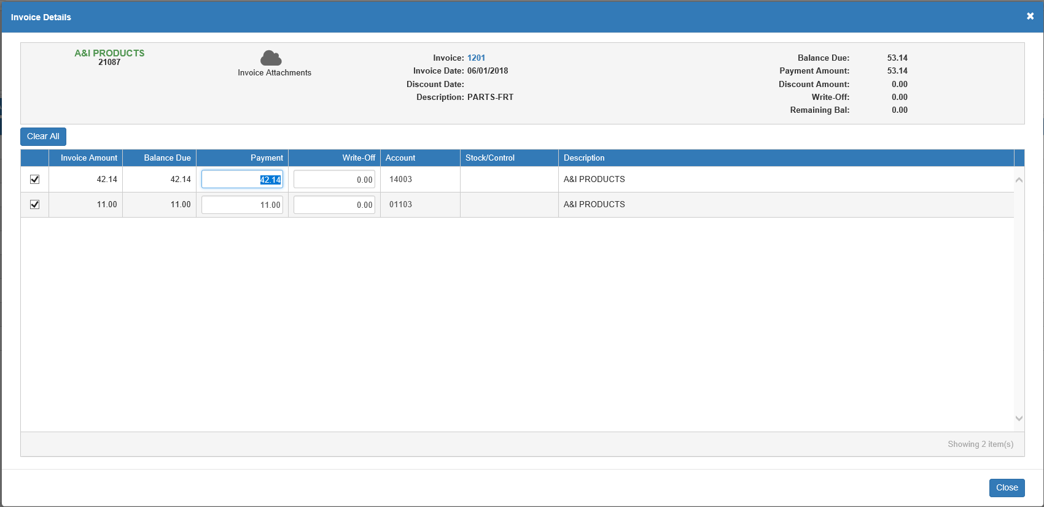

Invoice Details-Field Descriptions:

- Invoice Attachments: This icon shows how many eDocs are attached to the invoice record and can be used to see the invoice’s eDocs.
- Invoice: This field shows the invoice number.
- Invoice Date: This field shows the invoice’s date.
- Discount Date: This field shows the invoice’s discount date, if any.
- Description: This field shows the invoice’s header description from Enter A/P Invoices (EAPI).
- Balance Due: This field shows the balance currently due on the invoice.
- Payment Amount: This field shows the amount currently selected for payment.
- Write-Off: This field shows the amount currently selected as a write-off.
- Remaining Bal: This field shows the remaining balance on the invoice after the values in the Payment Amount and Write-Off fields is subtracted from the Balance Due value.
- Select/Clear All: Use this button to select or clear all the lines on the invoice for payment or write-off.

Invoice Detail Grid-Columns:

- Select/Clear: Check this box to select the invoice line for payment or write-off. Uncheck it to clear the line selection.
- Invoice Amount: This column shows the full original amount of the invoice line.
- Balance Due: This column shows the balance currently due on the invoice line.
- Payment: The fields in this column default to the full balance due on the invoice line. To make a partial payment, change the amount here. This will update the value in the Payment field in the header, as well as the Remaining Bal field. Entering a payment will also remove any write-offs entered for the line, as you cannot have a payment and a write-off on the same line.
- Write-Off: The fields in this column default to “0.00.” To write-off all or part of the invoice line, enter a value here. This will update the value in the Write-Off field in the header, as well as the Remaining Bal field. Entering a write-off will also remove any payments entered for the line, as you cannot have a payment and a write-off on the same line.
- Account: The fields in this column are active if an amount is entered in the write-off field. It will typically hold the General Ledger account entered on the line during the invoice creation process, but you may change it if you want the write-off to go to a different account. If you enter a non-existent account, the program will offer you the option to view all available G/L accounts and choose one to use for the line.
- Stock/Control: The fields in this column is active if an amount is entered in the write-off field. Enter a stock or control number for the G/L account if necessary. Sometimes a number will automatically appear for the account, provided one was entered for the line during the invoice creation process, but you can change the number if needed. If a stock number is required, a search icon will appear by the field, giving you the ability to look up stock numbers with the Unit Search if necessary.
- Description: This column shows the invoice line’s description.

Accessing eDocs in the Invoice Detail Screen: Click the Invoice Attachments icon in the header of this screen to view, add, and edit any eDocs attached to the invoice number.

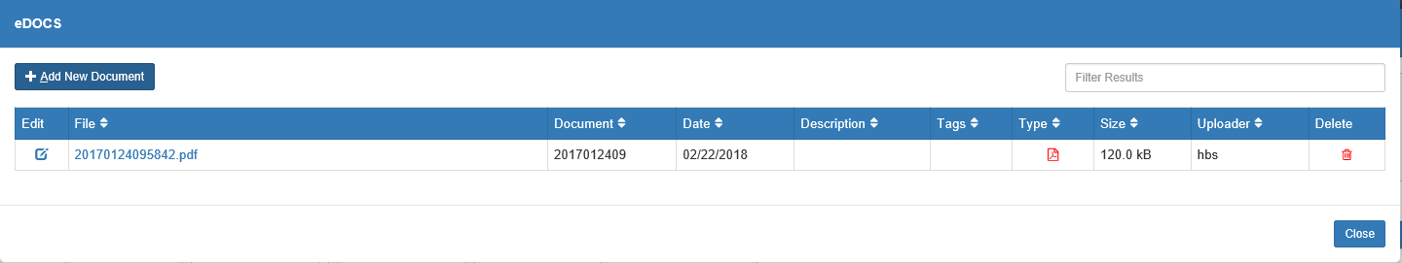

Close: Click this button when you have finished with the invoice details. Any changes you have made will save automatically.

Viewing A/P History Invoice Details in Date Mode: You can click on an invoice number in either the grid or the header of the Edit Selection Invoice Detail screen to view the invoice’s A/P history (when it was entered, any payments that have already been made, etc.).

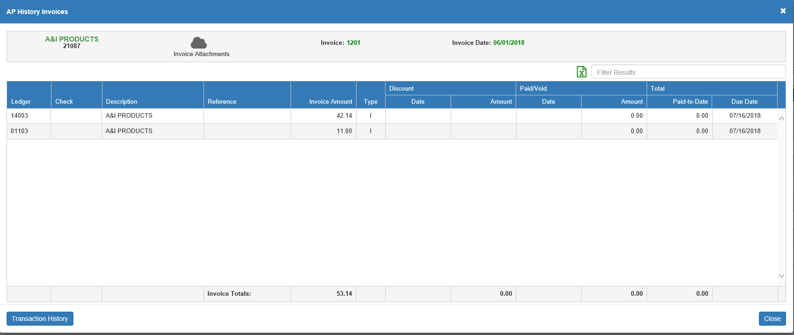

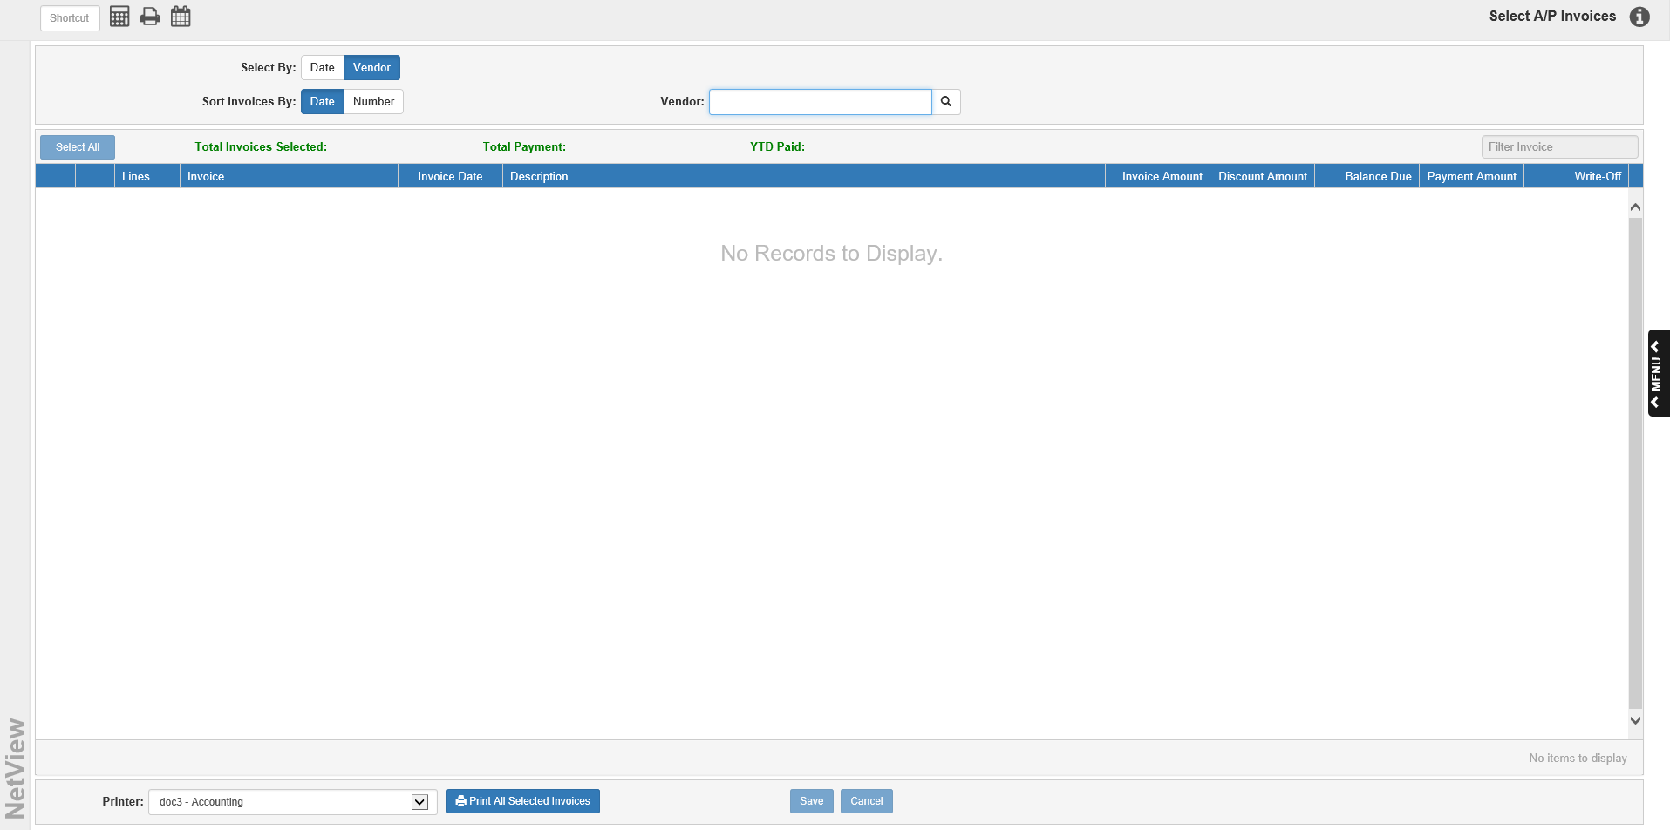

By Vendor Selection Screen: The By Vendor (SIBN) selection mode lets you select and/or clear invoices for payment for a single vendor.

Sort Invoices By:

- To sort the unpaid invoices by invoice number, choose Number.
- To sort the invoices in date order, choose Date.

Vendor: You may type in a vendor number here, or search for it by entering part of the vendor’s name. The Vendor Search will show if your entry appears in multiple fields. Locate the vendor and click on it to populate the Invoice Selection Grid with the vendor’s open invoices. The vendor’s name and number will also display to the right of the field. You can click on the vendor’s name to view their Vendor Insight (VI) page.

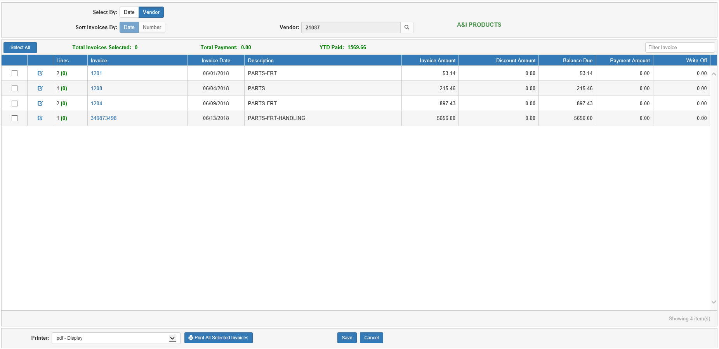

Total Invoices Selected: After you select a vendor, the total number of invoices currently selected for payment will display here.

Total Payment Amount: After you select a vendor, the total amount of all currently selected invoices (minus any discounts) displays here.

YTD Paid: After you select a vendor, the total amount paid to this vendor to date this year will appear here.

Filter Invoices: Use this field to filter the grid by entering specific invoice information (invoice number, amount, etc.). The grid will then only show entries with matching information. This is particularly useful if you only want to select a specific invoice or set of invoices for payment, like ones due on the same date or with the same remaining balance amount.

Clear/Select All: Click this button to clear or select all the invoices displayed in the grid results. The button’s function will switch depending on whether any invoices are selected or not.

Invoice Selection Grid Columns-By Vendor:

Clear/Select: Check this box to select the invoice for payment. Uncheck it to clear the invoice from the selection.

Edit Selection: Click this blue icon next to the Clear/Select check to edit the invoice selection.

Lines: This column shows the following:

- The number of lines on the invoice (in black)
- The number of those lines currently selected for full or partial payment/write-off (in green)

Invoice: This column shows the invoice number.

Description: This column shows the invoice’s header description from EAPI.

Invoice Amount: This column shows the invoice’s original amount (before discounts, payments, or write-offs).

Discount Amount: This column shows the invoice’s discount amount, if any. NOTE: Discounts are only applied if the invoice is selected to be paid in full; a partial payment will receive no discounts.

Balance Due: This column shows the remaining balance due on the invoices after previous payments/write-offs.

Payment Amount: This column shows the amount of the invoice currently selected for payment.

Write-Off: This column shows the amount of the invoice currently selected for write-off.

Editing a Payment Selection-Vendor Grid: Click the Edit Selection Icon to select invoices for partial payments or write-offs instead of full payment.

The following window will appear:

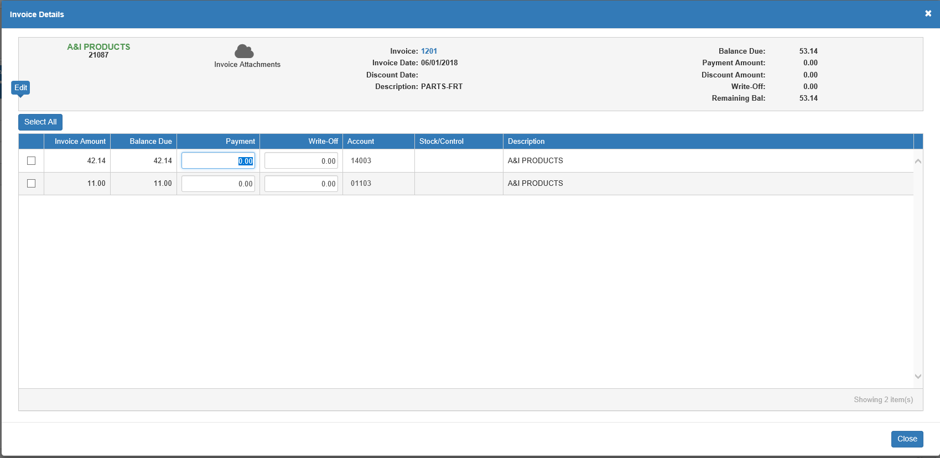

Invoice Details-Field Descriptions

- Invoice Attachments: This icon shows how many eDocs are attached to the invoice record and can be used to see the invoice’s eDocs
- Invoice: This field shows the invoice number.
- Invoice Date: This field shows the invoice’s date.
- Discount Date: This field shows the invoice’s discount date, if any.
- Description: This field shows the invoice’s header description from Enter A/P Invoices (EAPI).
- Balance Due: This field shows the balance currently due on the invoice.
- Payment Amount: This field shows the amount currently selected for payment.
- Write-Off: This field shows the amount currently selected as a write-off.
- Remaining Bal: This field shows the remaining balance on the invoice after the values in the Payment Amount and Write-Off fields is subtracted from the Balance Due value.
- Select/Clear All: Use this button to select or clear all the lines on the invoice for payment or write-off.

Invoice Detail Grid-Columns:

- Select/Clear: Check this box to select the invoice line for payment or write-off. Uncheck it to clear the line selection.
- Invoice Amount: This column shows the full original amount of the invoice line.
- Balance Due: This column shows the balance currently due on the invoice line.
- Payment: The fields in this column default to the full balance due on the invoice line. To make a partial payment, change the amount as necessary. This will update the value in the Payment field in the header, as well as the Remaining Bal field. Entering a payment will also remove any write-offs entered for the line, as you cannot have a payment and a write-off on the same line.
- Write-Off: The fields in this column default to “0.00.” To write-off all or part of the invoice line, enter a value in this field. This will update the value in the Write-Off field in the header, as well as the Remaining Bal field. Entering a write-off will also remove any payments entered for the line, as you cannot have a payment and a write-off on the same line.
- Account: The fields in this column are active if an amount is entered in the write-off field. It will typically hold the General Ledger account entered on the line during the invoice creation process, but you may change it if you want the write-off to go to a different account. If you enter a non-existent account, the program will offer you the option to view all available G/L accounts and choose one to use for the line.
- Stock/Control: The field in this column is active if an amount is entered in the write-off field. Enter a stock or control number for the G/L account if necessary. Sometimes, a stock/control will be automatically present for the account, provided one was entered for the line during the invoice creation process but that can be changed if needed.
- Description: This column shows the invoice line’s description.

Accessing eDocs in the Invoice Detail Screen: Click the Invoice Attachments icon in the header of this screen to view, add, and edit any eDocs attached to the invoice number.

Close: Click this button when you have finished with the invoice details. Any changes you have made will save automatically.

Viewing A/P History Invoice Details in Vendor Mode: You can click on an invoice number in either the grid or the header of the Edit Selection Invoice Detail screen to view the invoice’s A/P history (when it was entered, any payments that have already been made, etc.).

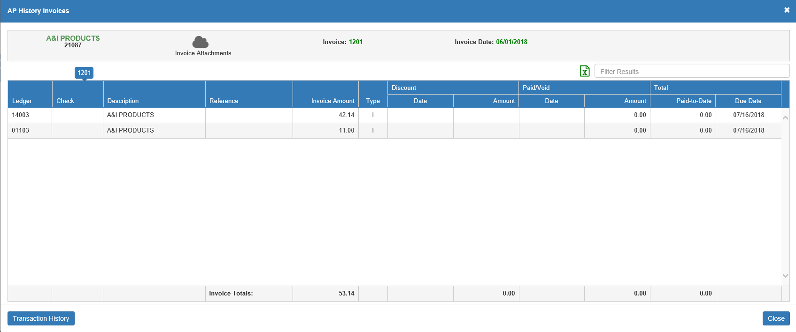

Footer Features: The features located in the program footer remain the same regardless of which selection mode you use.

Save: Click this button to save the invoice selection for payment. You will now be able to print checks to pay those invoices in Print Checks (PC).

Cancel: Click this button to cancel your selection before saving and clear the screen. You will receive a warning similar to the following:

- Click Continue to cancel the selection and clear the screen.
- Click Cancel to return to the main screen without discarding your changes.

Print All Selected Invoices: If you want to view a report of all the invoices you just selected for payment in this session, regardless of which mode you used to select them, select a printer to receive the report and click this button.

Selected Invoices Report:

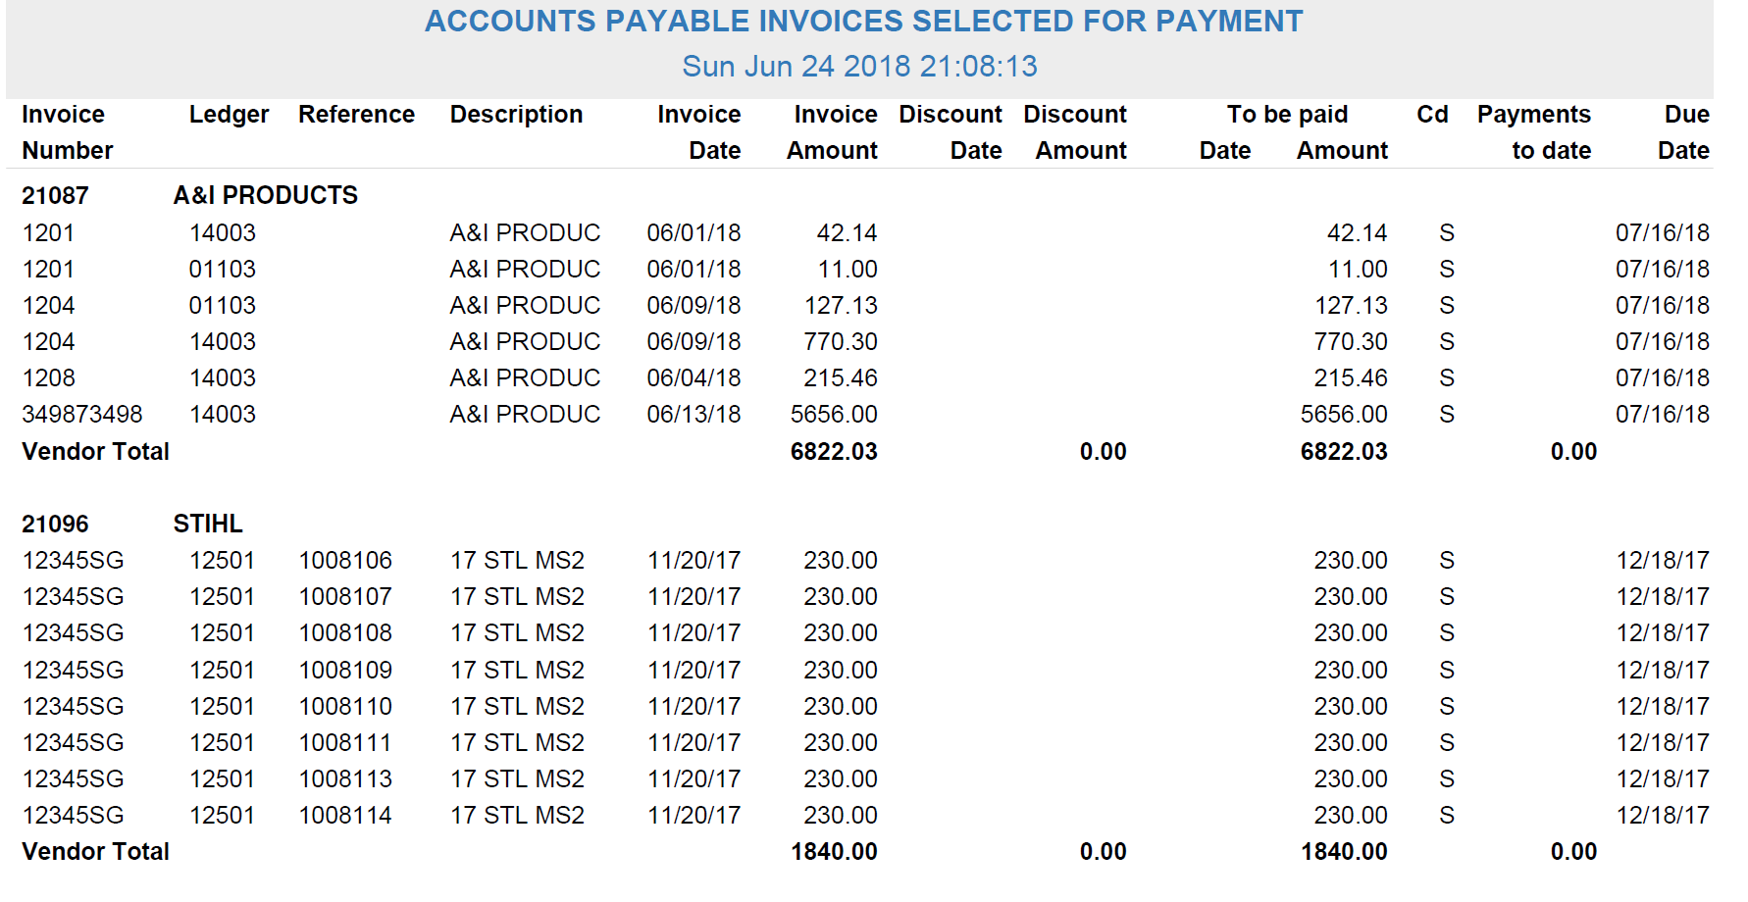

This report is the same report you would receive if you ran the Open Invoices Report (OIR) for all invoices selected for payment. The report is sorted into sections by vendor. The vendor number and name are printed on the first line of the section, followed by the invoices, which are separated out into the individual invoice lines. The report lists the following information per each invoice line:

Invoice Number: The invoice number is printed under this column.

Ledger: This is the G/L account number used for the invoice line (such as Parts Freight or Parts Inventory).

Reference: If the account supports a subledger or is tied to a unit, this column shows the Control Number or Stock Number for the invoice line. Even if the account is not tied to a subledger or a unit, this field can contain helpful information and comments for designating the reason for using the account number, like UPS, CHEVY REPAIR, POSTAGE, and so on.

Description: This column prints the description you entered on the particular invoice line.

Invoice Date: This column shows the date that the invoice was written.

Invoice Amount: This is the original amount of the invoice line item before any payments or discounts.

Discount Date: This prints the date by which the invoice must be paid in order to receive a discount, if applicable.

Discount Amount: This is the dollar amount of the discount if paid by the discount date, if applicable.

To Be Paid Date: If the check paying off the invoice line has already been printed, but not yet posted to the General Ledger, the check’s paid date prints here (Status Code=P).

To Be Paid Amount: This column shows the amount of the invoice line selected for payment, but not yet posted to the General Ledger (Status Code=S or P).

CD (Code): The column displays the status of the invoice. It will almost always be S=Selected, with P=Paid only occurring if the selected invoice has been paid, but the payment has not yet been journaled.

Payments to Date: If partial payments have been made toward this invoice line entry, or if the invoice’s Status Code is P, the amount of payments made to date on the line appears in this column.

Due Date: The date when the payment is due prints in this column.

Vendor Total Line: This line calculates the invoice totals for this vendor account by adding up the values on all the lines of all the vendor’s invoices on the report. It prints vendor totals for the following columns:

Invoice Amount

Discount Amount

To Be Paid Amount

Payments to Date

Grand Total Line: This line appears at the end of the report and calculates totals for all vendors on the report. It shows the total number of invoices listed on the report, as well as report totals for the following columns:

- Invoice Amount
- Discount Amount
- To Be Paid Amount
- Payments to Date

