Stale Inventory Report: The Stale Inventory Report creates a report listing all rental units that have not been rented within a set period of time going back from the current date: the past 30 days, the past 60 days, or the past 90 days.

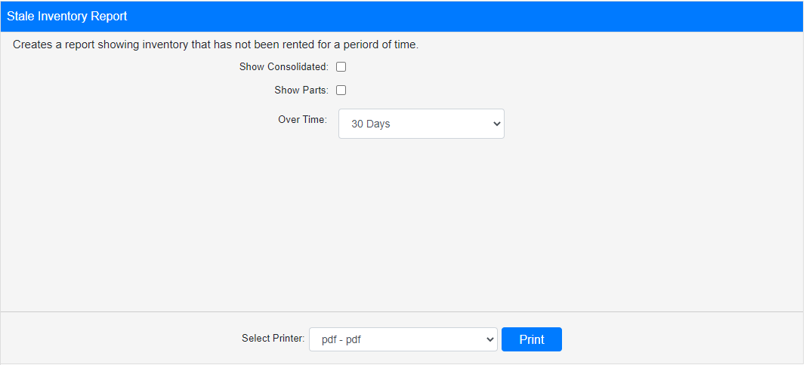

Field Definitions:

Show Consolidated: If you are a multi-location dealership with a Consolidated location, check this box to include the Consolidated location’s information on your report. Uncheck it to only print a report for your individual location. NOTE: If running the report in the Consolidated location, you must check this box to receive a report.

Show Parts: If you wish to include non-serialized units (aka rental parts) on the report check this box. Leave it unchecked to only see serialized units on the report.

Over Time: Select the time period for the report to examine: the past 30 days, the past 60 days, or the past 90 days. The report will only include units that had their last sale on a date prior to this period of time. The field defaults to 30 days.

Select Printer: Select the printer you want to receive the report from here. Use the pdf printer to preview the report.

Click “Print” to print the report.

Sample Report:

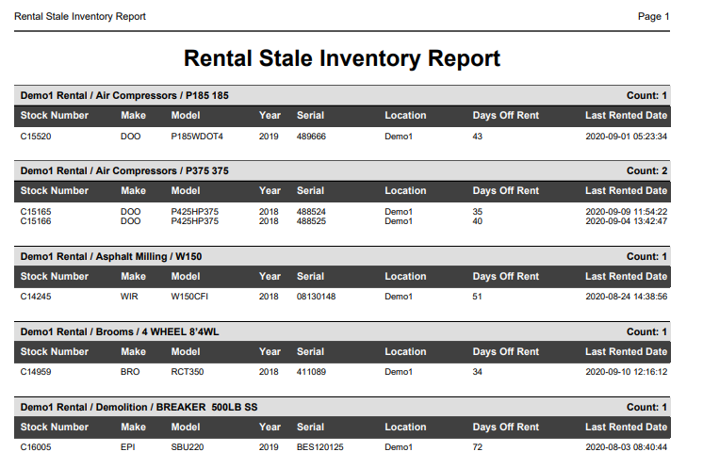

The report is grouped into sections by Rental Class, with a total count in the section header indicating how many units in that Class appear on the report. The following information is shown for each unit:

- Stock Number
- Make
- Model
- Year
- Serial Number
- Dealer Location (will be the same for all units unless running report at Consolidated location)
- Days Off Rent
- Last Rented Date (will be before the start of the report period)

