G/L Subledger Report (SLED)

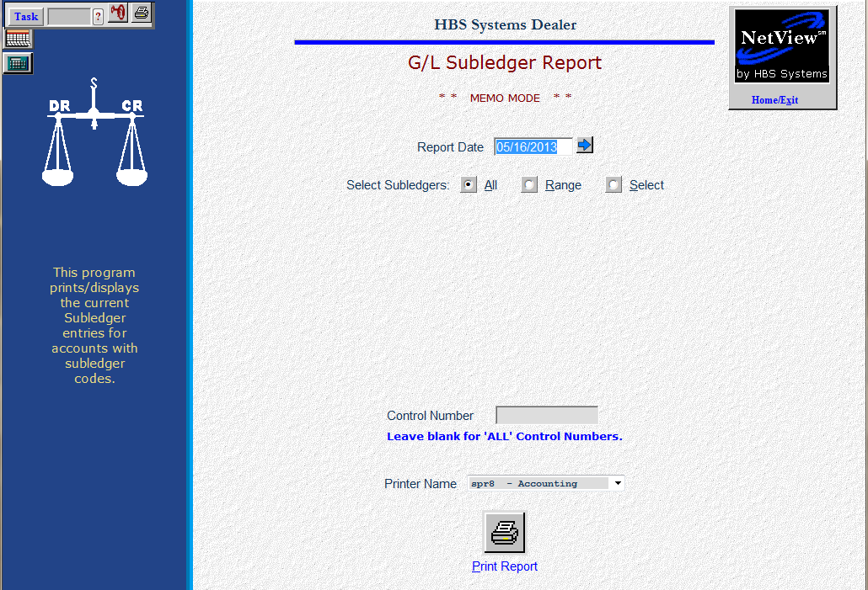

Subledgers (SLED) provide an additional layer of detail for “elements” (control numbers) within a GL account. This detail is typically sorted and subtotaled by the control number (such as stock number, vendor number, customer number, or customer name). By reviewing the SLED reports, you can account for each penny of each item detailed within the account.

- To access this function, you can either:
  - Select “General Ledger” from the menu. Choose the “Memo Reports” submenu and click “Subledgers.”
  - Type “SLED” in the Shortcuts Bar.

The Subledger reports are helpful to examine:

- A single document
- A single control number
- All the activity within a selected General Ledger account

The SLED report is flexible and can produce a display or printout of:

- A single account
- A range of accounts
- A selection of accounts
- Details about a control number that spans all accounts

Screen Fields

Report Date: Select the report date you wish to see. The report will be generated “as of” the date you specify.

Select Subledgers:

- All: Displays or prints all accounts that have a subledger code and that have any activity.
- Range: Lets you specify a range of account numbers. This would be a good choice when you want to examine a group of sequential accounts (i.e. a range of Units inventory accounts).

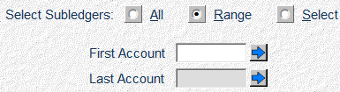

- Select: Displays Ledger fields that let you pick and choose up to 21 account numbers you want to examine.

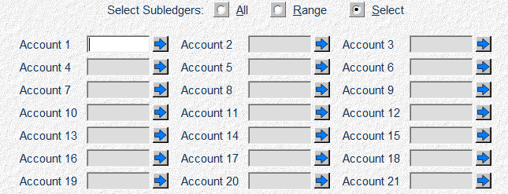

Control Number: This field lets you enter a specific control number to examine. It can work with an account number entered or by itself to look for all activity in all account numbers. Leave this field blank to see ALL activity for a given account number.

Common Uses of Sub-ledger Codes
Type of Account | SLED Code | Control Number
Unit Inventory | 5 | Stock #
Notes Payable (Units | 5 | Stock #
Warranty Receivables | 5 | Invoice #/Document #
Contracts in Transit | 5 | Customer # or Name
Customer Deposits | 5 | Customer # or Name

Printer Name: Identify the printer to receive your printout. A default printer is pre-filled but you may change it as necessary. Use the PDF printer or the “see” printer to display the report.

Print Report: Click this button to print the report.

TIP—Date Selection: While you may use any date in this field, we recommend using the pre-filled current date. Subledger activity is best viewed as of the current time frame.

Code 4 Example—Detail Preserved at Month End sorted by document number
Tue May 06 14:25:59 2013 CONTRACTS IN TRANSIT Page 1
ACCOUNT 10600
05/06/2013
MEMO
DOC# CNTRL JN DOC DATE JN DATE DESCRIPTION CURRENT TOTAL
2561 JC567 01 04/04/2013 04/04 SIMMS CONTR-STK 267 38,780.95
06915 10 04/13/2013 04/13 JVC CREDIT INV 38,780.95-
TOTAL 2561 38,780.95-** 0.00 **

2984 MV58 01 04/20/2013 04/20 TYLER CONTR-STK 356 18,500.00
TOTAL 2984 0.00 ** 18,500.00 **

3061 MV591 01 04/20/2013 04/20 DUNNS CONTR-STK 192 7,150.00
3598 19 04/30/2013 04/31 MARVIN CHECK 7,150.00-
TOTAL 3061 7,150.00-** 0.00 **

3072 JV698 01 04/15/2013 04/15 EARL CONTR-STK 325 18,990.50
TOTAL 3072 18,990.50 ** 18,990.50 **

TOTAL 10600 17,751.94 *** 82,182.89 ***
THIS TYPE OF SUBLEDGER CODE IS NOT COMMONLY USED. For a Subledger Type 4 Report, every entry is sorted by the document number and then by the control number. Each document number forms a paragraph. The paragraph provides totals for the current open accounting period and a YTD balance total. The Type 4 Subledger carries all document number detail from month to month until the balance for the document becomes zero. When the month of the zeroing activity is closed, the detail falls off the printout.

Code 5 Example—Detail Preserved at Month End sorted by control number
Tue May 6 08:58:07 2013 NEW UNITS INVENTORY Page 1
ACCOUNT 12001
05/06/2013
MEMO
CNTRL DOC# JN DOC DATE JN DATE DESCRIPTION CURRENT TOTAL
621 052314 11 04/20/2012 04/20 00 MV SR-300 750.00
2009 11 04/20/2012 04/20 FREIGHT 15.00
R475 03 11/14/2012 11/14 SET-UP CHARGE 110.00
20013 01 12/01/2012 12/14 00 MV SR-300 875.00-
TOTAL 621 875.00-** 0.00 **

783 28654 11 05/15/2012 05/15 00 JVC B175 3,000.00
R557 03 06/01/2012 06/01 SET-UP CHARGE 110.00
25009 01 12/01/2012 12/04 00 JVC B175 3,110.00-
TOTAL 783 3,110.00-** 0.00 **

871 659711 11 07/10/2012 07/10 00 CS 9710 50,600.00
R690 03 07/12/2012 07/12 REPAIR & SET-UP 200.00
R730 03 07/20/2012 07/20 ADD OPTION 450.00
TOTAL 871 0.00 ** 51,250.00 **
877 1325 11 07/15/2012 07/15 00 JVC F254 78,000.00
TOTAL 877 0.00 ** 78,000.00 **

878 12698 11 09/15/2012 09/15 01 JVC T569 55,000.00
TOTAL 878 0.00 ** 55,000.00 **
2100 65932 11 02/01/2013 02/15 01 MV FRD-L10 10,600.00
TOTAL 2100 10,600.00 ** 10,600.00 **

TOTAL 12001 37,865.00 *** 239,960.00 ***

For the Subledger Type 5 Report, all entries are sorted by the control number (stock number, vendor number, customer number, or customer name) and then by document number. Each control number forms a paragraph. The paragraph shows totals for the current open accounting period and a YTD balance.

This type of Subledger retains all control number detail from month to month until the balance for the control number becomes zero. When the month of the zeroing activity is closed, the detail falls off the printout.

This type is commonly selected for unit accounts: inventory and notes. The complete accounting history from the original purchase, repair orders, miscellaneous charges and adjustments, to the final sale of the equipment, is readily available on the Subledger Report. Also, accounts like Contracts in Transit or Customer Deposits are also good candidates for a Type 5 Subledger.

Code 8 Example—Register Format with Balance Forward at Month End sorted by document number
Tue May 05 10:32:02 2013 CASH IN BANK - REGULAR Page 1
ACCOUNT 10200
04/31/2013
MEMO
DOC# CNTRL JN DOC DATE JN DATE DESCRIPTION CURRENT TOTAL
BF 03/30/2013 03/30 BALANCE FORWARD 89,368.95
445 02572 10 04/05/2013 04/05 JOHN'S STORE 350.00-
446 268 10 04/05/2013 04/05 MARVIN INC. 5,600.38-
447 09391 10 04/05/2013 04/05 JOHNSON MFR CO 200.60-
448 LN5981 10 04/05/2013 04/05 FIRST FEDERAL 4,050.00-
449 PETTY 10 04/05/2013 04/05 PETTY CASH 59.34-
450 354 10 04/05/2013 04/05 CS L&G INC 2,561.95-
451 90531 13 04/28/2013 04/28 Net Pay BLAIR, B 1,830.46-
452 91069 13 04/28/2013 04/28 Net Pay HARBER, 1,258.72-
453 91562 13 04/28/2013 04/28 Net Pay JONES, K 1,901.84-
454 92691 13 04/28/2013 04/28 Net Pay CAREY, D 938.52-
457 JVC589 10 04/28/2013 04/28 JVC MFR INC. 59,693.58-
458 COD 10 04/28/2013 04/28 UPS COD-SHOP 35.01-
459 86132 10 04/28/2013 04/28 LONE STAR GAS 936.45-
460 7361 10 04/28/2013 04/28 MERRIAM TELEPHONE 609.52-
461 RO#895 10 04/28/2013 04/28 C & J TRUCK SHOP 159.66-
DEP32 DEP9 15 04/17/2013 04/17 DAILY DEPOSIT 5,961.31
DEP33 DEP10 15 04/19/2013 04/19 DAILY DEPOSIT 6,190.30
DEP34 DEP11 15 04/21/2013 04/21 DAILY DEPOSIT 17,002.67
DEP35 DEP12 15 04/24/2013 04/24 DAILY DEPOSIT 20,950.05

TOTAL 10200 30,081.17- *** 59,287.25***
THIS TYPE OF SUBLEDGER CODE IS NOT COMMONLY USED. The Subledger Type 8 Report organizes the entries by the document number and then by the control number. However, the Subledger Report does not separate the document numbers into individual paragraphs as types 4 and 5 provide. This style provides only grand totals for the current open accounting period and one for YTD.

The result is numerically, and then alphabetically, sorted document numbers arranged as a register. This format could be used for bank accounts and other receivable accounts.
The Type 8 Subledger stores and maintains only current open period information. When GLME is run, all accounting detail for that closed period is reduced to a single-line balance forward entry.

